The State of Housing in Wellington City: Infographic Report

Text version

February 2024

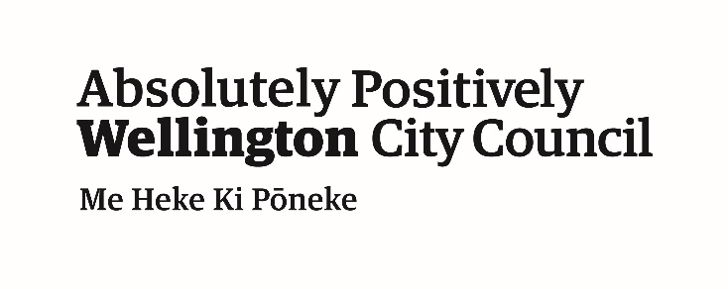

Contents
Introduction 4
Caveats 4
Key insights 5
Wellington City Context 6
Gross domestic product (GDP) 6
Median household income 6
Estimated population 7
Age and gender of Wellingtonians 7
Ethnicity of Wellingtonians 8
Sources of population growth 8
Overall and housing deprivation in Wellington City 9
Rented and owner-occupied dwellings 10
Affordability 11
The housing continuum 11
Annual household income by renting and owner-occupied households 11
Perceived affordability 12
Severe housing deprivation in Wellington City 13
Unmet need for public housing 14
Growth in rental prices and house prices 15
Rental prices 15
House prices 17
Housing supply 19
Total housing supply 19
Public housing supply 20
Te Kāinga affordable rental programme 20
Building age 20
Building consents 21
Household crowding 22
Presence of damp and mould 23
Housing quality 24
Housing suitability 25
Future housing demand 26
Population and housing projections over the next 30 years 26
Projected demand for attached and standalone dwellings 28

Introduction
Improving housing outcomes to enhance the wellbeing of our communities is a priority for the Council, as reflected through our Housing Strategy (2018-2028) and Housing Action Plan (2023-2025).
The State of Housing project brings together trusted data from a variety of national and local sources to provide insights into the current state of housing in Wellington City.
This report provides commentary around the Wellington City context, affordability, housing supply, and future housing demand.
Six interactive reports accompany this report and explore spatial patterns through maps presented at the Statistical Area 2 (SA2) geography. Spatial data is displayed as residential built up areas so mostly empty rural areas do not visually dominate the maps.
These interactive reports and a data source repository are available on the State of Housing website.

Caveats
This report was prepared by Wellington City Council in February 2024.
All data presented in this report are sourced from publicly available data sources or data held internally by Wellington City Council.
Results from the 2018 Census are used throughout this report as 2023 Census results were not available at the time of preparation. 2023 Census results are expected in late 2024/2025.
Data source details are available on the State of Housing website. Refer to the original data sources for full details, considerations, and caveats.

Key insights
- Wellington City’s estimated population was 216,200 in 2023. In 2018, there were approximately 80,000 dwellings, 41 percent of which were rented.
- Wellington City has above average housing deprivation compared to national levels, but lower than average overall deprivation (based on 2018 data).
- Public housing is undersupplied, with the waitlist more than doubling over the last 5-years. In December 2023, 813 households were waiting for a home.
- Rental price increases have closely followed growth in household income over the last decade, while house prices have increased at a faster rate.
- Two-fifths of renting households spent over 30% of their income on rent in 2018.
- Overall, 8 percent of Wellingtonians lived in crowded dwellings in 2018. Notably, 26 percent of Pacific peoples and 14 percent of Māori lived in crowded dwellings.
- A larger proportion of rented dwellings had reports of dampness and visible mould compared to owner-occupied dwellings in 2018.
- The population is projected to increase by 26 percent over the next 30 years, requiring 30,407 additional dwellings.

Wellington City Context
Wellington City is the vibrant capital city of Aotearoa New Zealand and the economic centre of the Wellington Region. Wellington City has experienced substantial economic and population growth over the last decade.

Gross domestic product (GDP)
In 2023, GDP for Wellington City was $31 billion. This is an increase of 28 percent from 2014 to 2023.
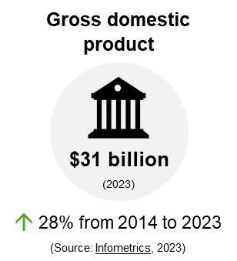

Median household income
In 2018, the median household income for Wellington City was $109,300. This is an increase of 20 percent from 2013 to 2018 Census years.
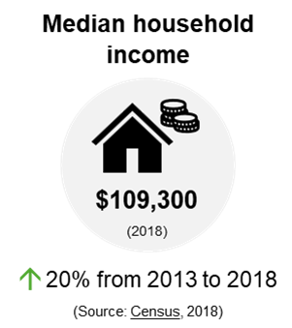

Estimated population
In 2023, the estimated population of Wellington City was 216,200 people. This is an increase of 8 percent from 2014 to 2023.
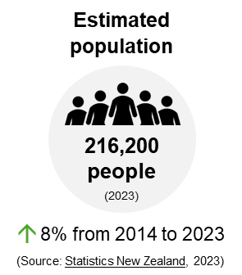

Age and gender of Wellingtonians
In 2018, the median age of Wellingtonians was 34 years.
The proportion of females and males in each 10-year age bracket was similar. Young adults (20-29 years) made up the largest proportion of the population, followed by those 30-39 years and 40-49 years of age.
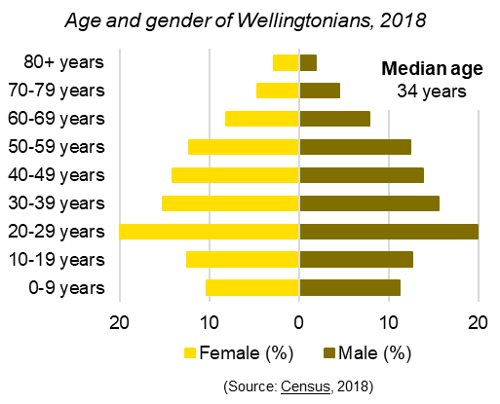

Ethnicity of Wellingtonians
Three-quarters of Wellingtonians reported their ethnicity as European (74%)⁴. This was followed by Asian (18%) and Māori (9%) ethnicities. A smaller proportion reported being Pacific (5%), Middle Eastern / Latin American / African (3%), or an Other ethnicity (1%).
Note, ethnicity is a multiple response variable, so numbers will not add to 100 percent.
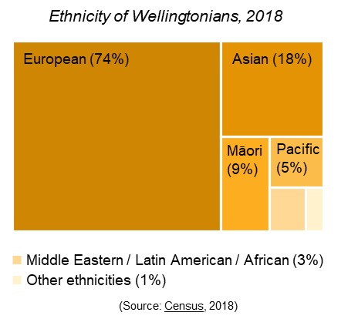

Sources of population growth
Since 2014, Wellington City’s population increased from international migration and natural growth. Domestic migration trends show people moving away from the city.
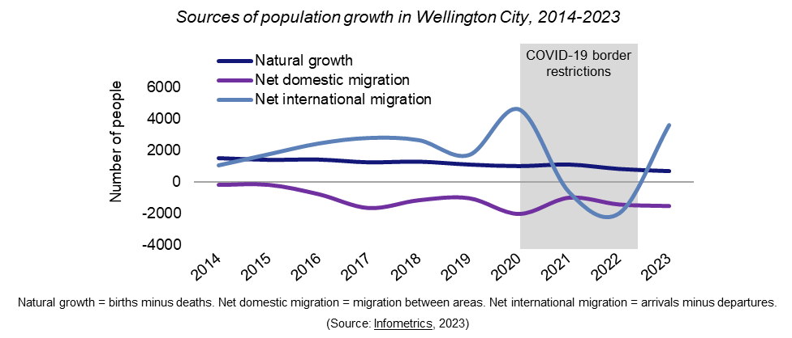

Overall and housing deprivation in Wellington City
The New Zealand Index of Multiple Deprivation 2018 is a set of tools for identifying concentrations of deprivation. Compared to national levels in 2018, Wellington City had:
- Lower than average overall deprivation. Sixty-eight percent of SA2s were in the lowest two quintiles (least deprived).
- Above average housing deprivation. Forty-five percent of SA2s were in the highest two quintiles (most deprived).
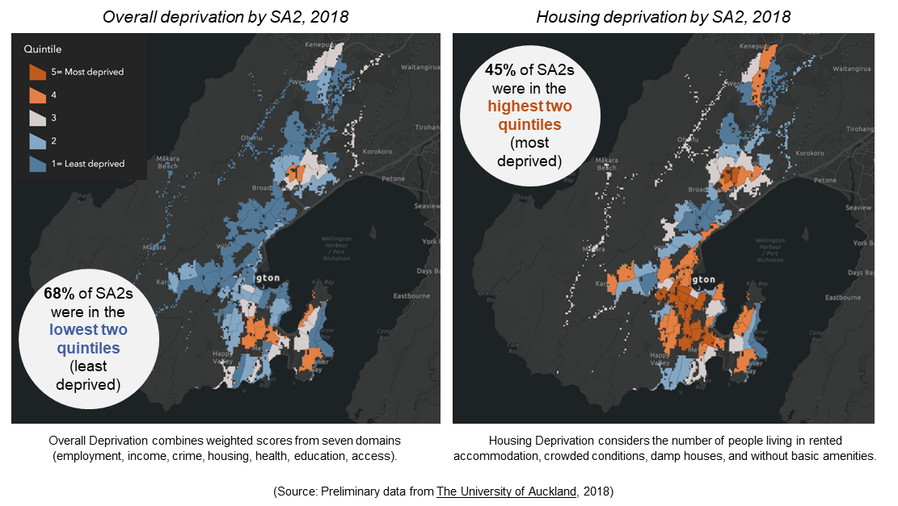

Rented and owner-occupied dwellings
The average household size in 2018 was 2.6 people.
The proportion of rented (41%) and owner-occupied (59%) dwellings fluctuated slightly between 2006 and 2018:
- Rented dwellings increased by 1.7 percent from 2006.
- Owner-occupied dwellings decreased by 1.7 percent from 2006.
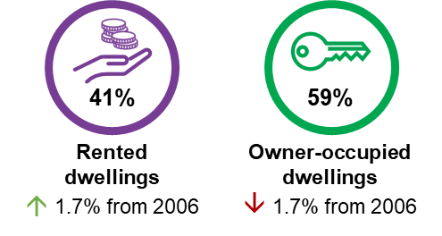
Central and Inner Wellington suburbs had the lowest proportion of owner-occupied dwellings.
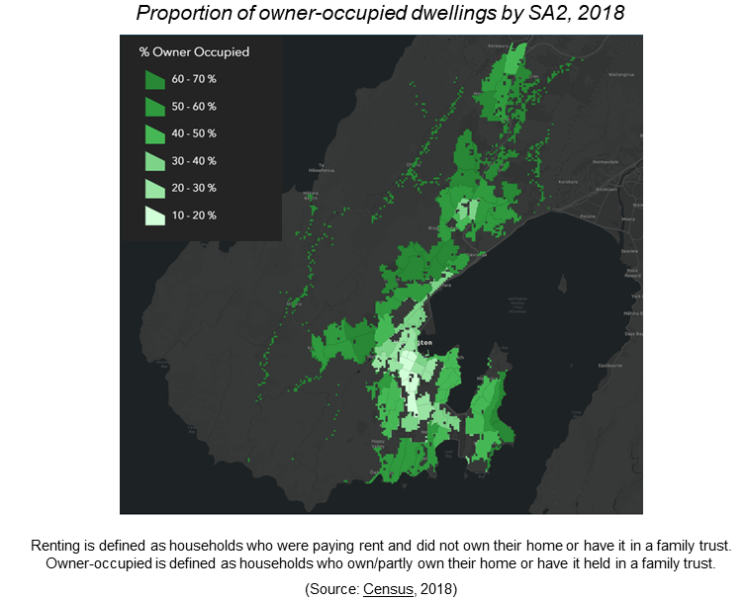

Affordability
Housing affordability refers to people’s capacity to balance housing costs with available household financial resources, so there is enough income left to cover other necessities. Housing costs include entry costs, ongoing expenses, and living costs.

The housing continuum
The housing continuum reflects the range of housing types that are present in a community: Emergency housing, social housing, assisted rental, private rental, assisted ownership, and private ownership. Wellington City Council has a role in every part of the housing continuum.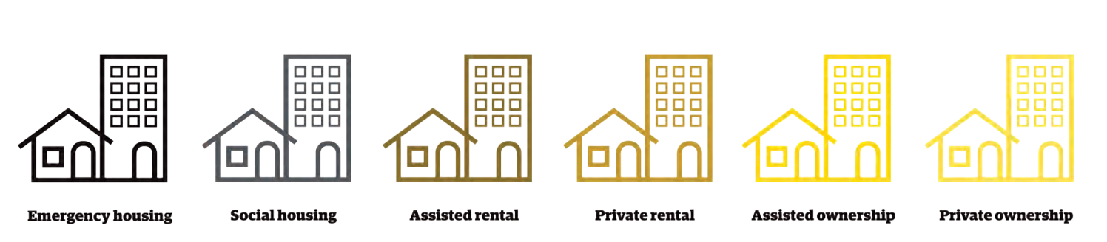

Annual household income by renting and owner-occupied households
In 2018, a larger proportion of renting households had annual household incomes (before tax) of less than $100k.
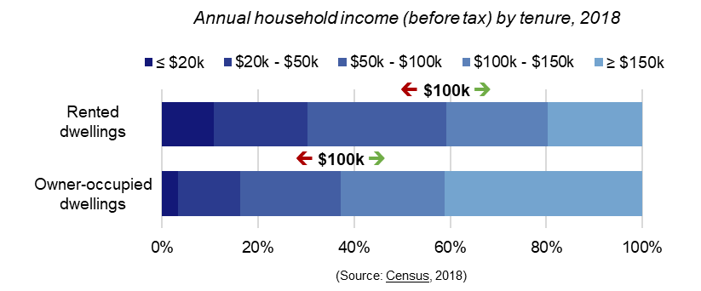

Perceived affordability
A larger proportion of private renters perceived their housing costs were less affordable and they did not have enough money to meet everyday needs, compared to owner-occupiers.
Housing costs include rent or mortgage, rates, insurance, and maintenance. Everyday needs include housing, food, clothing, and necessities.
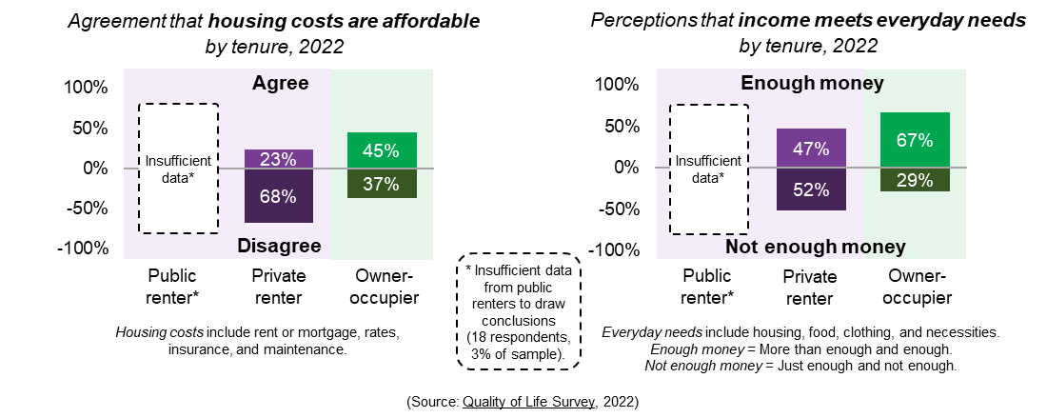

Severe housing deprivation in Wellington City
Severe housing deprivation is synonymous with homelessness.
Statistics New Zealand defines homelessness as living situations where people with no other options to acquire safe and secure housing are without shelter, in temporary accommodation, sharing accommodation with a household, or living in uninhabitable housing.
In 2018, 1254 people were severely housing deprived. This value is made up of 93 people without shelter (e.g., rough sleeping, in a mobile dwelling), 363 people in temporary accommodation (e.g., night shelter, motel, camping ground), and 798 people sharing accommodation (being a temporary resident in a severely crowded private dwelling).
Note, severe housing deprivation is challenging to measure. These values do not reflect the impact of government policies since 2018 or the COVID-19 pandemic.
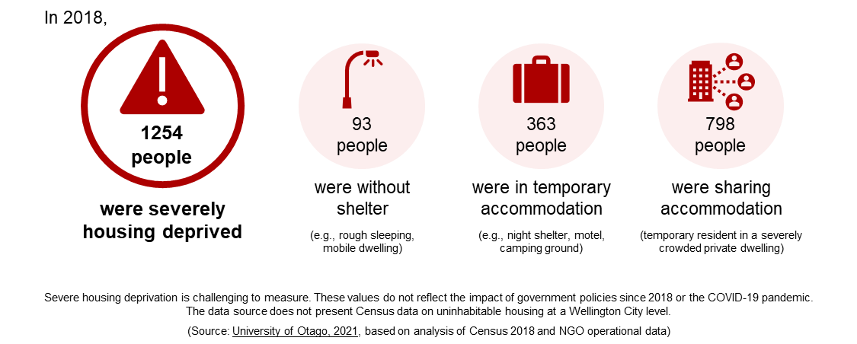

Unmet need for public housing
The Housing Register reflects eligible applicants waiting for a suitable home, while the Transfer Register reflects current tenants needing to be rehoused.
In December 2023, 813 households were waiting for public housing tenancies to become available. This represents an increase of 110 percent from December 2018.
The largest demand for public housing is currently for one- and two-bedroom houses (86%).

Growth in rental prices and house prices
House prices have grown at a faster rate than household income since 2015, peaking in 2021 (a 142% increase compared to September 2014).
Rental prices have closely followed growth in median household income since September 2014.
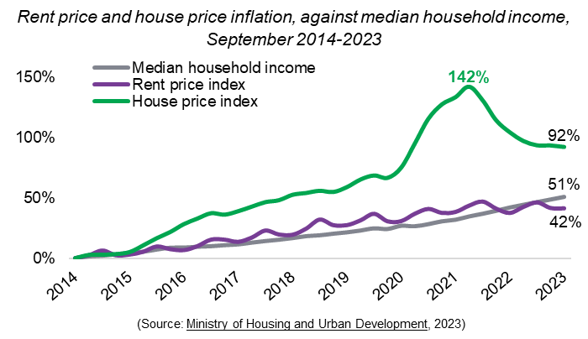

Rental prices

Weekly rental prices and active bonds
The median weekly rental price between January to July 2023 was $573. The average number of active bonds over the same period was 26,288. This is an increase of 14 percent from 2014.
Over the last decade, the median weekly rental price has increased the most for two-bedroom dwellings (54% increase), followed by three-bedroom (51% increase), one-bedroom (47% increase), four-bedroom (43% increase), and five-or-more bedroom dwellings (38% increase). Across all bedroom types, annual rental price growth averaged 4-5 percent over the last decade.
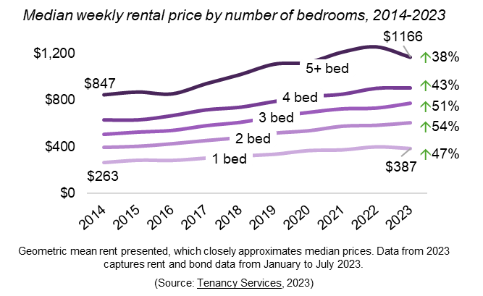

Rental stressed households
In 2018, the proportion of renting households spending over 30 percent of their income on rent was 41 percent. This value represents a 6 percent increase from 2006.
Between 2006 and 2018, the proportion of renting households spending over 50 percent of their income on rent increased by 5 percent.
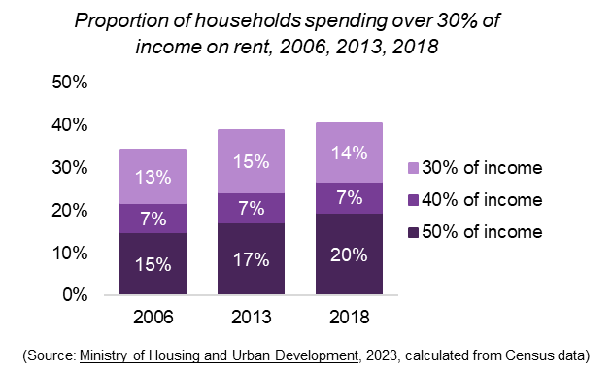

House prices
The median house sale price in January 2024 was 17 percent below 2021 rateable values. However, indications are that prices are increasing.

Mortgage serviceability and deposit affordability
Mortgage serviceability reflects changes in the purchasing power of mortgage interest payments compared with median household income. Mortgage serviceability peaked in 2020, at 63 percent more affordable than September 2014. This peak reflects record low interest rates.
Deposit affordability reflects changes in house sale prices compared with median household income. Deposit affordability dropped to a low in 2021, at 44 percent less affordable than September 2014¹⁸. This low reflects record high house values.
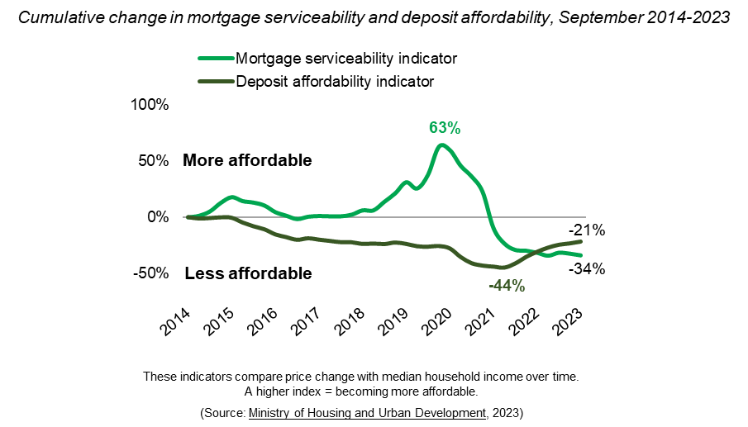

Home ownership by ethnicity
The proportion of people (15+ years) living in an owner-occupied dwelling was lowest for Middle Eastern / Latin American / African (21%) ethnicities and highest for European ethnicities (49%).
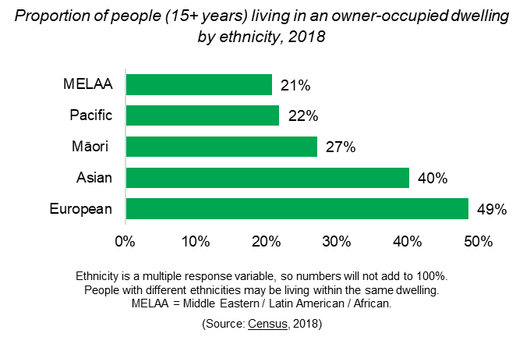

Residential property sales
In 2023, 2178 residential properties were sold. This is a reduction of 7 percent from 2022.
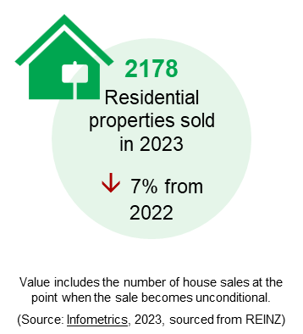

Housing supply
Housing supply reflects the number of dwellings available for rent or purchase, potential future supply from building consents, and housing stock characteristics (for example, building age, quality, and suitability).

Total housing supply
In 2018, there were 75,201 occupied private dwellings in Wellington City. This is an increase in 5 percent from 2013 to 2018.
There were a further 4908 unoccupied dwellings and 579 dwellings under construction. Unoccupied dwellings cover those which were empty or where residents were away on Census night.
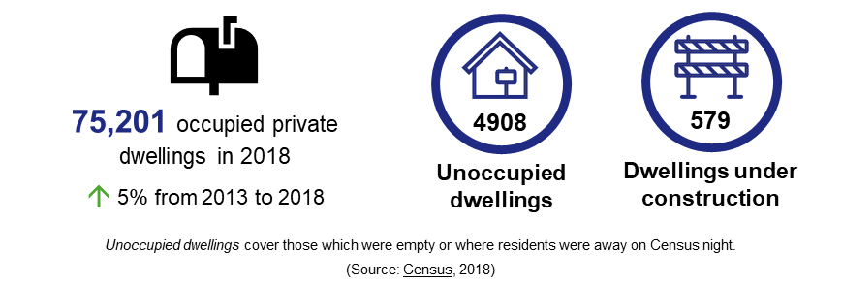
Over one-third of occupied private dwellings had three-bedrooms (36%). Twenty-four percent had two-bedrooms and a further 20 percent had four-bedrooms. A smaller proportion of dwellings had one-bedroom (13%) or five-or-more bedrooms (7%).
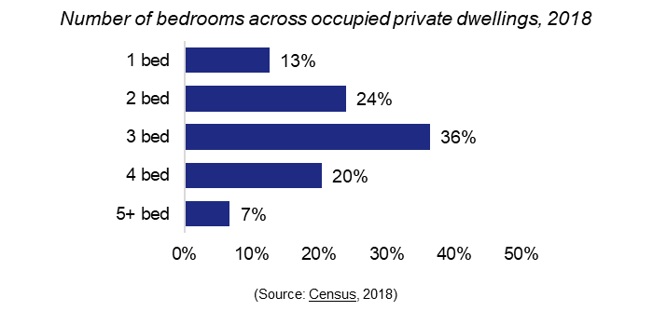

Public housing supply
Public housing provides stable and affordable housing for those who cannot access or sustain a private rental. Transitional housing provides support to help people transition into longer-term accommodation.
In January 2024, there were 4153 public homes managed by:
- Community Housing Providers: 2273
- Kāinga Ora: 1880
There were also 238 contracted transitional housing places.
These numbers equate to 19 public housing units per 1000 people, and 5 percent of the total housing stock.

Te Kāinga affordable rental programme
The Te Kāinga programme provides secure, high quality, and long-term rental housing to Wellingtonians at below-market rates.
In January 2024, there were 212 units available across three buildings in the central city. Nine units were designed with accessible features.

Building age
Fifty-one percent of Wellington City’s housing stock has been built since 1960. Twenty-one percent has been built since 1990.
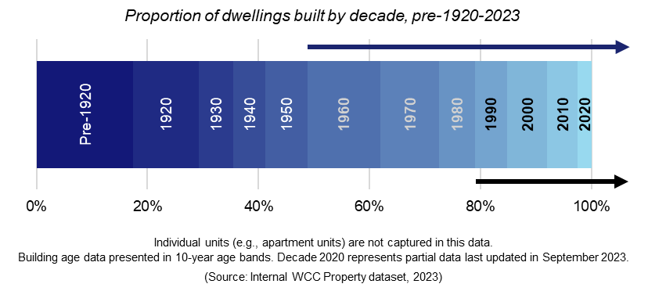

Building consents
Building consents provide an indication of potential building activity over the short and medium term. However, not all consented buildings are completed.
Between 2014 and 2023, 9103 buildings were consented. This number peaked in 2019, with 1429 buildings being consented. Apartment consents were the most common type of building consented.
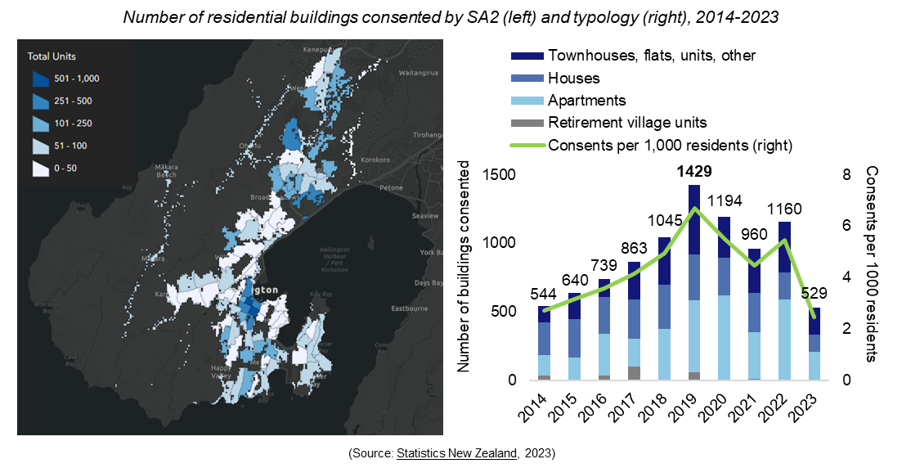

Household crowding
Household crowding occurs when houses are too small for the number of people living there. Severe crowding means two or more bedrooms are needed. Moderate crowding means one bedroom is needed.
In 2018, 5 percent of households were crowded. One percent were severely crowded, and 4 percent were moderately crowded.
In 2018, 15,030 people lived in a crowded dwelling. This equates to 8% of the population. Notably, 14% of the Māori population and 26% of Pacific peoples lived in a crowded dwelling.
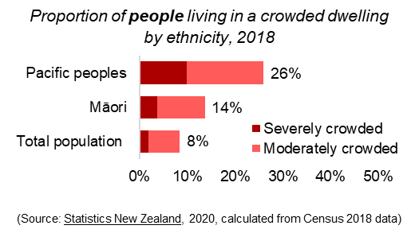
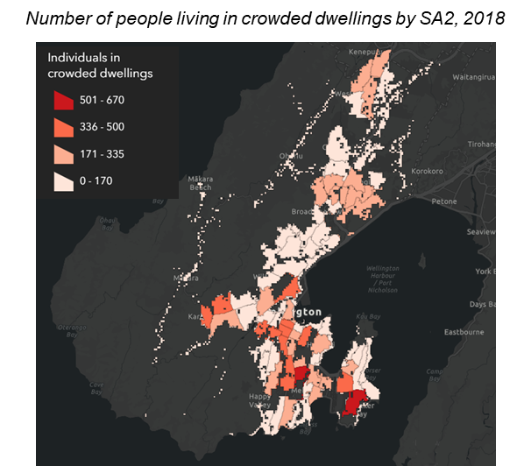

Presence of damp and mould
In 2018, 24% of dwellings were reported as being damp always or sometimes. Similarly, 18% of dwellings were reported as having visible mould over A4 size always or sometimes.
A larger proportion of renting households reported presence of damp and mould, compared to owner-occupied dwellings.
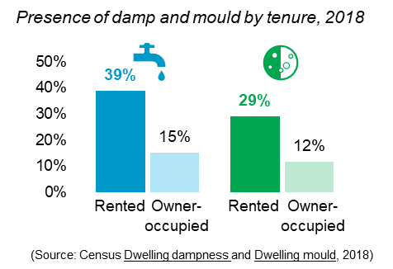
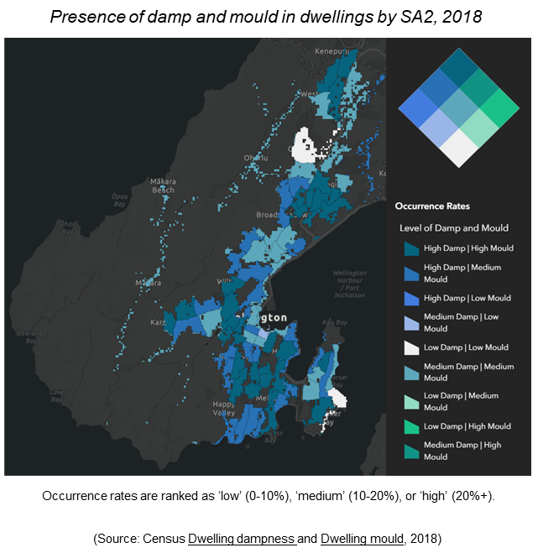

Housing quality
In 2018, 0.2% of occupied private dwellings did not have basic amenities.
The Quality of Life Survey 2020 results showed that:
- 17% of respondents of respondents could not afford to heat their home properly, and
- 15% of respondents disagreed that their heating system kept the home warm.
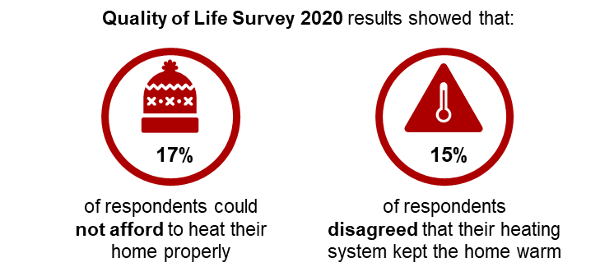
The proportion of homes reported as being damp, cold, hard to heat, or having inadequate insulation has reduced since 2020.
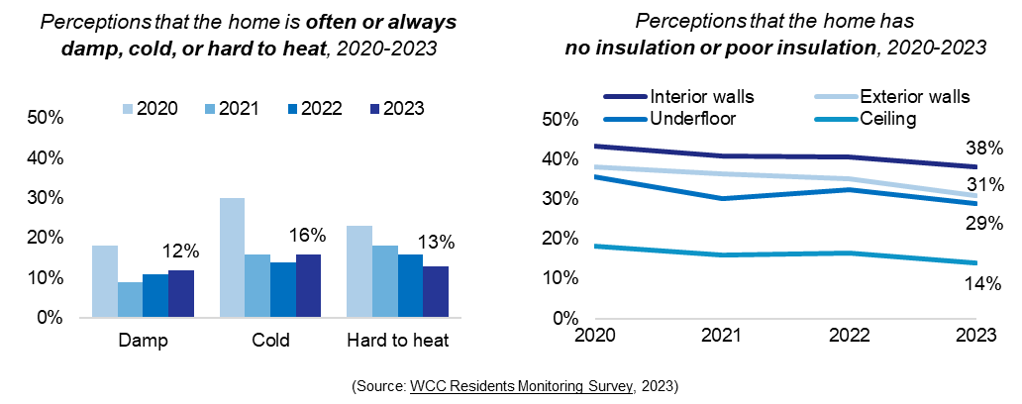

Housing suitability
The Quality of Life Survey 2022 results showed that³⁰:
- 74% of respondents agreed that their home type suited their household’s needs (17% disagreed), and
- 84% agreed that their area of neighbourhood suited their household’s needs (9% disagreed).

Future housing demand
Population growth is a core driver of demand for housing, services, and amenities in Wellington City. Understanding population trends and growth projections can support evidence-informed decisions about new housing supply.

Population and housing projections over the next 30 years
Wellington City’s population is projected to increase by 26% over the next 30 years to 271,288 people.
To meet this projected increase, 30,407 additional dwellings are estimated to be needed. Wellington City currently has identified capacity for 73,856 dwellings.
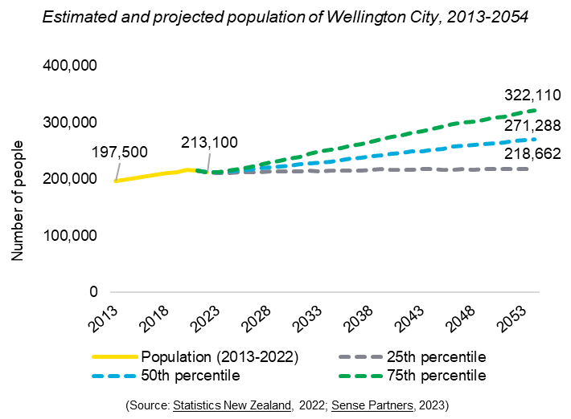
While all age groups and household types are projected to materially increase in number by 2054, Wellington City’s population age structure is also projected to shift.
These changes have implications for the types of homes that will be required in future.
By 2054:
- The working age population (15-64 years) is projected to make up 71% of the population. This is a decrease of 4% from 2021.
- The older adult population (65+ years) is projected to make up 15% of the population. This is an increase of 4% from 2021.
- The proportion of households who are living alone is projected to make up 28% of the population. This is an increase of 2% from 2021³².
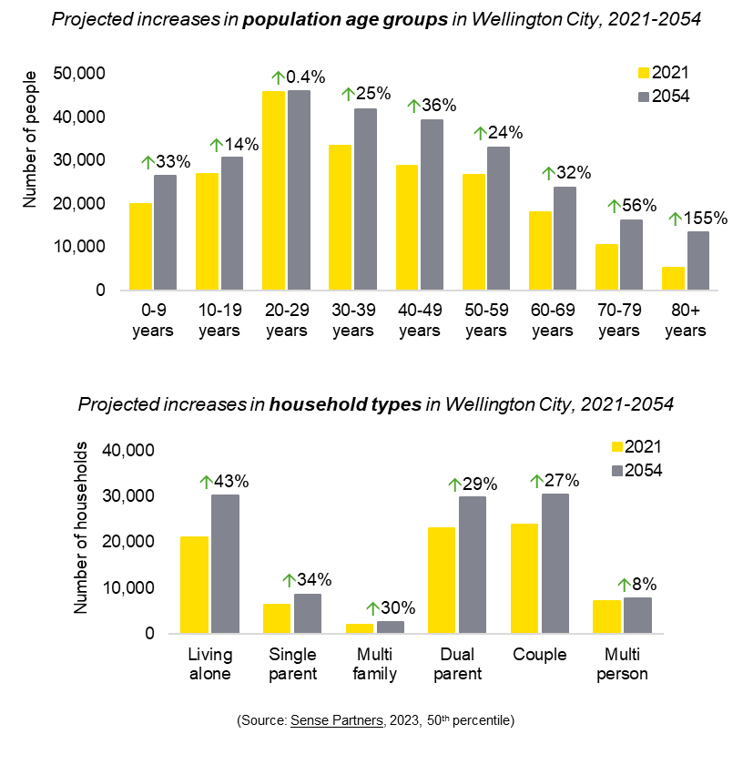

Projected demand for attached and standalone dwellings
By 2051, the demand for dwellings is projected to be highest in North Wellington suburbs (9582 dwellings), followed by Central Wellington (6370 dwellings) and West Wellington (5028 dwellings)³³.
The demand for attached dwellings (including apartments and terraced houses) is projected to be highest in Central Wellington and North Wellington.
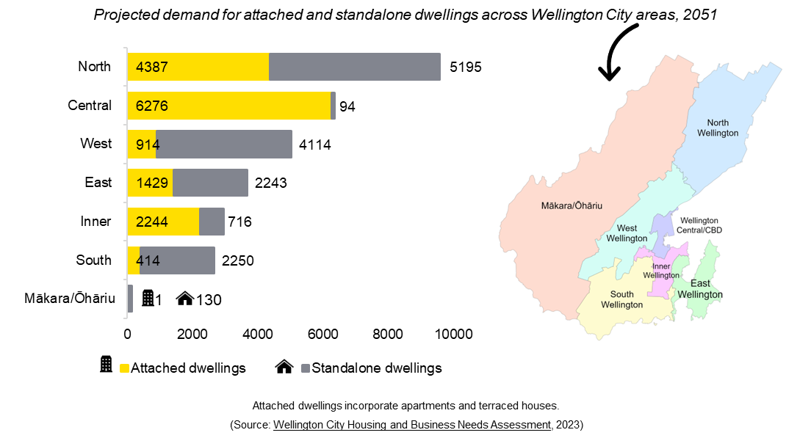

Infometrics, 2023: Gross domestic product growth.
Census, 2018: Median household income.
Statistics New Zealand, 2023: Subnational population estimates.
Census, 2018: Age and gender by ethnic group.
Infometrics, 2023: Sources of population growth. Natural growth = births minus deaths. Net domestic migration = migration between areas. Net international migration = arrivals minus departures.
Preliminary data from The University of Auckland, 2018: Index of Multiple Deprivation. Overall Deprivation combines weighted scores from seven domains (employment, income, crime, housing, health, education, access). Housing Deprivation considers the number of people living in rented accommodation, crowded conditions, damp houses, and without basic amenities.
Census, 2018: Proportion of rented and owner-occupied dwellings. Renting is defined as households who were paying rent and did not own their home or have it in a family trust. Owner-occupied is defined as households who own/partly own their home or have it held in a family trust.
Wellington City Council Housing Strategy, 2018-2028.
Census, 2018: Annual household income.
Quality of Life Survey, 2022. There was insufficient data from public renters to draw conclusions (18 respondents, 3% of sample).
Statistics New Zealand, 2015: Definition of homelessness. Data on uninhabitable housing is not available at a Wellington City level.
University of Otago, 2021: Severe housing deprivation based on an analysis of Census 2018 and Non-Governmental Organisation operational data. The data source does not present Census data on uninhabitable housing at a Wellington City level.
Ministry of Social Development, 2023: Number of households on the Housing Register and Transfer Register.
Ministry of Housing and Urban Development, 2023: Affordability indicators of median household income, rent price index, and house price index.
Tenancy Services, 2023: Rental prices and active bonds. Rental price data are presented as geometric mean rent, which closely approximates median prices.
Ministry of Housing and Urban Development, 2023: Rental stressed households calculated from Census data.
Internal WCC property data, 2023.
Ministry of Housing and Urban Development, 2023: Affordability indicators of mortgage serviceability and deposit affordability. These indicators compare price change with median household income over time. A higher index = becoming more affordable.
Census, 2018: Home ownership by ethnicity. Note, ethnicity is a multiple response variable, so numbers will not add to 100%. People with different ethnicities may be living within the same dwelling.
Infometrics, 2023: Residential sales volumes. Data sourced from REINZ.
Census, 2018: Occupied dwellings, unoccupied dwellings, and dwellings under construction.
Census, 2018: Number of bedrooms in occupied private dwellings.
Ministry of Housing and Urban Development, 2023; Internal WCC dataset, 2023: Number of public homes and transitional homes. Note, the number of public houses is the best available estimate at a point in time. Some Community Housing Provider dwellings may not be captured.
WCC Te Kāinga: Affordable rental programme.
Internal WCC Property dataset, 2023. Note, individual units (e.g., apartment units) are not captured in this data. Decade 2020 represents partial data last updated in September 2023.
Statistics New Zealand, 2023: Residential building consents.
Statistics New Zealand, 2020: Household crowding statistics calculated from Census 2018 data.
Census, 2018: Dwelling dampness and Dwelling mould.
Census, 2018: Access to basic amenities. Basic amenities = Cooking facilities, kitchen sink, tap water that is safe to drink, refrigerator, bath or shower, toilet, and electricity supply.
Quality of Life Survey, 2022.
WCC Residents Monitoring Survey, 2023.
Sense Partners, 2023: 50th percentile projections.
Wellington City Housing and Business Needs Assessment, 2023.

