Part C: Financial information

Annual plan disclosure statement for year ending 30 June 2024

What is the purpose of this statement?
The purpose of this statement is to disclose the council’s planned financial performance in relation to various benchmarks to enable the assessment of whether the council is prudently managing its revenues, expenses, assets, liabilities, and general financial dealings.
The council is required to include this statement in its annual plan in accordance with the Local Government (Financial Reporting and Prudence) Regulations 2014 (the regulations). Refer to the regulations for more information, including definitions of some of the terms used in this statement.
Benchmark |  | Planned | Met
- Rates affordability benchmark
- Income | Quantified limit $475m | $480m | No
- Increases | Quantified increase limit 10.5% | 12.3% increase | No
- Debt affordability benchmark | Net closing debt over operating income 225% | 176% | Yes
- Balanced budget benchmark | 100% | 106% | Yes
- Essential services benchmark | 100% | 239% | Yes
- Debt servicing | 10% | 7% | Yes

Notes:

1 Rates affordability benchmark
(1) For this benchmark:
(a) the council’s planned rates income for the year is compared with a quantified limit on rates contained in the financial strategy included in the council’s LTP; and
(b) the council’s planned rates increases for the year are compared with a quantified limit on rates increases for the year contained in the financial strategy included in the council’s long-term Plan.
(2) The council meets the rates affordability benchmark if:
(a) its planned rates income for the year equals or is less than each quantified limit on rates; and
(b) its planned rates increases for the year equal or are less than each quantified limit on rates increases.

2 Debt affordability benchmark
(1) For this benchmark, the council’s planned borrowing is compared with a quantified limit on borrowing contained in the financial strategy included in the council’s long-term plan.
(2) The council meets the debt affordability benchmark if its planned borrowing is within each quantified limit on borrowing.

3 Balanced budget benchmark
(1) For this benchmark, the council’s planned revenue (excluding development contributions, vested assets, financial contributions, gains on derivative financial instruments, and revaluations of property, plant, or equipment) is presented as a proportion of its planned operating expenses (excluding losses on derivative financial instruments and revaluations of property, plant, or equipment).
(2) The council meets the balanced budget benchmark if its revenue equals or is greater than its operating expenses.

4 Essential services benchmark
(1) For this benchmark, the council’s planned capital expenditure on network services is presented as a proportion of expected depreciation on network services.
(2) The council meets the essential services benchmark if its planned capital expenditure on network services equals or is greater than expected depreciation on network services.

5 Debt servicing benchmark
(1) For this benchmark, the council’s planned borrowing costs are presented as a proportion of planned revenue (excluding development contributions, financial contributions, vested assets, gains on derivative financial instruments, and revaluations of property, plant, or equipment).
(2) Because Statistics New Zealand projects that the council’s population will grow slower than the national population growth rate, it meets the debt servicing benchmark if its planned borrowing costs equal or are less than 10% of its planned revenue.

Fees and user charges
Our Revenue and Financing Policy guides our decisions on how to fund Council services. Under the policy, we consider who benefits from a service (individuals, parts of the community, or the community as a whole) because this helps us determine how the service should be funded. The policy sets targets for each Council activity, determining what proportion should be funded from the user charges, general rates, targeted rates and other sources of income.
A breakdown of changes to user fees and charges can be found in our online appendices at wellington.govt.nz/annual-plan

Funding impact statements

Funding impact statement for whole of Council
 | 2022/23 | 2023/24 | 2023/24 | Notes
 | AP | LTP | AP
 | $000s | $000s | $000s
Sources of operating funding
General rates, uniform annual general charges, rates penalties | 270,117 | 291,055 | 286,872
Targeted rates (other than a targeted rate for water supply) | 156,236 | 188,780 | 194,238 | 1
Subsidies and grants for operating purposes | 9,558 | 9,701 | 19,599
Fees and charges | 167,109 | 162,669 | 175,548
Interest and dividends from investments | 1,913 | 10,913 | 10,913
Local authorities fuel tax, fines, infringement fees, and other receipts | 11,874 | 12,122 | 11,876
Total operating funding (A) | 616,807 | 675,239 | 699,047
Applications of operating funding
Payments to staff and suppliers | 448,360 | 427,941 | 500,777 | 2
Finance costs | 41,375 | 44,881 | 60,972 | 3
Other operating funding applications | 49,085 | 57,858 | 59,384
Total applications of operating funding (B) | 538,820 | 530,680 | 621,133
Surplus (deficit) of operating funding (A-B) | 77,988 | 144,559 | 77,914
Sources of capital funding
Subsidies and grants for capital expenditure | 30,719 | 32,195 | 166,011 | 4
Development and financial contributions | 3,500 | 3,500 | 3,500
Increase (decrease) in debt | 307,566 | 199,008 | 308,807 | 5
Gross proceeds from sales of assets | 2,000 | 2,000 | 9,834
Lump sum contributions | 0 | 0 | 0
Total sources of capital funding (C) | 343,786 | 236,703 | 488,152
Applications of capital funding
Capital expenditure
- to meet additional demand | 61,756 | 44,766 | 56,334
- to improve level of service | 200,126 | 179,881 | 354,436
- to replace existing assets | 160,040 | 156,525 | 155,296
Increase (decrease) in reserves | (148) | 89 | (0)
Increase (decrease) in investments | 0 | 0 | 0
Total applications of capital funding (D) | 421,773 | 381,262 | 566,066
Surplus (deficit) of capital funding (C-D) | (77,988) | (144,559) | (77,914)
Funding balance ((A-B) + (C-D)) | 0 | 0 | 0
Expenses for this activity grouping include the following depreciation/amortisation charge | 187,605 | 181,581 | 196,468

Notes
1. Targeted rates which include targeted water rates have increased due to the temporary change in funding approach for depreciation on water, sewerage and stormwater (3 waters) network assets due to the unexpected and un-forecasted increase in the 3 waters revaluation of assets at 30 June 2022, which saw a significant increase in value, and subsequent increase in depreciation. Council resolved to fund the depreciation on the 3 waters assets based on the capital renewals of the 3 waters assets for 2022/23 and 2023/24.
2. Payments to staff and suppliers has increased due to continuing increased costs to deliver existing services, insurance and inflationary pressures.
3. Finance costs have increased due an increase in the cost of borrowings and an increase in borrowings.
4. Subsidies and grants for capital expenditure has increased due to the Infrastructure and Financing Funding for the Sludge Minimisation Facility.
5. The increase in debt is due to borrowing for capital expenditure.

2023/24 Annual plan Funding Impact Statement ​— rating mechanisms

Rates
Rates are a property tax to fund local government activities. Rates are assessed under the Local Government (Rating) Act 2002 (the Act) on rating units in the Rating Information Database. Where rates requirements are allocated based on a rating unit’s value, the rateable value will be the capital value as assessed by the Council’s valuation services provider. The latest city-wide revaluation was carried out as at 1 September 2021. This revaluation remains effective through until the 2023/24 rating year, except where subsequent maintenance valuations have been required under valuation rules or the Council’s rating policies.
City-wide revaluations are performed every three years. The 1 September 2021 revaluation was effective for the 2021/22 rating year and the two consecutive rating years, 2022/23 and 2023/24 (subject again to subsequent maintenance valuations).

Policy objective:
- To provide the Council with adequate income to carry out its mission and objectives.
- To support the Council’s achievement of its strategic objectives.
- To be simply administered, easily understood, allow for consistent application and generate minimal compliance costs.
- To spread the incidence of rates as equitably as possible by balancing the level of service provided by the Council with ability to pay and the incidence of costs in relation to benefits received.
- To be neutral in that it does not encourage people to redirect activity in order to avoid its impact.
- ​To reflect the decisions of the Council’s policies and rating reviews.

General Rates
General rates are set under section 13 of the Act on all rateable rating units in the City of Wellington.
The Council has set a general rate based on the capital value of each rating unit within the city.
The general rate is set on a differential basis, based on the use to which the land is put and/or the zoning. All rating units (or part thereof) will be classified for the purposes of general rates within one of the following differential rating categories.

Differential Rating Categories

Base Differential
The Base differential rating category shall be applied to the following rating units:
- Separately rateable land used for one or more household units; excluding those properties that provide short stay (28 days or less) commercial accommodation for which a tariff is charged
- Vacant land zoned residential
- Land used as farmland and lifestyle blocks which is included in the rural activity area in the District Plan
- Farmland is defined as land used exclusively or principally for agricultural, horticultural, pastoral or silvicultural purposes, or for the keeping of bees or poultry or other livestock but excluding commercial dog kennels or catteries.
- ​Separately rateable land occupied by a charitable organisation which is deemed by the Council to be used exclusively or principally for sporting, recreation or community purposes and that does not generate any private pecuniary benefit.
This category has a general rate differential rating factor of 1.0.

Commercial, Industrial and Business Differential
The Commercial, Industrial and Business differential rating category shall be applied to the following rating unit:
- Separately rateable land used for a commercial or industrial purpose
- Vacant land zoned commercial, industrial or business
- Land used for offices, administrative and/or associated functions
- Land used for commercial accommodation for which a tariff is charged and where the principal purpose is the provision of short stay (28 days or less) accommodation
- Business-related premises used principally for private pecuniary benefit
- Any rating unit not otherwise categorised within the Base Differential.
This category has a general rate differential rating factor of 3.7.

Differential Rating Category Conditions
Differential rating 3.7:1 Commercial, Industrial and Business: Base
- The differential apportionment for the Commercial, Industrial and Business differential is 3.7 times the rate per dollar of capital value payable by those properties incorporated under the Base differential.
- Where a rating unit has more than one land use the rating unit may be ‘divided’ so that each part may be differentially rated based on the land use of each part.
A rating unit will be differentially rated where a division of the rating unit is established, based on the use to which the land is put and/or the zoning. A division will be established where:
- a rating unit has a value of greater than $800,000 or
- the minority use(s) account for more than 30 percent of the total capital value of the rating unit
If neither of these criteria are met no division will take place, and the rating category will be established on the primary use of the rating unit.
In any other case, the general rate differential is determined by principal use.
In regard to the rates attributable to a rating unit during the transition period between two differential rating categories, a ratepayer may apply for a change in rating category at any time between the lodgement of a building consent application with the Council (on the condition that the principal prior use has ended) and the earlier of either:
- The time at which the Council gives final approval of the completed works, or
- The property is deemed (by the Council) to be available for its intended use.
  - In situations where the change in land use does not require a Council consent, but warrants a change in differential rating category, the onus is on the ratepayer to inform the Council prior to the property being utilised under the new use.
  - The differential rating category of all rating units must be set prior to the commencement of a rating year and will remain in place for that entire rating year. Any change in circumstances that results in a change of differential rating category during a rating year will apply from 1 July of the following rating year.
  - Any property eligible for mandatory 50 percent non-rateability under Part 2, Schedule 1, of the Act, will be first classified under the appropriate general rate differential classifications and the non-rateability applied to that rate.

Uniform Annual General Charge
The Council does not assess a uniform annual general charge.

Non-rateable land

Non-Rateable
Any land referred to in Part 1, Schedule 1 of the Act is non-rateable with the exception of targeted rates solely for sewerage and water where the service is provided.

50 Percent Non-Rateable
All land referred to in Part 2, Schedule 1 of the Act is 50 percent non-rateable in respect of the rates that apply, except for targeted rates for sewerage and water for which the land is fully rateable if the service is provided.

Targeted Rates
Targeted rates are set under section 16, 17, 18 and 19, and schedules 2 and 3 of the Act.
The Council has not adopted any lump sum contribution schemes under part 4A of the Act in respect of its targeted rates, and will not accept lump sum contributions in respect of any targeted rate.
The differential rating categories described above are unitised and referred to in a number of targeted rates.

Sewerage Targeted Rate
Targeted sewerage rates are to be apportioned 60 percent:40 percent of rates between properties incorporated under the Base differential and the Commercial, Industrial and Business differential in accordance with the Revenue and Financing Policy.
This rate is set to pay for the cost of the provision and maintenance of the sewage collection and disposal network, and sewage treatment facilities for the city.
This rate is assessed on all rating units connected to the public sewerage drain.
For the purposes of these rates the sewage collection, and disposal and treatment service is treated as being provided to a rating unit if the rating unit is connected to a public sewerage drain (either directly or indirectly), irrespective of whether the property is considered fully rateable or is mandatory non-rateable or 50 percent non-rateable under Schedule 1 of the Act.
Sewerage targeted rate is calculated as follows:
- For rating units incorporated in the Commercial, Industrial and Business differential rating category:
  - A rate per dollar of capital value on all rating units connected to a public sewerage drain, to collect 40 percent of the required rates funding, after having deducted the total dollar amount budgeted to be collected through Trade Waste Charges (excluding consent fees).
- For rating units incorporated in the Base differential rating category:
  - A fixed amount per annum per rating unit, plus a rate per dollar of capital value on all rating units connected to a public sewerage drain, to collect 60 percent of the required rate funding.

Water Targeted Rate
A targeted rate for water is to be apportioned with the aim of achieving a 60 percent:40 percent split between properties incorporated under the Base differential rating category and the Commercial, Industrial and Business differential rating category in accordance with the Revenue and Financing Policy.
This rate is set to pay for the provision and maintenance of water collection and treatment facilities, the water distribution network and water conservation for the city.
This rate is assessed on all rating units connected to the public water supply.
For the purposes of these rates, the water service is treated as being provided to a rating unit if the rating unit is connected to the public water supply (either directly or indirectly), irrespective of whether the property is considered fully rateable or is mandatorily non-rateable or 50 percent non-rateable under Schedule 1of the Act.
Water targeted rate is calculated as follows:
- For rating units incorporated in the Commercial, Industrial and Business differential rating category, either:
  - A consumption unit rate per cubic metre of water used for all rating units connected to the public water supply with a water meter installed, plus a fixed amount per annum per rating unit.
Or
- A rate per dollar of capital value on all rating units connected to the public water supply, without a water meter installed.

- For rating units rated incorporated in the Base differential rating category, either:
- A consumption unit rate per cubic metre of water used for all rating units connected to the public water supply with a water meter installed, plus a fixed amount per annum per rating unit.
Or
- A fixed amount per annum per rating unit, plus a rate per dollar of capital value on all rating units connected to the public water supply without a water meter installed.

Stormwater Targeted Rate
A targeted stormwater rate is to be apportioned 77.5 percent to the non-rural rating units incorporated under the Base differential and 22.5 percent to the non-rural rating units incorporated under the Commercial, Industrial and Business differential in accordance with the Revenue and Financing Policy.
This rate is set to pay for the provision and maintenance of the stormwater collection/disposal network for the city.
Properties classified in the rural area in the Council’s District Plan are excluded from the liability of this rate.
Stormwater targeted rate is calculated as follows:
For the Commercial, Industrial and Business differential rating category:
A rate per dollar of rateable capital value to collect 22.5 percent of the required rates funding.
For the Base differential rating category:
A rate per dollar of rateable capital value to collect 77.5 percent of the required rates funding.

Base Sector Targeted Rate
This rate is set to pay for activities where the Council’s Revenue and Financing Policy identifies that the benefit can be attributed to properties incorporated under the Base differential rating category.
This incorporates the following activities:
- 100 percent of the facilitation of cultural grants, facilitation of recreation partnerships and community advocacy activities.
- ​95 percent of the provision of community centres and halls activities.
This rate is assessed on all properties incorporated in the Base differential rating category and is calculated on a rate per dollar of rateable capital value.

Commercial Sector Targeted Rate
This rate is set to pay for activities where the Council’s Revenue and Financing Policy identifies that the benefit can be attributed to properties incorporated in the Commercial, Industrial and Business differential rating category.
This incorporates the following activity:
- Approximately 30 percent of the cost of the Wellington Regional Economic Development Agency (WREDA) and Venues. This is the equivalent of 100 percent funding of the events attraction and support activity within WREDA.
This rate is assessed on all properties incorporated in the Commercial, Industrial and Business differential rating category and is calculated on a rate per dollar of rateable capital value.

Downtown Targeted Rate
This rate is set to pay for tourism promotion.
This incorporates the following activities:
- 50 percent of the cost of the Wellington Regional Economic Development Agency (WREDA) and Venues activities
- 40 percent of the cost of the Wellington Convention Centre activity
- 70 percent of the visitor attractions activity
- 25 percent of galleries and museums activity.
This rate is assessed on all properties incorporated in the Commercial, Industrial and Business differential rating category in the downtown area and is calculated on a rate per dollar of rateable capital value. For the purposes of this rate, the downtown area refers to the area as described by the Downtown Area map as follows:
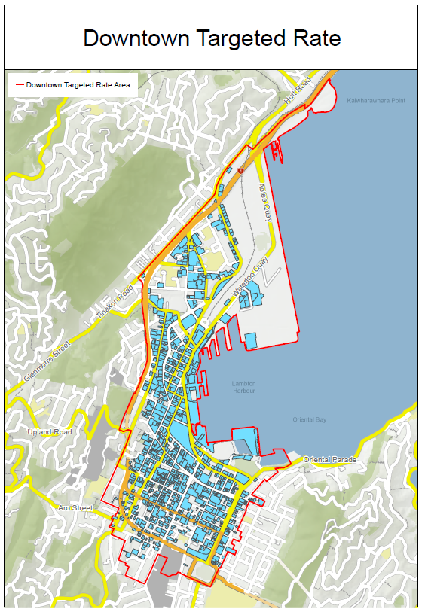
The graphic shows the boundaries of the downtown targeted rate

Tawa Driveways Targeted Rate
This rate is set to pay for the maintenance of a specified group of residential access driveways in the suburb of Tawa, overseen by the Council.
This rate is assessed on a specific group of rating units that have shared access driveway that are maintained by Council in the former Tawa Borough.
The rate is calculated at a fixed amount per annum per rating unit.

Miramar Business Improvement District Targeted Rate
This rate is set by Council to fund the Business Improvement District activities of Enterprise Miramar Peninsula Incorporated.
This rate is set is on all rating units within the Miramar Business Improvement District (see map) which are subject to the Commercial, Industrial and Business differential rating category.
This rate is calculated as a fixed amount per rating unit, plus a rate per dollar of rateable capital value.
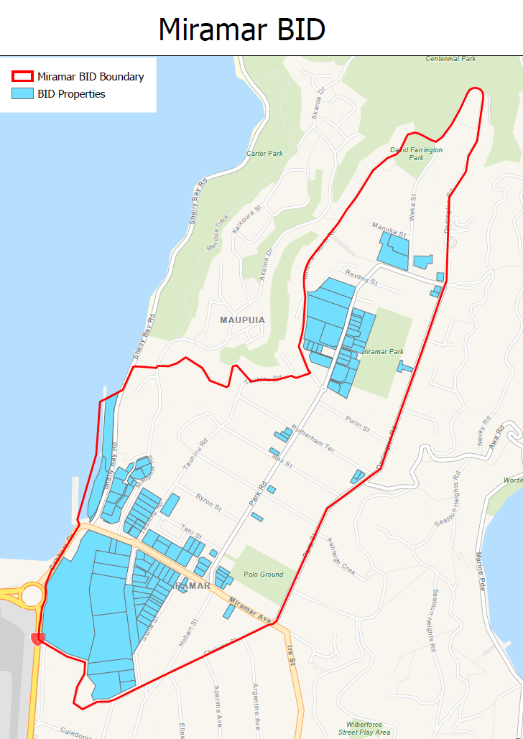
The graphic shows the boundaries of the Miramar BID

Khandallah Business Improvement District Targeted Rate
This rate is set by Council to fund the Business Improvement District activities of the Khandallah Village Business Association.
This rate is assessed on all rating units within the Khandallah Business Improvement District (see map) which are subject to the Commercial, Industrial and Business differential rating category.
This rate is calculated as a rate per dollar of rateable capital value.
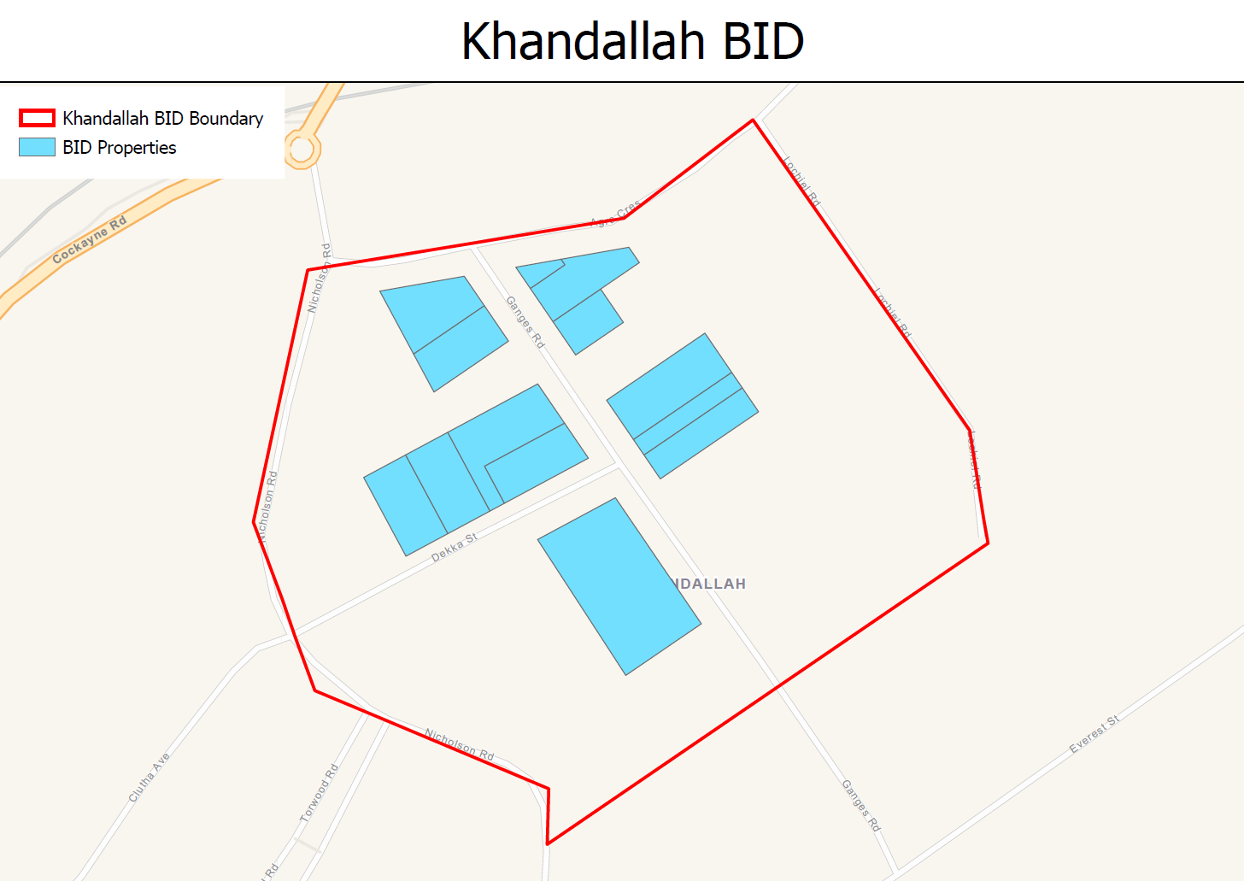
The graphic shows the boundaries of the Khandallah BID

Kilbirnie Business Improvement District Targeted Rate
This rate is set by Council to fund the Business Improvement District activities of the Kilbirnie Business Network.
This rate is set on all rating units within the Kilbirnie Business Improvement District (see map) which are subject to the Commercial, Industrial and Business differential rating category.
This rate is calculated as a fixed amount per rating unit, plus a rate per dollar of rateable capital value.
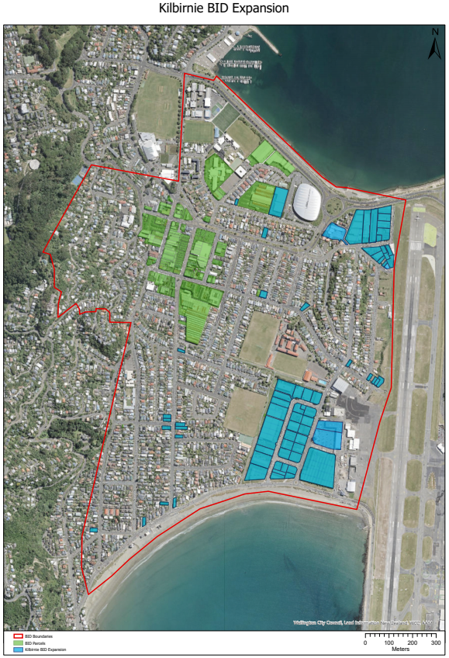
The graphic shows the boundaries of the Kilbirnie BID

Tawa Business Improvement District Targeted Rate
This rate is set by Council to fund the Business Improvement District activities of the Tawa Business Network.
This rate is assessed on all rating units within the Tawa Business Improvement District area (see map) which are subject to the Commercial, Industrial and Business differential rating category.
This rate is calculated as a fixed amount per rating unit, plus a rate per dollar of rateable capital value.
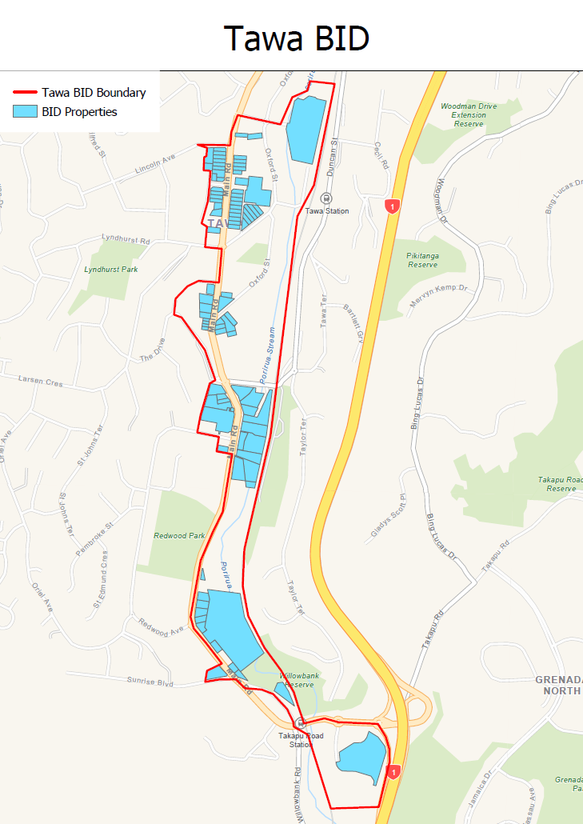
The graphic shows the boundaries of the Tawa BID

Karori Business Improvement District Targeted Rate
This rate is set by Council to fund the Business Improvement District activities of the Karori Business Association.
This rate is assessed on all rating units within the Karori Business Improvement District area (see map) which are subject to the Commercial, Industrial and Business differential rating category.
This rate is calculated as a rate per dollar of rateable capital value.
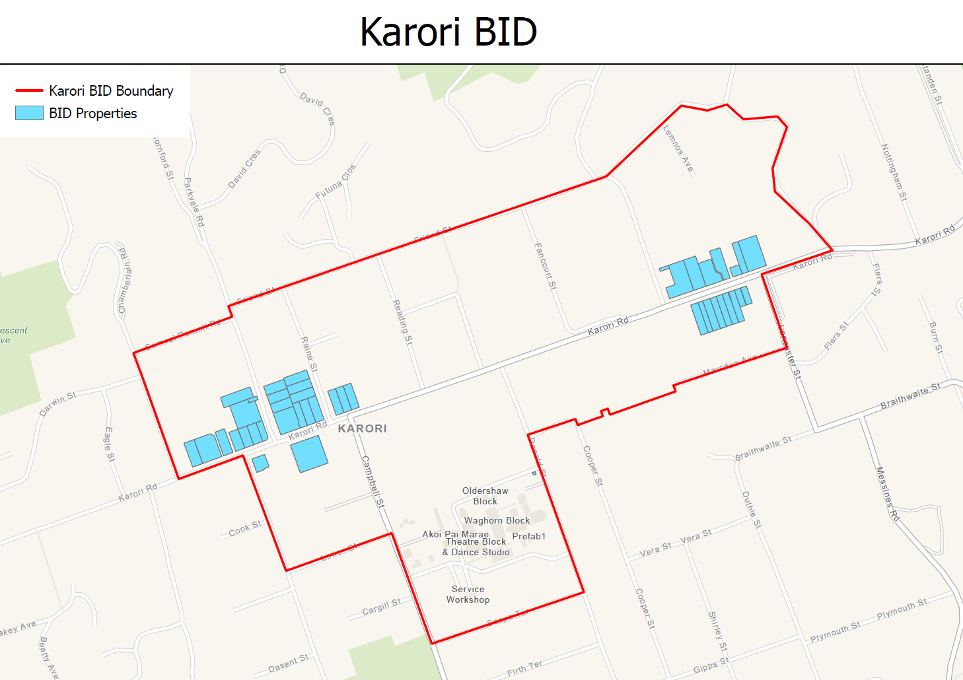
The graphic shows the boundaries of the Karori BID

Johnsonville Business Improvement District Targeted Rate
This rate is set by Council to fund the Business Improvement District activities of the Johnsonville business network.
This rate is assessed on all rating units within the Johnsonville Business Improvement District area (see map) which are subject to the Commercial, Industrial and Business differential rating category.
This rate is calculated as a fixed amount per rating unit, plus a rate per dollar of rateable capital value.
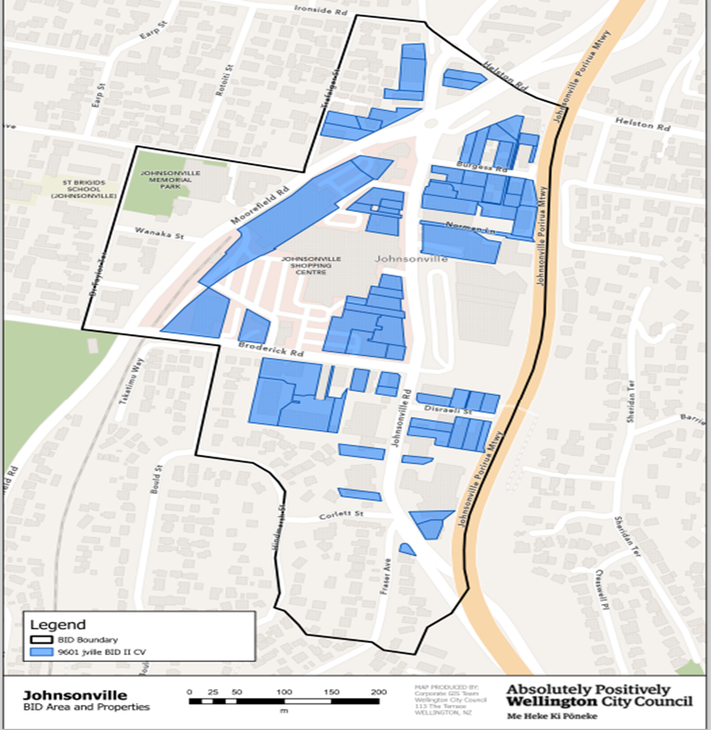

2023/24 Funding Impact Statement - Rates Funding Statement (excluding GST)
Rate | Category | Factor | Differential Charge Type | Total Value of Factor | Rate/charge* |  | Rates yield GST Exclusive
General Rate | Base | Capital Value | Base differential | $95,798,143,000 | ¢0.168632 |  | $161,546,325
 | Commercial, Industrial & Business | Capital Value | Commercial, industrial & business differential | $19,905,313,000 | ¢0.623160 |  | $124,041,948
 | TOTAL |  |  |  |  |  | $285,588,273
Sewerage targeted rate | Base | Fixed amount / rating unit | Base differential per connection status | 71637 properties | $121.15 |  | $8,678,551
 |  | Capital Value | Base differential per connection status | $99,376,622,000 | ¢0.030808 |  | $30,615,950
 | Commercial, Industrial & Business | Capital Value | Commercial, industrial and business differential per connection status | $16,909,132,000 | ¢0.149576 |  | $25,292,003
 | TOTAL |  |  |  |  |  | $64,586,504
Water targeted rate | Base | Fixed amount / rating unit | Base differential per connection status without a water meter | 62575 properties | $243.42 |  | $15,232,007
 |  | Capital Value | Base differential per connection status without a water meter | $84,237,829,000 | ¢0.029382 |  | $24,750,759
 | Base | Consumption unit charge | Base differential per connection status with a water meter | n/a | $4.091 / m3 |  | $954,703
 |  | Fixed amount / rating unit | Base differential per connection status with a water meter | n/a | $197.83 |  | $124,237
 | Commercial, Industrial & Business | Capital Value | Commercial, industrial and business differential per connection status without a water meter | $1,049,288,000 | ¢0.365581 |  | $3,835,998
 | Commercial, Industrial & Business | Consumption unit charge | Commercial, industrial and business differential per connection status with a water meter | n/a | $4.091 / m3 |  | $22,912,861
 |  | Fixed amount / rating unit | Commercial, industrial and business differential per connection status with a water meter | n/a | $197.83 |  | $625,934
 | TOTAL |  |  |  |  |  | $68,436,498
Stormwater targeted rate | Base | Capital Value | Base differential (excluding land defined in the rural activity area) | $94,219,235,000 | ¢0.021132 |  | $19,910,409
 | Commercial, Industrial & Business | Capital Value | Commercial, industrial and business differential (excluding land defined in the rural activity area) | $17,924,720,000 | ¢0.032246 |  | $5,780,005
 | TOTAL |  |  |  |  |  | $25,690,414
Base sector targeted rate | Base | Capital Value | Base differential | $95,929,595,000 | ¢0.012954 |  | $12,426,720
Commercial sector targeted rate | Commercial, Industrial & Business | Capital Value | Commercial, industrial & business differential | $19,765,260,000 | ¢0.026390 |  | $5,216,052
Downtown targeted rate | Commercial, Industrial & Business | Capital Value | Commercial, industrial & business differential located in the downtown area | $13,191,911,000 | ¢0.131672 |  | $17,370,053
Tawa driveways targeted rate | Base | Fixed amount / rating unit | Shared residential access driveways maintained by Council in the suburb of Tawa (extent of provision of service) | 257 properties | $133.33 |  | $34,266
Karori Business Improvement District targeted rate | Commercial, Industrial & Business | Capital Value | Commercial, industrial & business differential located in the Karori Business Improvement District area | $73,526,000 | ¢0.081604 |  | $60,000
Khandallah Business Improvement District targeted rate | Commercial, Industrial & Business | Capital Value | Commercial, industrial & business differential located in the Khandallah Business Improvement District area | $27,491,000 | ¢0.072751 |  | $20,000
Kilbirnie Business Improvement District targeted rate | Commercial, Industrial & Business | Fixed amount / rating unit | Commercial, industrial & business differential located in the Kilbirnie Business Improvement District area | 210 properties | $500.00 |  | $105,000
 |  | Capital Value | Commercial, industrial & business differential located in the Kilbirnie Business Improvement District area | $607,208,000 | ¢0.007411 |  | $45,000
 | TOTAL |  |  |  |  |  | $150,000
Tawa Business Improvement District targeted rate | Commercial, Industrial & Business | Fixed amount / rating unit | Commercial, industrial & business differential located in the Tawa Business Improvement District area | 71 properties | $520.00 |  | $36,920
 |  | Capital Value | Commercial, industrial & business differential located in the Tawa Business Improvement District area | $197,614,000 | ¢0.029391 |  | $58,080
 | TOTAL |  |  |  |  |  | $95,000
Miramar Business Improvement District targeted rate | Commercial, Industrial & Business | Fixed amount / rating unit | Commercial, industrial & business differential located in the Miramar Business Improvement District area | 122 properties | $365.00 |  | $44,530
 |  | Capital Value | Commercial, industrial & business differential located in the Miramar Business Improvement District area | $414,302,150 | ¢0.011099 |  | $45,985
 | TOTAL |  |  |  |  |  | $90,515
Johnsonville  Business Improvement  District  targeted rate | Commercial, Industrial & Business | Fixed amount / rating unit | Commercial, industrial & business differential located in the Johnsonville Business Improvement District area | 81 properties | $520.00 |  | $42,120
 |  | Capital Value | Commercial, industrial & business differential located in the Johnsonville Business Improvement District area | $306,464,000 | ¢0.017255 |  | $52,880
 | TOTAL |  |  |  |  |  | $95,000
TOTAL RATES REQUIREMENT (excluding GST) |  |  |  |  |  | $479,859,295

*Note:
When rates for 2023/24 are assessed, GST will be applied to the final rates. The total rates requirement includes rates remissions but excludes rates penalties which are budgeted separately.
The total rates requirement (excluding GST) differs from the revenue from rates in Forecast Statement of Comprehensive Revenue and Expense as the revenue from rates includes penalties not included in this statement.

Rates Increases
 | 2024 |  |  | Year on Year % change
 | Commercial | Base | total | Commercial | Base | total
General Rate | 124,041,948 | 161,546,325 | 285,588,273 | 6.6% | 6.0% | 6.2%
Water Rate | 27,374,792 | 41,061,705 | 68,436,498 | 36.3% | 36.3% | 36.3%
Sewerage Rate | 25,292,003 | 39,294,500 | 64,586,504 | 38.6% | 37.1% | 37.7%
Stormwater rate | 5,780,005 | 19,910,409 | 25,690,414 | -11.4% | -11.4% | -11.4%
Targeted Service rate | 5,216,052 | 12,426,720 | 17,642,772 | -3.0% | 22.0% | 13.4%
Downtown Levy | 17,370,053 | 0 | 17,370,053 | 22.9% |  | 22.9%
BIDs & Tawa Driveways | 510,515 | 34,266 | 544,781 | 23.4% | 0.0% | 21.7%
Total | 205,585,369 | 274,273,924 | 479,859,295 | 13.5% | 12.4% | 12.9%
Growth per sector |  |  |  | 0.60% | 0.60% | 0.60%
Rates increase per sector after growth |  |  |  | 12.9% | 11.8% | 12.3%

Indicative rates
The following table shows the indicative residential and commercial property rates inclusive of GST for a selection of billing categories, based on the 2023/24 budget:
Indicative residential property (for properties without a water meter) |  |  | Indicative suburban commercial property rates (for properties with a water meter)* |  |  | Indicative downtown commercial property rates (for properties with a water meter)*
Capital Values | 2023/24 Proposed Rates | Increase over 2022/23 | Capital Values | 2023/24 Proposed Rates | Increase over 2022/23 | Capital Values | 2023/24 Proposed Rates | Increase over 2022/23
400,000 | 1,629 | 13.98% | 1,000,000 | 9,788 | 9.29% | 1,000,000 | 11,303 | 10.63%
500,000 | 1,931 | 13.51% | 1,250,000 | 12,178 | 9.19% | 1,250,000 | 14,071 | 10.55%
600,000 | 2,233 | 13.16% | 1,500,000 | 14,569 | 9.12% | 1,500,000 | 16,840 | 10.49%
700,000 | 2,536 | 12.90% | 1,750,000 | 16,959 | 9.08% | 1,750,000 | 19,609 | 10.45%
800,000 | 2,838 | 12.69% | 2,000,000 | 19,349 | 9.04% | 2,000,000 | 22,378 | 10.42%
900,000 | 3,140 | 12.53% | 2,250,000 | 21,739 | 9.01% | 2,250,000 | 25,146 | 10.40%
1,000,000 | 3,443 | 12.39% | 2,500,000 | 24,129 | 8.99% | 2,500,000 | 27,915 | 10.38%
1,100,000 | 3,745 | 12.28% | 2,750,000 | 26,520 | 8.97% | 2,750,000 | 30,684 | 10.37%
1,200,000 | 4,047 | 12.18% | 3,000,000 | 28,910 | 8.95% | 3,000,000 | 33,453 | 10.35%
1,300,000 | 4,350 | 12.10% | 3,250,000 | 31,300 | 8.94% | 3,250,000 | 36,221 | 10.34%
1,400,000 | 4,652 | 12.02% | 3,500,000 | 33,690 | 8.93% | 3,500,000 | 38,990 | 10.33%
1,500,000 | 4,954 | 11.96% | 3,750,000 | 36,080 | 8.92% | 3,750,000 | 41,759 | 10.32%
1,600,000 | 5,257 | 11.91% | 4,000,000 | 38,471 | 8.91% | 4,000,000 | 44,528 | 10.32%
1,700,000 | 5,559 | 11.86% | 4,250,000 | 40,861 | 8.90% | 4,250,000 | 47,296 | 10.31%
1,800,000 | 5,861 | 11.81% | 4,500,000 | 43,251 | 8.90% | 4,500,000 | 50,065 | 10.30%
1,900,000 | 6,164 | 11.77% | 4,750,000 | 45,641 | 8.89% | 4,750,000 | 52,834 | 10.30%
2,000,000 | 6,466 | 11.73% | 5,000,000 | 48,031 | 8.88% | 5,000,000 | 55,603 | 10.30%
*Excludes water by consumption which are charged based on consumption

Projected property information
Projected property information at 30 June 2022
Rating Units | 81,656
Capital Value | 124,201,005,150
Land value | 78,997,314,801

Financial statements

Forecast Statement of Comprehensive Revenue and Expense For the year 2023/24
 | 2022/23  Annual Plan | 2023/24  Annual Plan | Variance
 | $000's | $000's | $000's
REVENUE
Revenue from rates | 426,357 | 481,110 | 54,753
Revenue from development contributions | 3,500 | 3,500 | 0
Revenue from grants, subsidies and reimbursements | 40,277 | 184,634¹ | 144,357
Revenue from operating activities | 167,489 | 174,811 | 7,322
Investments | 12,294 | 22,427 | 10,133
Fair value movement on investment property revaluation | 7,046 | 13,883 | 6,837
Vested asset revenue | 0 | 100 | 100
Other revenue | 1,101 | 1,963 | 862
Finance Revenue | 13 | 13 | 0
TOTAL REVENUE | 658,077 | 882,440 | 224,363
EXPENSE
Finance expense | 41,375 | 60,972 | 19,597
Expenditure on operating activities | 497,220 | 560,161 | 62,941
Depreciation and amortisation | 187,605 | 196,468 | 8,863
TOTAL EXPENSE | 726,200 | 817,601 | 91,401
NET SURPLUS FOR THE YEAR | (68,123) | 64,840 | 132,963
OTHER COMPREHENSIVE INCOME
Fair value movement - property, plant and equipment (net) | 0 | 0 | 0
Share of equity accounted surplus from associates
TOTAL OTHER COMPREHENSIVE INCOME | 0 | 0 | 0
TOTAL COMPREHENSIVE INCOME FOR THE YEAR | (68,123) | 64,840 | 132,963

Notes
1. Revenue from grants, subsidies and reimbursements includes $126.2m of Infrastructure & Financing Funding for the Sludge Minimisation Facility. The Council recognises the funding
as revenue in accordance with GAAP. As the funding is received for capital purposes, it cannot be used to offset the rates requirement. This is recognised as Capital Revenue which is used to fund the cost of the project.

Prospective Statement of Financial Position For the year 2023/24
 | 2022/23  Annual Plan | 2023/24 Annual Plan | Variance
 | $000's | $'000 | $'000
ASSETS
Current Assets
Cash and cash equivalents | 26,481 | 40,330 | 13,849
Investments | 112,500 | 205,716 | 93,216
Receivables and recoverables | 69,915 | 87,324 | 17,409
Inventories | 787 | 944 | 157
Other financial assets | 0 | 0 | 0
Prepayments | 19,123 | 22,426 | 3,303
Total Current Assets | 228,806 | 356,741 | 127,935
Non Current Assets
Derivatives - non-current assets | 7,821 | 58,191 | 50,370
Other financial assets | 19,581 | 29,297 | 9,716
Intangible Assets | 41,617 | 50,832 | 9,215
Investment Properties | 296,513 | 308,427 | 11,914
Property, plant and equipment | 10,492,077 | 11,029,147 | 537,070
Investment in subsidiaries | 5,998 | 5,998 | 0
Investment in associates | 19,474 | 19,474 | 0
Total Non Current Assets | 10,883,081 | 11,501,366 | 618,285
Total Assets | 11,111,887 | 11,858,106 | 746,219
LIABILITIES
Current Liabilities
Derivative financial liabilities | 1,798 | 260 | (1,538)
Trade and other payables | 71,886 | 112,631 | 40,745
Deferred revenue | 19,751 | 20,855 | 1,104
Borrowings | 111,816 | 204,816 | 93,000
Provisions for other liabilities | 5,551 | 3,756 | (1,795)
Employee benefit liabilities and provisions | 13,116 | 13,364 | 248
Total Current Liabilities | 223,918 | 355,682 | 131,764
Non Current Liabilities
Derivative financial liabilities | 53,045 | 523 | (52,522)
Borrowings | 1,362,430 | 1,591,343 | 228,913
Provisions for other liabilities | 44,727 | 27,802 | (16,925)
Employee benefit liabilities and provisions | 1,246 | 1,186 | (60)
Total Non Current Liabilities | 1,461,448 | 1,620,854 | 159,406
Total Liabilities | 1,685,366 | 1,976,535 | 291,169
Net Assets | 9,426,521 | 9,881,571 | 455,050
Equity
Accumulated funds and retained earnings | 5,010,862 | 5,159,690 | 148,828
Revaluation reserves | 4,437,653 | 4,637,773 | 200,120
Hedging Reserve | (47,022) | 57,624 | 104,646
Fair value through other comprehensive income reserve | 6,029 | 6,854 | 825
Restricted funds | 18,999 | 19,630 | 631
Total Equity | 9,426,521 | 9,881,571 | 455,050

Prospective Statement of Changes in Equity For the year 2023/24
 | 2022/23  Annual Plan | 2023/24  Annual Plan | Variance
 | $000's | $000's | $000's
Equity - opening balances
Accumulated funds and retained earnings | 5,078,999 | 5,094,854 | 15,855
Revaluation reserves | 4,437,653 | 4,637,773 | 200,120
Hedging reserve | (47,022) | 57,624 | 104,646
Fair value through other comprehensive revenue and expense reserve | 6,029 | 6,854 | 825
Restricted funds | 18,985 | 19,626 | 641
Total Equity - opening balances | 9,494,644 | 9,816,731 | 322,087
Changes in Equity
Retained earnings
Net surplus for the year | (68,123) | 64,840 | 132,963
Transfer to restricted funds | (3,439) | (19) | 3,420
Transfer from restricted funds | 3,425 | 15 | (3,410)
Transfer from revaluation reserves | - | -
Transfer to revaluation reserves | - | -
 | - | -
Revaluation reserves
Fair value movement - property, plant and equipment - net | - | -
Transfer to retained earnings | - | -
Hedging reserve
Movement in hedging reserve | - | -
Fair value through other comprehensive revenue and expense reserve
Movement in fair value | - | -
Restricted Funds
Transfer from retained earnings | 3,439 | 19 | (3,420)
Transfer to retained earnings | (3,425) | (15) | 3,410
Total comprehensive revenue and expense | (68,123) | 64,840 | 132,963
Net Equity - Closing Balances
Accumulated funds and retained earnings | 5,010,862 | 5,159,690 | 148,828
Revaluation reserves | 4,437,653 | 4,637,773 | 200,120
Hedging reserve | (47,022) | 57,624 | 104,646
Fair value through other comprehensive revenue and expense reserve | 6,029 | 6,854 | 825
Restricted funds | 18,999 | 19,630 | 631
Total Equity - closing balances | 9,426,521 | 9,881,571 | 455,050

Prospective Statement of Cash Flows For the year 2023/24
 | 2022/23  Annual Plan | 2023/24 Annual Plan | Variance
 | $000's | $000's | $000's
Cash flows from operating activities
Receipts from rates – Council | 427,313 | 480,105 | 52,792
Receipts from rates - Greater Wellington Regional Council | 89,736 | 101,033 | 11,297
Receipts from activities and other income | 169,761 | 171,568 | 1,807
Receipts from grants and subsidies - operating | 9,558 | 19,599 | 10,041
Receipts from grants and subsidies - capital | 32,014 | 43,168 | 11,154
Receipts from investment property lease rentals | 10,394 | 11,527 | 1,133
Cash paid to suppliers and employees | (444,333) | (463,245) | (18,912)
Rates paid to Greater Wellington Regional Council | (89,736) | (101,033) | (11,297)
Grants paid | (48,944) | (59,321) | (10,377)
Net GST (paid) / received
Net cash flows from operating activities | 155,763 | 203,401 | 47,638
Cash flows from investing activities
Dividends received | 1,900 | 10,900 | 9,000
Interest received | 13 | 13 | -
Loan repayments | - | - | -
Proceeds from sale of investment properties | - | - | -
Proceeds from sale of property, plant and equipment | 5,400 | 9,834 | 4,434
Proceeds from sale of intangibles | - | - | -
Increase / (decrease) in investments | - | - | -
Purchase of investment properties | - | - | -
Purchase of intangibles | (5,038) | (3,062) | 1,976
Purchase of property, plant and equipment | (399,420) | (454,794) | (55,374)
 |  |  | -
Net cash flows from investing activities | (397,145) | (437,109) | (39,964)
Cash flows from financing activities
New borrowings | 507,234 | 521,570 | 14,336
Repayment of borrowings | (209,000) | (204,816) | 4,184
Interest paid on borrowings | (41,375) | (60,972) | (19,597)
Net cash flows from investing activities | 256,859 | 255,782 | (1,077)
Net increase/(decrease) in cash and cash equivalents | 15,477 | 22,073 | 6,596
Cash and cash equivalents at beginning of year | 11,004 | 18,257 | 7,253
Cash and cash equivalents at end of year | 26,481 | 40,330 | 13,849

Prospective statement of changes in restricted funds for the period ended 2023/24
 | Opening balance  2023/24 | Deposits | Expenditure | Closing balance  2023/24
 | $000 | $000 | $000 | $000 | Purpose
Special reserves and funds
Reserve purchase and development fund | 782 | - | - | 782
City growth fund | 4,513 | - | - | 4,513
Insurance reserve | 13,836 | - | - | 13,836 | Allows the Council to meet the uninsured portion of insurance claims
Total special reserves and funds | 19,131 | - | - | 19,131
Trusts and bequests
A Graham Trust | 4 | - | - | 4 | For the upkeep of a specific area of Karori Cemetery
A W Newton Bequest | 372 | 16 | (15) | 373 | For the benefit of art (Fine Arts Wellington), education (technical and other night schools) and athletics (rowing)
E A McMillan Estate | 6 | - | - | 6 | For the benefit of the public library
E Pengelly Bequest | 20 | - | - | 20 | For the purchase of children's books
F L Irvine Smith Memorial | 9 | - | - | 9 | For the purchase of books for the Khandallah Library
Greek NZ Memorial Association | 5 | - | - | 5 | For the maintenance and upgrade of the memorial
Kidsarus 2 Donation | 5 | 1 | - | 6 | For the purchase of children's books
Kirkaldie and Stains Donation | 17 | - | - | 17 | For the beautification of the BNZ site
QEII Memorial Book Fund | 25 | 1 | - | 26 | For the purchase of books on the Commonwealth
Schola Cantorum Trust | 9 | 1 | - | 10 | For the purchase of musical scores
Terawhiti Grant | 10 | - | - | 10 | To be used on library book purchases
Wellington Beautifying Society Bequest | 14 | - | - | 14 | To be used on library book purchases
Total trusts and bequests | 495 | 19 | (15) | 499
Total restricted funds | 19,626 | 19 | (15) | 19,630

Explanation of surplus/deficit
The following are items that are presented in the Prospective Statement of Comprehensive Revenue and Expense but do not offset rates.
 | 2023/24
 | $000s
Balanced Budget | 0
Depreciation not funded by rates | (70,344)
Revenue received for capital purposes | 169,599¹
Ring-fenced expenditure | (18,732)
Items funded from prior year surpluses | (2,860)
Operational expenditure funded through other funding mechanisms | (26,706)
Fair value movement on investment property revaluation | 13,883
Total Surplus / (Deficit) | 64,840

Notes
1. Revenue received for capital purposes includes $126.2m of Infrastructure & Financing Funding for the Sludge Minimisation Facility. The Council recognises the funding as revenue in accordance with GAAP. As the funding is received for capital purposes, it cannot be used to offset the rates requirement. This is recognised as Capital Revenue which is used to fund the cost of the project.

Summary of accounting policies
The following indicative financial statements show the 2023/24 financial year’s income and expenditure, and financial position.

Balanced budget
The Council operates a “balanced budget”. This means that rates only fund what is required to pay for the services delivered each year.
Note that the prospective statement of comprehensive financial performance shows a deficit, this is due to the change in the approach of funding “3 waters” depreciation from rates to debt funding of this operational expenditure to an amount equal to the difference between depreciation and capital expenditure renewals. This change in rate funding approach has arisen from the revaluation of water assets which has increased significantly in value and that of depreciation expense after the consultation period of the Annual Plan. Which meant residents weren’t able to be advised of this impact on rates prior to consultation.
So although there is a net deficit, the Council does not budget or rate to make an operating profit or deficit.
The Funding and Financial Statements attached are based on the project and programmes outlined and are informed by the Financial Strategy and significant forecasting assumptions.

Reporting entity
Wellington City Council is a territorial local authority governed by the Local Government Act 2002.
The primary objective of the Council is to provide goods or services for community or social benefits rather than making a financial return. As a defined public entity under the Public Audit Act 2001, for the purposes of financial reporting, the Council is audited by the Auditor General, and is classed as a Public Sector Public Benefit Entity.
These prospective financial statements are for Wellington City Council (the Council) as a separate legal entity. Consolidated prospective financial statements comprising the Council and its controlled entities, joint ventures and associates have not been prepared.

Basis of preparation

Statement of compliance
The prospective financial statements have been prepared in accordance with the requirements of the Local Government Act 2002, which includes the requirement to comply with New Zealand Generally Accepted Accounting Practice (NZ GAAP).
The prospective financial statements have been prepared to comply with Public Benefit
Entity Accounting Standards (PBE Accounting Standards) for a Tier 1 entity. A Tier 1 entity is defined as being either publicly accountable or large (i.e. expenses over $30m).
The reporting period for these prospective financial statements is the 9-year period ending 30 June 2031. The prospective financial statements are presented in New Zealand dollars, rounded to the nearest thousand ($000), unless otherwise stated.
The accounting policies set out below have been applied consistently to all periods presented in these prospective financial statements.

Measurement base
The measurement basis applied is historical cost, modified by the revaluation of certain assets and liabilities as identified in this summary of significant accounting policies. The accrual basis of accounting has been used unless otherwise stated.
For the assets and liabilities recorded at fair value, fair value is defined as the amount for which an item could be exchanged, or a liability settled, between knowledgeable and willing parties in an arm’s-length transaction. For investment property, non-current assets classified as held for sale and items of property, plant and equipment which are revalued, the fair value is determined by reference to market value. The market value of a property is the estimated amount for which a property could be exchanged on the date of valuation between a willing buyer and a willing seller in an arm’s-length transaction.
Amounts expected to be recovered or settled more than one year after the end of the reporting period are recognised at their present value. The present value of the estimated future cash flows is calculated using applicable inflation factors and a discount rate.

Judgements and estimations
The preparation of prospective financial statements using PBE accounting standards requires the use of judgements, estimates and assumptions. Where material, information on the main assumptions is provided in the “Significant forecasting assumptions”.
The estimates and assumptions are based on historical experience as well as other factors that are believed to be reasonable under the circumstances. Subsequent actual results may differ from these estimates and these variations may be material.
The estimates and assumptions are reviewed on an ongoing basis and adjustments are made where necessary.

Revenue
Revenue comprises rates, revenue from operating activities, investment revenue, gains, finance and other revenue and is measured at the fair value of consideration received or receivable.
Revenue may be derived from either exchange or non-exchange transactions.

Revenue from exchange transactions
Revenue from exchange transactions arises where the Council provides goods or services to another entity or individual and directly receives approximately equal value in a willing arm’s length transaction (primarily in the form of cash in exchange).

Revenue from non-exchange transactions
Revenue from non-exchange transactions arises from transactions that are not exchange transactions. Revenue from non-exchange transaction arises when the Council receives value from another party without giving approximately equal value directly in exchange for the value received.
An inflow of resources from a non-exchange transaction recognised as an asset, is recognised as revenue, except to the extent that a liability is also recognised in respect of the same inflow.
As the Council satisfies a present obligation recognised as a liability in respect of an inflow of resources from a non-exchange transaction recognised as an asset, it reduces the carrying amount of the liability recognised and recognises an amount of revenue equal to that reduction.

Approximately equal value
Approximately equal value is considered to reflect a fair or market value, which is normally commensurate with an arm’s length commercial transaction between a willing buyer and willing seller. Some goods or services that the Council provides (e.g. the sale of goods at market rates) are defined as being exchange transactions. Only a few services provided by the Council operate on a full user pays, cost recovery or breakeven basis and these are considered to be exchange transactions unless they are provided at less than active and open market prices.
Most of the services that the Council provides for a fee are subsidised by rates and therefore do not constitute an approximately equal exchange. Accordingly, most of the Council’s revenue is categorised as non-exchange.
Specific accounting policies for major categories of revenue are outlined below:

Rates
Rates are set annually by resolution from the Council and relate to a particular financial year. All ratepayers are invoiced within the financial year for which the rates have been set. Rates revenue is recognised in full as at the date when rate assessment notices are sent to the ratepayers. Rates are a tax as they are payable under the Local Government Ratings Act 2002 and are therefore defined as non-exchange.
Water rates by meter are regulated in the same way as other rates and are taxes that use a specific charging mechanism to collect the rate. However, as the water rates are primarily charged on a per unit of consumption basis, water rates by meter are considered to be more in the nature of an exchange transaction. Revenue from water rates by meter is recognised as an accrual based on usage.

Operating activities
Revenue from operating activities is generally measured at the fair value of consideration received or receivable.
The Council undertakes various activities as part of its normal operations, some of which generate revenue, but generally at below market rates.
The following categories (except where noted) are classified as transfers, which are non-exchange transactions other than taxes.
- Grants, subsidies and reimbursements
Grants and subsidies are recognised as revenue immediately except to the extent a liability is also recognised in respect of the same grant or subsidy. A liability is recognised when the grant or subsidy received are subject to a condition such that the Council has the obligation to return those funds received in the event that the conditions attached to them are breached. As the Council satisfies the conditions, the carrying amount of the liability is reduced and an equal amount is recognised as revenue.
Reimbursements (eg NZ Transport Agency roading claim payments) are recognised upon entitlement, which is when conditions relating to the eligible expenditure have been fulfilled.
- Development contributions
Development contributions are recognised as revenue when the Council provides, or is able to provide, the service for which the contribution was charged. In the event that the Council is unable to provide the service immediately, or the development contribution is refundable, the Council will recognise an asset and a liability and only recognise revenue when the Council has met the obligation for which the development contribution was charged.
- Rendering of services
Revenue from exchange transactions is recognised by reference to the stage of completion of the transaction at the reporting date.
Revenue from the rendering of services where the service provided is non-exchange is recognised when the transaction occurs to the extent that a liability is not also recognised.
- Fines and penalties
Revenue from fines and penalties (e.g. traffic and parking infringements, library overdue book fines) is recognised when infringement notices are issued or when the fines/penalties are otherwise imposed. In particular the fair value of parking related fines is determined based on the probability of collection considering previous collection history and a discount for the time value of money.
- Sale of goods
The sale of goods is classified as exchange revenue. Sale of goods is recognised when products are sold to the customer and all risks and rewards of ownership have transferred to the customer.

Investment revenues

Dividends
Dividends from equity investments, other than those accounted for using equity accounting, are classified as exchange revenue and are recognised when the Council’s right to receive payment has been established.

Investment property lease rentals
Lease rentals (net of any incentives given) are classified as exchange revenue and recognised on a straight-line basis over the term of the lease unless another systematic basis is more representative of the time pattern in which benefits derived from the leased asset is diminished.

Other revenue

Donated, subsidised or vested assets
Where a physical asset is acquired for nil or nominal consideration, with no conditions attached, the fair value of the asset received is recognised as non-exchange revenue when the control of the asset is transferred to the Council.

Gains
Gains include additional earnings on the disposal of property, plant and equipment and movements in the fair value of financial assets and liabilities.

Finance revenue

Interest
Interest revenue is exchange revenue and recognised using the effective interest rate method.

Donated services
The Council benefits from the voluntary service of many Wellingtonians in the delivery of its activities and services (eg beach cleaning and Otari-Wilton’s Bush guiding and planting). Due to the difficulty in determining the precise value of these donated services with sufficient reliability, donated services are not recognised in these prospective financial statements.

Expenses
Specific accounting policies for major categories of expenditure are outlined below:

Operating activities

Grants and sponsorships
Expenditure is classified as a grant or sponsorship if it results in a transfer of resources (eg cash or physical assets) to another entity or individual in return for compliance with certain conditions relating to the operating activities of that entity. It includes any expenditure arising from a funding arrangement with another entity that has been entered into to achieve the objectives of the Council. Grants and sponsorships are distinct from donations that are discretionary or charitable gifts. Where grants and sponsorships are discretionary until payment, the expense is recognised when the payment is made. Otherwise, the expense is recognised when the specified criteria have been fulfilled.

Finance expense

Interest
Interest expense is recognised using the effective interest rate method. All borrowing costs are expensed in the period in which they are incurred.

Depreciation and amortisation
Depreciation of property, plant and equipment and amortisation of intangible assets are charged on a straight-line basis over the estimated useful life of the associated assets.

Taxation
The Council, as a local authority, is only liable for income tax on the surplus or deficit for the year derived from any Council controlled trading organisations and comprises current and deferred tax.
Current tax is the expected tax payable on the taxable income for the year, using tax rates enacted or substantively enacted at the end of the reporting period, plus any adjustment to tax payable in respect of previous periods.
Deferred tax is provided using the balance sheet liability method, providing for temporary differences between the carrying amounts of assets and liabilities for financial reporting purposes and amounts used for taxation purposes. The amount of deferred tax provided is based on the expected manner of realisation or settlement of the assets and liabilities, and the unused tax losses using tax rates enacted or substantively enacted at the end of the reporting period. Deferred income tax assets are recognised to the extent that it is probable that future taxable profit will be available against which they can be utilised.

Goods and services tax (GST)
All items in the prospective financial statements are exclusive of GST, except for receivables and payables, which are stated as GST inclusive. Where GST is not recoverable as an input tax, it is recognised as part of the related asset or expense.

Financial instruments

Financial classification
Financial instruments include financial assets (measured at amortised cost, measured at fair value through surplus or deficit or measured at fair value through other comprehensive revenue and expense), financial liabilities (measured at amortised cost) and derivative financial instruments. Financial instruments are initially recognised on trade-date at their fair value plus transaction costs. Subsequent measurement of financial instruments depends on the classification determined by the Council. Financial assets are derecognised when the rights to receive cash flows have expired or have been transferred and the Council has transferred substantially all the risks and rewards of ownership.
Financial instruments are classified into the categories outlined below based on the purpose for which they were acquired. The classification is determined at initial recognition and re-evaluated at the end of each reporting period.

Financial assets
Financial assets are classified as either financial assets at amortised cost, financial assets at fair value through surplus or deficit or financial assets at fair value through other comprehensive revenue and expense.
Financial assets at amortised cost comprise cash and cash equivalents, trade and other receivables and loans and deposits.
Cash and cash equivalents comprise cash balances and call deposits with maturity dates of 3 months or less.
Receivables and recoverables have fixed or determinable payments. They arise when the Council provides money, goods or services directly to a debtor, and has no intention of trading the receivable or recoverable.
Loans and deposits include loans to other entities (including subsidiaries and associates), and bank deposits with maturity dates of more than 3 months.
Financial assets in this category are recognised initially at fair value plus transaction costs and subsequently measured at amortised cost using the effective interest rate method. Fair value is estimated as the present value of future cash flows, discounted at the market rate of interest at the reporting date for assets of a similar maturity and credit risk. Receivables and recoverables due in less than 12 months are recognised at their nominal value.
Financial assets at fair value through other comprehensive revenue and expense relate to equity investments that are held by the Council for long-term strategic purposes and therefore are not intended to be sold. Financial assets at fair value through other comprehensive revenue and expense are initially recorded at fair value plus transaction costs. They are subsequently measured at fair value and changes, other than impairment losses, are recognised directly in a reserve within equity. On disposal, the cumulative fair value gain or loss previously recognised directly in other comprehensive revenue and expense is recognised within surplus or deficit.
Impairment losses are recognised based on an “expected loss model” which requires the Council to look at forward-looking, current and historic information when assessing impairment. As there are statutory remedies to recover unpaid rates, rates penalties and water meter charges, no provision has been made for impairment in respect of these receivables.

Financial liabilities
Financial liabilities comprise payables under exchange transactions, taxes, transfers and borrowings. Financial liabilities with duration of more than 12 months are recognised initially at fair value plus transaction costs and subsequently measured at amortised cost using the effective interest rate method. Amortisation is recognised within surplus or deficit. Financial liabilities with duration of less than 12 months are recognised at their nominal value.
On disposal any gains or losses are recognised within surplus or deficit.

Derivatives
Derivative financial instruments include interest rate swaps used to hedge exposure to interest rate risk on borrowings. Derivatives are initially recognised at fair value, based on quoted market prices, and subsequently remeasured to fair value at the end of each reporting period. Fair value is determined by reference to quoted prices for similar instruments in active markets. Derivatives that do not qualify for hedge accounting are classified as non-hedged and fair value gains or losses are recognised within surplus or deficit.
Recognition of fair value gains or losses on derivatives that qualify for hedge accounting depends on the nature of the item being hedged. Where a derivative is used to hedge variability of cash flows (cash flow hedge), the effective part of any gain or loss is recognised within other comprehensive revenue and expense while the ineffective part is recognised within surplus or deficit. Gains or losses recognised in other comprehensive revenue and expense transfer to surplus or deficit in the same periods as when the hedged item affects the surplus or deficit. Where a derivative is used to hedge variability in the fair value of the Council’s fixed rate borrowings (fair value hedge), the gain or loss is recognised within surplus or deficit.
As per the International Swap Dealers’ Association (ISDA) master agreements, all swap payments or receipts are settled net.

Investment properties
Investment properties are properties that are held primarily to earn rental revenue or for capital growth or both. These include the Council’s ground leases, and certain land and buildings.
Investment properties exclude those properties held for strategic purposes or to provide a social service. This includes properties that generate cash inflows as the rental revenue is incidental to the purpose for holding the property. Such properties include the Council’s social housing assets, which are held within operational assets in property, plant and equipment. Borrowing costs incurred during the construction of investment property are not capitalised.
Investment properties are measured initially at cost and subsequently measured at fair value, determined annually by an independent registered valuer. Any gain or loss arising is recognised within surplus or deficit. Investment properties are not depreciated.

Non-current assets classified as held for sale
Non-current assets held for sale are separately classified as their carrying amount will be recovered through a sale transaction rather than through continuing use. A non-current asset is classified as held for sale where:
- the is available for immediate sale in its present condition subject only to terms that are usual and customary for sales of such assets
- a plan to sell the asset is in place and an active programme to locate a buyer has been initiated
- the asset is being actively marketed for sale at a price that is reasonable in relation to its current fair value
- the sale is expected to occur within 1 year or beyond 1 year where a delay has occurred that is caused by events beyond the Council’s control and there is sufficient evidence the Council remains committed to sell the asset
- actions required to complete the sale indicate it is unlikely that significant changes to the plan will be made or the plan will be withdrawn.
A non-current asset classified as held for sale is recognised at the lower of its carrying amount or fair value less costs to sell. Impairment losses on initial classification are included within surplus or deficit.

Property, plant and equipment
Property, plant and equipment consists of operational assets, restricted assets and infrastructure assets.
Operational assets include land, the landfill post-closure asset, buildings, the Civic Centre complex, the library collection, and plant and equipment.
Restricted assets include art and cultural assets, restricted buildings, parks and reserves and the Town Belt. These assets provide a benefit or service to the community and in most cases cannot be disposed of because of legal or other restrictions.
Infrastructure assets include the roading network, water, waste and drainage reticulation networks, service concession assets and infrastructure land (including land under roads). Each asset type includes all items that are required for the network to function.
Vested assets are those assets where ownership and control are transferred to the Council from a third party (e.g. infrastructure assets constructed by developers and transferred to the Council on completion of a subdivision). Vested assets are recognised within their respective asset classes as above.
Heritage assets are tangible assets with historical, artistic, scientific, technological, geophysical or environmental qualities that are held and maintained principally for their contribution to knowledge and culture. The Council recognises these assets within these prospective financial statements to the extent their value can be reliably measured.

Recognition
Expenditure is capitalised as property, plant and equipment when it creates a new asset or increases the economic benefits of an existing asset. Costs that do not meet the criteria for capitalisation are expensed.

Measurement
Property, plant and equipment is recognised initially at cost, unless acquired for nil or nominal cost (e.g. vested assets), in which case the asset is recognised at fair value at the date of transfer. The initial cost of property, plant and equipment includes the purchase consideration (or the fair value in the case of vested assets), and those costs that are directly attributable to bringing the asset into the location and condition necessary for its intended purpose. Subsequent expenditure that extends or expands the asset’s service potential is capitalised.
Borrowing costs incurred during the construction of property, plant and equipment are not capitalised.
After initial recognition, certain classes of property, plant and equipment are revalued to fair value. Where there is no active market for an asset, fair value is determined by optimised depreciated replacement cost.
Specific measurement policies for categories of property, plant and equipment are shown below:

Operational assets
Plant and equipment and the Civic Centre complex are measured at historical cost and not revalued.
Library collections are valued at depreciated replacement cost on a 3-year cycle by the
Council’s library staff in accordance with guidelines outlined in Valuation Guidance for Cultural and Heritage Assets, published by the Treasury Accounting Team, November 2002.
Land and buildings are valued by independent registered valuers, at fair value, on a 3-year cycle, or whenever the carrying amount differs materially to fair value.

Restricted assets
Art and cultural assets (artworks, sculptures and statues) are valued at historical cost. All other restricted assets (buildings, parks and reserves and the Town Belt) were valued at fair value as at 30 June 2005 by independent registered valuers. The Council has elected to use the fair value of other restricted assets at 30 June 2005 as the deemed cost of the assets. These assets are no longer revalued. Subsequent additions have been recorded at cost.

Infrastructure assets
Infrastructure assets (the roading network, water, waste and drainage reticulation networks including service concession arrangement assets (wastewater treatment plants) are valued at optimised depreciated replacement cost on a regular basis or, whenever the carrying amount differs materially to fair value, by independent registered valuers. Infrastructure valuations are based on current quotes from actual suppliers. As such, they include ancillary costs such as breaking through seal, traffic control and rehabilitation. Between valuations, expenditure on asset improvements is capitalised at cost.
Infrastructure land (excluding land under roads) is valued at fair value on a regular basis or, whenever the carrying amount differs materially to fair value.
Land under roads, which represents the corridor of land directly under and adjacent to the
Council’s roading network was valued as at 30 June 2005 at the average value of surrounding adjacent land discounted by 50 percent to reflect its restricted nature. The Council elected to use the fair value of land under roads at 30 June 2005 as the deemed cost of the asset. Land under roads is no longer revalued. Subsequent additions have been recorded at cost.
The service concession arrangement assets consist of the Moa Point, Western (Karori) and Carey’s Gulley wastewater treatment plants, which are owned by the Council but operated by Veolia Water under agreement. These assets are included within and valued consistently with waste infrastructure network assets.
The carrying values of revalued property, plant and equipment are reviewed at the end of each reporting period to ensure that those values are not materially different to fair value.

Revaluations
The result of any revaluation of the Council’s property, plant and equipment is recognised within other comprehensive revenue and expense and taken to the asset revaluation reserve. Where this results in a debit balance in the reserve for a class of property, plant and equipment, the balance is included in the surplus or deficit. Any subsequent increase on revaluation that offsets a previous decrease in value recognised within surplus or deficit will be recognised firstly, within surplus or deficit up to the amount previously expensed, with any remaining increase recognised within other comprehensive revenue and expense and in the revaluation reserve for that class of property, plant and equipment.
Accumulated depreciation at the revaluation date is eliminated so that the carrying amount after revaluation equals the revalued amount.
While assumptions are used in all revaluations, the most significant of these are in infrastructure. For example, where stormwater, wastewater and water supply pipes are underground, the physical deterioration and condition of assets are not visible and must therefore be estimated. Any revaluation risk is minimised by performing a combination of physical inspections and condition modelling assessments.

Impairment
The Council’s assets are defined as cash generating if the primary purpose of the asset is to provide a commercial return. Non-cash generating assets are assets other than cash generating assets.
The carrying amounts of cash generating property, plant and equipment assets are reviewed at least annually to determine if there is any indication of impairment. Where an assets, or class of assets, recoverable amount is less than it’s carrying amount it will be reported at its recoverable amount and an impairment loss will be recognised. The recoverable amount is the higher of an item’s fair value less costs to sell and value in use. Losses resulting from impairment are reported within surplus or deficit unless the asset is carried at a revalued amount in which case any impairment loss is treated as a revaluation decrease and recorded within other comprehensive revenue and expense.
The carrying amounts of non-cash generating property, plant and equipment assets are reviewed at least annually to determine if there is any indication of impairment. Where an assets, or class of assets, recoverable service amount is less than it’s carrying amount it will be reported at its recoverable service amount and an impairment loss will be recognised. The recoverable service amount is the higher of an item’s fair value less costs to sell and value in use. A non-cash generating asset’s value in use is the present value of the asset’s remaining service potential. Losses resulting from impairment are reported within surplus or deficit unless the asset is carried at a revalued amount in which case any impairment loss is treated as a revaluation decrease and recorded within other comprehensive revenue and expense.

Disposal
Gains and losses arising from the disposal of property, plant and equipment are recognised within surplus or deficit in the period in which the transaction occurs. Any balance attributable to the disposed asset in the asset revaluation reserve is transferred to retained earnings.

Work in progress
The cost of projects within work in progress is transferred to the relevant asset class when the project is completed and then depreciated.

Depreciation
Depreciation is provided on all property, plant and equipment, with certain exceptions. The exceptions are land, restricted assets other than buildings, and assets under construction (work in progress). Depreciation is calculated on a straight-line basis, to allocate the cost or value of the asset (less any assessed residual value) over its estimated useful life. The estimated useful life ranges of the major classes of property, plant and equipment are as follows:
Estimated useful lives of tangible assets
Asset Category | Useful Life (years)
Operational assets
Land | unlimited
Buildings:
Structure | 20 – 100
Roof | 20 – 90
Interior | 5 – 100
Services | 5 – 100
Civic Precinct | 2 – 67
Plant and equipment | 1 – 100
Library collection | 4 – 11
Infrastructure assets:
Land (including land under roads) | unlimited
Roading:
Road pavement | 10 – 40
Retaining / sea walls | 50 – 100
Kerb and channel | 10 – 60
Structures - other sea defences | 100 – 250
Tunnels - structure and services | 20 – 175
Bridges | 90 – 110
Drainage, waste and water:
Pipes | 60 – 110
Reservoirs | 25 – 90
Pump stations | 32 – 105
Fittings | 25 – 70
Restricted assets (excluding buildings) | unlimited

The large variations in the range of lives for infrastructural assets is due to these assets being managed and depreciated by individual component rather than as a whole asset.
The useful lives are updated after each revaluation cycle and are reflected in the new depreciation rates that will apply.
The landfill post closure asset is depreciated over the life of the landfill based on the capacity of the landfill.

Intangible assets
Intangible assets predominantly comprise computer software and carbon credits. They are recorded at cost less any subsequent amortisation and impairment losses.
Computer software has a finite economic life and amortisation is charged to surplus or deficit on a straight-line basis over the estimated useful life of the asset. Typically, the estimated useful life range of these assets are as follows:
Estimated useful lives of intangible assets
Asset Category | Useful Life (years)
Computer software | 2 - 11
Carbon credits comprise either allocations of emission allowances granted by the Government related to forestry assets or units purchased in the market to cover liabilities associated with landfill operations. Carbon credits are recognised at cost at the date of allocation or purchase.
Gains and losses arising from disposal of intangible assets are recognised within surplus or deficit in the period in which the transaction occurs. Intangible assets are reviewed at least annually to determine if there is any indication of impairment. Where an intangible asset’s recoverable amount is less than its carrying amount, it will be reported at its recoverable amount and an impairment loss will be recognised. Losses resulting from impairment are reported within surplus or deficit.

Research and development
Research costs are expensed as incurred. Development expenditure on individual projects is capitalised and recognised as an asset when it meets the definition and criteria for capitalisation as an asset and it is probable that the Council will receive future economic benefits from the asset. Assets which have finite lives are stated at cost less accumulated amortisation and are amortised on a straight-line basis over their useful lives.

Leases

Operating leases as lessee
Leases where the lessor retains substantially all the risks and rewards of ownership of the leased items are classified as operating leases. Payments made under operating leases are recognised within surplus or deficit on a straight-line basis over the term of the lease. Lease incentives received are recognised within surplus or deficit over the term of the lease as they form an integral part of the total lease payment.

Operating leases as lessor
The Council leases investment properties and a portion of land and buildings. Rental revenue is recognised on a straight-line basis over the lease term .

Finance leases
Finance leases transfer to the Group (as lessee) substantially all the risks and rewards of ownership of the leased asset. Initial recognition of a finance lease results in an asset and liability being recognised at amounts equal to the lower of the fair value of the leased property or the present value of the minimum lease payments.
The finance charge is released to surplus or deficit over the lease period and the capitalised values are amortised over the shorter of the lease term and the useful life of the leased item.

Employee benefit liabilities
A provision for employee benefit liabilities (holiday leave, long-service leave and retirement gratuities) is recognised as a liability when benefits are earned but not paid .

Holiday leave
Holiday leave includes annual leave, long-service leave, statutory time off in lieu and ordinary time off in lieu. Annual leave is calculated on an actual entitlement basis in accordance with section 21(2) of the Holidays Act 2003.

Retirement gratuities
Retirement gratuities are calculated on an actuarial basis based on the likely future entitlements accruing to employees, after taking into account years of service, years to entitlement, the likelihood that employees will reach the point of entitlement, and other contractual entitlements information.

Other contractual entitlements
Other contractual entitlements include termination benefits, which are recognised within surplus or deficit only when there is a demonstrable commitment to either terminate employment prior to normal retirement date or to provide such benefits as a result of an offer to encourage voluntary redundancy. Termination benefits settled within 12 months are reported at the amount expected to be paid, otherwise they are reported as the present value of the estimated future cash outflows.

Provisions
Provisions are recognised for future liabilities of uncertain timing or amount when there is a present obligation as a result of a past event, it is probable that expenditure will be required to settle the obligation and a reliable estimate of the obligation can be made. Provisions are measured at the expenditure expected to be required to settle the obligation. Liabilities and provisions to be settled beyond 12 months are recorded at their present value.

Landfill post-closure costs
The Council, as operator of the Southern Landfill, has a legal obligation to apply for resource consents when the landfill or landfill stages reach the end of their operating life and are to be closed. These resource consents will set out the closure requirements and the requirements for ongoing maintenance and monitoring services at the landfill site after closure. A provision for post-closure costs is recognised as a liability when the obligation for post-closure arises, which is when each stage of the landfill is commissioned and refuse begins to accumulate.
The provision is measured based on the present value of future cash flows expected to be incurred, taking into account future events including known changes to legal requirements and known improvements in technology. The provision includes all costs associated with landfill post-closure including final cover application and vegetation; incremental drainage control features; completing facilities for leachate collection and monitoring; completing facilities for water quality monitoring; completing facilities for monitoring and recovery of gas.
Amounts provided for landfill post-closure are capitalised to the landfill asset. The capitalised landfill asset is depreciated over the life of the landfill based on the capacity used.

Net assets/equity
Net assets or equity is the community’s interest in the Council and is measured as the difference between total assets and total liabilities. Net assets or equity is disaggregated and classified into a number of components to enable clearer identification of the specified uses of equity within the Council.
The components of net assets or equity are accumulated funds and retained earnings, revaluation reserves, a hedging reserve, a fair value through other comprehensive revenue and expense reserve and restricted funds (special funds, reserve funds, trusts and bequests).
Restricted funds are those reserves that are subject to specific conditions of use, whether under statute or accepted as binding by the Council, and that may not be revised without reference to the Courts or third parties. Transfers from these reserves may be made only for specified purposes or when certain specified conditions are met.

Prospective statement of cash flows
Cash and cash equivalents for the purposes of the cash flow statement comprise bank balances, cash on hand and short-term deposits with a maturity of 3 months or less. The prospective statement of cash flows has been prepared using the direct approach subject to the netting of certain cash flows. Cash flows in respect of investments and borrowings that have been rolled over under arranged finance facilities have been netted in order to provide more meaningful disclosures.
Operating activities include cash received from all non-financial revenue sources of the Council and record the cash payments made for the supply of goods and services. Investing activities relate to the acquisition and disposal of assets and investment revenue. Financing activities relate to activities that change the equity and debt capital structure of the Council and financing costs.

Related parties
Related parties arise where one entity has the ability to affect the financial and operating policies of another through the presence of control or significant influence. Related parties include members of the Group and key management personnel. Key management personnel include the Mayor and Councillors as Directors, the Chief Executive and all members of the Executive Leadership Team being key advisors to the Directors and Chief Executive.
The Mayor and Councillors are considered Directors as they occupy the position of a member of the governing body of the Council reporting entity. Directors’ remuneration comprises any money, consideration or benefit received or receivable or otherwise made available, directly or indirectly, to a Director during the reporting period. Directors’ remuneration does not include reimbursement of authorised work expenses or the provision of work-related equipment such as mobile phones and laptops.

Cost allocation
The Council has derived the cost of service for each significant activity (as reported within the Statements of Service Performance). Direct costs are expensed directly to the activity. Indirect costs relate to the overall costs of running the organisation and include staff time, office space and information technology costs. These indirect costs are allocated as overheads across all activities.

Comparatives
To ensure consistency with the current year, certain comparative information has been reclassified where appropriate. This has occurred:
- where classifications have changed between periods
- where the Council has made additional disclosure in the current year, and where a greater degree of disaggregation of prior year amounts and balances is therefore required
- where there has been a change of accounting policy.

Public Benefit Entity Financial Reporting Standard 42 Prospective Financial Statements (PBE FRS 42)
The Council has complied with PBE FRS 42 in the preparation of these prospective financial statements. In accordance with PBE FRS 42, the following information is provided:
- Description of the nature of the entity’s current operation and its principal activities
The Council is a territorial local authority, as defined in the Local Government Act 2002. The
Council’s principal activities are outlined within this annual plan.
- Purpose for which the prospective financial statements are prepared
It is a requirement of the Local Government Act 2002 to present prospective financial statements that span 1 year and include them within the Long-term Plan. This provides an opportunity for ratepayers and residents to review the projected financial results and position of the Council. Prospective financial statements are revised annually to reflect updated assumptions and costs.
- Bases for assumptions, risks and uncertainties
The financial information has been prepared on the basis of best estimate assumptions as the future events which the Council expects to take place. The Council has considered factors that may lead to a material difference between information in the prospective financial statements and actual results. These factors, and the assumptions made in relation to the sources of uncertainty and potential effect, are outlined within this Long-term Plan.
- Cautionary note
The financial information is a forecast. Actual results are likely to vary from the information presented, and the variations may be material.
- Other disclosures
These prospective financial statements were adopted as part of the assumptions that form the LTP amendment 2022-31 for issue on 30 June 2022 by Wellington City Council. The Council is responsible for the prospective financial statements presented, including the assumptions underlying prospective financial statements and all other disclosures. The LTP amendment is a forecast and as such contains no actual operating results.

Part D: Ō Kaikaunihera | Your Mayor and Councillors
The Wellington City Council is made up of 15 elected Councillors and a Mayor. The Council is elected, along with all other local authority elected members in New Zealand, every 3 years.
The Mayor is elected by the city’s residents. The Councillors are elected by voters from the wards they represent. The wards and number of elected Councillors for each are:
Mayor Tory Whanau
Elected: Mayor in 2022
Chair: Te Kaunihera o Pōneke | Wellington City Council, and Ngutu Taki | CEO Performance Review Committee
Contact: mayor@wcc.govt.nz
Deputy Mayor Laurie Foon  Paekawakawa/Southern Ward  Elected: 2019  Deputy Chair: Te Kaunihera o Pōneke | Wellington City Council, and Ngutu Taki | CEO Performance Review Committee  Contact: laurie.foon@wcc.govt.nz | Councillor Nureddin Abdurahman  Paekawakawa/Southern Ward  Elected: 2022  Deputy Chair: Kōrau Mātinitini | Social, Cultural, and Economic Committee  Contact: nureddin.abdurahman@wcc.govt.nz
Councillor John Apanowicz  Takapū/Northern Ward  Elected: 2022  Deputy Chair: Kōrau Tōtōpū | Long-term Plan, Finance, and Performance Committee  Contact: john.apanpwocz@wcc.govt.nz | Councillor Tim Brown  Motukairangi/Eastern Ward  Elected: 2022  Deputy Chair: Kōrau Tūāpapa | Environment and Infrastructure Committee  Contact: tim.brown@wcc.govt.nz
Councillor Diane Calvert  Wharangi/Onslow-Western Ward  Elected: 2016  Contact: diane.calvert@wcc.govt.nz | Councillor Ray Chung  Wharangi/Onslow-Western Ward  Elected: 2022  Contact: ray.chung@wcc.govt.nz
Sarah Free  Motukairangi/Eastern Ward  Elected: 2013  Chair: Koata Hātepe | Regulatory Processes Committee  Contact: sarah.free@wcc.govt.nz | Rebecca Matthews  Wharangi/Onslow-Western Ward  Elected: 2019  Chair: Kōrau Tōtōpū | Long-term Plan, Finance, and Performance Committee  Contact: rebecca.matthews@wcc.govt.nz
Councillor Ben McNulty  Takapū/Northern Ward  Elected: 2022  Deputy Chair: Koata Hātepe | Regulatory Processes Committee  Contact: ben.mcnulty@wcc.govt.nz | Councillor Teri O’Neill  Motukairangi/Eastern Ward  Elected: 2019  Chair: Kōrau Mātinitini | Social, Cultural, and Economic Committee  Contact: teri.oneill@wcc.govt.nz
Councillor Iona Pannett  Pukehīnau/Lambton Ward  Elected: 2007  Contact: iona.pannett@wcc.govt.nz | Councillor Tamatha Paul  Pukehīnau/Lambton Ward  Elected: 2019  Chair: Kōrau Tūāpapa | Environment and Infrastructure Committee  Contact: tamatha.paul@wcc.govt.nz
Councillor Tony Randle  Takapū/Northern Ward  Elected: 2022  Deputy Chair: Unaunahi Māhirahira | Audit and Risk Committee  Contact: Tony.Randle@wcc.govt.nz | Councillor Nīkau Wi Neera  Te Whanganui-a-Tara Māori Ward  Elected: 2022  Deputy Chair: Kāwai Whakatipu | Grants Subcommittee  Contact: nikau.wineera@wcc.govt.nz
Councillor Nicola Young  Pukehīnau/Lambton Ward  Elected: 2013  Chair: Kāwai Whakatipu | Grants Subcommittee  Contact: nicola.young@wcc.govt.nz | Holden Hohaia  Pouiwi / Mana Whenua Representative  Contact: holden.hohaia@wcc.govt.nz
Liz Kelly
Pouiwi / Mana Whenua Representative
Contact: liz.kelly@wcc.govt.nz

