Summary of Applications to the Built Heritage Incentive Fund – August 2014

Project 1 | 77 Holloway Road
Applicant | Belinda Bonnette
Project: | Structural repair work
Total project cost | $11,612
Amount requested | $11,612
Recommended Grant  ex GST if applicable | Decline
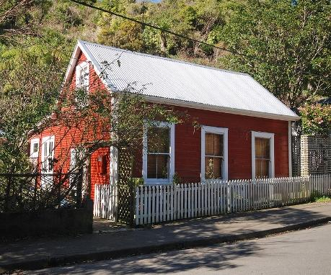 | Building Information  - District Plan: Individually listed building (Map 11, symbol 151/1)  - This building has architectural value as a representative example of a simple Colonial Georgian style dwelling, a common building type throughout the early settlement of New Zealand. Its style, type of construction, and materials are representative of a typical house of the day.  - This house has had few modifications made and retains a relatively authentic quality. It has authenticity of style, craftsmanship, materials and setting.  - This house is an important part of the local community and makes a contribution to the wider setting of Holloway Road. It contributes significantly to the sense of place and continuity in the Aro Valley.
The Issue | It is understood from the applicant that the upper story of 77 Holloway Road is still in an original state. However the structural integrity of the flooring is now in question after the August 2013 earthquake and probably pest damage to the joists below the floorboards.
Review of Proposal | Although this work appears to be necessary to maintain the building’s structural integrity into the future, the work would not result in any exterior restoration with significant community benefit. Given that the BHIF’s current focus is on assisting seismic projects and there appears not to be a discernable community benefit, it is recommended to decline this application.  This particular BHIF round has resulted in a higher level of applications for funding of seismic strengthening projects, and declining this application is consistent with other applications that have been considered to be outside the current priority for the fund, such as:  - Exterior painting of building; 66 Abel Smith Street, Te Aro; March 2013 round.  - Exterior painting of building; Fire Station Apartments, 12 Murphy Street, Thorndon; March 2013 round.

Project 2 | Moore’s Building  9-11 Riddiford Street
Applicant | Michel Sangalli, Green Comet LTD
Project | Building re-painting
Total project cost | $11,000
Amount requested | $8,250
Recommended Grant  ex GST if applicable | Decline
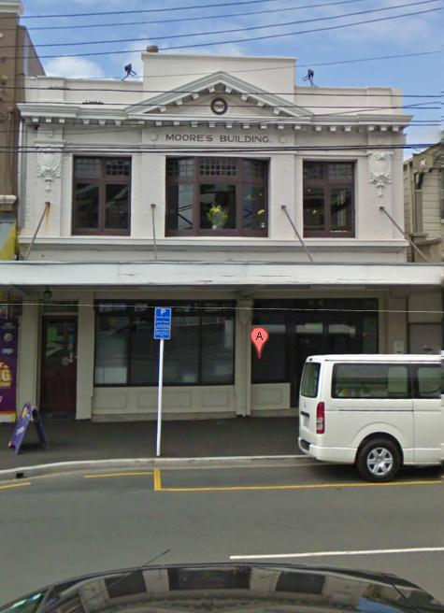 | Building Information  - District Plan: John Street Intersection Shopping Centre Newtown Heritage Area (Map 6, symbol 32)  - The Moore’s Building is a two-storey masonry structure that is one of the most architecturally refined buildings within the John Street Intersection Shopping Centre (Newtown) Heritage Area and is a good example of its kind.  - The retention of original materials, the Neo Classical/Beaux Arts ornaments, the materials used, and quality of the design all give this building architectural and aesthetic value.  - The group of buildings at the John Street Intersection are a representative example of an Edwardian commercial centre. Such an unbroken and consistent historic streetscape is now rare in Wellington. The variety in the age and type of buildings and the strong historic and visual contribution that the buildings make to this well-known part of Wellington, make this an important historic streetscape.
The Issue | The building requires extensive repairs and maintenance including re-painting of the full façade. The owners wish to replace the upper storey front façade window and are looking into ways in which they can retrofit double glazing into the casement leadlight windows. Ahead of this re-painting of the full façade is required in the short term.
Review of Proposal | While the planned work is essential to upkeep this heritage building in a weathertight condition, it is not required to improve seismic performance and therefore considered to be out of scope of the current priority for the fund.  This particular BHIF round has resulted in a higher level of applications for funding of seismic strengthening projects, and declining this application is consistent with other applications that have been considered to be outside the current priority for the fund, such as:  - Repair and restoration of the cottage’s exterior front façade; 48 Tarikaka Street, Ngaio; $3,000; July 2013 round;  - Exterior repairs and reinstatement; 218 Rintoul Street, Newtown; $10,000; June 2012 round.

Project 3 | Former Wellington Gas Company Building  60-64 Courtney Place
Applicant | Keith Chin, Intrepid Horizons Ltd
Project | Seismic detailed design
Total project cost | $50,000
Amount requested | $50,000
Recommended Grant  ex GST if applicable | $25,000
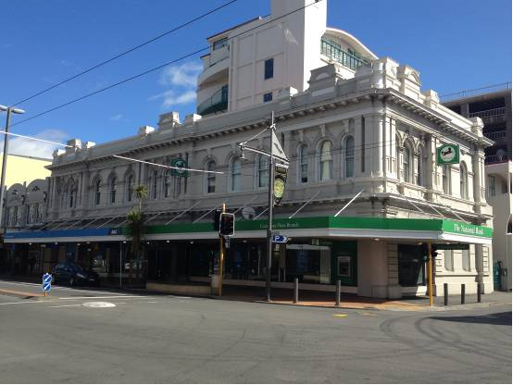 | Building Information  - District Plan: Individually listed building (Map 16, symbol 66/1)  - The former Wellington Gas Company Building is a relatively grand example of a late-Victorian commercial building. It was designed by prominent local architect, Thomas Turnbull, and is particularly notable for its well-proportioned and ornate Classical Palazzo-style facades to both Courtenay Place and Tory Street.  - This building housed the offices and main showroom of the Wellington Gas Company from 1898 to 1992. The company manufactured and sold coal-gas; and imported, sold and educated consumers on the use of gas appliances in the 19th and 20th centuries.  - But for the ground floor front façade, this building is relatively unaltered and has occupied this prominent corner site for over 110 years. It makes a major contribution to the streetscape, and to the sense of place and continuity of Courtenay Place and the nearby Courtenay Place Heritage Area.
The Issue | The building is currently listed by Council as being ‘potentially earthquake prone’. The owner of one unit of the body corporate has undertaken to prepare a detailed design for the full building that would achieve above 80% NBS performance. Given the costs involved in designing for the whole building, they cannot meet the full cost applied for in this BHIF application and wish for financial assistance to bridge their costs.
Review of Proposal | The project is supported from a heritage perspective given that the applicant has given an undertaking that the seismic solution will be to internal fabric only. With the importance of the building historically and as a fine representative example of a late Victorian commercial building, it is considered important to assist the body corporate with a detailed design for seismic strengthening of the full building.  While there is risk that the body corporate may not agree to the works as designed to the whole building, the unit title owner has provided assurances that at the very least the western most bay (encompassing his unit and the floor above) will be seismically strengthened following this design.  The project is in accordance with the current focus of the fund and previous grants for similar work incude:  - Seismic assessment and design; 216 Cuba Street; $20,000; November 2013 round.  - Seismic assessment and design; 33 Aro Street (School of Philosophy); $25,000
BHIF Outcome | The grant will:  - Acknowledge the additional costs associated retaining heritage fabric and replacing ‘like with like’ in a heritage building.  - Endorse Council recognition of a potential hazard to the community and visitors;
Additional BHIF condition(s) | Release of funds is subject to:  - Relevant drawings and reports to be submitted to WCC

Project 4 | St Mary’s Anglican Church  170 Karori Road
Applicant | Geoffrey Lee, Karori Anglican Churchs
Project | Conservation Plan for the Seismic Strengthening of St Mary's Anglican Church
Total project cost | $10,000
Amount requested | $10,000
Recommended Grant  ex GST if applicable | $8,000
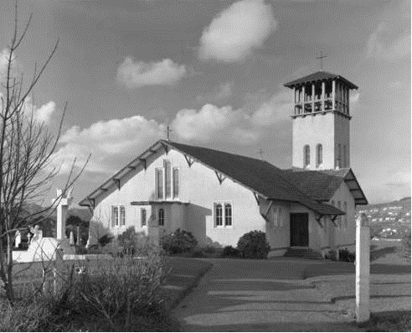 | Building Information  - District Plan: Individually listed building (Map 11, symbol 170)  - St Mary’s Anglican Church has historic and social value as it has been a place of worship since early immigrants settled in Karori in the 1840s. Several buildings on this site have served Karori’s Anglican community since 1866, while the present building has served the suburb for over 100 years.  - St Mary the Virgin is an important example of the work of Wellington’s leading ecclesiastic architect, Frederick de Jersey Clere. The building has particular aesthetic value for the architectural quality of the Italianate design, the grace of the interior space, and the high level of craftsmanship displayed in its construction.  - The church is a significant landmark in the suburb, located prominently on Karori Road and visible from much of the surrounding area.
The Issue | The building was issued a notice under section 124 of the Building Act 2004. The notice signifies that the building is earthquake prone as its seismic performance, based on engineering advice, falls below 33% of the NBS.  The celebrated church tower is believed to be the primary risk feature and the Parish is investigating strengthening options and plans to apply to the BHIF for assistance on remedial works in the near future. The Conservation Plan will inform the seismic strengthening design, taking into account the most important features of the building.
Review of Proposal | It is best practice for heritage buildings to prepare a conservation plan to understand in detail the condition and hierarchy of significance of the place and to guide modifications to the building. Given the plans to seismically strengthen the complex of buildings in the near future, assisting the preparation of a Conservation Plan at this stage is supported  The proposed work to prepare for the future seismic strengthening of the building fits with the current priority of the BHIF and is consistent with other examples of grants awarded, such as:  - Roof repair and conservation plan, Karitane Products Society Factory; $24,000; Mar 2011 round.  - Consultant fees to review existing Conservation Plan and write new Conservation Plan; Mount Street Cemetery, $8,248; March 2007 round
BHIF Outcome | The grant will:  - Acknowledge the additional costs associated maintaining a heritage building;  - Endorse Council recognition of a potential hazard to the community and visitors;  - Acknowledge and protect the heritage values of this individually listed heritage building.
Additional BHIF condition(s) | Release of funds is subject to:  - Conservation plan to be submitted to WCC

Project 5 | Katherine Mansfield Birthplace  25 Tinakori Road
Applicant | Emma Godwin, Katherine Mansfield Birthplace Society
Project | Seismic Risk Mitigation - Chimney
Total project cost | $18,830
Amount requested | $15,000
Recommended Grant  ex GST if applicable | $10,000
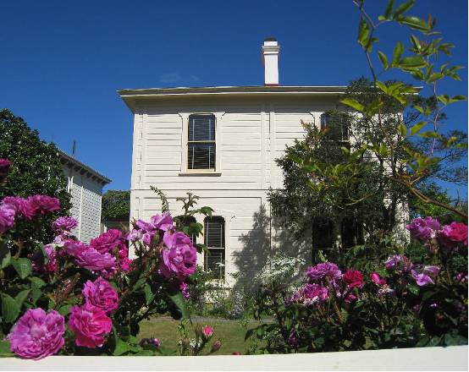 | Building Information  - District Plan: Individually listed building (Map 18, symbol 305)  - This house has outstanding historical value for its association with Katherine Mansfield. Mansfield is internationally recognised as a writer and the house features in a number of her works and appears to have played an important role in her early life. The house is also of historical importance as the home of Mansfield’s father, Sir Harold Beauchamp, who was a nationally significant figure in New Zealand financial and business circles at the turn of the century.  - The Katherine Mansfield Birthplace is a Classically influenced, symmetrical, remarkably devoid of decoration, two storey timber home that is representative of the time in which it was built. It is reminiscent of early Regency housing, with cover boards as vestigial columns.  - There are significant technological values in the house – surviving original wallpaper has been reproduced, adding to a limited knowledge of what styles were popular at this time.
The Issue | The building is not considered to be earthquake prone, however the chimney in question is thought to present a significant risk to life, given its construction in unreinforced masonry. Its replacement with a lightweight replica will remove this risk whilst preserving the aesthetic quality that the chimney provides.
Review of Proposal | The chimney has been identified by a conservation architect as not being an original chimney – having been replaced or rebuilt in recent decades. The work is supported from a heritage perspective given that it the replacement chimney will be designed by a conservation architect, and the works will remove a significant risk feature of the building.  The proposed work fits with the current priority of the BHIF and is consistent with other examples of work required to strengthen a building of this nature, such as:  - Design, develop and install earthquake strengthening; 130 Riddiford Street, Newtown; $10,000; March 2012 round.  - Earthquake Strengthening; Moxham Buldings, 3a-3c Moxham Avenue; $10,000; July 2010.
BHIF Outcome | The grant will:  - Endorse Council recognition of a potential hazard to the community on a high profile traffic and pedestrian route  - Acknowledge and protect the heritage values of this individually listed building.
Additional BHIF condition(s) | Release of funds is subject to:  - Relevant drawings and reports to be submitted to WCC  - WCC Heritage Advisor on site approval of works

Project 6 | 260 Riddiford Street
Applicant | Leonie Brunt
Project | Repair and re-clad of north wall of Heritage Building
Total project cost | $38,615
Amount requested | $21,328
Recommended Grant  (ex GST if applicable) | Decline
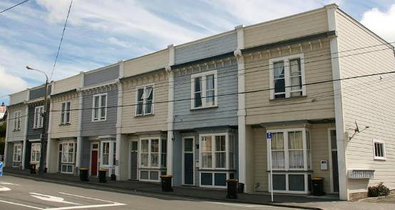 | Building Information  - District Plan: One of a group of seven listed buildings (Map 6, symbol 404)  - 250 – 262 Riddiford Street is a somewhat-altered terrace of seven shop/dwellings. The buildings are good representative examples of Edwardian timber mixed-use commercial buildings, but their architectural/aesthetic value has been somewhat diminished by the removal of the original shop-fronts.  - The buildings are associated with the development of twentieth century Newtown and its commercial development into a central shopping and commercial district.  - The terrace is made up of a distinct group of seven individual buildings that were built for Hamilton and Gilmer in 1901.
The Issue | Many of the weatherboards on the house need replacing, and other weatherproofing issues need to be addressed.
Review of Proposal | While the planned work is essential to upkeep this heritage building in a weathertight condition, it is not required to improve seismic performance and therefore considered to be out of scope of the fund.  This particular BHIF round has resulted in a higher level of applications for funding of seismic strengthening projects, and declining this application is consistent with other applications that have been considered to be outside the current focus of the fund, such as:  - Repair and restoration of the cottage’s exterior front façade; 48 Tarikaka Street, Ngaio; $3,000; July 2013 round;  - Exterior repairs and reinstatement; 218 Rintoul Street, Newtown; $10,000; June 2012 round.

Project 7 | Lilburn House  22 Ascot Street, Thorndon
Applicant | Diana Marsh, Lilburn Residence Trust
Project | Development of a conservation plan
Total project cost | $11,000
Amount requested | $5,000
Recommended Grant  (ex GST if applicable) | Decline
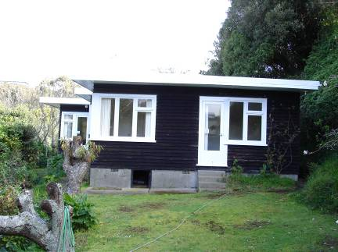 | Building Information  - District Plan: Individually Listed Building (Map 15, 18, reference 422)  - The Lilburn House is of significant historical value, principally for its association with Douglas Lilburn, a figure of national importance in New Zealand’s musical history. During his residence in the house, Lilburn continued to be a primary influence on the development of New Zealand music, and also began pioneering New Zealand compositions of electronic music  - The Lilburn House is of architectural value as an early and highly authentic example of post war NZ Modernist architecture that remains in near original condition.  - The Lilburn House is held in high public esteem, particularly by those who have been influenced by Lilburn and his contributions to the development of New Zealand music. The importance of the house is demonstrated by its purchase by the Lilburn Residence Trust for use as New Zealand’s first residence for composer
The Issue | The Lilburn Residence Trust would like a conservation plan to ensure maintenance and work carried out on the house and garden is consistent with its special character.
Review of Proposal | While the preparation of Conservation Plans are considered heritage best practice and encouraged generally, it is recommended to decline this application given that it is outside the current priority of the fund and the conservation plan is not specifically going towards a seismic strengthening project (such as projects 4&16). It is noted that the BHIF has previously (July 2010) funded the trust in repairs to the foundations of the building  This particular BHIF round has resulted in a higher level of applications for funding of seismic strengthening projects, and declining this application is consistent with other applications that have been considered to be outside the current priority of the fund, such as:  - Exterior painting of building; 68 Abel Smith Street, Te Aro; March 2013 round.  - Exterior painting of building; Fire Station Apartments, 12 Murphy Street, Thorndon; March 2013 round.

Project 8 | Wellington Chinese Masonic Society Building  23 Frederick Street
Applicant | Mark Baylis
Project | Seismic strengthening works
Total project cost | $200,500
Amount requested | $35,000
Recommended Grant  (ex GST if applicable) | $30,000
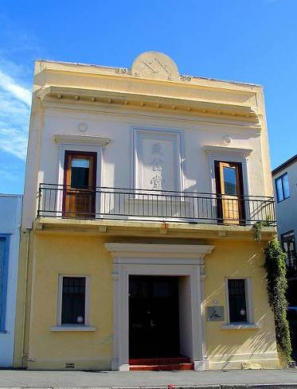 | Building Information  - District Plan: Individually Listed Building (Map 16, reference 123)  - The building has historical value due to its association with the Chee Kung Tong, a secret society that was originally dedicated to overthrowing the Qing Dynasty (1644-1912) in China.  - Built in 1925, the building has architectural value due to its Inter-War Free-Classical style and incorporation of traditional Hung League designs.  - The building has architectural authenticity due to its exterior façade having retained a significant amount of its original fabric.  - The building has social value to members of New Zealand’s Chinese community.
The Issue | The building is currently listed by Council as being ‘potentially earthquake prone’. The owner believes it can currently achieve 34% of NBS but that carrying out the works applied for in this BHIF application would result in a building of 70% NBS at a minimum. The owners do not have the financial capacity to meet the costs required to strengthen the building and wish for financial assistance to bridge their costs.
Review of Proposal | The proposal has significant heritage merit in that it aims to maintain the facades of the building intact and install internal seismic strengthening by way of a steel portal frame. The main costs of the project will be to install the portal frame, the engineering input around that as well as making good. Other elements such as insulation and fire protection measures are also included in the application.  The applicants have not demonstrated that they can meet the full amount estimated. Regardless of the amount awarded in the BHIF, the applicant will need to seek bank loans to complete the works. With this in mind, there is a risk of the project not being completed, however the recommended amount granted reflects the current focus of the fund and a recognition of the difficulty of remedying the seismic performance of such an important heritage building.  The grant amount recommended for this project is consistent with previous grants for similar work and scale, such as:  - Seismic strengthening works to the Evening Post Building; 62 Willis Street; $60,000; November 2013 round.  - Seismic strengthening works to the Former Sydney Street Substation, 19 Kate Sheppard Place; $30,000; March 2014 round.
BHIF Outcome | The grant will:  - Acknowledge the additional costs associated retaining heritage fabric and replacing ‘like with like’ in a heritage building.  - Endorse Council recognition of a potential hazard to the community on a high profile traffic and pedestrian route;
Additional BHIF condition(s) | Release of funds is subject to:  - WCC Heritage Team’s onsite approval of works.

Project 9 | Clarke’s Building  121 The Parade, Island Bay
Applicant | Simon Copland, Milton Investments No 2 Ltd
Project | Seismic strengthening detailed design
Total project cost | $16,000
Amount requested | $16,000
Recommended Grant  (ex GST if applicable) | $16,000
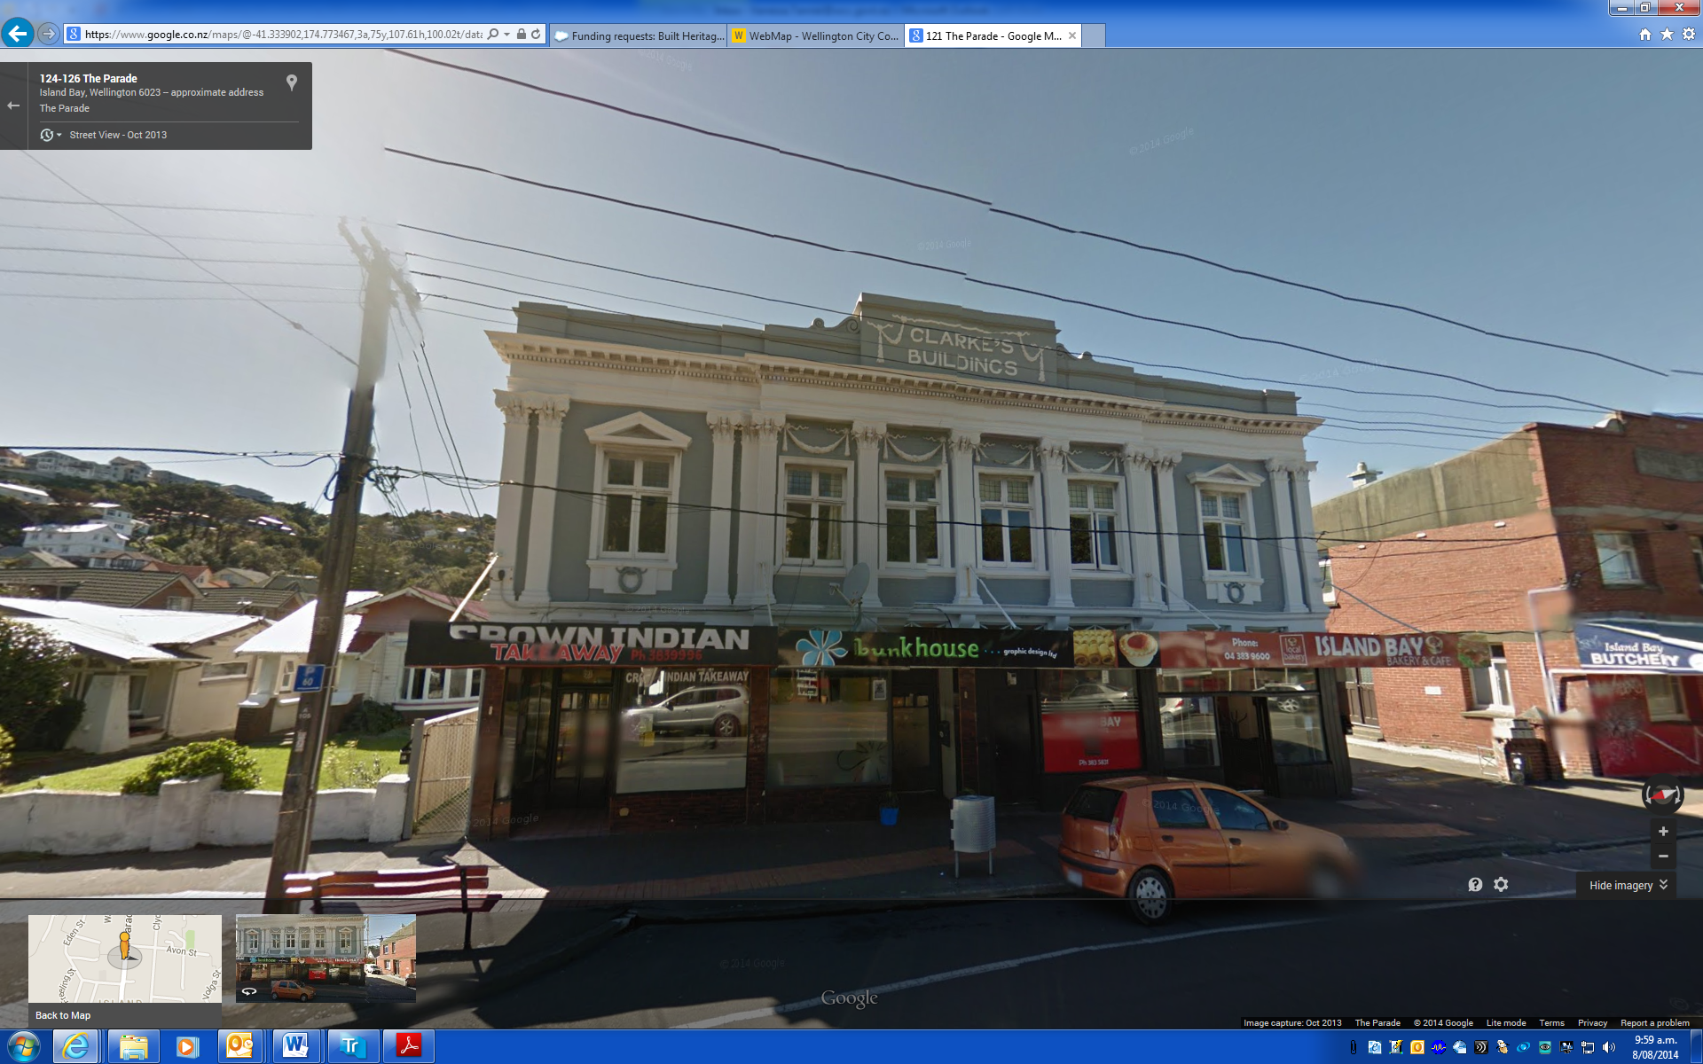 | Building Information  - District Plan: Island Bay Heritage Area (Map 4, Symbol 25)  - The collection of commercial buildings near the intersection of Medway Street and The Parade has considerable heritage value as one of Wellington's best preserved groups of early 20th century commercial buildings.  - The buildings all retain authentic fabric from the time of their construction. Minor alterations and additions to the front and rear of the shops do not significantly undermine this quality.  - This building was constructed in 1923 for S.D. Clarke whose name is in relief on the façade. This building has always been an investment property. The first listed ground floor occupant was the Island Bay Post Office, which stayed in the building until World War II
The Issue | The building was issued a notice under section 124 of the Building Act 2004. The notice signifies that the building is earthquake prone as its seismic performance, based on engineering advice, falls below 33% of the NBS. It is currently thought to be able to achieve 10% of the NBS.
Review of Proposal | The owner is seeking to ensure the long term viability of the building by increasing its seismic performance to above 67%.  The applicant has had some early design drawings carried out and these have been reviewed by a recognised conservation architect as being appropriate for the building. The internal portal frame proposed will be partly visible from the exterior of the building but this is to be minimal.  The detailed design and strengthening works applied for will be reviewed by a conservation architect and it is hoped that the project will maintain the quality and longevity of this significant and prominent heritage building in Island Bay.  The proposed work fits with the current priority of the BHIF and is consistent with other examples of work required to strengthen a building of this nature, such as:  - Seismic assessment and design, 216 Cuba Street; $20,000; November 2013;  - Major works including seismic strengthening; Morgan Building, 199 Cuba Street; $18,000; March 2012.
BHIF Outcome | The grant will:  - Endorse Council recognition of a potential hazard to the community on a high profile traffic and pedestrian route;  - Acknowledge the additional costs associated retaining heritage fabric and replacing ‘like with like’ in a heritage building.
Additional BHIF condition(s) | Release of funds is subject to:  - Relevant drawings and reports to be submitted to WCC;

Project 10 | 2-14 Riddiford Road, Newtown
Applicant | Aphra Green, Riddifort Court Body Corporate
Project | Seismic strengthening detailed design
Total project cost | $28,175
Amount requested | $28,175
Recommended Grant  (ex GST if applicable) | $28,175
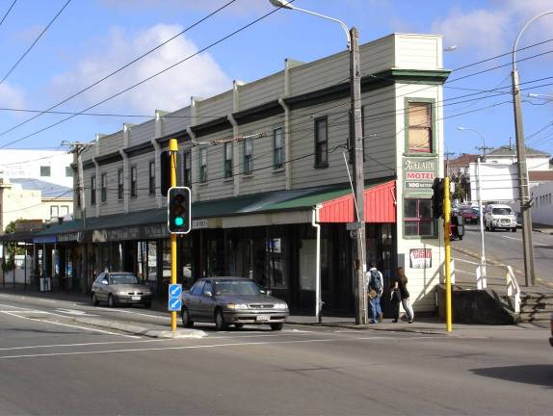 | Building Information  - District Plan: Individually Listed Heritage Building (Map 6, symbol 447) situated in the John Street Intersection Shopping Centre Newtown Heritage Area (Map 6, symbol 32).  - 2-14 Riddiford Street is an unusual variation of a typical Wellington timber shop/residence adapted to suit a prominent wedge-shaped corner site. It is an important example of the work of architect James Bennie (well-known for an assortment of interesting wedge-shaped buildings in Wellington) and is one of several he designed with E. C. Farr.  - The building is a distinctive local landmark for its wedge-shaped form and location on the prominent corner intersection at the northern end of Newtown and makes an important contribution to the John Street Intersection Shopping Centre Newtown Heritage Area.  - Built in 1903, the building has retained a high level of authenticity. The general plan layout of the shops and accommodation appears largely intact.
The Issue | The building was issued a notice under section 124 of the Building Act 2004. The notice signifies that the building is earthquake prone as its seismic performance, based on engineering advice, falls below 33% of the NBS.
Review of Proposal | For a number of years the body corporate of this building have been looking to address the seismic issues with their building, previously aiming for 67% of NBS. It has been agreed to aim for a simpler solution in order to avoid high costs and loss of tenancy during works while taking the body corporate off the earthquake prone list.  This design phase will result in plans to bring the building to the very least above 33% of the NBS. A previous allocation of $15,000 in 2011 was used to carry out a seismic assessment with a view to a higher % of NBS solution – the data from this assessment will be utilised as part of upcoming design works. A conservation architect has been engaged to oversee the design phase.  The proposed work fits with the current priority of the BHIF and is consistent with other examples of work required to strengthen a building of this nature, such as:  - Design, develop and install for remedial work to achieve a suitable earthquake level; 130 Riddiford Street; $10,000; March 2012 round;  - Former Ashleigh Court Private Hotel, 112-126 Riddiford Street; $20,000; Mar 2013 round.
BHIF Outcome | The grant will:  - Endorse Council recognition of a potential hazard to the community on a high profile traffic and pedestrian route;  - Acknowledge the additional costs associated retaining heritage fabric and replacing ‘like with like’ in a heritage building.
Additional BHIF condition(s) | Release of funds is subject to:  - Relevant Reports and plans to be submitted to WCC

Project 11 | 216 Cuba Street
Applicant | Sarah Harrow
Project | Seismic strengthening and upgrade – Phase 1 works
Total project cost | $57,933
Amount requested | $42,933
Recommended Grant  (ex GST if applicable) | $20,000
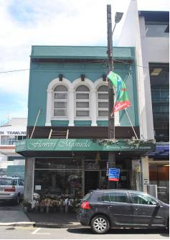 | Building Information  - District Plan: Individually Listed Heritage Building (Map 16, symbol 90) situated within the Cuba Street Heritage Area (Map 16/17, symbol 27)  - Designed by Young and Fearn and built in 1922, this two-storey Stripped Classical masonry building is a good representative example of a small two storey shop/residence.  - The building is one of the southern-most masonry shop/residences constructed on Cuba Street, and is notable for its well-proportioned façade and restrained palette of Classical ornamentation.  - The building contributes to the townscape, and the sense of place and continuity of the Cuba Street Heritage Area.
The Issue | The building was issued a notice under section 124 of the Building Act 2004. The notice signifies that the building is earthquake prone as its seismic performance, based on engineering advice, falls below 33% of the NBS. The owners are committed to seismically strengthening the building to 70% of NBS. With $20,000 in BHIF support in November 2013 the applicant has paid for seismic assessments/ design reports and is proceeding with phase 1 of the construction of the seismic solution.
Review of Proposal | The owner is seeking to ensure the long term viability of the building by increasing its seismic performance to above 70%. The solution involves the introduction of a new internal concrete frame ties to ground anchors. It will maintain the exterior of the building and has the support of Heritage New Zealand on this basis.  The proposed work fits with the current priority of the BHIF and is consistent with other examples of work required to strengthen a building of this nature, such as:  - Seismic strengthening works; Adelphi Finance House, 15 Courtenay Plance; $18,750; Mar 2012 round.  - Seismic upgrade to Wellington Downtown Backpackers, 1 Bunny Street; $15,000; Mar 2012 round.
BHIF Outcome | The grant will:  - Endorse Council recognition of a potential hazard to the community on a high profile traffic and pedestrian route;  - Acknowledge the additional costs associated retaining heritage fabric and replacing ‘like with like’ in a heritage building.
Additional BHIF condition(s) | Release of funds is subject to:  - The WCC Heritage Team’s on site approval of works.

Project 12 | Ohariu Valley Hall  550 Ohariu Valley Road, Makara
Applicant | Bruce Macintyre, The Ohariu Valley Hall Company Ltd
Project | Seismic strengthening and re-piling works
Total project cost | $46,071
Amount requested | $25,000
Recommended Grant  (ex GST if applicable) | $25,000
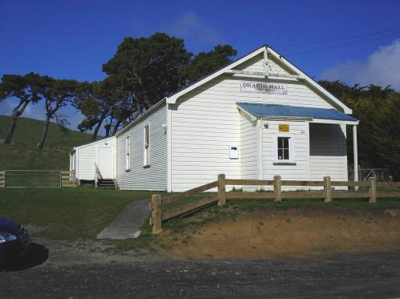 | Building Information  - District Plan: Individually Listed Heritage Building (Map 25, symbol 443)  - The Ohariu Valley Community Hall has hosted the area’s social and official occasions for 100 years, and is known to everyone who has lived in the valley. It has significant social value for the important community function it has served.  - The building is typical of many such halls around New Zealand. The building is representative as a good example of its type, a straightforward architectural design that was built specifically for the purpose.  - The hall stands out in this context, a landmark along the Ohariu Valley Road, in much the same way as the Holy Trinity Church further up the valley.
The Issue | The building was issued a notice under section 124 of the Building Act 2004. The notice signifies that the building is earthquake prone as its seismic performance, based on engineering advice, falls below 33% of the NBS.
Review of Proposal | Being a designated Civil Defence location as well as its other community uses, the Ohariu Bay community is committed to seismically improving the hall to 100% of NBS. This is to be achieved primarily by replacing the piles and using new anchor piles. The building has previously (August 2012) received the support of the BHIF of $9,000 for a seismic assessment report, which identified the specific work to be carried out in the upcoming construction phase.  The proposed work fits with the current priority of the BHIF and is consistent with other examples of work required to strengthen a building of this nature, such as:  - Futuna Chapel Seismic Analysis and Upgrade, 67 Futuna Close, Karori; $30,000; July 2013 round.  - Earthquake Strengthening design and works of School Hall; Thorndon School Hall, 20 Turnbull Street; $15,000; March 2014.
BHIF Outcome | The grant will:  - Endorse Council recognition of a potential hazard to the community and support the building’s use as a communityhall and Civil Defence building;  - Acknowledge the additional costs associated retaining heritage fabric and replacing ‘like with like’ in a heritage building.
Additional BHIF condition(s) | Release of funds is subject to:  - The WCC Heritage Team’s on site approval of works.

Project 13 | Wellington Rowing Club, Taranaki St Wharf
Applicant | Wellington Rowing Club (joint application with Star Boating Club – Project 14)
Project | Seismic design and strengthening works
Total project cost | $47,450 (half of total for joint project)
Amount requested | $17,500
Recommended Grant  (ex GST if applicable) | $17,500
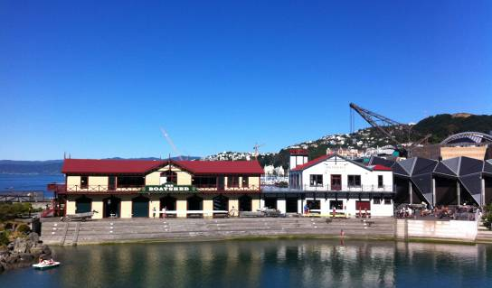 | Building Information  - The Star Boating club building has architectural and technological significance as it was specifically designed by the eminent architect William Chatfield to facilitate its relocation, responding to the ongoing reclamation of Wellington's waterfront.  - The building has high historical significance given its continuous association with the Star Boating Club, one of the oldest rowing and sporting clubs in New Zealand. The building has also had a significant historical association with New Zealand's longest running professional theatre, Downstage.  - This distinctive building contributes greatly to the streetscape and, along with the neighbouring Wellington Rowing Club building occupies a prominent place on the waterfront.
The Issue | The building was issued a notice under section 124 of the Building Act 2004. The notice signifies that the building is earthquake prone as its seismic performance, based on engineering advice, falls below 33% of the NBS.  The club has undertaken to seismically upgrade the building jointly with the abutting Star Boating Club to achieve above 66% NBS. It being reliant on memberships for funding, the club is not in a position to fund the full amount for this upgrade and seeks assistance from the BHIF.
Review of Proposal | The owner is seeking to ensure the long term viability of the building by increasing its seismic performance to above 66%.  The applicant has had some early design drawings carried out and these have been reviewed by a conservation architect who has been engaged to oversee the project.  The detailed design and strengthening works applied for will maintain the quality and longevity of this significant and prominent heritage building.  The proposed work fits with the current priority of the BHIF and is consistent with other examples of work required to strengthen a building of this nature, such as:  - Structural investigation and design for strengthening; The Plumbers Building, 124 Wakefield Street, Te Aro; $25,000; March 2013;  - Morgan Building, 199 Cuba Street; Major works including seismic strengthening; $18,000.
BHIF Outcome | The grant will:  - Endorse Council recognition of a potential hazard to the community in a high profile location;  - Acknowledge the additional costs associated retaining heritage fabric and replacing ‘like with like’ in a heritage building.
Additional BHIF condition(s) | Release of funds is subject to:  - Report and plans to be submitted to WCC;  - Evidence of discussions with the New Zealand Historic Places Trust about archaeological provisions that might be required to undertake ground work;  - The WCC Heritage Team’s on site approval of works.

Project 14 | Star Boating Club, Taranaki St Wharf
Applicant | Wellington Rowing Club (joint application with Wellington Rowing Club – Project 13)
Project | Seismic design and strengthening works
Total project cost | $47,450
Amount requested | $17,500
Recommended Grant  (ex GST if applicable) | $17,500
The Issue | The building was issued a notice under section 124 of the Building Act 2004. The notice signifies that the building is earthquake prone as its seismic performance, based on engineering advice, falls below 33% of the NBS.  The club has undertaken to seismically upgrade the building jointly with the abutting Star Boating Club to achieve above 66% NBS. It being reliant on memberships for funding, the club is not in a position to fund the full amount for this upgrade and seeks assistance from the BHIF.
Review of Proposal | The owner is seeking to ensure the long term viability of the building by increasing its seismic performance to above 66%.  The applicant has had some early design drawings carried out and these have been reviewed by a conservation architect who has been engaged to oversee the project.  The detailed design and strengthening works applied for will maintain the quality and longevity of this significant and prominent heritage building.  The proposed work fits with the current priority of the BHIF and is consistent with other examples of work required to strengthen a building of this nature, such as:  - Earthquake Strengthening design and works of School Hall; Thorndon School Hall, 20 Turnbull Street; $15,000; March 2014;  - Earthquake Strengthening of Dominion Building; 78-84 Victoria Street; $10,000.
BHIF Outcome | The grant will:  - Endorse Council recognition of a potential hazard to the community in a high profile location;  - Acknowledge the additional costs associated retaining heritage fabric and replacing ‘like with like’ in a heritage building.
Additional BHIF condition(s) | Release of funds is subject to:  - Report and plans to be submitted to WCC;  - Evidence of discussions with heritage New Zealand about archaeological provisions that might be required to undertake ground work;  - The WCC Heritage Team’s on site approval of works.
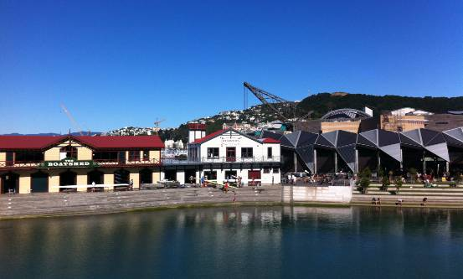 | Building Information  - The Wellington Rowing Club is a fine example of a Victorian military building. Despite many alterations, and its 1992 relocation, the building is notable for its octagonal tower, and for its decorative scheme made up of timber ornamentation and external timber boarding.  - The building is a legacy of the late 19th century period of New Zealand history when great anxiety about a sea-invasion, particularly from Russia, led to the erection of a whole range of defence structures. It was designed by prominent local architect, Frederick de Jersey Clere and has a historic association with the Wellington Naval Artillery Volunteers; the Wellington Free Ambulance; and, since 1931, the Wellington Rowing Club.  - Together with the Star Boating Club, the Rowing Club forms part of a distinctive townscape on this part of the Wellington waterfront. These two buildings provide a tangible reminder of Wellington's long standing connections with the harbour.

Project 15 | Wellington Rowing Club, Taranaki St Wharf
Applicant | Wellington Rowing Club (Barry Sayer)
Project | Roof repair and a replacement
Total project cost | $27,630
Amount requested | $12,630
Recommended Grant  (ex GST if applicable) | decline
Building Information
- The Wellington Rowing Club is a fine example of a Victorian military building. Despite many alterations, and its 1992 relocation, the building is notable for its octagonal tower, and for its decorative scheme made up of timber ornamentation and external timber boarding.
- The building is a legacy of the late 19th century period of New Zealand history when great anxiety about a sea-invasion, particularly from Russia, led to the erection of a whole range of defence structures. It was designed by prominent local architect, Frederick de Jersey Clere and has a historic association with the Wellington Naval Artillery Volunteers; the Wellington Free Ambulance; and, since 1931, the Wellington Rowing Club.
- Together with the Star Boating Club, the Rowing Club forms part of a distinctive townscape on this part of the Wellington waterfront. These two buildings provide a tangible reminder of Wellington's long standing connections with the harbour.

The Issue | The club is intending to undertake a joint (with Star Boating Club) seismic upgrade in the near future (see projects 13 & 14). Alongside this, repair work is required to address leaking in the roof.
Review of Proposal | The applicant intends to replace most if not all of the roof and have engaged a conservation architect to oversee both the seismic work and roof repair work. The owner is seeking to ensure the long term viability of the building by increasing its seismic performance and weather-tightness, which is supported by the Heritage Team. It is recommended to decline this request, given that the roof repair sits outside the priority of the fund. It is noted that recommendations for the seismic component of the work would meet the full amount requested.  This particular round has resulted in a higher level of applications for funding of seismic projects, and declining this application is consistent with other applications that have been considered to be outside the current priority of the fund, such as:  - Exterior painting of building; 68 Abel Smith Street, Te Aro; March 2013 round.  - Exterior painting of building; Fire Station Apartments, 12 Murphy Street, Thorndon; March 2013 round.

Project 16 | Wesley Methodist Church, 75 Taranaki Street
Applicant | Board of Administration of the Methodist Church of NZ (c/o Carol Dale)
Project | Preparation of a conservation plan in advance of seismic strengthening
Total project cost | $6,500
Amount requested | $6,500
Recommended Grant  (ex GST if applicable) | $6,500
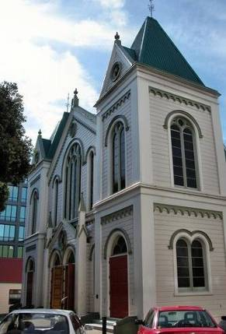 | Building Information  - The Wesley Methodist Church is one of the finest 19th century timber churches in Wellington. It has high aesthetic value for the rich and interesting composition in timber of the front façade to Taranaki Street and for the quality of the main interior space.  - The building continues to have spiritual significance to the religious community that, for over 130 years had used the Church. Public access to religious and secular events at the Church is supported and it remains popular. It holds particular importance for the Pacific Island community in Wellington who, in the last several decades, have made this their spiritual home.  - The Wesley Church has stood as the symbol of Methodism in Wellington for over 130 years, and has historic value for its association with the Methodist religion in Wellington and the development of the city. It is also associated with prominent Wellington architect Thomas Turnbull.
Project Description | Preparation of a conservation plan in advance of seismic strengthening
The Issue | The building is currently listed by Council as being ‘potentially earthquake prone’. The Wesley Methodist Church have undertaken seismic assessments and plan to upgrade their buildings in the near future. In preparation for upgrade they have engaged a conservation architect to assess the heritage significance of their buildings and input on their preferred methods of strengthening.
Review of Proposal | It is best practice for heritage buildings to prepare a conservation plan to understand in detail the condition and hierarchy of significance of the place and to guide modifications to the building. Given the plans to seismically strengthen the complex of buildings in the near future the preparation of a Conservation Plan at this stage is supported  The proposed work to prepare for the future seismic strengthening of the building fits with the current priority of the BHIF and is consistent with other examples of grants awarded, such as:  - Roof repair and conservation plan, Karitane Products Society Factory; $24,000; Mar 2011 round.  - Consultant fees to review existing Conservation Plan and write new Conservation Plan; Mount Street Cemetary, $8,248; March 2007 round
BHIF Outcome | The grant will:  - Acknowledge the additional costs associated retaining heritage fabric and in a heritage building.  - Endorse Council recognition of a potential hazard to the community and visitors;  - Acknowledge and protect the heritage values of this individually listed heritage building.
Additional BHIF condition(s) | Release of funds is subject to:  - Conservation Plan to be submitted to WCC Heritage Team

