Ordinary Meeting

of

Regulatory Processes Committee

Agenda

Time: 9:30am
Date: Wednesday, 13 September 2017
Venue: Committee Room 1
Ground Floor, Council Offices
101 Wakefield Street
Wellington

mEMBERSHIP
Mayor Lester
Councillor Calvert
Councillor Calvi-Freeman
Councillor Lee
Councillor Sparrow (Chair)

Have your say!
You can make a short presentation to the Councillors at this meeting. Please let us know by noon the working day before the meeting. You can do this either by phoning 803-8334, emailing public.participation@wcc.govt.nz or writing to Democratic Services, Wellington City Council, PO Box 2199, Wellington, giving your name, phone number and the issue you would like to talk about.

AREA OF FOCUS
The Regulatory Processes Committee has responsibility for overseeing the Council’s regulatory functions.
The committee will have responsibility for:
- Resource Management Act (RMA) Commissioners – Approve List and Appointment Guidelines
- Dog Objections and Fencing of Swimming Pools
- Road Stopping
- Temporary Road Closures
- Liquor Ban Bylaw Appeals
- Development Contributions Remissions.
- Approving leases under the “Leases Policy for Community and Recreation Groups”

Quorum: 3 members

TABLE OF CONTENTS
13 September 2017

Business Page No.

1. Meeting Conduct 3
1. 1 Apologies 3
1. 2 Conflict of Interest Declarations 3
1. 3 Confirmation of Minutes 3
1. 4 Public Participation 3
1. 5 Items not on the Agenda 3
2. General Business 3
2.1 Annual dog report 2017 3
2.2 Road Closures 3
2.3 Proposed Road Stopping – Land adjoining 42 Maupuia Road, Miramar 3

1 Meeting Conduct

1. 1 Apologies
The Chairperson invites notice from members of apologies, including apologies for lateness and early departure from the meeting, where leave of absence has not previously been granted.

1. 2 Conflict of Interest Declarations
Members are reminded of the need to be vigilant to stand aside from decision making when a conflict arises between their role as a member and any private or other external interest they might have.

1. 3 Confirmation of Minutes
The minutes of the meeting held on 16 August 2017 will be put to the Regulatory Processes Committee for confirmation.

1. 4 Public Participation
A maximum of 60 minutes is set aside for public participation at the commencement of any meeting of the Council or committee that is open to the public. Under Standing Order 3.23.3 a written, oral or electronic application to address the meeting setting forth the subject, is required to be lodged with the Chief Executive by 12.00 noon of the working day prior to the meeting concerned, and subsequently approved by the Chairperson.

1. 5 Items not on the Agenda
The Chairperson will give notice of items not on the agenda as follows:

Matters Requiring Urgent Attention as Determined by Resolution of the Regulatory Processes Committee.
- The reason why the item is not on the agenda; and
- The reason why discussion of the item cannot be delayed until a subsequent meeting.

Minor Matters relating to the General Business of the Regulatory Processes Committee.
No resolution, decision, or recommendation may be made in respect of the item except to refer it to a subsequent meeting of the Regulatory Processes Committee for further discussion.

2. General Business

Annual dog report 2017

Purpose

1. S10A of the Dog Control Act 1996 requires the Council to report annually to the Secretary of Local Government on its dog control policy and practices.

Summary

2. The attached Report sets out details of:

• The Council’s dog control policy and practices

• Information relating to fees

• Details of key achievements

• Statistical data.

This information relates to the year 1st July 2016 to 30th June 2017.

Recommendations
That the Regulatory Processes Committee:
1. Receive the information.
2. Agree on its contents of the Annual Dog Control Report 2017.
3. Adopt the Report.

Background

3. The collation of this Report is a legal requirement of S10A of the Dog Control Act 1996.

Attachments
Attachment 1. | Annual Dog Control Report 2017 | Page 3

Author | Helen Jones, Manager Public Health Group
Authoriser | Jane Hill, Manager Community Networks  Barbara McKerrow, Chief Operating Officer

SUPPORTING INFORMATION
Engagement and Consultation
This report was completed in conjunction with Hutt City Council who are contracted to provide animal control services on behalf of Wellington City Council.

Treaty of Waitangi considerations
There are no considerations relevant to this Report

Financial implications
There are no financial implications relating to the completion of this Report

Policy and legislative implications
Completion of this Report is a legislative requirement

Risks / legal
Not relevant, a statutory requirement

Climate Change impact and considerations
Not relevant, a statutory requirement

Communications Plan
Once this report has been adopted by Council, a copy will be sent to the Secretary for Local Government at the Department for Internal Affairs . A copy will also be posted on the Wellington City Council website. Hard copies of the report will be made available if requested

Health and Safety Impact considered
As animal control services are contracted to Hutt City Council, the animal control contract covers all health and safety obligations of both parties in relation to that contract.
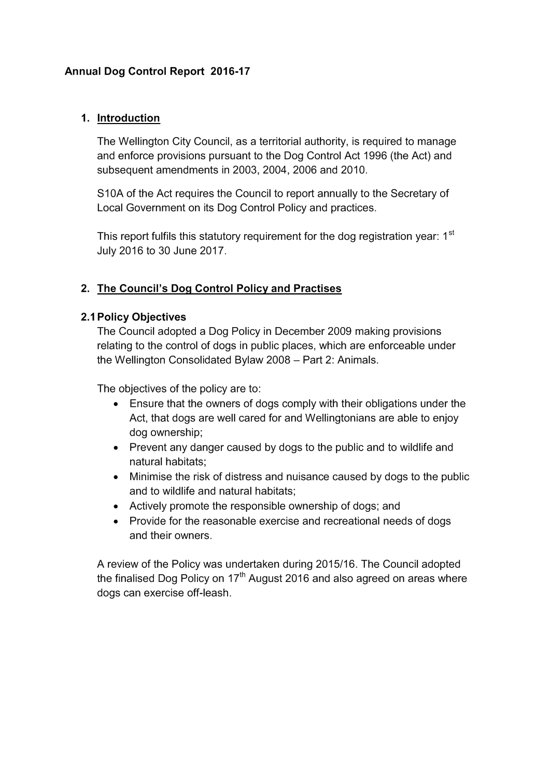

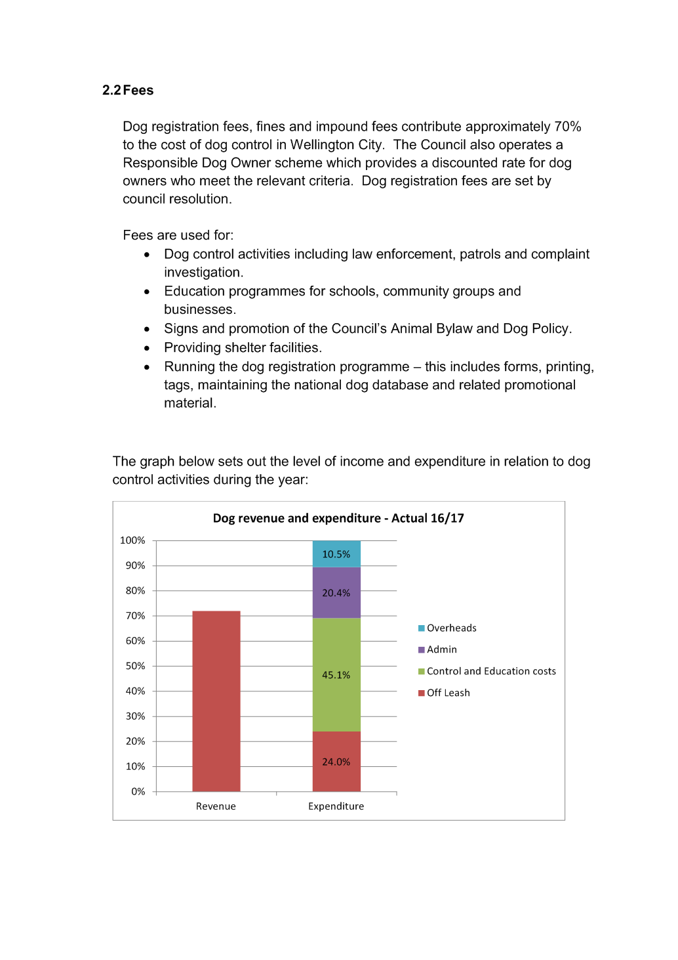

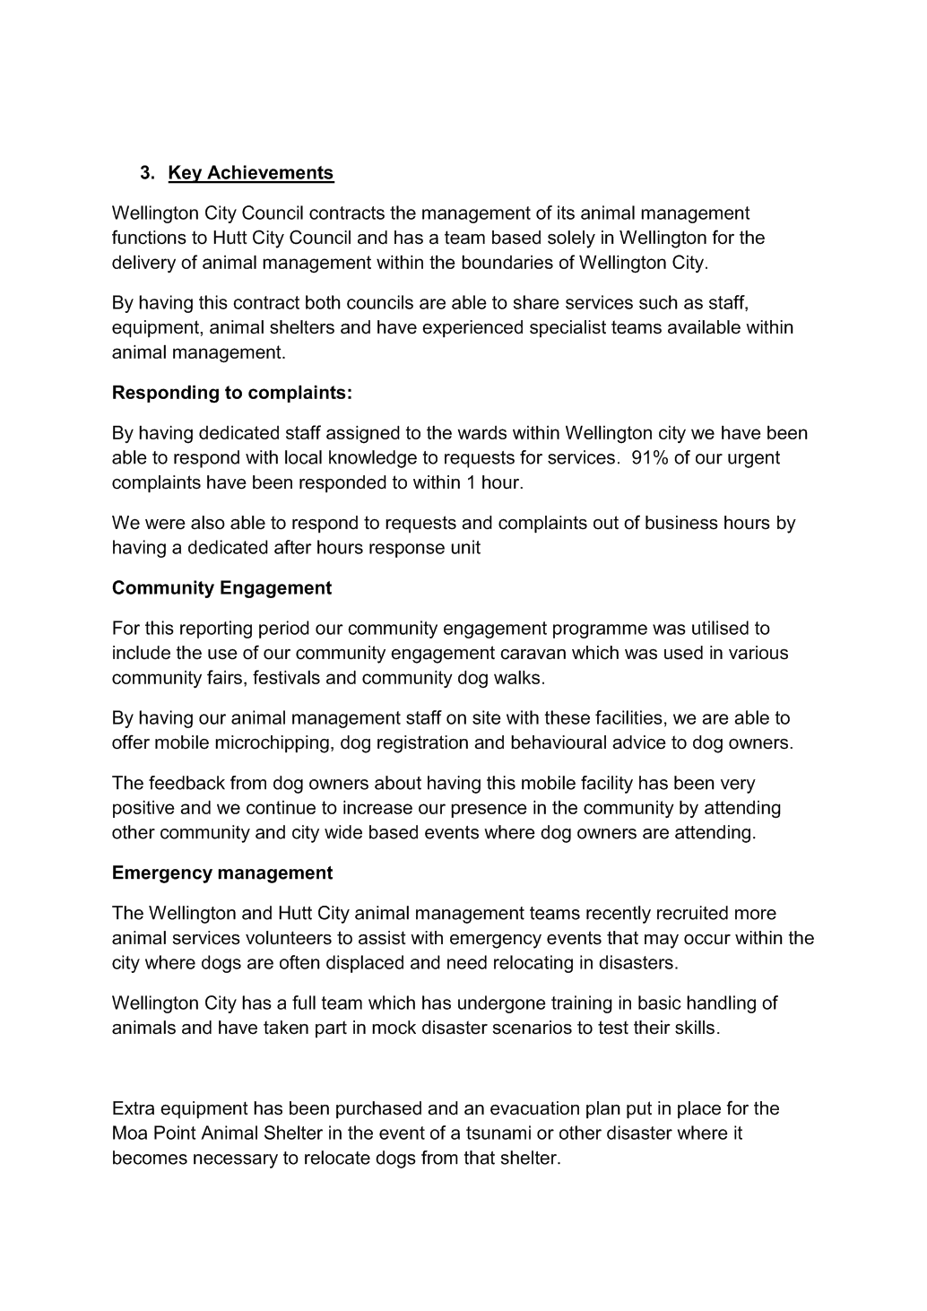

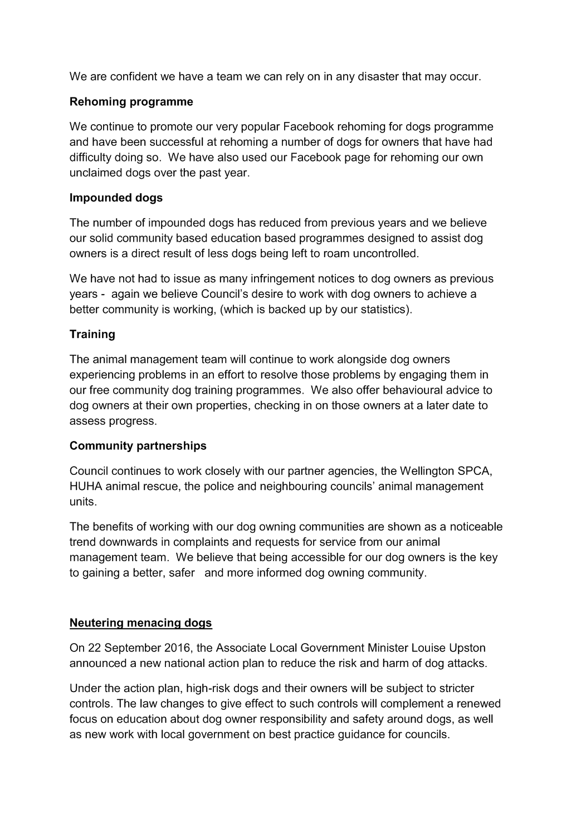

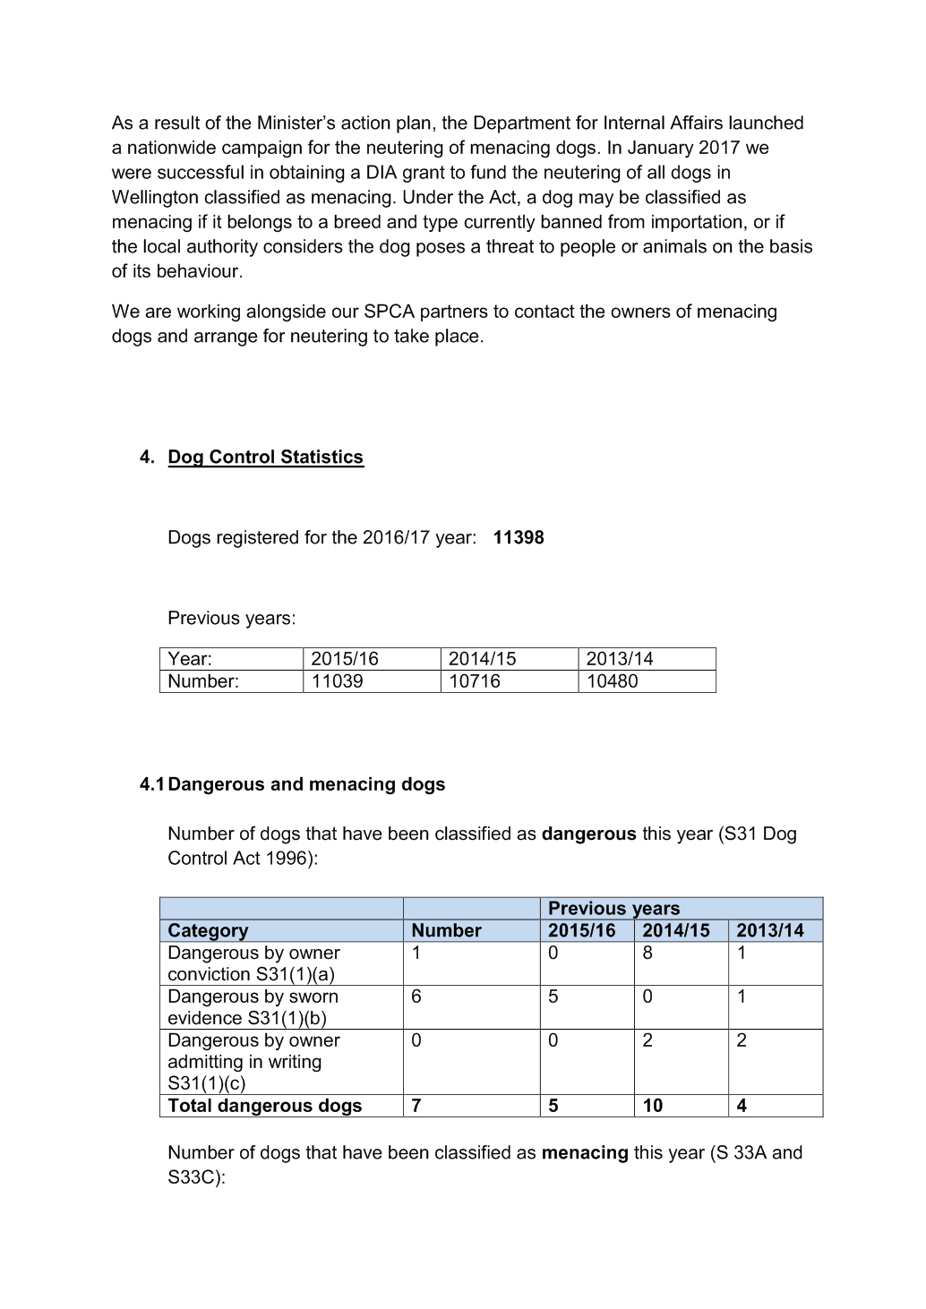

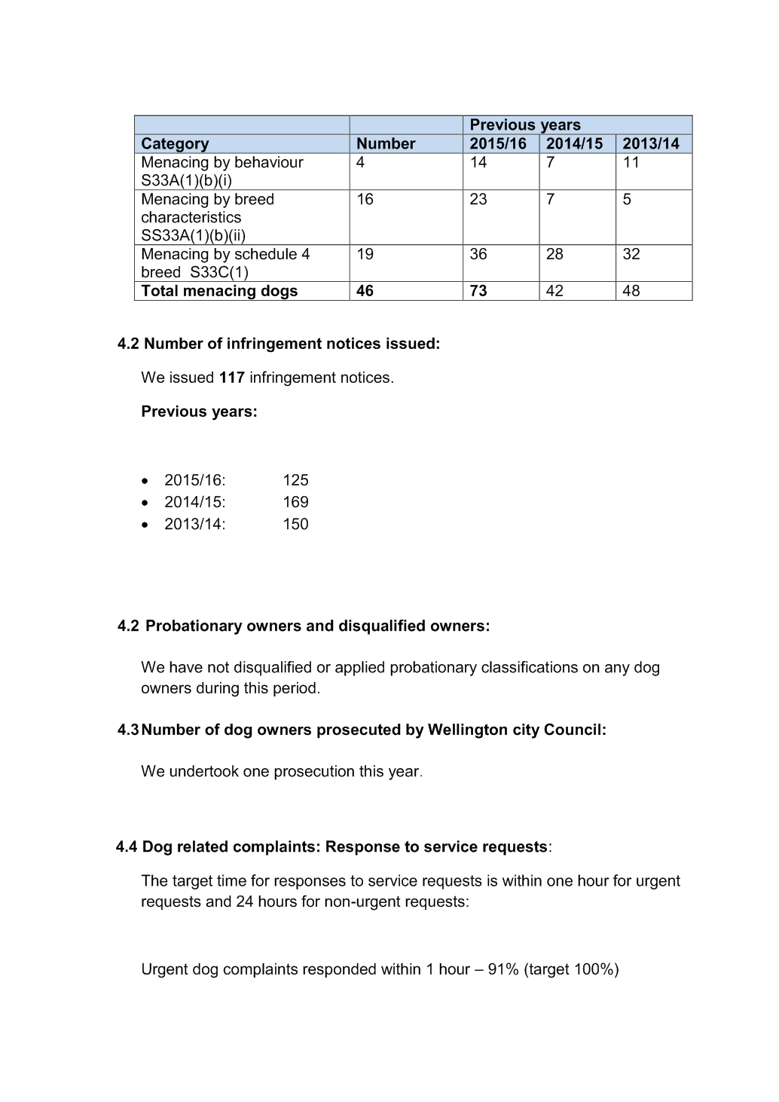

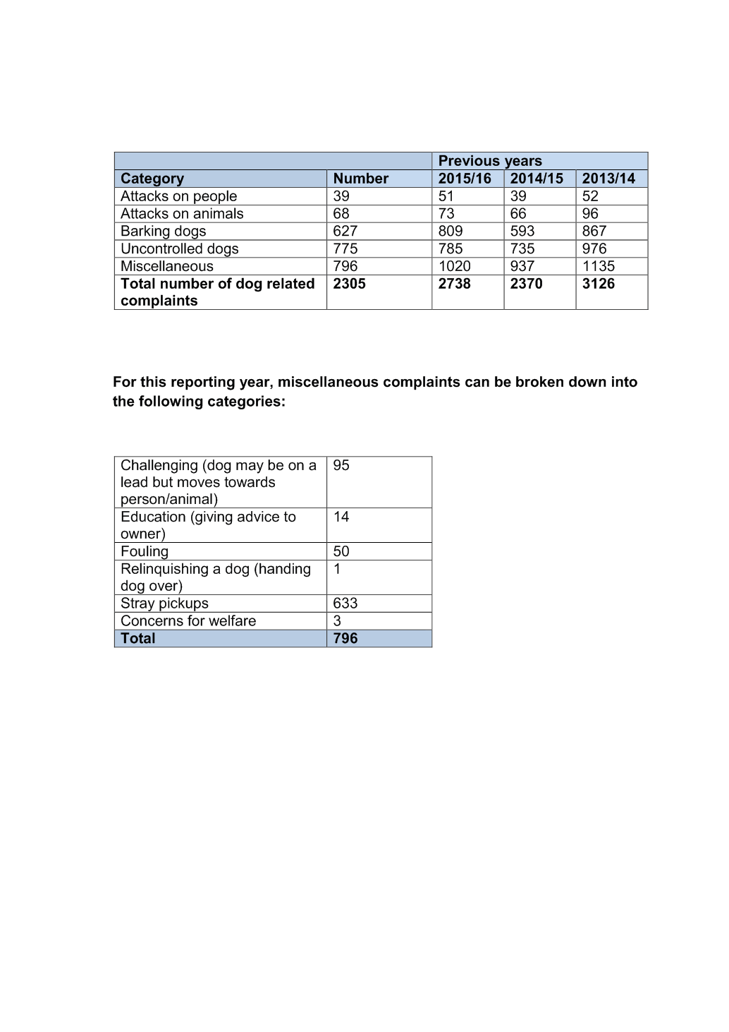

Road Closures

Purpose

1. To seek approval of the Regulatory Processes Committee for the temporary closure of roads in Wellington City for events.

Summary

2. The Wellington City Council has received applications from event organisers for approval of road closures for the following events:

• Island Bay Festival

• A Very Welly Christmas

• Basin Reserve

• Newtown Festival

• Targa NZ

Recommendation/s
That the Regulatory Processes Committee:
1. Receive the information.
2. Note that recommendations in this report should not be amended without first carrying out further consultation with affected parties and verification from the Council’s Traffic engineer that the amendment is not likely to cause unreasonable impact on traffic.

3. Agree to close the following road for the above event to vehicles only, subject to the
Conditions listed in the Proposed Temporary Road Closure Impact Report.

Island Bay Festival
Avon Street (between Clyde Street and The Parade)
Reef Street (between the Esplanade and The Parade)
The Esplanade (between Derwent Street and Brighton Street)
The Parade (Reef Street to Derwent Street)
Ribble Street
A Very Welly Christmas
Lambton Quay (Whitmore Street to Willis Street)
Balance Street (Old Bailey side entrance to Lambton Quay)
Stout Street (Balance Street to Lambton Quay)
Waring Taylor Street (Intersection Maginnity and Waring Taylor to Lambton Quay)
Johnson Street (Wilson Carpark to Lambton Quay)
Brandon Street (Half way on Brandon Street to Lambton Quay)
Basin Reserve 2017/2018
Slip Lane (Buckle Street to Kent Terrace)
Newtown Festival
Arney Street
Colombo Street
Constable Street (between Riddiford Street and Daniell Street)
Donald Mclean Street (between Riddiford Street and Ferguson Street)
Emmet Street
Ferguson Street (60m south of Donald McLean Street)
Florence Street
Gordon Place
Green Street
Hall Street (Riddiford Street to number 10)
Newtown Avenue (Riddiford Street to 100m east)
Normanby (Riddiford Street and 80m east)
Riddiford Street (between Mein Street and Rhodes Street)
Rintoul Street (Riddiford Street to Millward Street)
Wilson Street (Riddiford Street to number 17)
Targa New Zealand
Takarau Gorge Road (intersection of Rifle Range Rd and Ohariu Valley Rd, ending at Makara Rd intersection)
Makara Road (intersection of Takarau Gorge Rd, ending at Skyline Walkway Trail)
Intersections with South Makara Road

Background

3. The Council receives numerous requests throughout the year for public roads to be closed for events. These requests are processed and a detailed traffic impact report is prepared for each as attached. This report to the Committee has been prepared, in accordance with the procedures that were approved by the committee on 15 December 2010.

4. Approval is required from the Regulatory Processes Committee to allow the temporary closure of roads in the Wellingon District for an event supported by the Wellington City Council. This will ensure that the Wellington City Council is complying with the requirements of the Local Government Act 1974 for the temporary closure of roads within its jurisdiction.

Discussion

5. NA

Options

6. NA

Next Actions

7. NA

Attachments
Attachment 1. | Island Bay Festival | Page 3
Attachment 2. | A Very Welly Xmas | Page 3
Attachment 3. | Basin Reserve | Page 3
Attachment 4. | Newtown Festival | Page 3
Attachment 5. | Targa NZ | Page 3

Author | Maria Taumaa, Street Activities Coordinator
Authoriser | Stephen Harte, PM: Transport Network Developmt  David Chick, Chief City Planner

SUPPORTING INFORMATION
Engagement and Consultation
Affected stakeholders were notified of the Council’s intention to consider the proposed temporary road closures through an advertisement in the Dominion Post. This advertisement requested the public to make submissions on the proposed road closures.

The New Zealand Police and the Ministry of Transport have also been consulted with. Any correspondence received in response to the proposed closures has been included in the attached impact report.

Prior approval of a traffic management plan for the event will address, and show how any objections raised, are to be managed.

The City Events Team has assessed the proposed events with regard to their contribution towards Council’s strategies and policies. The proposed events support the Council’s strategy of being the “events capital” and will contribute to the economic success of the city.

Treaty of Waitangi considerations
There are no treaty implications.

Financial implications
The administration of events is managed under project C481. There are no unforseen costs associated with these events.

Policy and legislative implications
A Council Traffic Engineer has assessed the proposed closures with regard to the expected impact on traffic. The Traffic engineer has provided a professional opinion as whether the resulting impact on traffic is likely to be reasonable or unreasonable.

The proposed closures, if implemented according to an approved traffic management plan and in accordance with specific conditions set by the Traffic Engineer, will enable the safe running of the event and minimise the impact on traffic. If, in the opinion of the Council, the closure may or does impede traffic unreasonably, any approval granted by the Council may be revoked and the event organiser may be required to open the road at the direction of the Council’s Traffic Engineer.

Risks / legal
N/A

Climate Change impact and considerations
N/A

Communications Plan
Road closure will be advertised in the Dominion Post and affected parties will be notified by the event organiser in advance of each event.

Health and Safety Impact considered
A Health and Safety Management Plan is required as part of the event planning and approval.

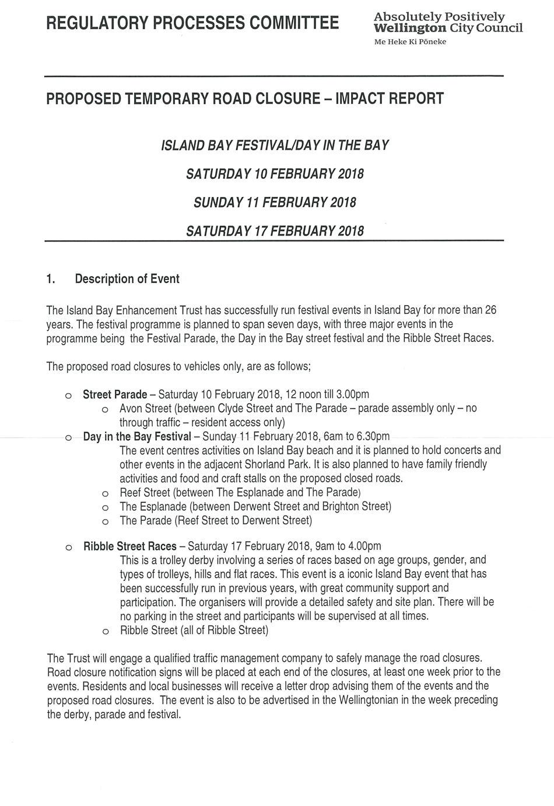

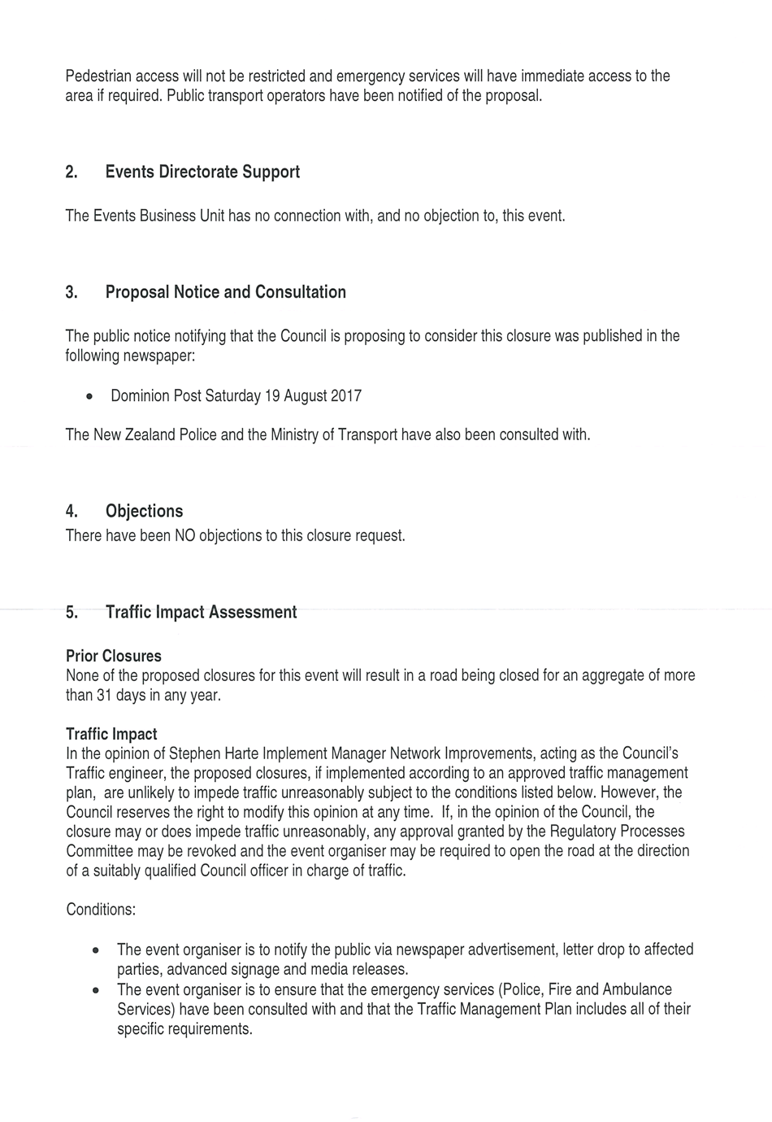

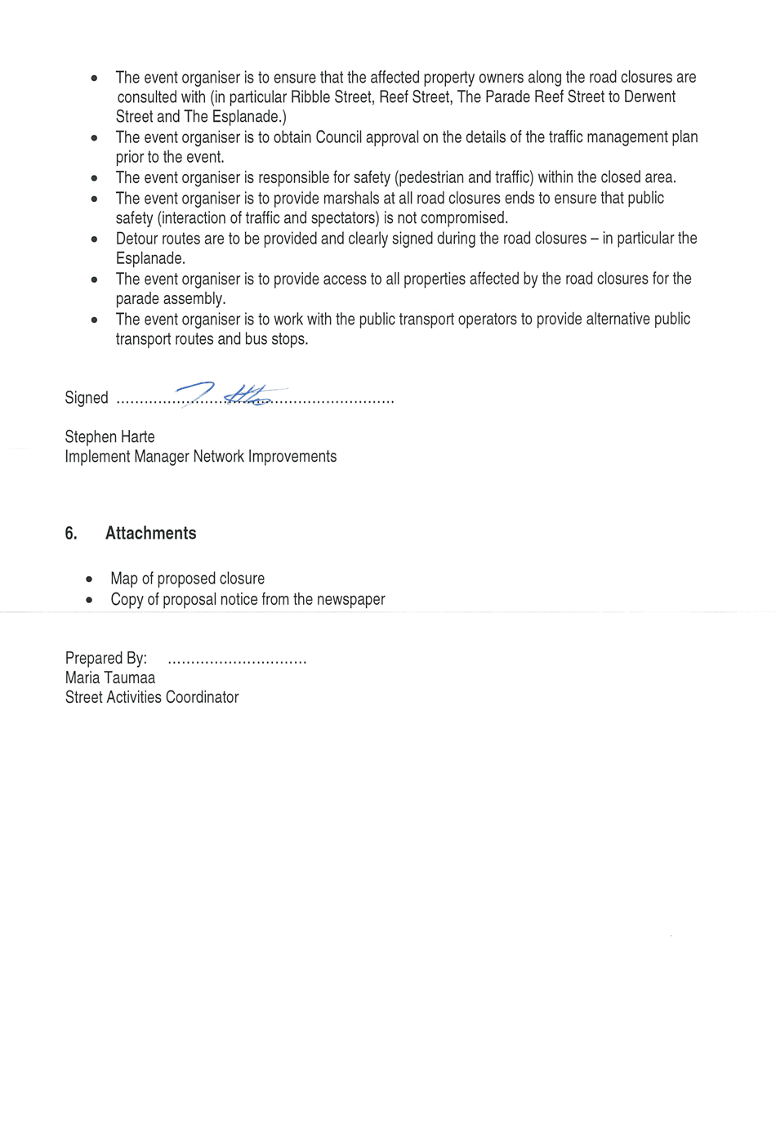

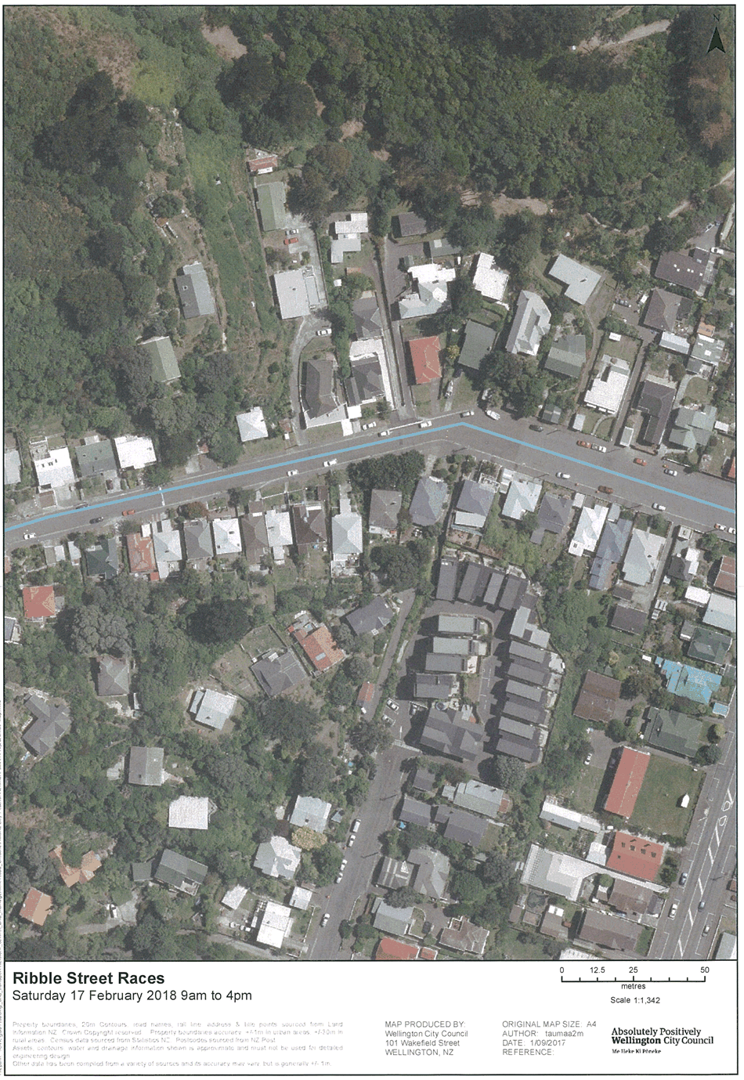

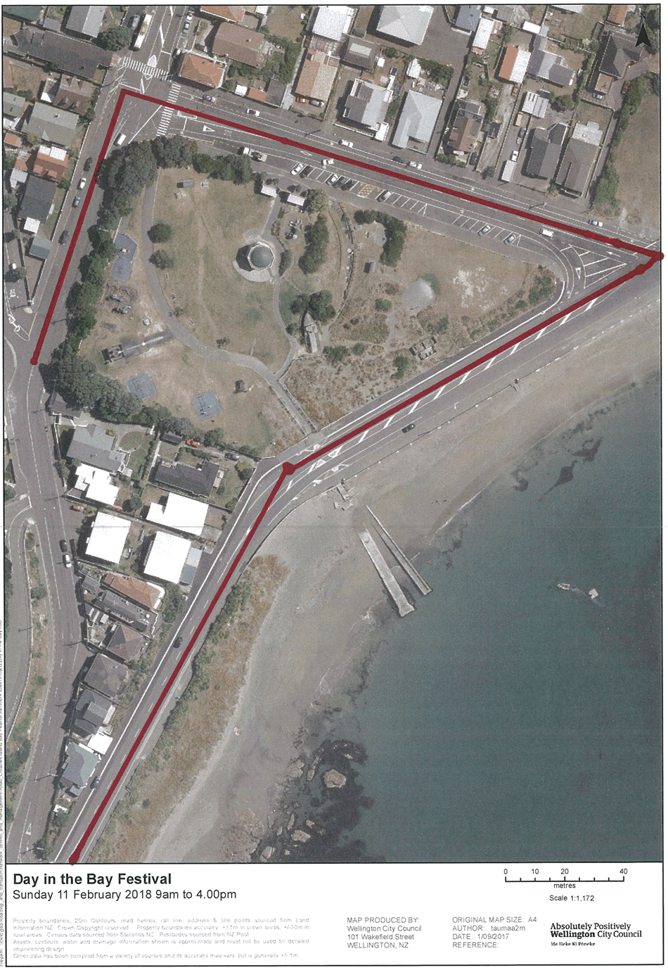

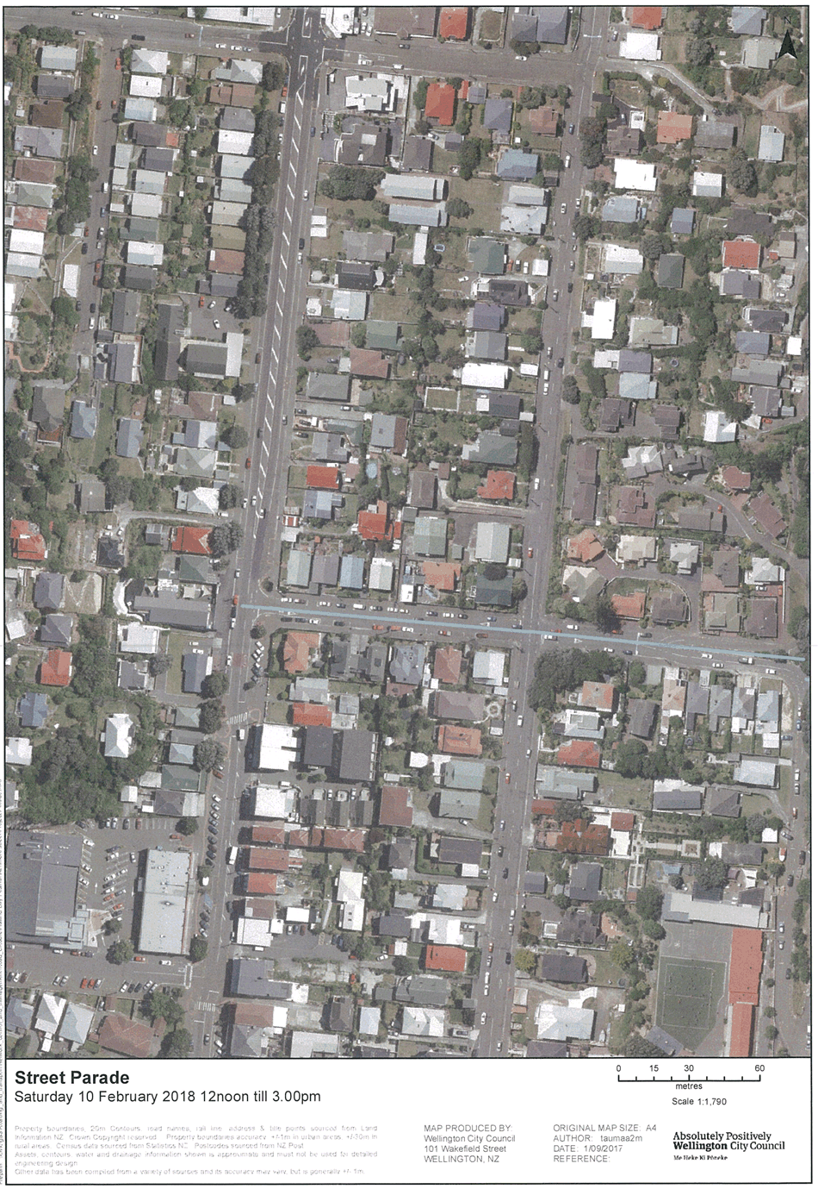

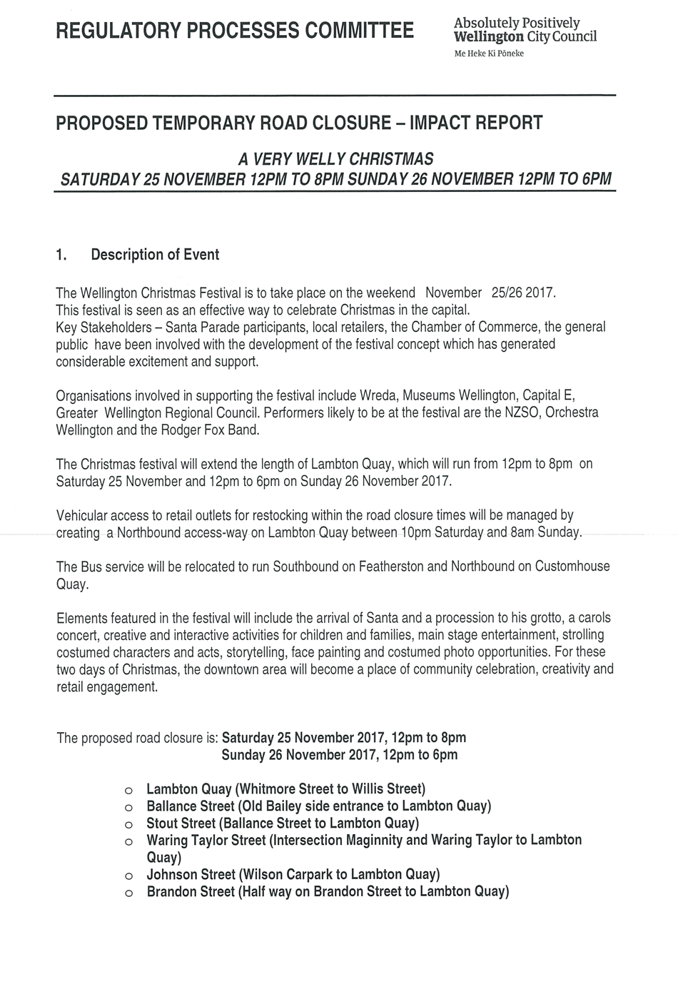

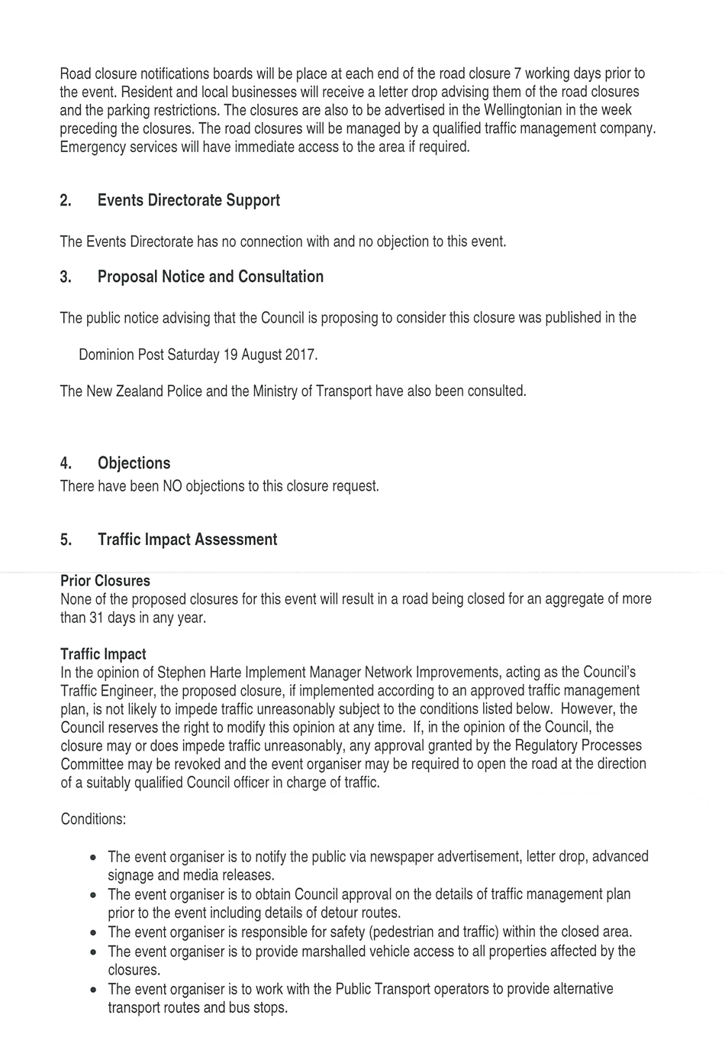

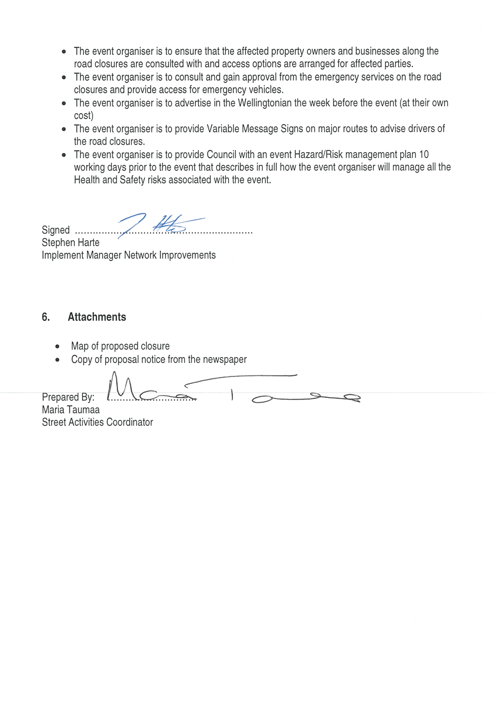

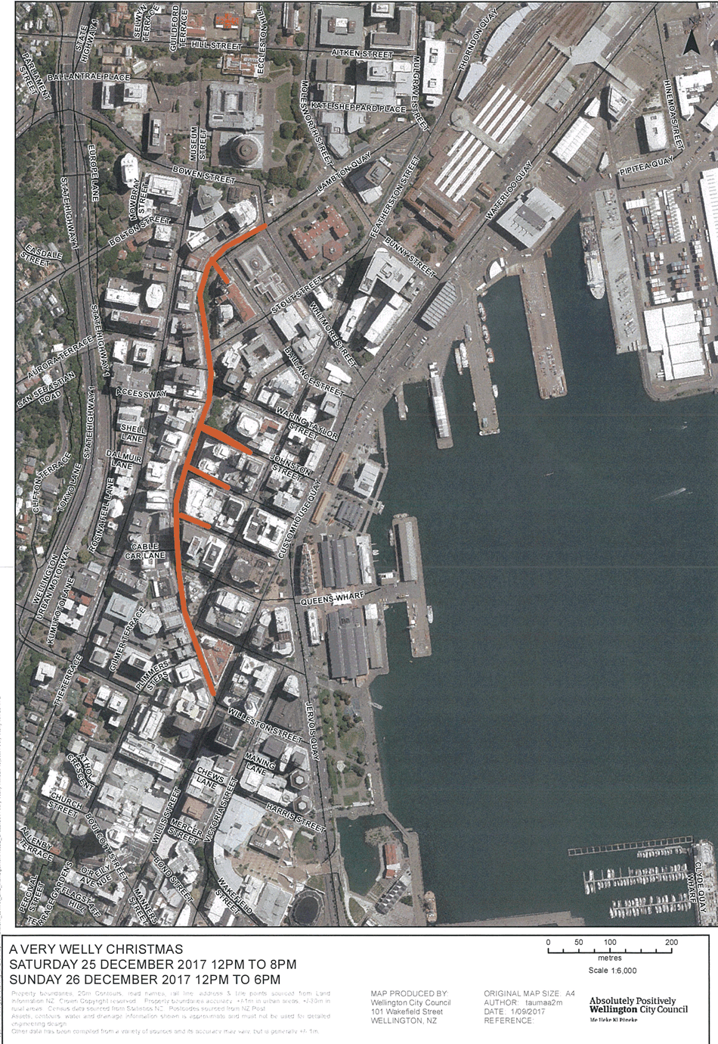

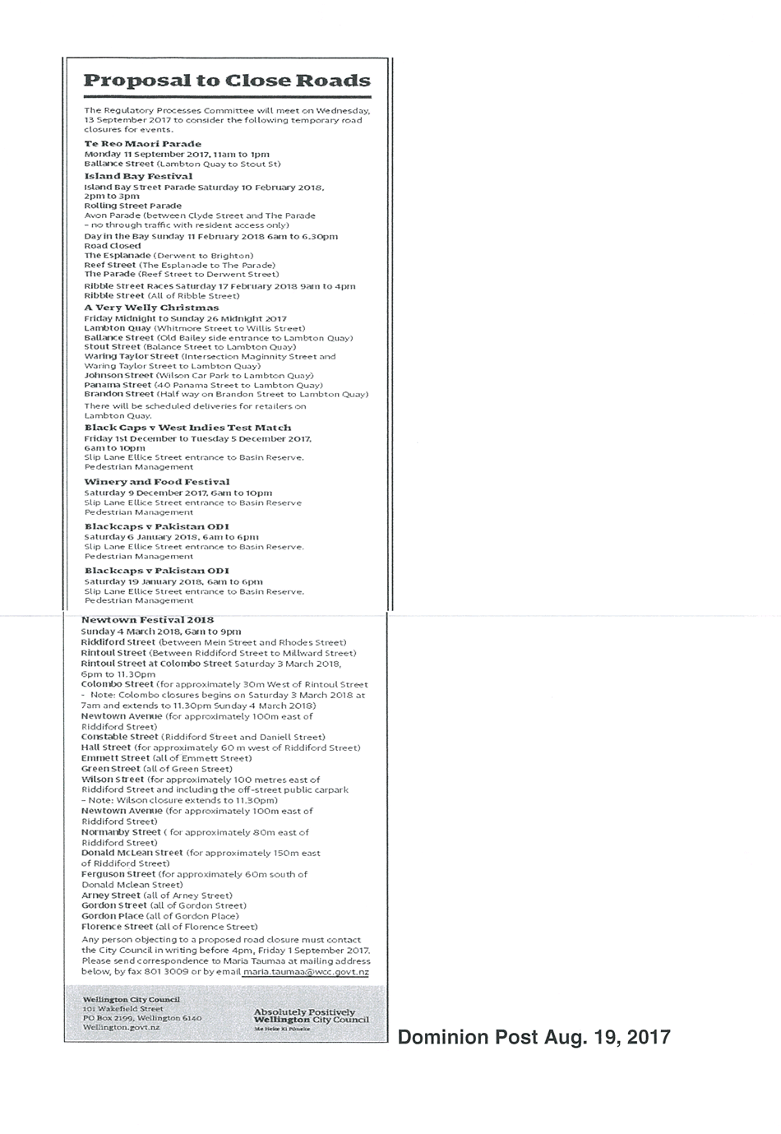

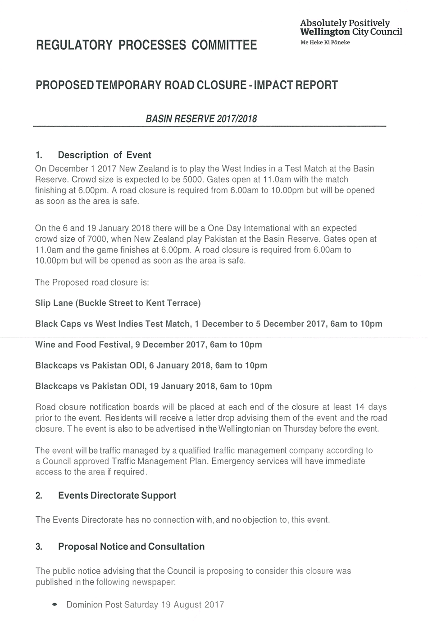

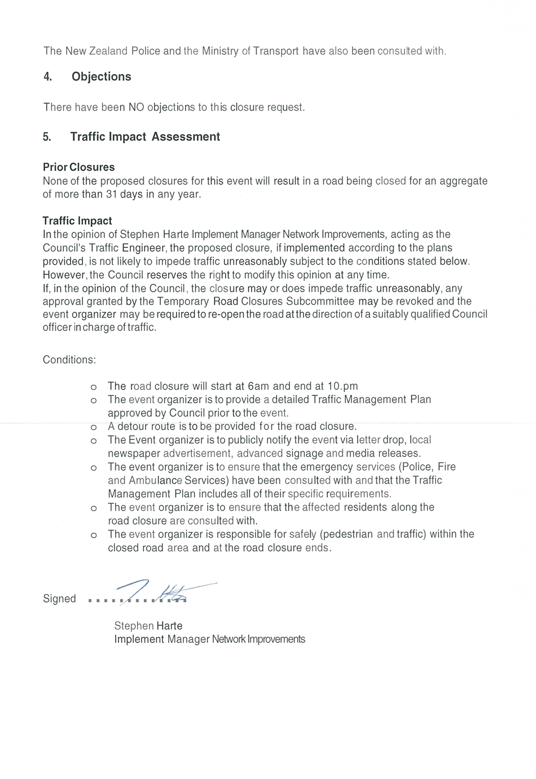

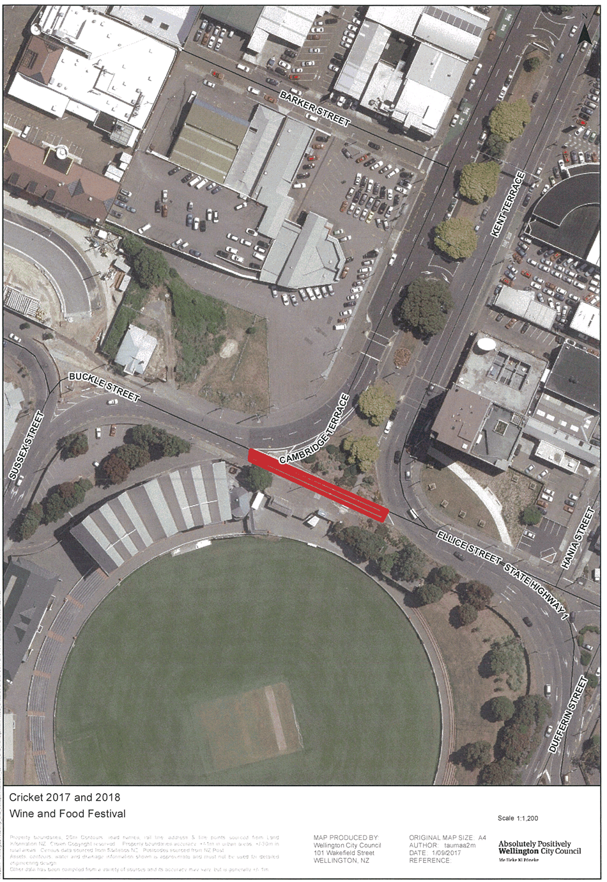

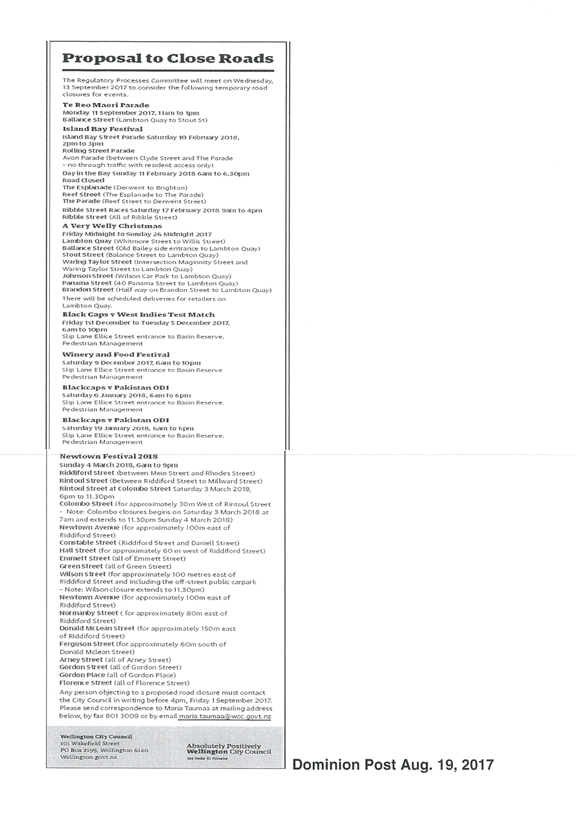

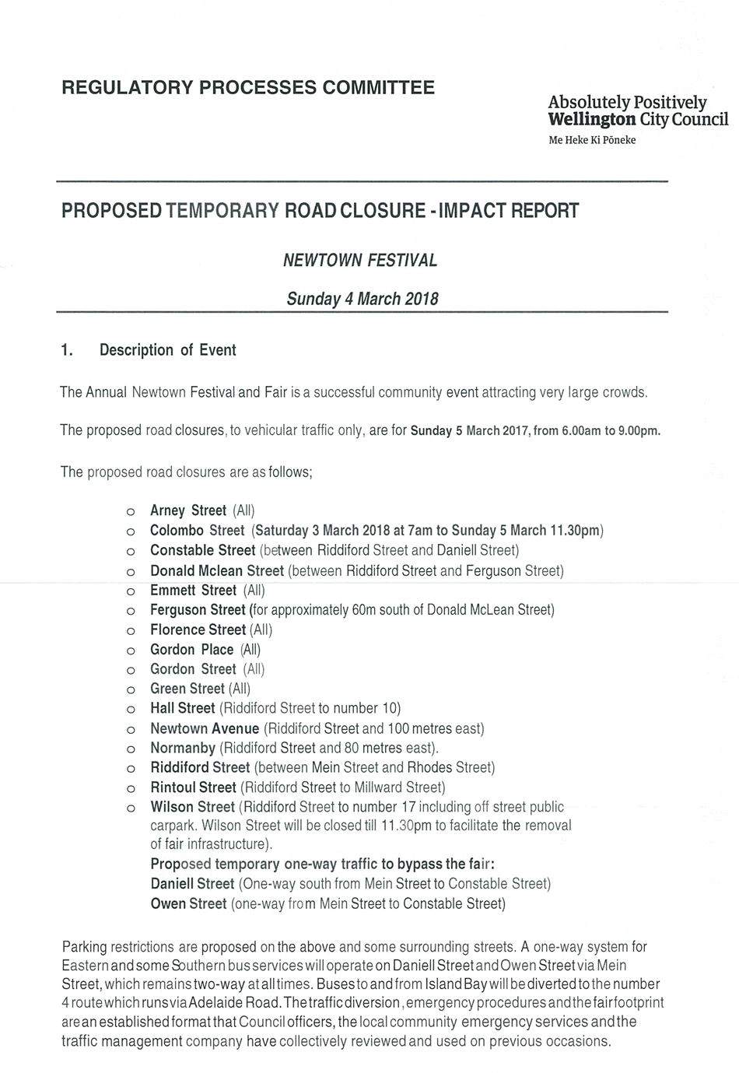

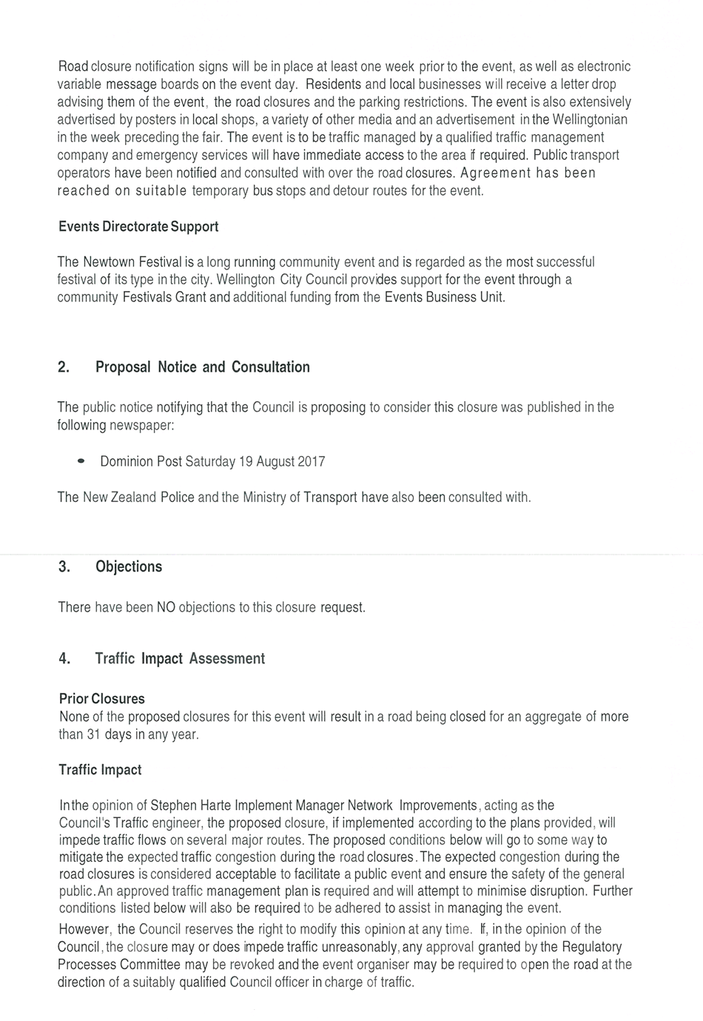

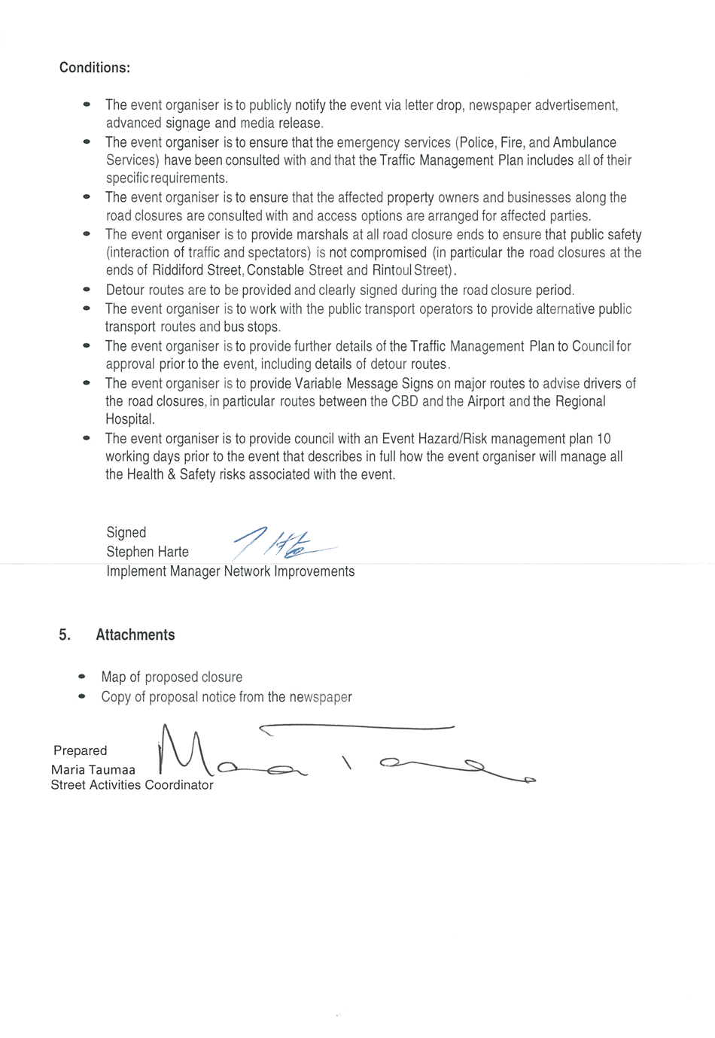

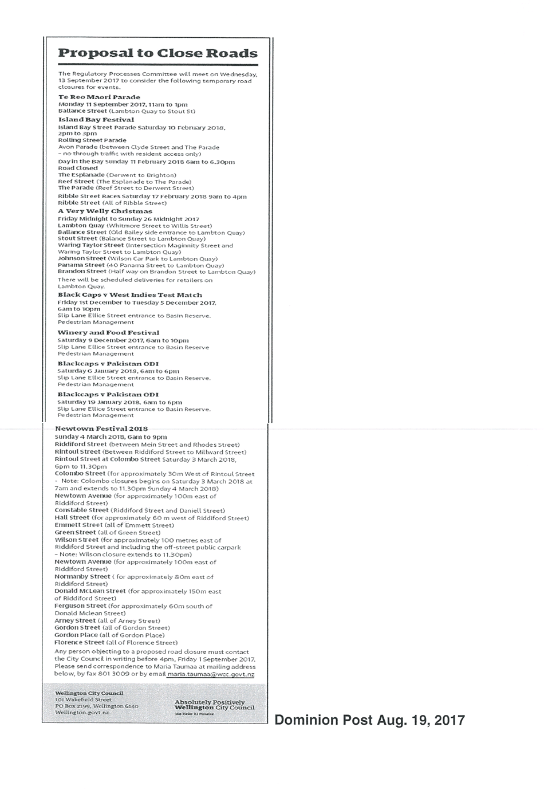

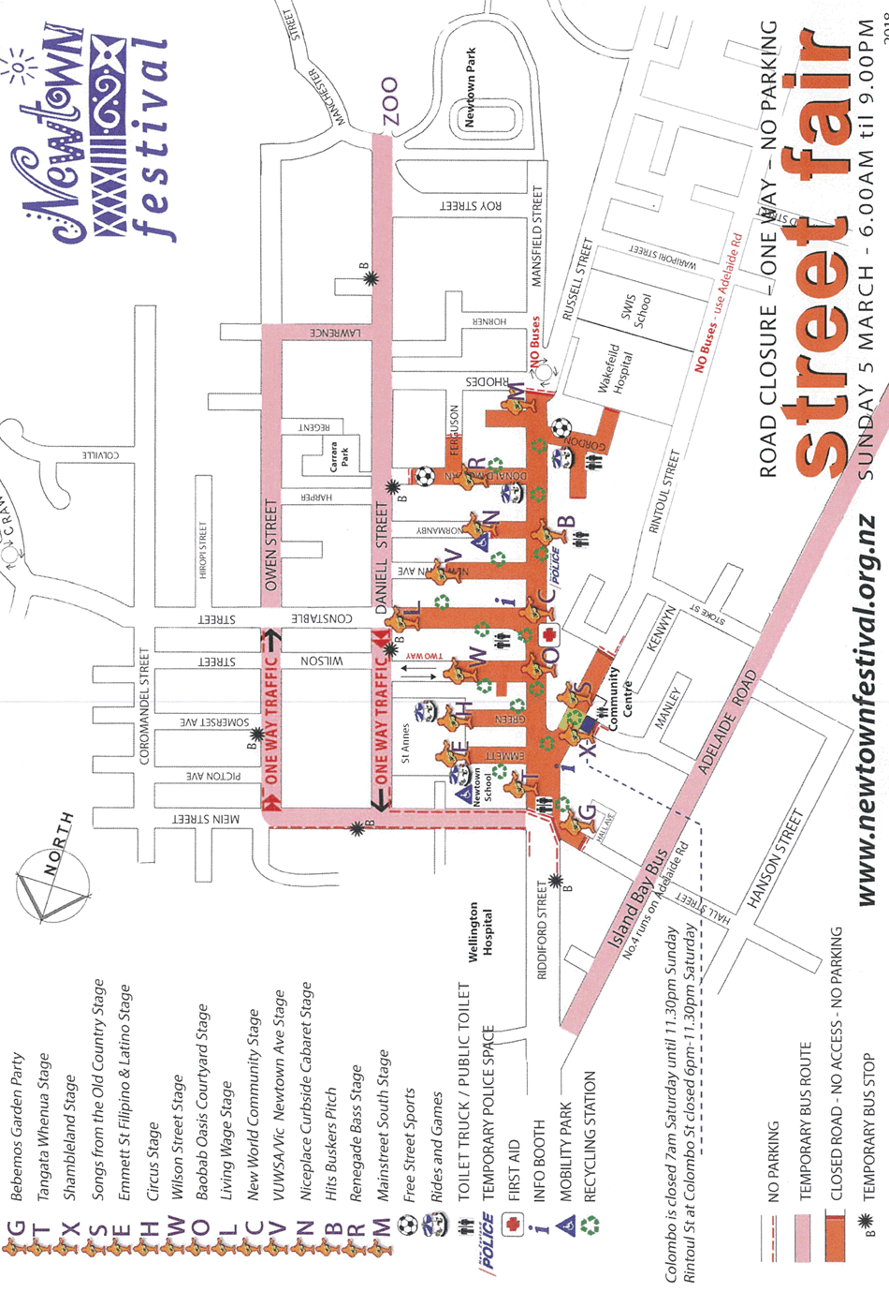

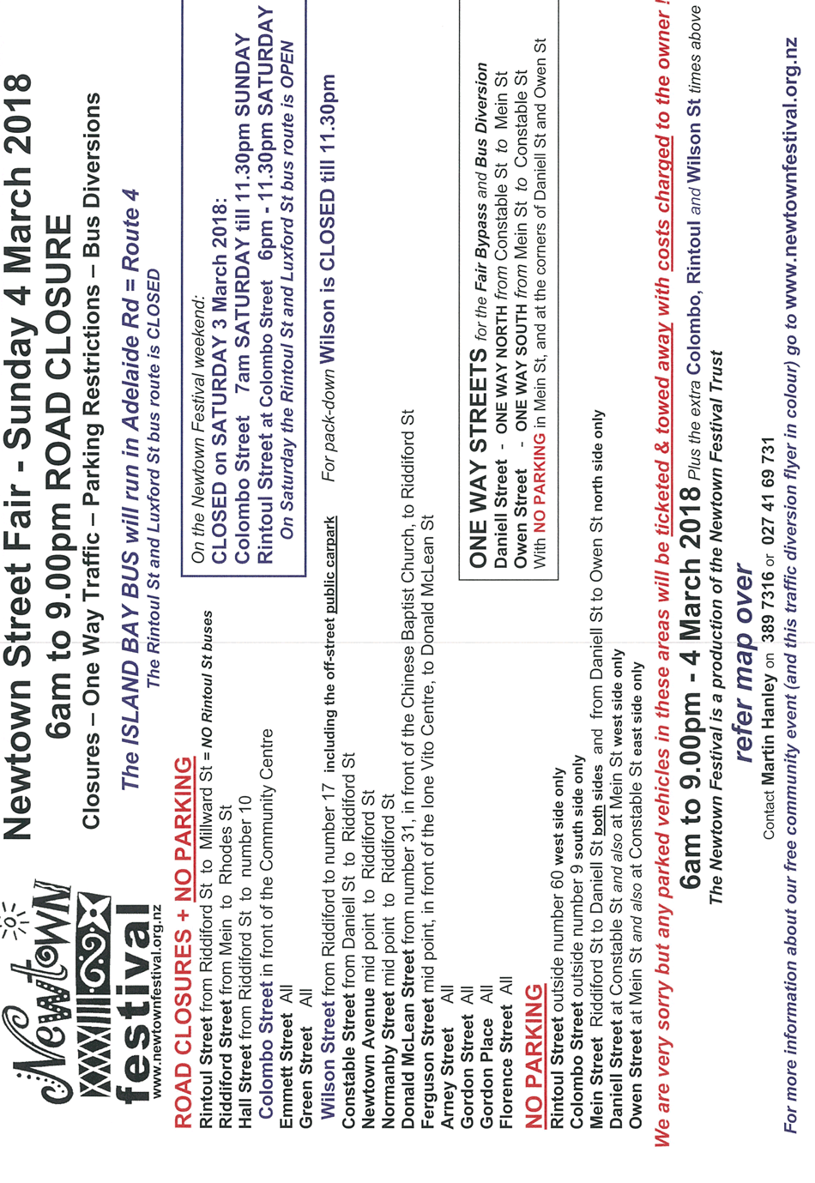

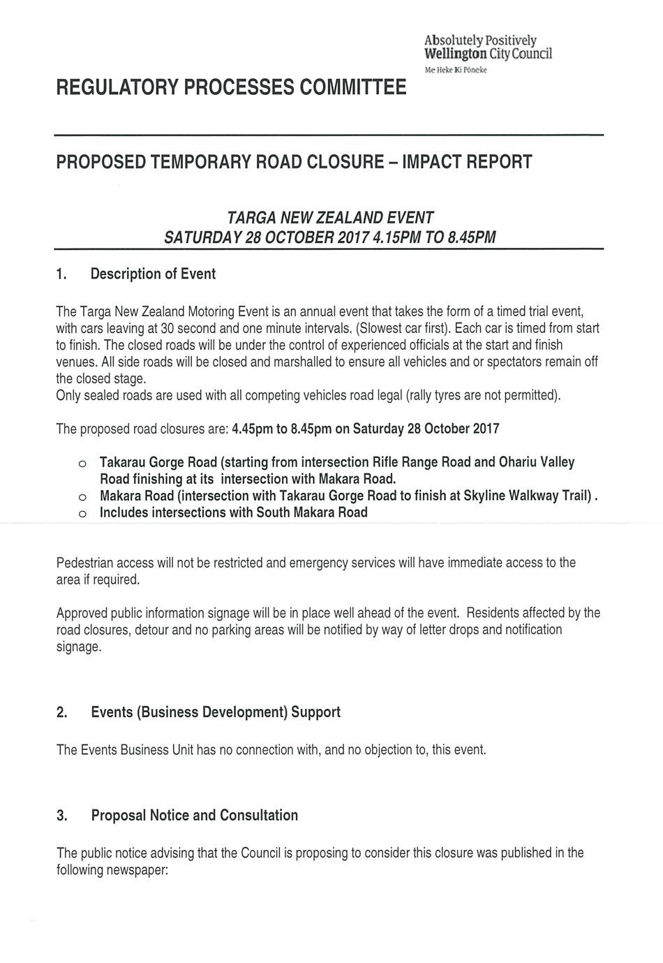

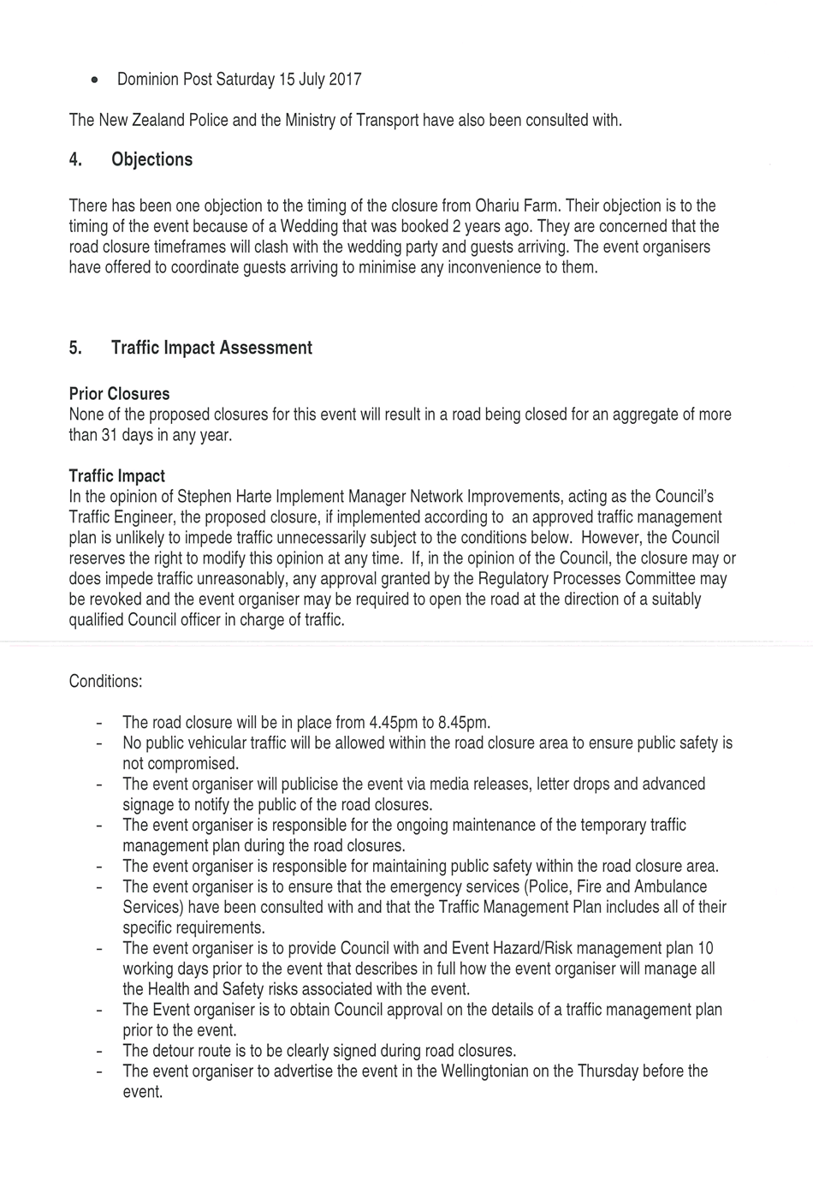

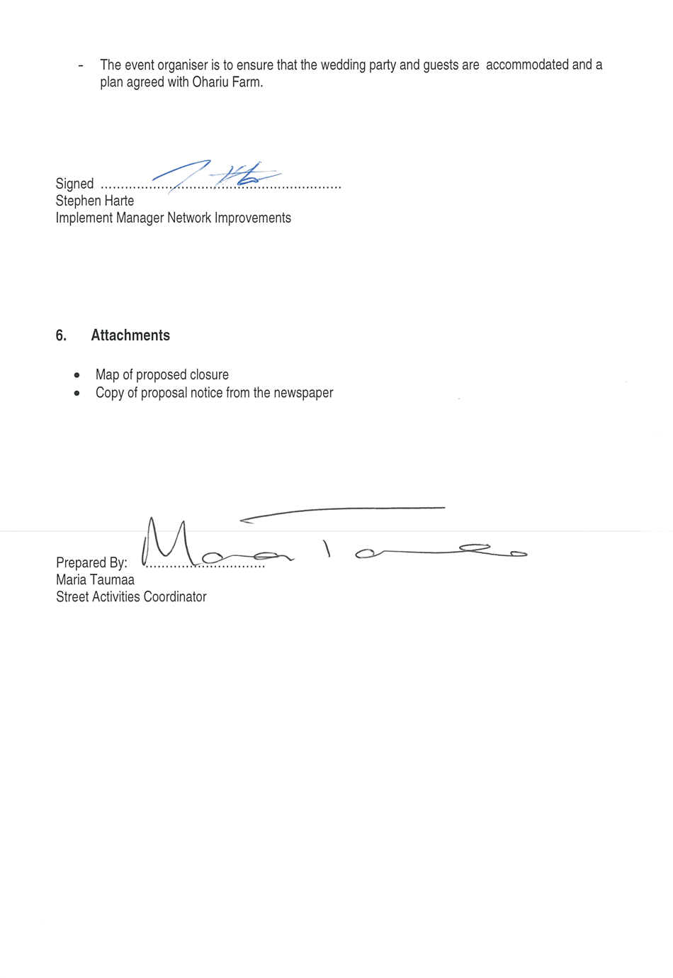

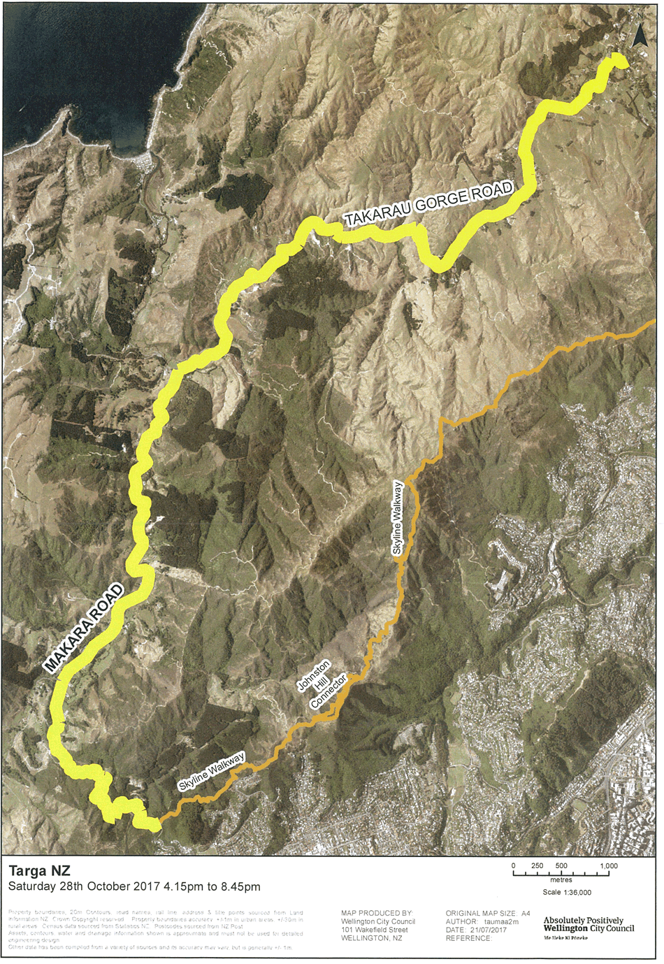

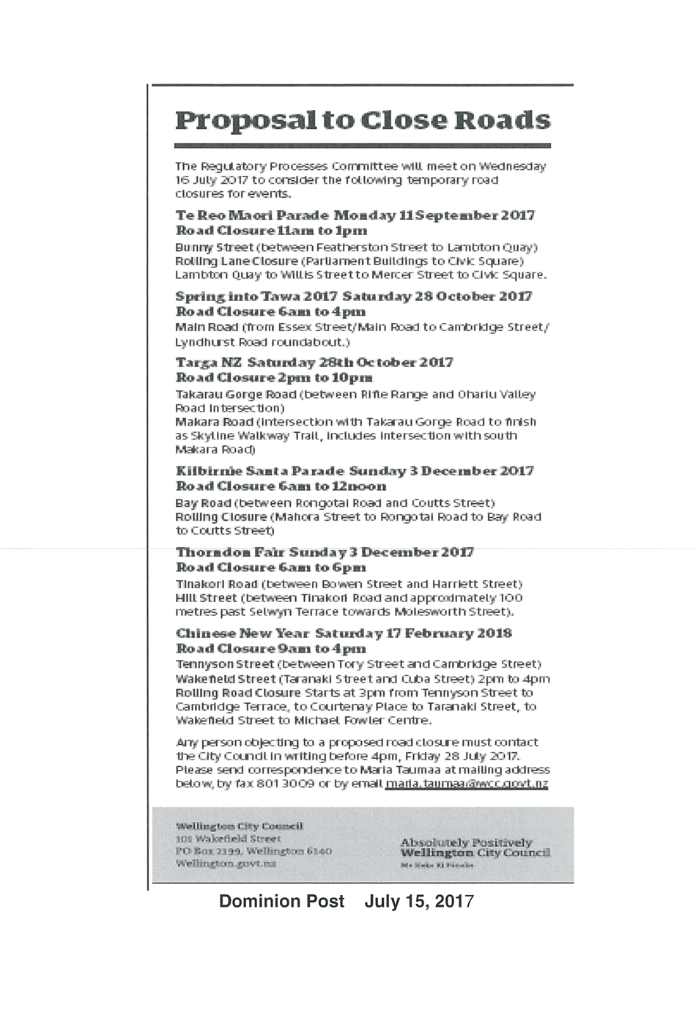

Proposed Road Stopping – Land adjoining 42 Maupuia Road, Miramar

Purpose

1. The purpose of this report is to recommend that the Council disposes of approximately 95m² of unformed legal road adjoining 42 Maupuia Road, Miramar (refer attachments 1 and 2)

Summary

2. The owners of 42 Maupuia Road, Miramar, have applied to purchase part of the unformed legal road adjoining the road frontage of their property.

3. The approximately 95m² of legal road to be purchased (the Land) is shown bordered red on the plan in Attachment 2.

4. Utility providers and relevant Council business units have been consulted. All support the proposal, subject to conditions (where relevant).

5. Initial consultation letters were sent to adjacent neighbours and, at time of writing of the report, no replies had been received.

6. If the Council agrees with the recommendation of the Regulatory Processes Committee the road stopping will then be publicly notified. At that time any neighbours, organisations, or any other member of the public will have the opportunity to make a submission.

Recommendations
That the Regulatory Processes Committee:
1. Receives the information.
2. Recommends to the Council that it:
a. Agrees that approximately 95m² of unformed legal road on Maupuia Road, Miramar, shown as the land bordered red on the plan in Attachment 2 (the Land) and abutting 42 Maupuia Road, Miramar (being Lot 2 DP 315384, CFR 60645), is not required for a public work and is surplus to requirements.
b. Agrees to dispose of the land.
c. Delegates to the Chief Executive Officer the power to conclude all matters in relation to the roads stopping and disposal of the Land, including all legislative matters, issuing of relevant public notices, declaring the road stopped, negotiating the terms of sale or exchange, imposing any reasonable covenants and anything else necessary.
3. Notes that if objections are received to the road stopping, and the applicant wishes to continue with the process, a further report will be presented to the Regulatory Processes Committee for consideration.

Background

7. Maupuia Road was oringinally set out in 1906 (DP2221) while 42 Maupuia Road is the result of a more recent subdivision completed 2003 (DP315384).

8. 42 Maupuia Road comprises vacant land covered predominantly by established trees and scrub. The topography slopes steeply down from the Maupuia Road carriageway towards the east.

9. The Land forms part of this same vegetated and sloping bank (refer Attachment 3).

10. The applicant is seeking to purchase the Land to increase the available development potential of the existing site and improve the ability to access Maupuia Road.

Discussion

11. Road stopping is provided for under sections 319(1)(h) and 342(1)(a) of the Local Government Act 1974 (the LGA).

12. Council, under section 40 of the Public Works Act 1981 (the PWA), ‘shall endeavour’ to dispose of any land not required for the public work for which it was taken and which is not required for any other public work.

13. The Transport Network Team has confirmed the Land is not required for road or access purposes in the foreseeable future. No other relevant business units of the Council seek to retain the Land for other purposes.

14. The section 40 PWA report will, otherwise, determine whether any offer back obligations exist.

Options

15. The alternative to undertaking the road stopping is to retain the Land in Council ownership as unformed legal road. In the long term this will incur maintenance and retaining costs on land that Council no longer requires or intends to use.

16. An encroachment licence could be issued for the Land if it is not stopped. Such a licence provides less certainty of tenure for the adjacent landowner and limits the scope for better utilisation of the land by these owners.

Next Actions

17. Conclude a section 40 PWA acquisition history investigation.

18. Prepare a survey legalisation plan and agreement for the Land.

19. Initiate the public notification process.

Attachments
Attachment 1. | 42 Maupuia Road - Location Plan | Page 3
Attachment 2. | 42 Maupuia Road - Aerial Plan | Page 3
Attachment 3. | Photo looking south over road stopping area, from footpath outside 46 Maupuia Rd | Page 3

Author | Brett Smith, Property Advisor
Authoriser | Tracy Morrah, Property Services Manager  David Chick, Chief City Planner

SUPPORTING INFORMATION

Engagement and Consultation
Community
In July 2017 letters were sent to adjacent neighbours of the Land. At time of writing no replies had been received.

Utility Provider and Council Business Units
The applicant is obliged to obtain comment from utility providers prior to submission of the application. None objected to the road stopping and/or have provided conditional support subject to the creation of relevant easements.

Several business units of the Council were consulted: specifically Transport Networks (including Vehicle Access), Planning, District Plan Policy and Parks, Sport & Recreation. None objected to the road stopping or provided conditional support.

Conditions such as carriageway setbacks, the inclusion of an isolation strip, amalgamation of parcels, CFR encumbrances and compensation payments have been adopted where applicable and agreed by the applicant.

Treaty of Waitangi considerations
Iwi groups have not been consulted. The proposal does not conflict with the principles of the Treaty of Waitangi nor is the land located within a Māori Precinct or an area identified as significant to Māori.

As sale to, and amalgamation with, the adjacent parcel is a condition of the stopping the Land is unlikely to be made available for purchase by iwi or the public in general.

Financial implications
Costs associated with the disposal of the Land will be recovered from the applicant, and the proceeds of the sale are directed towards the general fund.

As of August 2011 a new cost sharing initiative for road stoppings was approved by the Council. The rebate amount is a percentage of the sale price, so is determined at the end of the process when these costs are known.

Policy and legislative implications
The recommendations of this report are consistent with the policies of the Council. The road stopping is also undertaken in accordance with relevant legislation.

This is not a significant decision. This report sets out the Council’s options under the relevant legislation and under the Council’s Road Encroachment and Sale Policy 2011.

Risks / legal
The road stopping process will be undertaken in accordance with legislative and Council, requirements. Any legal agreement, or action in the Environment Court, will be overseen by the Council’s lawyers.

Climate Change impact and considerations
There are no climate change implications arising from this road stopping.

Communications Plan
Public consultation in accordance with the Tenth Schedule of the LGA will be carried out later in the road stopping process.

Health and Safety Impact considered
The road stopping is a minimal risk to health and safety. The work is almost entirely administrative and a normal operational function of Council Officers.

