TO | Land Development
COPIEd to
From | Ivan Kholodov
Date | 1/02/2023
SUBJECT | Response to Land Development Enquiry for 7 Beauchamp Street, Karori
FOR YOUR INFORMATION
Asset impact assessment
SITE DETAILS
Address | 7 Beauchamp Street, Karori
Source | Email dated 31/01/2023
Type | Development enquiry
Reference
Asset | Stormwater
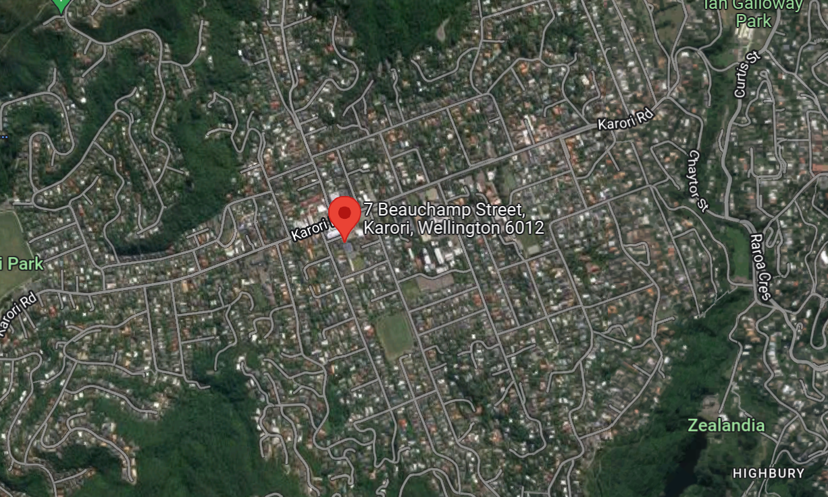
FLOODING RESULTS
Vertical Datum | 1953 Wellington Circuit
Software | InfoWorks ICM
Model | Karori
Model Status | Validated
Flood Scenario | 100 year ARI + Climate Change (assuming 2.1 C temperature increase)
Sea Water Level | 2.1 m aMSL

FLOOD IMPACT ON THE PROPERTY
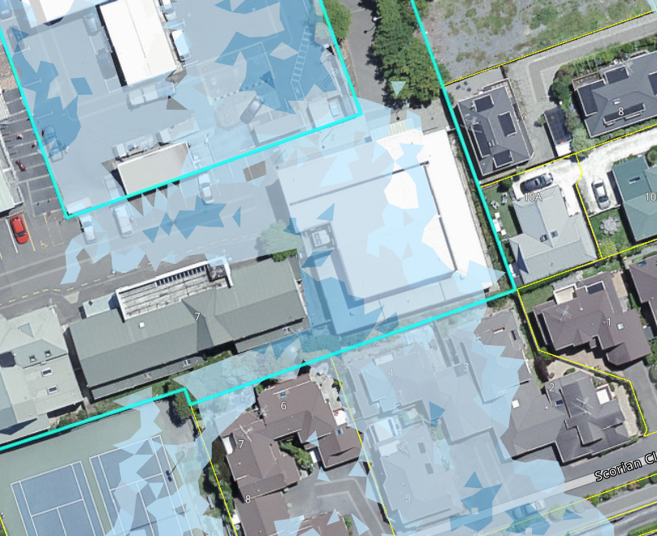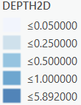
Maximum Flood Depth | 400 mm
Maximum Water Level | 161.8 m aMSL (Proposed Extention)
Minimum Water Level | N/A
Overland Flow | 0.150 m/s

RECOMMENDATIONS
Minimum Floor Level (including 200 mm Free board) | 162 m aMSL  (Minimum floor level provided is quoted to the underside of the concrete slab or floor timber joist.)
Overland Flow | Relatively slow flow with higher velocity between buildings.

