Wellington COMMUNITY FACILITIES
Needs Analysis report
Accessible Version
June 2024
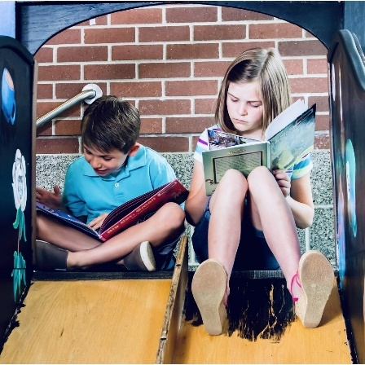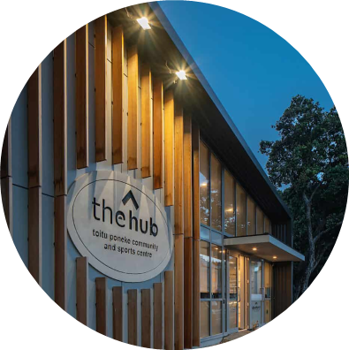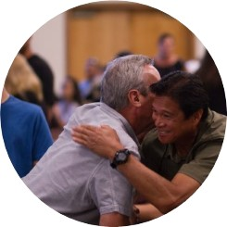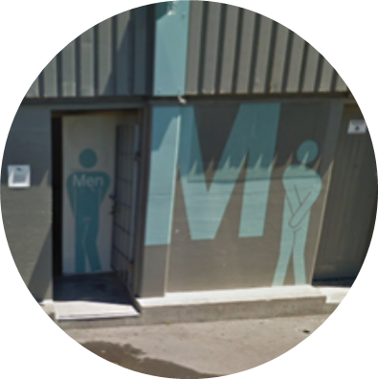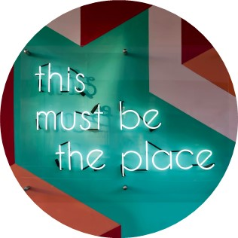

DOCUMENT SUMMARY

Document Reference
Wellington Community Facilities: Needs Analysis Report: Accessible Version
Authors
Visitor Solutions: Anita Coy-Macken, Gordon Cessford, Craig Jones
Market Economics: Lawrence McIlrath, Anamaria Rodriguez, Katie Moore
Architecture HDT: Mark Bates, Roger Simmons
Powell Fenwick: Nick Yannakis, Xander Wijninckx
Sign off
Kristine Ford, Wellington City Council
Version
Final
Date
18 June 2024
Acknowledgements:
This report has been written with collaboration and input from Visitor Solutions, Market Economics, Architecture HDT and Powell Fenwick.

In addition, many people and organisations across Wellington’s community facilities have contributed to the compilation of data and information outlined in this report.

The authors wish to specifically acknowledge Wellington City Council’s Project Manager Kristine Ford, the Council’s Technical Advisory Group and Council officers and partners involved in delivery of Wellington’s community facilities for their contribution toward this Needs Analysis.

Disclaimer:
Information, data and general assumptions used in the compilation of this report have been obtained from sources believed to be reliable. Visitor Solutions Ltd has used this information in good faith and makes no warranties or representations, express or implied, concerning the accuracy or completeness of this information. Interested parties should perform their own investigations, analysis and projections on all issues prior to acting in any way regarding this project.
© Visitor Solutions 2024.

EXECUTIVE SUMMARY
OVERVIEW
Wellington City Council developed Te Awe Māpara, Community Facilities Plan 2023 to guide the Council’s efforts to deliver “Thriving and accessible community facilities – where people connect, have fun and belong”. The purpose of the Plan is to guide the Council’s provision and decision-making about community facilities over the next 30 years.
The Plan is focused on 277 community facilities including 25 community centres, 12 libraries, 5 recreation centres, 7 swimming pools, 13 community spaces in housing assets, 1 marae on a ground lease, 131 leased facilities and 83 public toilets.
A city-wide needs analysis was undertaken to understand the current performance of community facilities in meeting community needs considering such things as levels of provision, catchment areas, facility condition, fit-for-purpose, impact of population growth, utilisation and community views from survey feedback from over 5,700 respondents.
Key issues, challenges and opportunities (across all facility types) identified in the needs analysis are summarised as follows.
Key findingS across wellington’s community facility network
SUBSTANTIAL PROVISION BUT NOT NECESSARILY FIT-FOR-PURPOSE
Wellington has 194 community facilities (excluding public toilets), equating to approximately one community facility for every 1,000 people.
Many facilities are small, single-purpose, ageing and not fit-for-purpose.
Many facilities are not accessible, fully inclusive or reflect te ao Māori.
Size and design of some buildings limits flexibility to meet a range of needs.
The average age of buildings is 57 years and some facilities are reaching the end of their useful life.
TOPOGRAPHY INFLUENCED UNEVEN DISTRIBUTION
Wellington’s topography has led to uneven distribution of facilities.
Many facilities reflect the age and needs at the time they were built, resulting in a good number of smaller buildings with design not necessarily reflective of modern needs.
Catchment analysis shows some facilities have overlapping catchments.
Geographic gaps identified for recreation centres (North/West) and public toilets (central city and certain parks).
GROWTH IMPLICATIONS
Wellington is forecast to grow between 50,000 to 80,000 people over the next 30 years.
Greatest population growth is projected in the Central and Northern areas.
Size, capacity and functionality of certain facilities limit the ability to accommodate demand arising from growth.
Wellington’s population is forecast to age, which is likely to modify demand for certain facilities and functions.
STRONG COMMUNITY ENGAGEMENT
Wellingtonians highly value community facilities.
There is generally good engagement in community facilities.
High importance placed on the many benefits of community facilities.
Generally good satisfaction with community facilities.
DESIRE FOR BETTER FACILITIES
Improving the quality and appearance of facilities was identified as the most important strategy for the future.
Expanding the benefits of existing facilities through longer opening hours, promoting more, and improving accessibility for wider range of needs.
Limited calls for new/more facilities except for more public toilets in specific areas and more indoor courts/indoor active spaces.
RELATIONSHIP BETWEEN PROVISION AND TRAVEL
There is a relationship between the number of facilities, the way people travel and user expectation regarding willingness to travel.
INCONSISTENT DATA INSIGHT
There is inconsistent data on the use and performance of facilities.
The Covid-19 pandemic had a significant impact on the use of community facilities and participation levels are still recovering.
There is generally good use across libraries, swimming pools and recreation centres for the level of provision and population levels but some of these facilities have low use.
Indication that several community centres and lease facilities are not well used, but more data is required to confirm this finding.
COLLABORATION ACROSS COMMUNITY FACILITIES
Feedback identified there is limited collaboration between community facilities, even when facilities are co-located on the same site.
There is a strong willingness identified by facility managers/operators to collaborate but people resource is cited as the main barrier.
There is community support for hub approach and evidence of clear success of recent hubs.
RESILIENCE ISSUES
Seven facilities were identified with seismic resilience issues.
Ten facilities are vulnerable to natural hazards.
Five indoor pools account for ~45% of Council’s building CO2 emissions.
INCREASING COSTS
In 2021/22, the 49 libraries, community & recreation centres and pools cost approximately $64 million to operate.
The cost has increased by 37% over the last seven years.

Overall, the key conclusion from the needs analysis is Wellington does not need more, but better community facility provision. There is a need to focus on evolving community facilities in response to community needs and aspirations, maximising the outcomes from existing facilities and delivering better value for money.
This needs analysis identifies a range of issues, challenges and opportunities across Wellington’s community facilities, but it does not provide specific answers for individual facilities. This is because any change to facility provision must be thoroughly investigated in partnership with the community to determine the best response.
Te Awe Māpara, the Community Facilities Plan, sets out the Council’s integrated approach to inform this future planning and decision-making, along with the prioritised actions to be investigated over the short, medium and long term.

Key Findings for each Facility tYPE

COMMUNITY CENTRES
25 community centres with a mixed model of ownership and delivery.
More than half are in repurposed buildings and 75% require improvement.
Significant catchment overlaps and there are no gaps in provision.
Limited understanding and awareness of community centre offerings.
Community desire to improve appearance and expand offerings.
Greater collaboration needed to minimise duplication/maximise benefits.

LIBRARIES
High number of libraries (12) equating to 1 library per 17,000 people.
Small footprint of libraries, average of 628m² compared to typical 900m².
Small size limits the ability to provide wide range of activities and does not reflect changing use of modern libraries.
Community desire to extend opening hours and improve appearance.

SWIMMING POOLS
Seven swimming pools provide 5,135m² of water-space.
Overall water-space is under pressure and clear undersupply of leisure and hydrotherapy provision, and potential geographic gaps in learn to swim.
Three pools have significant resilience, fit-for-purpose and capacity issues.
Community desire to address busyness of pools and improve condition.

RECREATION CENTRES
Five recreation centres provide total of 17 indoor courts.
There is insufficient capacity with a geographic gap in North-West area.
Limited understanding and awareness of recreation centre offerings.
Two facilities are too small, constained offerings and not fit-for-purpose.
Community desire to increase capacity and improve condition.

COMMUNITY SPACES IN HOUSING ASSETS
13 community spaces in Council’s Housing Assets.
Primary purpose to support tenant wellbeing and activities. Secondary opportunity to enable wider community use and build connections.
Limited community awareness of wider use opportunities.
Some spaces have functionality and quality issues.
Greater collaboration required to build connections with other facilities.

MARAE (GROUND LEASE)
Ngā Hau e Whā o Paparārangi is the only marae in scope as a ground lease.
There are also five other marae in Pōneke and two cultural facilities.
There is limited insight on current provision and need for more data.
Survey feedback indicates desire for greater connections to marae, improving quality of marae buildings and increasing provision.

LEASE FACILITIES
131 lease facilities with 41 owned by Council and 90 ground leases.
Range includes 64 sports, 28 childcare, 14 scout/guide, 10 recreation, 9 marine-based and 6 art/creative.
Limited information and oversight on the use and impact of lease facilities.
Overall use appears lower than desired, impacted by volunteer capacity, promotion, resourcing and quality/fit-for-purpose of facilities.

CREATIVE FACILITIES
Broad spectrum of art/creative activity undertaken in community facilities, particularly community centres and lease facilities dedicated to art.
Strategic need for improved access to affordable, accessible and fit-for-purpose venues, places and spaces.
Key issues include preference for longer term occupancy, central locations and the ability to store equipment.

PUBLIC TOILETS
83 public toilets, equates to 1 per 2,500 people. On par with other cities.
Current provision focused on central city, town centres and high visit areas.
Equal levels of satisfaction to dissatisfaction.
Cleanliness, smell and maintenance is the greatest area of dissatisfaction.
Community desire to increase provision, improve cleanliness and signage.

CONTENTS
1.0 INTRODUCTION 7
1.1 Purpose 7
1.2 Rationale 8
1.3 Scope 9
1.4 Methodology 10
1.5 Report Format & Companion Reports 12
1.6 Timing 13
1.7 Wellington’s Suburbs 14
2.0 STRATEGIC CONTEXT 15
2.1 Overview 15
2.2 Council Context 16
2.3 Policies Related to the Plan 20
3.0 GROWTH & POPULATION CONTEXT 22
3.1 Wellington Regional Growth Framework 23
3.2 Let’s Get Wellington Moving 24
3.3 National Planning Direction 25
3.4 Our City Tomorrow Spatial Plan 26
3.5 Population Growth 28
3.6 Growth by Age-Group 32
3.7 Deprivation Considerations 34
4.0 NATURAL HAZARDS CONTEXT 36
4.1 Southern & Eastern Wards 37
4.2 Central and Western Wards 38
4.3 Northern Ward 39
4.4 Hazards and Community Facilities 40
5.0 COMMUNITY FACILITY ECOSYSTEM 41
5.1 Council’s Facility Provision By Type 43
5.2 Council’s Facility Provision by Ward 44
5.3 Fit-for-Purpose Overview 51
5.4 Utilisation Overview 53
5.5 Operational Perspectives 54
5.6 Non-Council Provision 56
5.7 Regional Facilities 58
6.0 COMMUNITY VIEWS & USER PROFILE 59
6.1 Overview 59
6.2 Profile of Survey Respondents 60
6.3 Users of Community Facilities 61
6.4 User Behaviours 64
6.5 User Challenges 66
6.6 Non-Users 67
6.7 Community Facility Satisfaction 68
6.8 Benefits of Community Facilities 69
6.9 Ranking of Future Ideas 70
6.10 Willingness to Travel 71
6.11 Community Facility Hubbing 71
7.0 FINANCIAL PICTURE 72
7.1 Value of Community Facilities 72
7.2 Current Operating Costs 72
7.3 Projected Operating Costs 74
8.0 SUPPLY & DEMAND MODELLING 75
8.1 Overview 75
8.2 Distance Decay 76
8.3 Facility Catchments 77
8.4 Impact of Population Growth 80
8.5 Catchment Size & Building Size 82
9.0 KEY FACILITY FINDINGS 85
9.1 Community Centres 86
9.2 Libraries 87
9.3 Swimming Pools 88
9.4 Recreation Centres 89
9.5 Community Spaces in Council Housing Assets 90
9.6 Lease Facilities 91
9.7 Marae and Kaupapa Māori Spaces 92
9.8 Art and Creative Facilities 93
9.9 Public Toilets 94
10.0 CONCLUSIONS 95
11.0 APPENDIX 1: FACILITY METRICS 97
12.0 APPENDIX 2: FIT-FOR-PURPOSE CRITERIA 108

- INTRODUCTION
  - Purpose
Wellington City Council developed Te Awe Māpara, Community Facilities Plan 2023, to guide the Council’s efforts to deliver “Thriving and accessible community facilities – where people connect, have fun and belong”. The rationale for undertaking the work is to ensure the city has the right facilities in the right place at the right time, which are efficient and sustainable.
The purpose of Te Awe Māpara is to guide the Council’s provision and decision-making about community facilities for the next 30 years. Wellington City Council (Council/WCC) commissioned Visitor Solutions to develop Te Awe Māpara (the Plan) in collaboration with Council officers. Visitor Solutions worked with a team of consultants to undertake analysis including:
Market Economics (ME) who undertook the population, catchment, and demand modelling.
Architecture HDT who reviewed the condition of some community facilities.
Powell Fenwick who undertook the energy audits for the swimming pool facilities.
The creation and implementation of the Plan has three key phases as summarised in figure 1.1. This report (and companion reports) summarise the findings from the needs analysis phase. This report outlines the evidence, analysis, and conclusions about the current and future needs for community facilities, which informed the second phase.
The second phase was the development of Te Awe Māpara (the Community Facilities Plan), which outlines the policy framework, future approach, prioritised actions for future investigation and indicative investment required. The Plan summarises the key issues identified in the needs analysis and outlines the prioritised actions to investigate these issues over a 30-year timeframe.
The third phase is implementation, over the long-term, where the actions are progressively completed through the recommended investigation process to determine the specific scope, location, timing, and costs of future community facility developments.
Figure 1.1 Summary of Community Facilities Plan Development and Implementation Process

PHASE 1: NEEDS ANALYSIS
Facility network.
Catchment analysis.
Impact of population and infrastructure change.
Condition and fit-for-purpose assessment.
Utilisation and user profiles.
Community engagement and perceptions.
Financial picture.
PHASE 2: TE AWE MĀPARA, COMMUNITY FACILITIES PLAN
Why: mission, outcomes and challenges to address.
How: future approach and direction for facility types.
Where / when / what: prioritised action plan and monitoring framework.
PHASE 3: IMPLEMENTATION OVER THE LONG-TERM
Investigations to determine the specific scope, location, timing and cost of facility investment.

  - Rationale
Community facilities are a core part of the city’s social infrastructure – providing places where people can participate, play, create, perform, be inspired, build wellbeing and develop a sense of belonging and purpose. Community facilities are spaces that connect people to each other, the place and their communities.
Wellington City Council last considered community facility provision in the 2010 Community Facilities Policy. The Council identified the need to review this policy to take account of the recent context, issues, challenges, and opportunities. Several strategic directives identify the need for a new plan:
A priority objective in the 2021 Long-term Plan (LTP): The city has resilient and fit-for-purpose community, creative and cultural spaces.
Action 1.3.7 of the Spatial Plan: Develop a new Community Facilities Plan that provides for future investment in existing and new community facilities and partnership projects to respond to projected growth and changing community needs. The plan will inform future long-term plans and the Council’s finance strategy and will ensure a robust, integrated, and strategic decision-making approach across the Council’s portfolio of community infrastructure assets.
Action D1 of Te Whai Oranga Pōneke (Open Space and Recreation Strategy): Implement the Community Facilities Plan 2023, which will guide strategic decision-making about the investment required to provide a well-distributed, good quality network of recreational facilities.
Action 2.2 of the Strategy for Children and Young People 2021: Develop a plan for social infrastructure that responds to community needs and growth.
Action 3.2 of Aho Tini 2030: Develop a plan for community centres that responds to community needs and growth.
Two of the overall goals of the Accessible Wellington Action Plan 2019 are: Accessible facilities that are fit-for-purpose, and, People can find information in an accessible format about the accessibility of the facilities.
The intention was for the Plan to inform the Infrastructure Strategy and 2024-2034 Long-term Plan.
Drivers
Against this rationale, three drivers underpin the need for an updated Community Facilities Plan:
- There is a lack of an overarching strategy guiding the Council’s planning, provision, and investment in community facilities.
- The city is growing and changing, which is likely to result in changing needs and requirements for community facilities.
- There is a need to understand the current performance of community facilities in meeting community needs considering such things as condition, fit-for-purpose, location, and use etc.
At a more detailed level, the development of the Community Facilities Plan aims to answer:
Current performance: What does Wellington’s community facility eco-system look like? How is the current network performing to meet community needs and aspirations? What issues arise from current provision, such as poor condition, not being fit-for-purpose, not accessible or inclusive, under-utilised, and whether there are gaps or excess provision?
Future need: How will population growth and change impact future community facility provision? Where, when and what type of community facility provision may be required? How do community facilities need to adapt to climate change?
Direction: What is the Council’s role, alongside partners, in providing community facilities? How can Council’s investment in community facilities align with wider strategic outcomes? How will investment in community facilities provide value for money, and be affordable and sustainable? How should investment, optimisation and divestment decisions be made?
Priorities: What are the priorities over a 30-year view for community facility planning and investment? How should these priorities be implemented?
The over-riding rationale for the research is to “Guide the Council’s efforts to ensure the city has the right facilities in the right place at the right time, which are efficient and sustainable.”
  - Scope
The scope is focused on the Council’s network of community facilities, taking account of the wider community facility ecosystem in the region. The scope includes:
25 community centres and halls
12 libraries, acknowledging temporary libraries while Te Matapihi (the Central Library) is re-developed
7 swimming pools
5 recreation facilities
83 public toilets
13 community spaces in Council housing assets
1 Marae on a ground lease (receives operational funding to deliver outcomes for hapori Māori)
131 ground and premises leases:
  - 64 sport facilities
  - 10 recreation facilities
  - 9 marine facilities
  - 6 creative facilities
  - 14 scout/guide facilities
  - 28 childcare facilities.
For the need analysis, the network of community facilities was divided into two categories. These categories relate solely to the level of data and information available to support analysis and does not confer any hierarchy of provision between types of community facilities. The categories are:
Group A: community centres, libraries, swimming pools and recreation centres. There is sufficient data to support comprehensive analysis of the network and facility performance.
Group B: public toilets, housing community spaces and ground/premises leases. The data allows for a city-wide assessment of the overall network.
The wider community facility eco-system that has been considered but not analysed includes:
Marae (5 not located on Council land, plus a cultural centre).
Scout/guide halls not located on Council land.
School facilities on Ministry of Education or private land (including pools and indoor courts).
Churches and other community and recreation centres.
Facilities outside Wellington that serve a regional catchment such as the Walter Nash Centre.
Out of scope
Performing arts and gallery facilities, which are subject to a separate Venues Review.
Open-space, parks, playgrounds and tracks, which are addressed in other policies and plans.
Provide the definite location, scope, and cost of community facility interventions.
Collect information or engage with non-council community facilities, other than location.
Detailed analysis of facility operations and levels of services.

  - Methodology
The needs analysis report collates data sourced through a variety of methods.
Facility Data
Wellington City Council provided data on:
Network: Council’s network of community facilities including size, location, and amenities.
Condition: The Council’s Property and Parks, Sport and Recreation business units provided condition summary information for most Group A facilities and, where it was available, for Group B facilities.
Utilisation: Detailed data for swimming pools, recreation centres and libraries. Limited information was available for community centres and only user-reported commentary on other facilities.
Financial: Financial picture on the operation of community facilities.
Site visits and facility operator meetings: Site visits and meetings with managers of Group A facilities to understand what is and isn’t working well.
Condition summaries of selected facilities
To supplement the Council’s condition information, Architecture HDT undertook a high-level condition review of the following facilities:
7 swimming pools
5 recreation centres
2 community centres not owned by the Council: Hataitai and Vogelmorn
12 lease facilities: Netball Wellington, Southern Cross Scout Hall, Island Bay Softball, Island Bay Tennis & Squash, Johnsonville Rugby, Mornington Golf Club, Marist Rugby Club, Wellington Football Club, Wellington Badminton, Wellington Chinese Centre, Wellington Cook Island Building and Wellington Pipe Band Building.
Fit-for-Purpose Assessment
A set of criteria was developed to help assess whether facilities are fit-for-purpose for the intended activities. The criteria and facility assessments were undertaken with input from Council staff.
Swimming Pool energy Audits
Powell Fenwick undertook energy audits of Council’s swimming pools to assess opportunities to reduce the carbon emissions and decrease energy costs.
Leased Facilities Survey
A survey was conducted with all leased facilities between 14 October and 7 November 2022. The survey collected data from leased facilities about the use, condition, fit-for-purpose and future aspirations. The survey was completed by 68 organisations.
Community Facility Sample Survey
A survey on community facility use, perceptions and aspirations was conducted by Dynata between 31 October and 21 November 2022. The survey collected a sample of 786 Wellington residents and 575 residents from Lower Hutt and Porirua. The Wellington sample closely matches the profile of Wellington residents and has been weighted where necessary. The Lower Hutt and Porirua sample was open and not weighted.
The sample survey provides a picture of community use (user-profiles) and attitudes towards community facility provision across the population. This data has been compared with other city-wide surveys conducted by the Council, such as the Residents Monitoring Survey, to provide comparative analysis. As the sample closely matches Wellington’s population, the survey results are used to infer the behaviour of the population.
Community Engagement
Three open surveys hosted on Council’s Kōrero Mai / Let’s Talk between 1 to 29 November 2022:
General community facility survey: 2,258 respondents provided feedback on community facilities including their views on the benefits and future (1,939 complete, 319 partial).
Specific community facility survey: 1,040 respondents provided feedback on a specific community facility they have used or are interested in.
Public toilet survey: 1,029 respondents (992 complete, 37 partial).
13 surveys were completed on paper and 5 specific submissions by organisations.
Supply and demand Modelling
Market Economics undertook modelling of the community facility network (focused on the Group A facilities), which included:
Assessing the effects of population growth and infrastructure changes on residents.
Using GPS data collected from anonymised cell-phone data to understand the interaction of people with individual community facilities. Distance decay curves were prepared for facilities with sufficient data. The distance decay curves indicate the relationship between where people live and which facilities they visit.
These patterns were used to approximate the core geographic catchment of facilities. The catchments indicate the primary geographic area a facility serves, noting there will be outliers. Where individual facility data was limited, an approximate catchment was defined based on the patterns of similar and comparative facilities.
The catchments were refined in collaboration with Visitor Solutions based on the facility visit information and local knowledge.
The catchments were mapped to visually examine:
The geographic area of facility catchments;
Overlaps between different facility catchments; and
Areas that are not well served by existing provision (ie gaps in provision).
The Group A community facilities (community centres, libraries, swimming pools and recreation centres) were analysed by each facility type. The analysis used the Council’s population projections to estimate the potential change in the number of people residing in individual catchments.
Importantly, the catchment boundaries are not impervious, and a facility can ‘attract’ a person from beyond its primary catchment. The size and composition of a facility influences the relative attractiveness of a facility, and therefore the extent of the facility catchment. Facilities have primary and secondary catchments. The catchment size was initially defined by each individual facility’s GIS data and distance decay curve and then were adjusted based on inputs and advice from Visitor Solutions based on other data about the facility use.
Each facility has an interaction with other facilities, essentially ‘competing’ for users. These interactions are included in the model using a distance-weighting and relative attractiveness approaches. When a SA1 is in the catchment of multiple facilities (by type), proximity and relative attractiveness is used to distribute the population in the SA1 to different facilities. For example, the GIS data shows overlapping catchments between Tawa and Linden Community Centres, the size and attractiveness of each facility is used in the model to allocate people residing in each overlapping SA1 to the catchment of each facility. However, it is important to acknowledge, people might go to multiple facilities so a relationship with a specific venue is not exclusive.
Limitations and caveats
There are some caveats and limitations that apply. The GPS information was collected by 2019 cell-phone data, meaning it reflects the pre-Covid situation. There are some challenges in applying the phone data to this study, including:
Where a facility is located close to another, potentially competing facility, or another unrelated facility (like a school), the user cannot be differentiated in terms of the purpose of visit.
Some people do not take, turn off, or restrict the visibility of their mobile phones and therefore these users are not featured in the base data. However, the dataset is still vast, including over 2 billion data points.
The limitations introduce some uncertainty, but the alternative is to undertake expensive user tracking surveys, or to survey households in terms of the travel patterns and facility use.
The modelling draws on the principles of gravity modelling. In a retail gravity model, the anticipated sales (equivalent to usage) can be estimated and used to project sale levels and the impacts on other stores. But it was not possible to calibrate the Community Facilities Model to reflect the user information and patterns, because the level of visitor/use information is variable. Therefore, changes in the population in catchments were used as a proxy for demand shifts.
The modelling work is based on the current travel/use patterns and it is plausible these patterns might change. The potential implications are considered separately in the wider analysis.

  - Report Format & Companion Reports
Findings from the needs analysis phase are outlined in a suite of reports summarised below. This is the primary report that includes an overview of all analysis and the key findings across the community facility network. The companion reports focus on different aspects as indicated by the title. Given the number of facilities and the extent of analysis, the companion reports are in a summary format to aid in readability and reduce the volume of the reports.
WELLINGTON’S COMMUNITY FACILITIES NEEDS ANALYSIS REPORT
Strategic context for all community facilities
Growth and population context for Wellington
Natural hazards context for Wellington
Overview of Wellington’s community facility eco-system
Overview of community views and community facility user profiles
Financial overview of Council’s community facility provision
Overview of the supply and demand modelling
Summary of key findings by facility type
Community Facilities Plan Modelling and Supporting Analysis
Population composition and growth projections
Catchment analysis modelling completed by Market Economics
COMMUNITY CENTRE COMPANION REPORT
Facility network and fit-for-purpose analysis
Specific engagement findings and user profile
Catchment analysis and modelling for the future
Key findings and conclusions
LIBRARIES COMPANION REPORT
Specific strategic context
Facility network and fit-for-purpose analysis
Specific engagement findings and user profile
Utilisation of facilities and patterns of use
Catchment analysis and modelling for the future
Key findings and conclusions
SWIMMING POOL COMPANION REPORT
Specific strategic context
Facility network and fit-for-purpose analysis
Specific engagement findings and user profile
Utilisation of facilities and patterns of use
Catchment analysis and modelling across aquatic functions
Key findings and conclusions
Aquatics Energy Review
2 energy audit reports completed by Powell Fenwick: one for Wellington Regional Aquatic Centre and another report for 6 pools.
RECREATION CENTRE COMPANION REPORT
Specific strategic context
Facility network and fit-for-purpose analysis
Specific engagement findings and user profile
Utilisation of facilities and patterns of use
Catchment analysis and modelling for the future
Key findings and conclusions
COMMUNITY SPACES IN COUNCIL HOUSING ASSETS COMPANION REPORT
Inventory of facilities
Summary of engagement
Key findings and conclusions
LEASE FACILITIES COMPANION REPORT
Inventory of facilities
Summary of engagement
Key findings and conclusions
PUBLIC TOILETS COMPANION REPORT
Inventory of facilities
Summary of engagement
Key findings and conclusions
  - Timing
The work for Te Awe Māpara was undertaken over an 18-month period from June 2022 to November 2023 with completion of the final reports in June 2024.
The bulk of the needs analysis research was conducted from June to December 2022, concluding in a series of presentations in January 2023 and the Community Facilities Needs Analysis Summary Report in March 2023.
The draft Community Facilities Plan was publicly consulted on between July and August 2023, with 236 community submissions received. Te Awe Māpara, the final Community Facilities Plan, was adopted on 23 November 2023.
The key phases in the project are summarised as follows.
JUNE-DECEMBER 2022: NEEDS ANALYSIS
Data collection, condition and fit-for-purpose assessment of community facilities
Community engagement and surveys (receiving over 5,700 responses)
Supply and demand modelling
Energy audits of swimming pools
JANUARY – MARCH 2023: SUMMARY OF NEEDS ANALYSIS
Summary presentations on the key findings for each facility type
Community Facilities Needs Analysis Summary Report March 2023
MARCH – JUNE 2023: DRAFT COMMUNITY FACILITIES PLAN
Development of the draft Community Facilities Plan
JULY – AUGUST 2023: COMMUNITY FEEDBACK
236 submissions on the draft Community Facilities Plan
AUGUST – NOVEMBER 2023:
Refinement of the Community Facilities Plan responding to community feedback
Adoption of Te Awe Māpara: Community Facilities Plan - 23 November 2023
Final Needs Analysis reports June 2024

  - Wellington’s Suburbs
Wellington City Council is structured in five wards across multiple suburbs. For the purpose of this plan, some smaller suburbs were combined. The following list outlines the wards and suburbs referenced throughout this and the companion reports.
TAKAPŪ / NORTHERN WARD
Tawa
Grenada North
Grenada Village
Lincolnshire Farm (new growth)
Churton Park
Newlands
Johnsonville
Wharangi / Onslow-Western
Broadmeadows
Khandallah
Ngaio
Wadestown
Crofton Downs
Wilton
Northland
Kelston
Mākara
Pukehīnau/Lambton CENTRAL
Pipitea
Thorndon
Kelburn
Te Aro
Aro Valley
Oriental Bay
Mount Cook
Mount Victoria
Paekawakawa / Southern
Brooklyn
Vogelmorn
Kingston
Berhampore
Owhiro Bay
Newtown
Island Bay
Motukairangi / Eastern
Roseneath
Hataitai
Kilbirnie
Lyall Bay
Miramar
Seatoun
Strathmore Park

- STRATEGIC CONTEXT
  - Overview
The provision and use of community facilities contribute to Wellington’s strategic goals, outcomes and actions.
  - Council Context
The following summarises the Council strategies, policies and plans relevant to community facilities.
tūpiki ora: Māori strategy 2022
Kia mauri ora te taiao, kia mauri ora te whānau, kia mauri ora te ao Māori.
The vitality of our environment is nourished, the wellbeing of our whānau is fostered, te ao Māori is embraced and celebrated.
Tūpiki Ora emphasises the commitment of mana whenua, Māori and the Council to work collectively to support whānau to increase their wellbeing so they can thrive. The Strategy sets out the principles which underpin how to conduct ourselves and our mahi. These principles shaped our approach to how we endeavoured to understand how community facilities meet Māori needs and aspirations.
Tūpiki Ora identifies four priority waypoints:
Te whakatairanga i te ao Māori: Enhancing and promoting te ao Māori
Tiakina te Taiao: Caring for our environment
Te whakapakari pūmanawa: Building capability
He whānau toiora: Thriving and vibrant communities
The actions set out in the Tūpiki Ora Action Plan guided the Community Facilities Plan.
Tākai Here
Tākai Here brings to life the strategic partnership between Taranaki Whānui ki te Upoko o te Ika, Te Rūnanganui o Te Ātiawa, Te Rūnanga o Toa Rangatira and the Council underpinned by shared values and tikanga.
The following core values inform how we should conduct ourselves and guided our approach to working with mana whenua and weaving Tūpiki Ora into the Plan.
Matua te mana: The absolute care, reverence, and respect.
Matua te tapū: The absolute potential, spirituality, and sacredness.
Matua te kōhine: The absolute femininity, equilibrium, grounding and regard.
Matua te toa: The absolute warrior, success, attainment, and gain.
Matua te pononga: The absolute humility of service and contribution.
Long-term Plan 2021-2031
Sets the Council’s direction and investment for 10 years. It links the Council’s vision to four community outcomes that reflect each of the four dimensions of wellbeing.
One of the Plan’s six priority objectives is: The city has resilient and ft-for-purpose community, creative and cultural spaces – including libraries, marae, museums and community halls, where people connect, develop and express their arts, culture and heritage.
spatial plan 2021
The Spatial Plan is a blueprint which sets out a plan of action for where and how the city should grow and develop over 30 years.
Six goals:
Compact: build on the city’s layout and structures and have quality development in the right places.
Resilient: natural and built environments are healthy and robust. Good design fosters physical activity and social interaction and resilience.
Vibrant and prosperous: welcome social and cultural diversity. Support innovation and invest strategically.
Inclusive and connected: attractive and accessible public spaces that support diverse community and cultural values.
Greener: protect and value natural environment.
In partnership with mana whenua.
The Plan identifies investment is required in social and community facilities to support growth, and to ensure they are fit for purpose and adaptable. Further detail relating to population growth is outlined in Section 3.4.
WELLINGTON CITY DISTRICT PLAN
The proposed District Plan was notified in July 2022 and gives effect to the National Policy Statement Urban Development (NPS-UD) and Medium Density Residential Standards (MDRS), and the direction from Wellington’s Spatial Plan. The entire plan is expected to be operable in 2025.
Multiple sections that influence where growth can occur and how development can occur will influence future community facilities planning.
SOCIAL WELLBEING FRAMEWORK 2021
A tool to understand Council’s role in supporting the social wellbeing of its communities.
Social Wellbeing: An inclusive, liveable, and resilient city where people and communities can learn, are connected, well housed, safe and healthy.
Children and young people are thriving in diverse and inclusive neighbourhoods.
Communities and cultures are connected, thriving, have a sense of identity and enjoy access to open public spaces.
Our older, disabled and most vulnerable communities are supported, financially secure and connected.
Residents can develop healthy and active lifestyles with access to quality community, sport and recreation facilities.
Wellington is an affordable and resilient place to live with an accessible, compact and connected city.
Includes a process for Council to consider its role in social wellbeing.
economic development strategy 2022
Vision: Wellington is a dynamic city with a resilient and innovative and low waste, low carbon circular economy that provides opportunities for all and protects and regenerates our environment.
6 Strategy outcomes:
Outcome 1: Sustainable business and career pathways
Outcome 2: Transitioning to a zero-carbon circular economy
Outcome 3: A business-friendly city
Outcome 4: Centre of creativity and digital innovation
Outcome 5: Celebrate our Capital City status
Outcome 6: A Dynamic city heart and thriving suburban centres
Outcome six is most relevant to community facilities: We aim to be a compact inclusive and vibrant city where people can access quality jobs, housing, education, social care and recreation. It also ensures we have infrastructure to support our population from roading and water, to cultural and recreation venues.
Aho Tini 2030 Arts, culture and creativity strategy
Vision: The rich cultural traditions and identity of our capital city inspire our exciting and innovative arts, culture and creativity. Wellingtonians can access and participate in arts and culture, and explore their creativity. Together, in partnership with the arts, culture and creative sectors and with mana whenua and Māori, creativity, collaboration and innovation are woven through everything we do.
Outcomes relevant to provision of community facilities:
More spaces for people to create.
Council venues are suitable for current and future needs.
Venues, facilities and spaces are more accessible.
Artists and creatives are involved in infrastructure projects.
Te Whai Oranga Pōneke | Open Space and Recreation Strategy
Mission: A flourishing network of parks, and recreation opportunities, interwoven into everyday life, that supports Wellingtonians to live well, connect to nature and each other.
The Strategy provides direction for the Community Facilities Plan (as related to recreation). The Plan aligns to the Strategy benchmarks, principles and outcomes.
Wellington town Belt Act 2016
The Act provides a transparent basis for Council’s management and provides the Council with powers, to protect, manage and enhance the Wellington Town Belt. The Act also recognises the history of the original Town Belt and its significance to mana whenua and the inhabitants of Wellington.
children and young people strategy 2021
Vision: We support the wellbeing of children and young people in Wellington through the unique features of our place and qualities of our people. We want our children and young people to feel connected to Pōneke with a strong sense of belonging – helped by visible stories of mana whenua and Māori and celebrating the diverse Pacific and other cultures and communities living here.
Six relevant actions to the Community Facilities Plan:
1.2 Deliver more safe and inclusive spaces for young people.
1.3 Reflect the needs of children, young people and their families in city placemaking, development and investments.
2.2 Support new, existing, emerging or growing recreational activities that children and young people enjoy.
2.4 Partner with relevant agencies to improve access to parks, recreation spaces, performance and programmes to support mental health and wellbeing.
2.5 Deliver more safe and inclusive spaces for young people.
5.1 Extend reach of libraries through Youth Engagement Plan.
Te Atakura – first to zero 2019
A blueprint to make Wellington City a zero-carbon capital (net zero emissions) by 2050.
Key actions relevant for community facilities:
Commitment to the transport hierarchy.
Solar on community facilities.
Refit Council buildings for greatest possible green star rating.
Transition buildings to flexible carbon neutral energy supply.
Invest in energy savings.
Encourage more sustainable building, engineering and construction practices.
Accessibility action plan
Sets out specific actions to help make Wellington more accessible and inclusive for everyone.
Goal: All people, residents and visitors, are confident accessing the information they need to participate in Wellington city life, they are able to get to and from all venues and use the service at a destination with ease.
A goal specific to community facilities is: ‘Access to venues: facilities are accessible and fit for purpose, staff are helpful and knowledgeable about accessibility, compliant with NZS4121:2001 (and subsequent amendments).’
positive agEing policy 2012
Provides direction for the Council to consider and plan for the impacts of an ageing population.
Outcomes:
City embraces changing notions of ‘retirement’.
Wellington is a city of choice for older people who want to contribute to our social and economic vitality.
City is appealing to older people because they are stimulated by a variety of social interaction as their needs change.

  - Policies Related to the Plan
The following four policies were reviewed and considered in the Plan’s development. Both the Community Facilities and Public Conveniences policies were revoked and replaced by Te Awe Māpara, the Community Facilities Plan.
Community Facilities Policy (2010) – now revoked
The Community Facilities Policy outlined the Council’s overall approach towards providing community facilities and guided decision-making about future investment in or disposal of community facilities.
The policy included aquatic facilities, community centres, community halls, libraries and recreation centres. The overall objective was for facilities and services to be in place for everyone in Wellington to have the opportunity to engage in activities and services to meet their needs. The policy outlined facility catchments based on a maximum travel distance and broad service level requirements.
The policy recognised current facility provision was scattered and single-purpose. Many of the Council’s community centres and halls are in older facilities, often in ‘surplus’ buildings originally designed for other purposes and converted to a community centre or hall.
The key principles for decision-making included:
Developing partnerships
Making best use of existing facilities
Ensuring effectiveness of investments
Self-sustaining
Building strong communities
Improving access to facilities
Supporting existing centres
Integrated location
Balancing local and city-wide provision
Welcoming and attractive facilities
Sustainable and quality facilities
Multi-use facilities
Meeting the needs of the community
Public conveniences Policy 2002 – now revoked
The policy provided a framework for consistent decision-making on the location and service standard of Wellington’s public toilet facilities.
The principles:
Availability: appropriately located in the across the city. Special attention to areas with high resident and tourist numbers.
Accessibility: easily accessible for people with disabilities, parents with children and all residents and visitors.
Cleanliness and consistent quality: well maintained and offer a high standard of cleanliness and hygiene.
Free of charge: available without cost to the user.
Safety: designed or upgraded using Crime Prevention through Environmental Design (CPTED) principles.
Amenities: high quality, vandal resistant fixtures are provided in public conveniences.
Community involvement: Council will explore opportunities to develop distinctive facilities, while maintaining service standards, with the local community and business where opportunities arise.
Cost: Ratepayers money is used cost-effectively to provide and maintain public conveniences to a high standard.
Part two of the policy sets out service level standards and specifications for public conveniences.

Leases Policy for Community and Recreation Groups
This policy sets out the Council’s role in leasing land and/or buildings to groups and provides guidance on:
granting leases of land and/or buildings to community and recreation groups
managing leases relating to the groups
the standard to which land and/or buildings will be maintained to ensure appropriate asset management.
The objectives:
ensure maximum community benefit is derived from Council-owned land and buildings
strengthen participation and engagement in community and recreational activities
ensure leases are managed fairly, processes are transparent and Council officers have flexibility to respond to community needs.
The principles:
The Council will support groups whose activities contribute to the Council’s priorities and long-term community outcomes.
The relationship between the Council and groups will be collaborative: open communication and work collectively in a transparent manner. The Council will treat all groups fairly, by equally distributing support and resources.
Land and buildings will be responsibly maintained to the standard required for their economic life. Groups will be encouraged to adopt a sportsville or amalgamation model to effectively utilise land and/or buildings if they wish to do so, or if the Council believes it would be beneficial.
A flexible approach will be taken when responding to changing community and recreational activities and levels of demand.
Early childhood Centres policy 2009
This policy sets out the Council’s role regarding Early Childhood Centres (ECC) and provides:
guidance on how or when Council may offer support for ECC
guidance for managing ECC leases - recognising historic circumstances and relationships with lessees.
The Council has an interest in the provision of quality ECE services because of the contribution such services make to promoting economic and social wellbeing. ECE services support parents both as workers and in their parenting roles, as well as providing intellectual and social enhancement that contributes to a child’s later development. The Council’s major intervention in the ECE sector is providing suitable land and buildings for rental by service providers.
The Council has no responsibilities regarding the establishment, management or funding of ECC. The Council’s role is limited to:
the provision of land and buildings to lease to centres
advocacy and facilitation in support of the provision of services.
Guiding principles:
Promoting social cohesion
Being responsive
Optimising use of existing locations
Responsible lease management
Partnership

- GROWTH & POPULATION CONTEXT
  - Wellington Regional Growth Framework
The Wellington Regional Growth Framework is a 30-year spatial plan. It provides a structure for how the region will grow and change, and outlines how the region will respond to urban development challenges and opportunities. The Framework was developed through collaboration between central government, local government and mana whenua across the region.
The Framework considers how to accommodate a future population of 780,000, a potential increase of 200,000 people over the next 30 years. A range of developments are required to facilitate the growth and enable housing development. Examples of relevant changes include:
- Infill housing developments. This relates to intensifying residential land use and generally involves redeveloping standalone/single dwellings to higher intensities. Half of this type of housing is expected in Wellington City.
- Transformational change in Urban Renewal Areas on public transport corridors, rapid transits stops and in major centres.
- Widespread medium density developments in Future Urban Areas (greenfield) with an integrated approach to development.
- In the longer term, urban development along the west-east corridors.
For Wellington City, the Framework identifies the Let’s Get Wellington Moving (LGWM) corridor as general location for the development. The LGWM corridor is assumed to accommodate a quarter of regional residential growth. Other potential growth areas are associated with Upper Stebbings, Lincolnshire Farm and across Tawa.
Figure 3.1 Wellington Regional Growth Framework
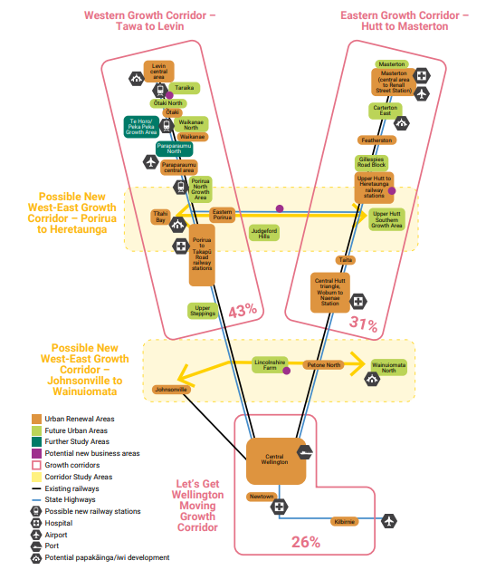
  - Let’s Get Wellington Moving
Let’s Get Wellington Moving (LGWM) was a joint initiative between Wellington City Council, Greater Wellington Regional Council, Waka Kotahi NZ Transport Agency, and mana whenua.
The aim was to “move more people with fewer vehicles” by providing more attractive travel choices and reshaping how people move around and through the city. LGWM goes hand in hand with planning and urban development changes that will make Wellington more compact and sustainable, thereby contributing towards reducing carbon emissions.
There were three broad phases:
Three-year programme focused on key projects to be implemented in short-term.
A City Streets package which will improve ways for people to bus, bike or walk through the central city and suburban areas.
A longer-term programme with more substantial transformation.
The longer-term programme included four projects:
New Mass Rapid Transit (MRT) connecting communities from the railway station through the City Centre to the Southern and Eastern suburbs. Figure 3.2 provides an aerial view of the potential corridors to the south to Newtown and Island Bay and to the east to the airport and Miramar.
Basin Reserve improvements to support the MRT by improving walking and cycling connections and enhancing the use of the Basin Reserve.
An extra Mt Victoria Tunnel to improve public transport and walking and cycling connections between the City Centre and Eastern suburbs.
Transport network improvements to encourage people to make better use of the transport system.
Figure 3.2 Indicative Mass Rapid Transit corridors for Let’s Get Wellington Moving
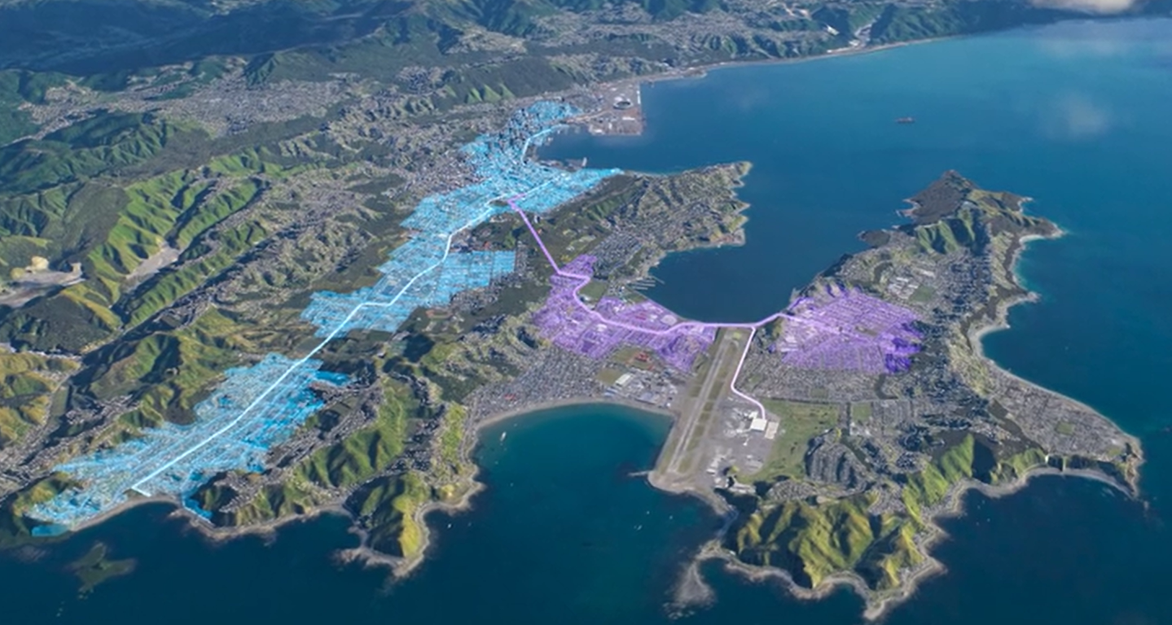

As at December 2023, central government dissolved the LGWM initiative. Although some elements will continue under the leadership of central, regional or local government.
  - National Planning Direction
The urban form of Wellington is strongly influenced by the city’s topography. The planning structures and location of different urban form elements also influencing future growth and spatial patterns of the city, along with national planning regulatory system.
National Policy Statement Urban Development: NPS-UD
The National Policy Statement on Urban Development was updated in May 2022 and replaced the National Policy Statement on Urban Development Capacity. In broad terms, the Statement sets out objectives and policies for urban development to enable improved housing affordability and deliver well-functioning urban areas.
The significant components in the context of this Plan relate to shifts in the typology of residential developments, and where medium and high-density dwelling developments are enabled. This influences where population and household growth are expected in future. The key parts are:
Enable greater height and density particularly across the city, including around centres and key transport nodes.
Enable building heights of at least 6 storeys within a walkable catchment of city centre, metropolitan centres and current/planned rapid transit stops.
Remove carparking requirements for developments, this is seen as a way to reduce cost (and therefore enhance affordability).
Councils are required to prepare “Future Development Strategies”, which set out the long-term strategic vision for accommodating urban growth and to illustrate how sufficient development capacity is enabled.
Medium Density Residential Standards: MDRS
The Resource Management (Enabling Housing Supply and Other Matters) Amendment Act 2021 requires medium density residential standards (MRDS) for specified urban areas to enable a wider variety of housing choice. The standards enable development of up to three dwellings on each site with each being up to three storeys without needing to apply for resource consent, provided the development adheres to all other rules and standards in the district plan.
Wellington City Proposed District Plan
The proposed District Plan was notified in July 2022 and gives effect to the NPS-UD and MDRS, and the direction from Wellington’s Spatial Plan (see Section 3.4). Parts of the District Plan are subject to intensification-provisions, which will become operational in 2024. The entire plan is expected to be operable in 2025. Resolutions made by the Council that will influence the District Plan include:
- Intensification and more mixed use within the existing urban area, which supports the city’s goal of becoming carbon neutral by 2050.
- Remove standards requiring 1.5m front yard and 1m side yards in the medium and high-density residential zones.
- Investigate the use of a targeted rate on land in identified growth areas of the city where additional height has been enabled by the PDP to fund an (affordable) housing fund as part of the wider review of the Rating Policy.
- Investigate options to incentivise development on underdeveloped land as part of the wider review of the Rating Policy, and a targeted rate on underdeveloped land in the city centre, metropolitan, local and neighbourhood centres.
- Removal of Johnsonville as a rapid transit line. This means that the walking catchment areas and additional height enabled around the rail stations will no longer apply.
- The application of the NPS-UD requirements for urban density in the Crofton Downs, Ngaio and Khandallah will shift from walkable catchments surrounding the railway stations to the centres-based growth approach in these communities.
- Agree that the walking catchments recommended by officers, in respect of the spatial plan, to be reinstated as follows:
- 10 mins walking catchment around City Centre Zone (CCZ) and metropolitan centres except where limited by natural hazard.
- 10 mins walking catchment around Tawa and Kenepuru stations.
- 5 mins walking catchment around the other stations designated as rapid transit along the Hutt/Melling Kapiti lines.
  - Our City Tomorrow Spatial Plan
He Mahere Mokowā mō Pōneke: A SpaTial Plan for Wellington City 2021
The Spatial Plan is a blueprint for the city, setting out a plan of action for where and how the city should grow and develop over the next 30 years. It takes account of key influences including Wellington’s Regional Growth Framework, Let’s Get Wellington Moving, national planning direction, infrastructure capacity and delivery schedules, climate change and natural hazards resilience.
The growth plan for the city includes the growth spine concept and the location of future growth areas (greenfield and infill). The growth areas are in the central city, inner suburbs, in proximity to key suburban centres, and around existing/planned rapid transit stops.
Table 3.1 outlines the infrastructure investment priorities included in the Spatial Plan to support growth. This provides an understanding of the timing of facilitated growth.

Table 3.1 Infrastructure Investment priorities to support growth
Timeframe for investment | Growth areas | Considerations
Short to medium term  (within next 10 years) | Tawa  Johnsonville  Central City  Newtown | - Initial focus for significant investment – three waters and transport – to create capacity for growth.  - Enable capacity for up to 33,600 people and 13,800 dwellings.
Medium to longer term  (10 to 20 years) | Newlands  Khandallah  Ngaio  Crofton Downs  Aro Valley  Mt Victoria  Mt Cook  Hataitai  Berhampore  Island Bay | - Close to and linked with initial growth areas.  - Focus on three waters and transport investment initially.  - Will provide additional capacity near key centres for up to 15,300 people and 6,400 dwellings.
Likely medium to longer term  10 to 20 years but some uncertainty | Kilbirnie  Miramar | - Good transport connections and range of services and amenities but subject to a range of natural hazards and sea level rise impacts.  - Current uncertainty and subject to LGWM investment.
Longer term  Likely 20+ years | Churton Park  Thorndon  Karori  Kelburn  Brooklyn  Lyall Bay | - Some areas require significant investment to resolve infrastructure capacity constraints, particularly Karori.  - Other suburbs have other constraints impacting timing or likelihood of future growth.
Developer / landowner driven  development likely within 10 years | Strathmore Park  Upper Stebbings & Glenside West  Lincolnshire Farm | - Timing of development determined by landowner intentions.  - Structure planning underway.  - Expectation infrastructure investment will be part of development proposals.

  - Population Growth
The companion report by Market Economics provides a comprehensive overview of Wellington’s population growth. This section summarises the key aspects influencing future community facility provision.
Wellington has seen moderate growth in recent years. In 2013, the city hosted 190,956 residents and over the five years to 2018 the population grew to 202,737, a 6% increase.
Over the next 30 years, Wellington is projected to grow by between 50,000 to 70,000 people. There are several different population projections for the city. The Council uses Sense Partners’ population projections (April 2022) and not the StatsNZ projections. To maintain consistency with other Council workstreams, the same Sense Partners projection data is used. The StatsNZ data is still valuable because it provides an ability to reflect the composition and age structures associated with different locations.
This analysis uses the medium projections, which estimate by 2048, the city will host an additional 56,870 people. This is equal to a 27% percentage growth (between the start and end years), or 0.8% compound growth (change every year).
For the community facilities analysis, three aspects of growth are important:
When is population growth expected to occur?
Where is population growth expected to occur?
What is the anticipated population composition?
Figure 3.4 shows the timing and distribution of population growth by the five wards. This shows:
All wards are projected to grow but at different rates.
Two-thirds of population growth is forecast in Northern (33%) and Central (32%) Wards.
Timing of growth is relatively evenly spread over the next thirty years.
By 2048, the largest wards are expected to be Northern at 67,750 and Central at 62,270.
By 2048, other wards are projected to be Western 52,290, Eastern 45,140 and Southern 40,600.
Figure 3.4 Population growth by Wellington Wards
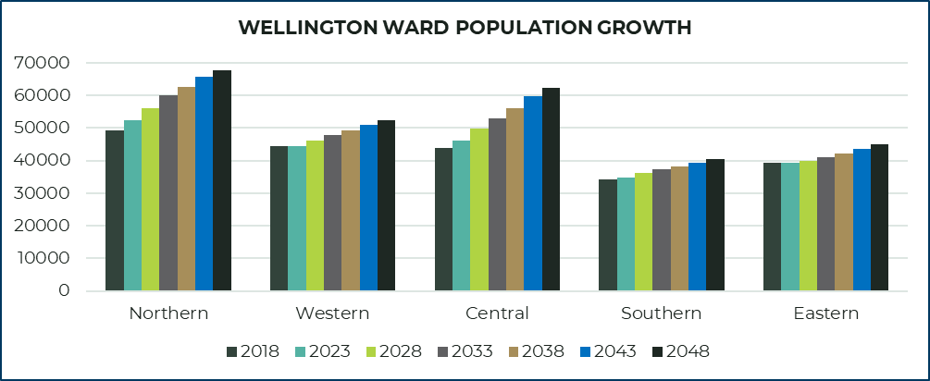
Figure 3.5 provides a graph of population growth by suburbs followed by maps highlighting different aspects of population change. The figures show:
Te Aro, in Central Wellington CBD, is projected to grow by the largest amount by 11,260 people.
The next largest growth is projected in Tawa (4,800) and Newlands (3,500) in Northern ward.
The areas with the most significant relative (percentage growth) are:
  - Lincolnshire Farm (8.3% compound growth, 2,510).
  - Churton Park including Upper Stebbings and Glenside (1.0% compound growth 2,000).
Figures 3.5 and 3.6 show multiples suburbs are forecast to grow by more than 2,000 people.
By 2048, the largest suburbs, over 15,000 people, are projected to be:
  - Te Aro (in Central Wellington)
  - Tawa
  - Karori
  - Newlands.
Potential growth scenario
It is important to note these population projections reflect the total population shift and are based on the work by Sense Partners. It is understood the projections and spatial patterns are based on the Spatial Plan distributions and capacity. The potential effects are the NPS-UD, MDRS and the LGWM are not explicitly factored into the patterns. However, the intensification is expected to see a degree of spatial re-orientation of growth around the city, but this is only a redistribution and is not expected to change the quantum of people.
The future spatial patterns are influenced by many, and diverse, factors. For example, housing preferences (how households decide on where to live, the housing typologies like terrace housing, apartments or standalone dwellings, as well as price, affordability and so forth) influence urban form outcomes. Initiatives like LGWM coupled with planning-enabled intensification, may see new spatial patterns. Areas such as the Southern and Eastern wards could see a larger share of growth due to higher residential density increases around the possible mass rapid transit route (see section 3.2). However, these changes will manifest over the long term and will not reduce the need to provide appropriately scaled and fit-for-purpose community facilities.

Figure 3.5 Population Growth by Suburbs
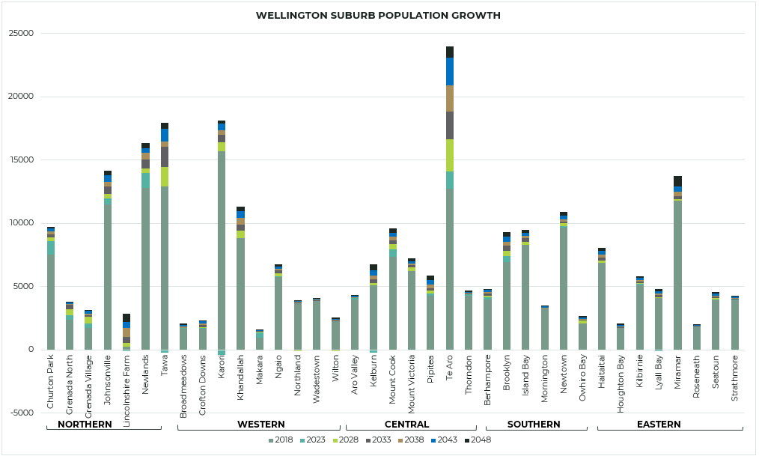

Figure 3.6 Population Change (Quantity) by Suburb
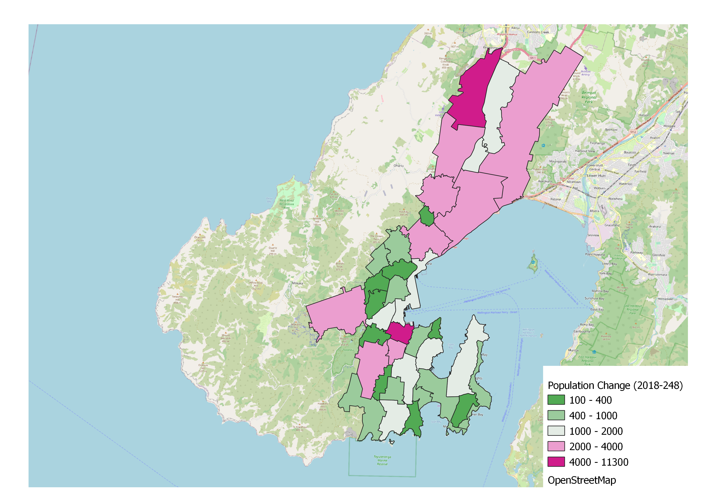
Figure 3.7 2048 Population Size by Suburb
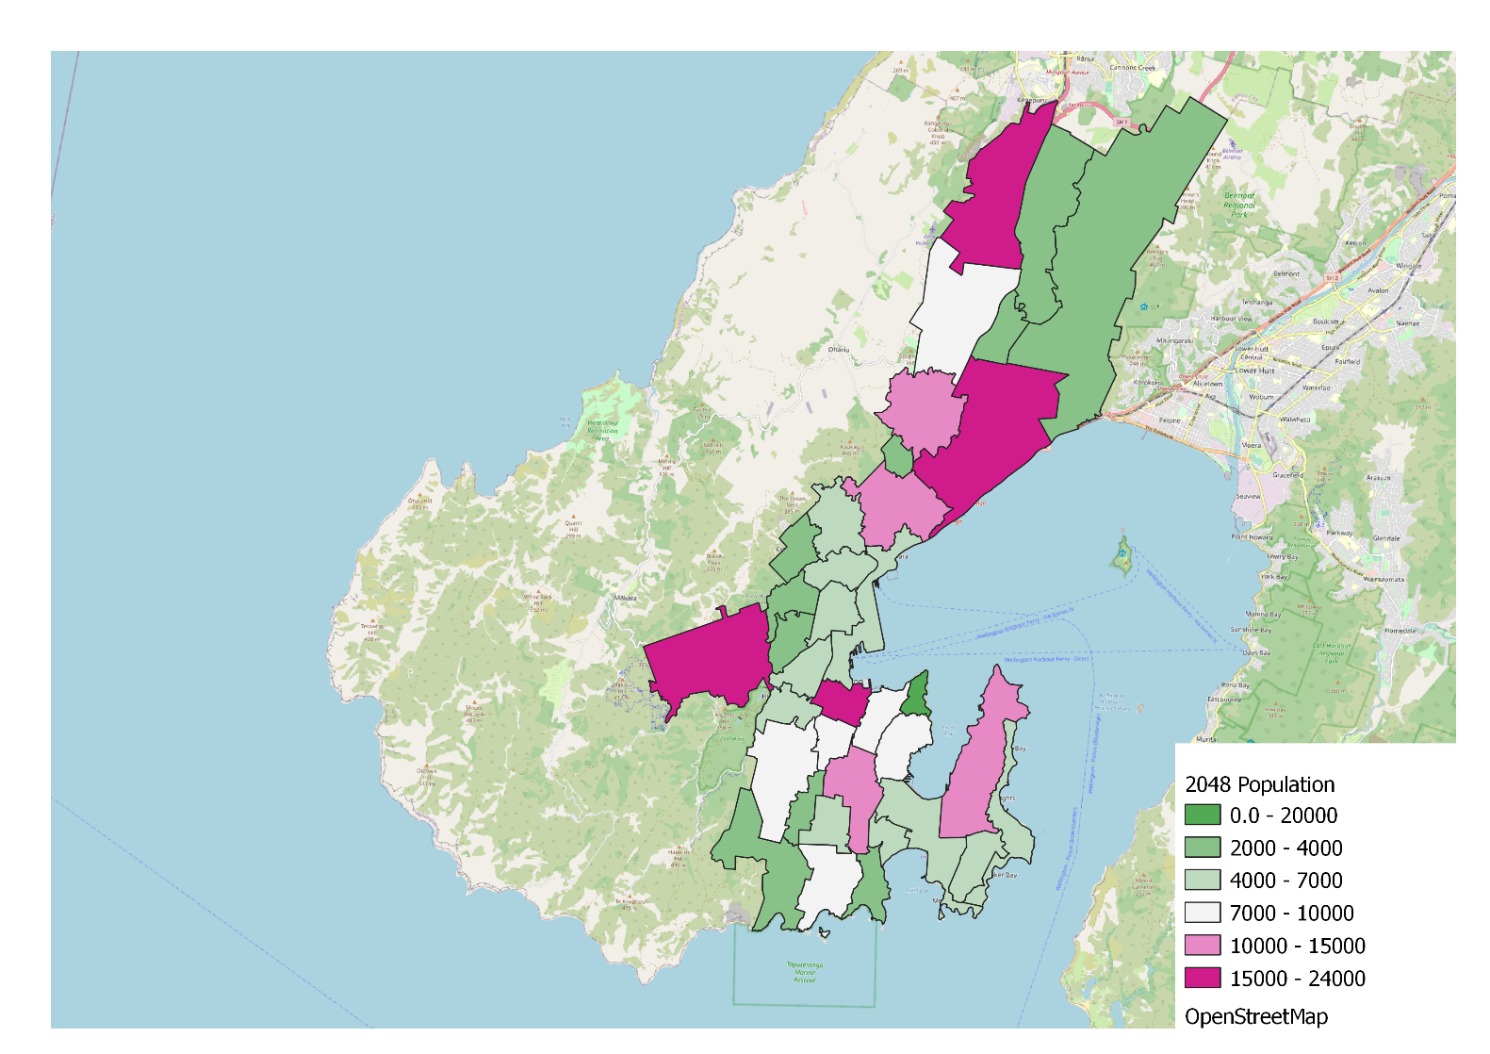

  - Growth by Age-Group
In addition to considering when and where population growth is expected, it is also important to consider the composition of the future population. A significant demographic factor for city-wide analysis is the age-profile. While other demographic features like ethnicity, disability, and sexuality are important for community facility provision, these demographic considerations are most relevant when considering individual community facilities rather than at the network level.
The age profile of a community influences how that community access, engage, and interact with community facilities. For example, some residential developments, like aged care provide some of the services normally associated with community facilities in-house (onsite). Generally, this places less demand on publicly provided community facilities and lowers the cost of delivery falling to the public sector because the private sector already pays for providing these services.
Age-Group Change
Like most areas in New Zealand, Wellington is expected to age going forward as illustrated by Figure 3.8 below. The over 70 year cohort is expected to grow the fastest (3.5% compound growth), followed by the 30-49 year cohort (1.1% compound growth). The other age cohorts remain relatively flat over the medium term after growing slightly over the short term. The number of people in the under 15 years cohort is projected to track down over the next decade or so, before stabilising around 30,000.
Figure 3.8 Forecast Population Growth by Age-Groups in Wellington
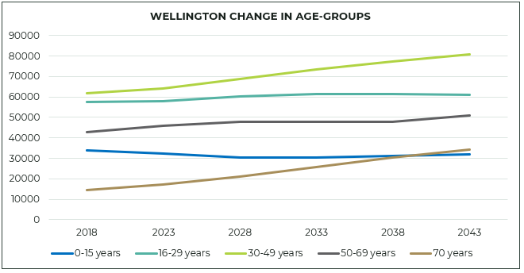
Figure 3.9 illustrates where population change in age-groups is projected to occur. This shows:
- Lincolnshire Farm and Te Aro are the only areas where broad growth across all age-groups is expected.
- While most suburbs are expected to see a decline in the number of children under 15 years, a few areas are forecast with small growth, these are Grenada North/Village, Aro Valley and Makara.
- For the young adults (16-29 years), the wider central city extending to Brooklyn, Mount Cook and Pipitea is projected to grow the most. This wide cohort has different and diverse needs. The young-adults group are also highly mobile, often relocating with early career opportunities.
- For working age adults (30-69 years), the Northern suburbs and City Centre are the main growth areas. The changing household structures, with less young children (or empty nesters) will see a shift in how this group interacts with community facilities.
- For older people over 70 years, all suburbs are projected to grow, with the most significant growth in Tawa, Johnsonville, Karori, Newlands, Khandallah and Miramar. This age-cohort is often associated with lower mobility and, for some, being socially isolated. The location of community facilities and catering for differing demand will need to be considered in future community facility provision.
Figure 3.9 Projected Population Change between 2023 and 2048 by Age-Groups
0-15 years |  | 16-29 years
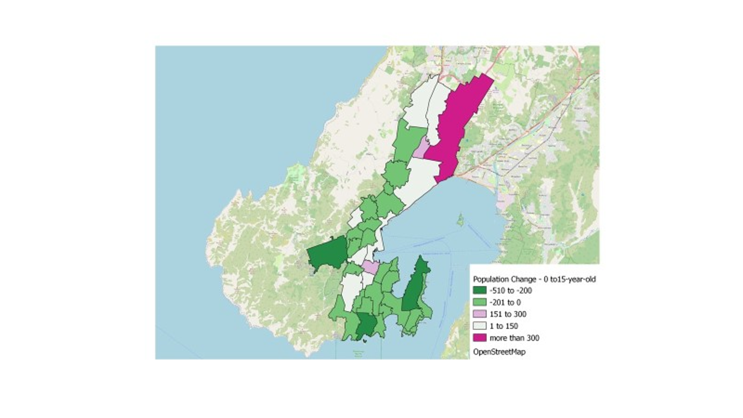 |  | 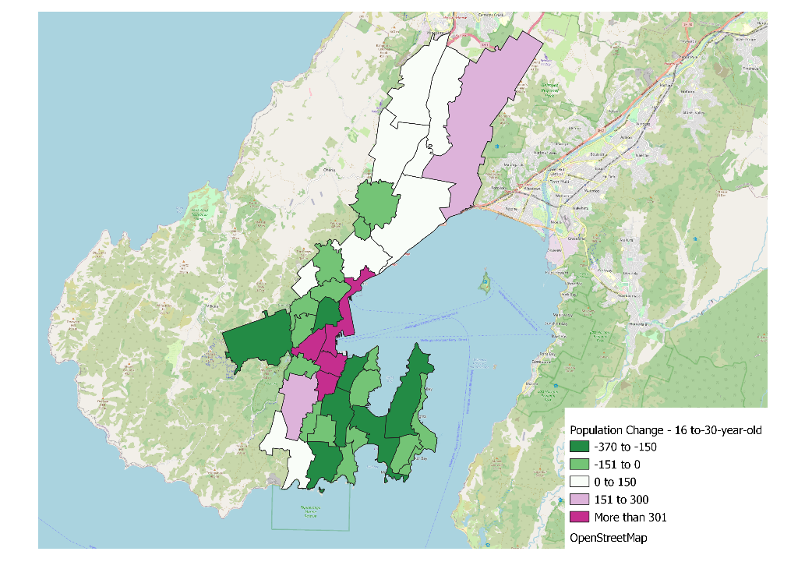
30-49 years |  | 50-69 years
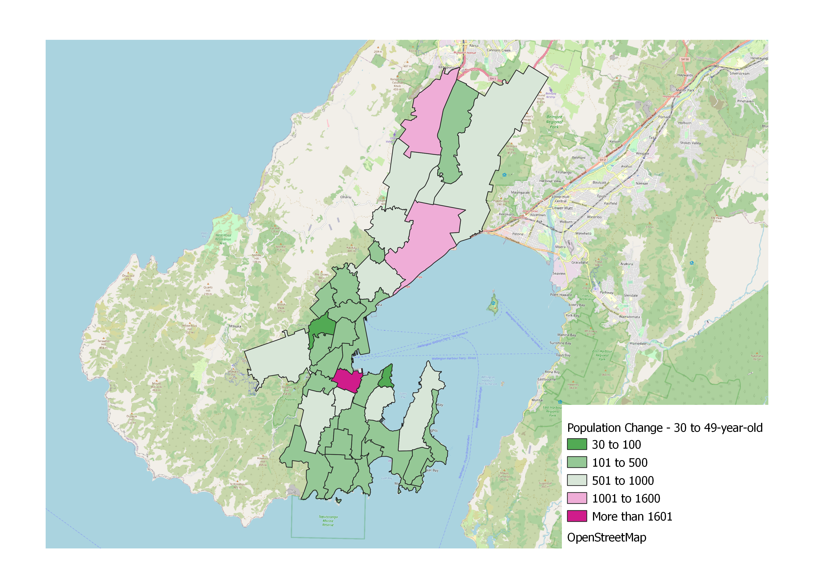 |  | 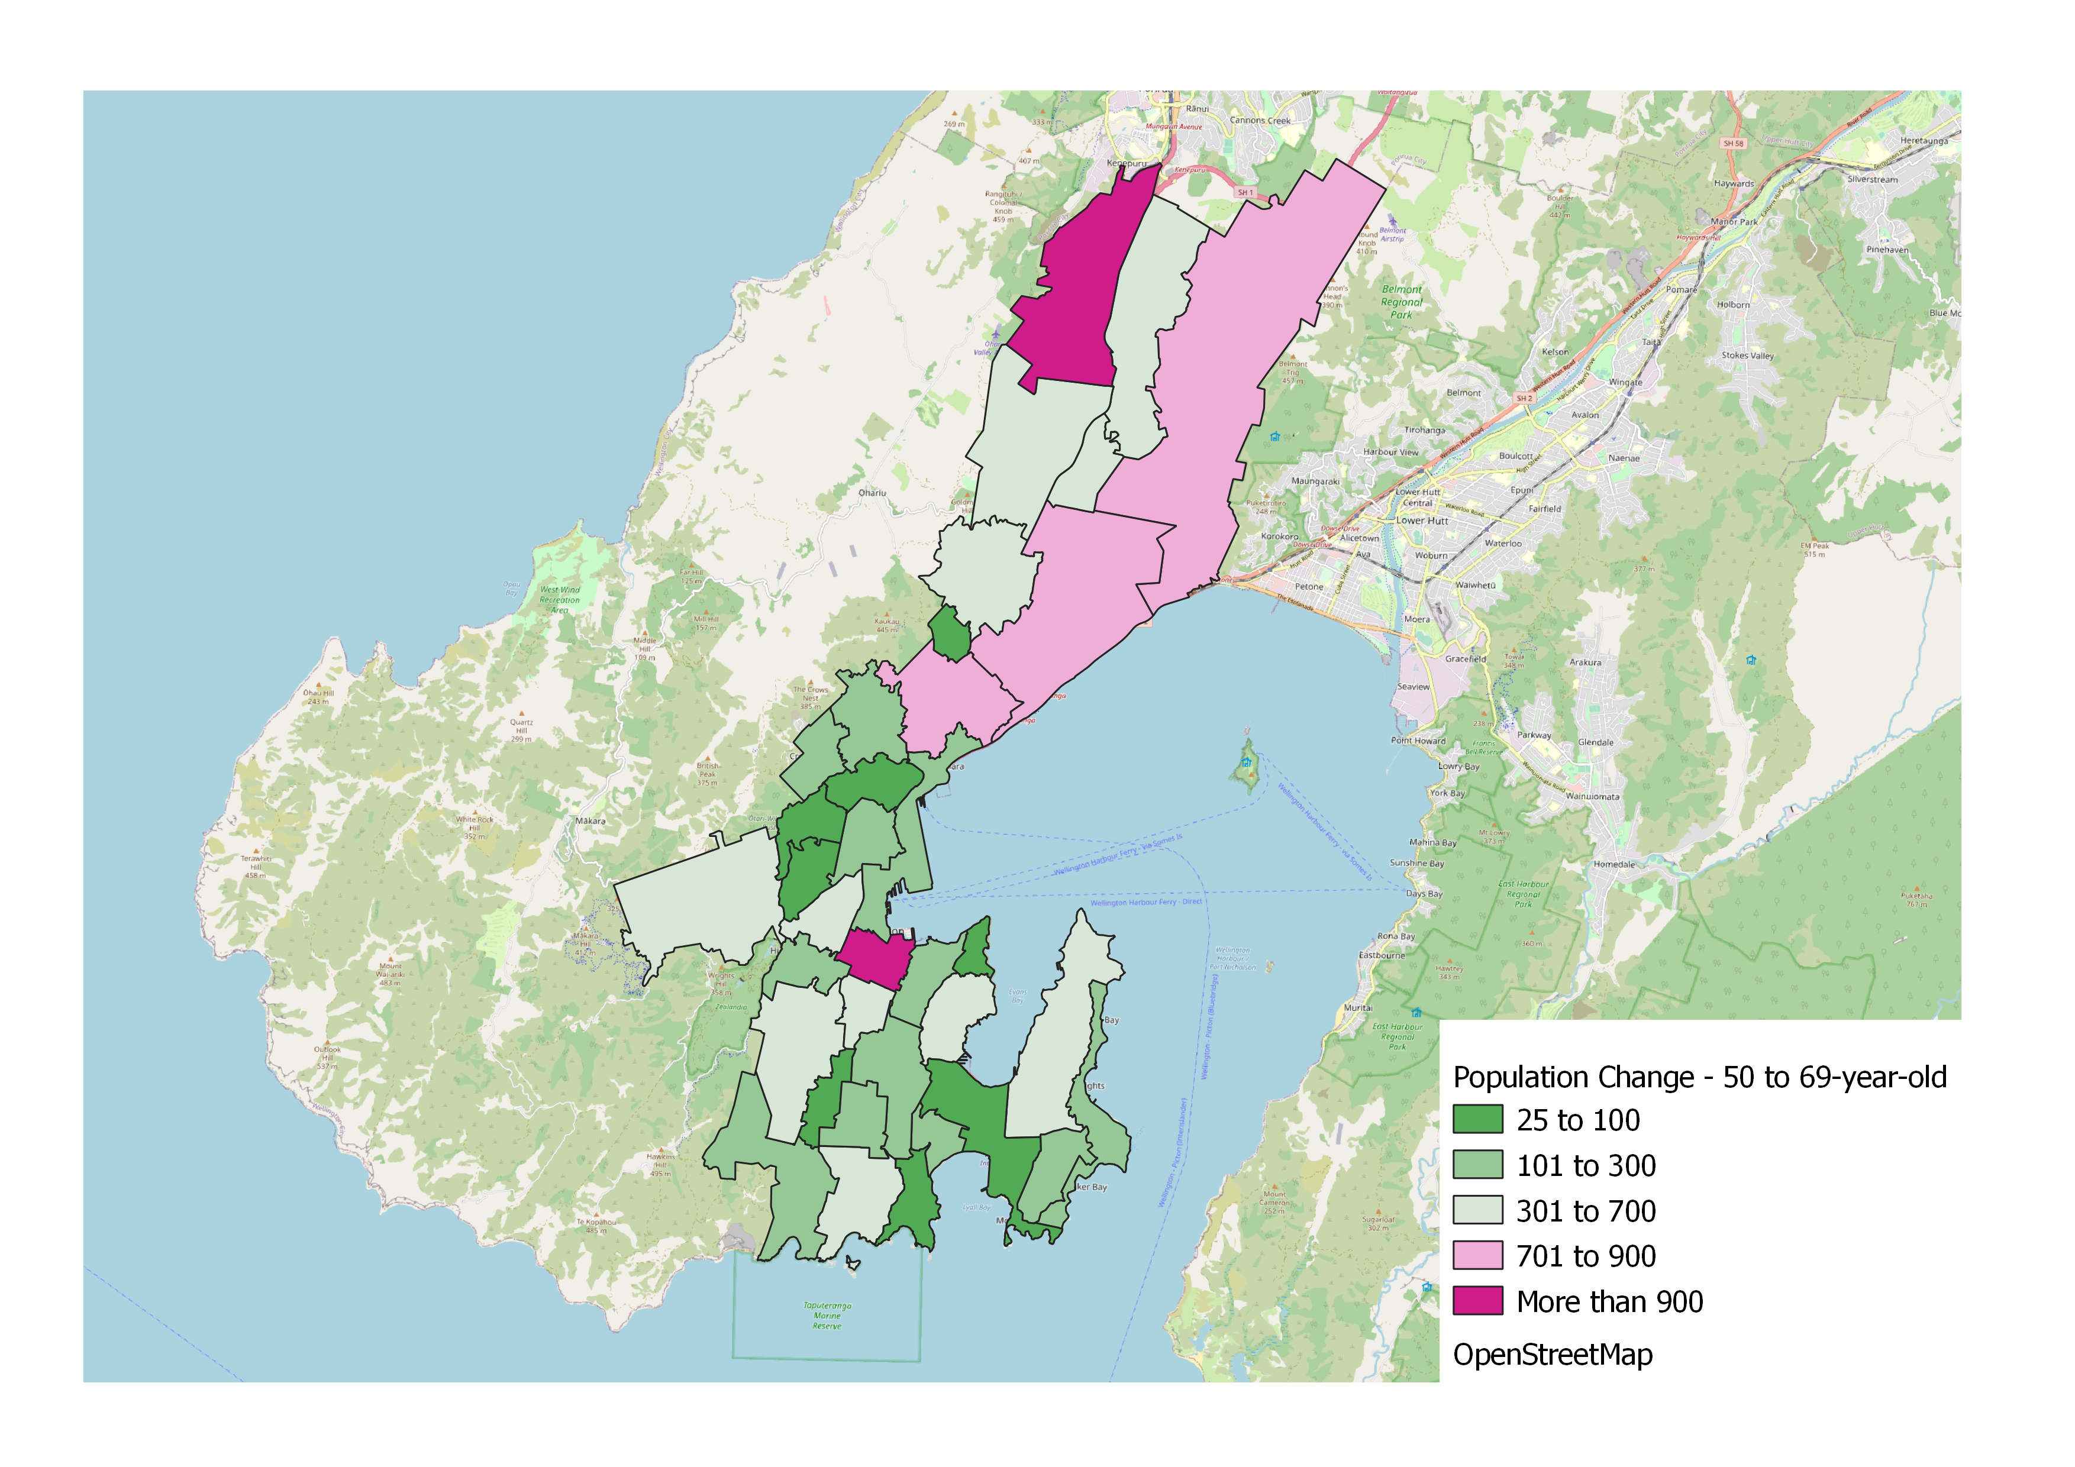
70+ years
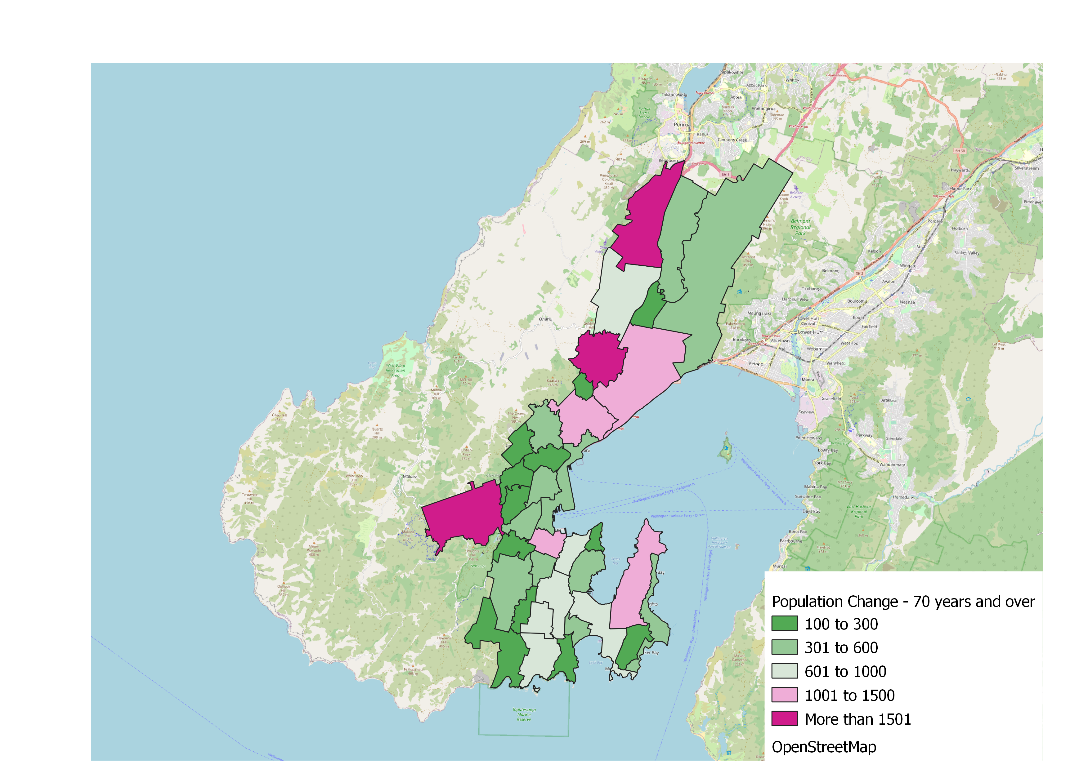

  - Deprivation Considerations
Alongside population growth and profile, it is also important to consider the levels of socio-economic deprivation of Wellington’s communities. The socio-economic status of a community can impact the use of community facilities, for example:
Household budgets may limit the ability to interact with community facilities due to transport or user fees.
Communities may require additional or specific types of community support around aspects like budgeting, family support, legal, health or wellness.
Communities may have specific needs such as access to technology, childcare, advice, and information.
The New Zealand Deprivation Index from the 2018 census (NZDep2018) is produced by University of Otago and visualised by Massey University Environmental Health Intelligence New Zealand. The measure is relative, meaning 10% of areas will always be the most deprived. The index measures the level of deprivation for an area based on nine 2018 census variables including:
access to home internet
source of income
household income
employment status
qualifications
home ownership
household composition
household occupancy
house condition.
Figure 3.10 (on the following page) provides a picture of Wellington’s socio-economic deprivation based on the 2018 Census and the provision of Wellington’s community facilities (see section 5.0 for details on this provision). This shows:
By comparison to Porirua and Hutt Valley, Wellington has lower levels of relative deprivation.
Areas of high deprivation but lower community facility provision are Strathmore and parts of Newlands.
Areas of high deprivation and higher community facility provision are Kilbirnie, Newtown/Mt Cook/Aro Valley, Johnsonville and Tawa. However, it still important to consider whether this provision is fit-for-purpose for community needs.
Areas of low deprivation and higher community facility provision are Khandallah, Wadestown, Ngaio and parts of Karori.
Community facility planning needs to be sensitive to socio-economic constraints, particularly when considering future specific facility / geographic action investigations.

Figure 3.10 Wellington Socio-Economic Deprivation and Community Facility Provision
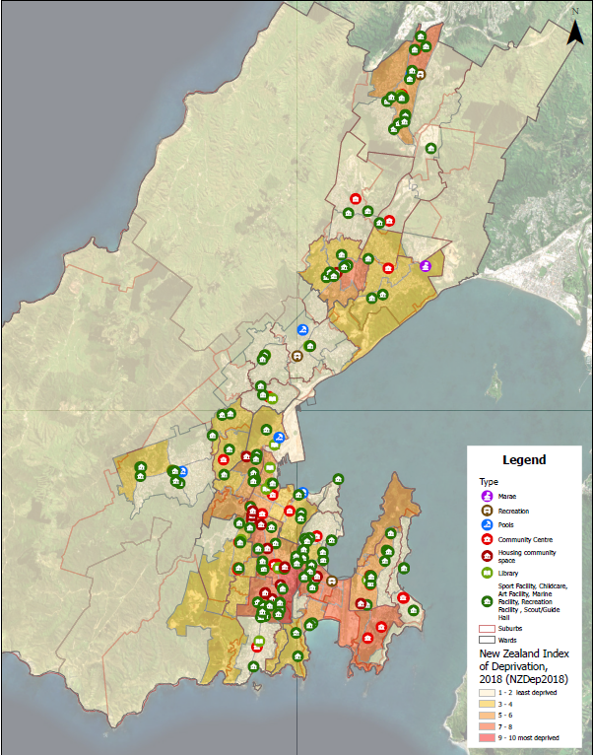

- NATURAL HAZARDS CONTEXT
Wellington’s geography presents a number of natural hazards that need to considered in community facility planning particularly around resilience and any new facilities. Wellington’s Proposed District Plan provides spatial information on the following hazards, shown in Figure 4.1:
Coastal inundation: mainly around the Southern, Eastern and inner harbour coastlines.
Coastal tsunami: similar to coastal inundation but extending into Lyall Bay, Rongotai, Kilbirnie, Miramar and Wellington CBD.
Fault lines extend through Wellington through Thorndon, Kelburn and Aro Valley.
Liquefaction: concentrated around the central city and Kilbirnie.
Flood risks (shown on Figure 4.2, 4.4 and 4.5) are spread throughout Wellington but particularly in Miramar, Kilbirnie, Island Bay, Karori and parts of Wellington CBD.
Figure 4.1 Overview of Wellington’s Natural Hazards
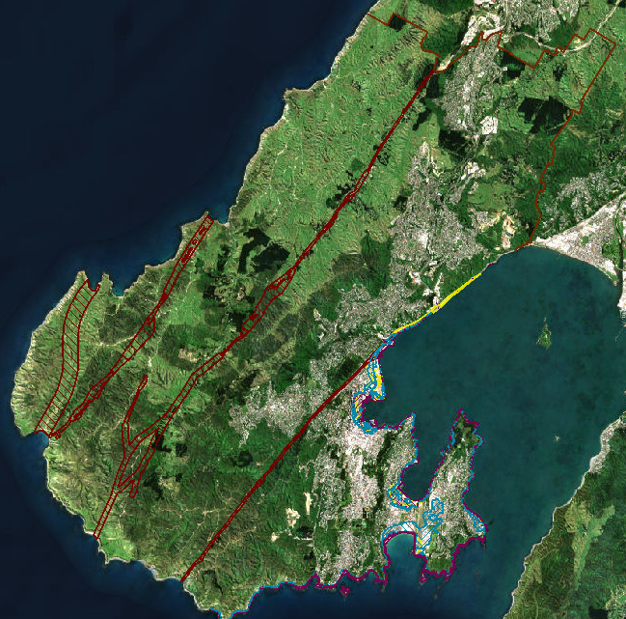

  - Southern & Eastern Wards
The Southern and Eastern wards have the greatest risks from coastal inundation, tsunami and flooding, as shown in Figure 4.2. Being flat and low-lying, Miramar, Kilbirnie, Rongotai and Island Bay have greater risk of flooding and tsunami. Parts of Kilbirnie where there is a concentration of community facilities and Evans Bay have greater risk for liquefaction shown in Figure 4.3.
Figure 4.2 Southern and Eastern Ward Hazards
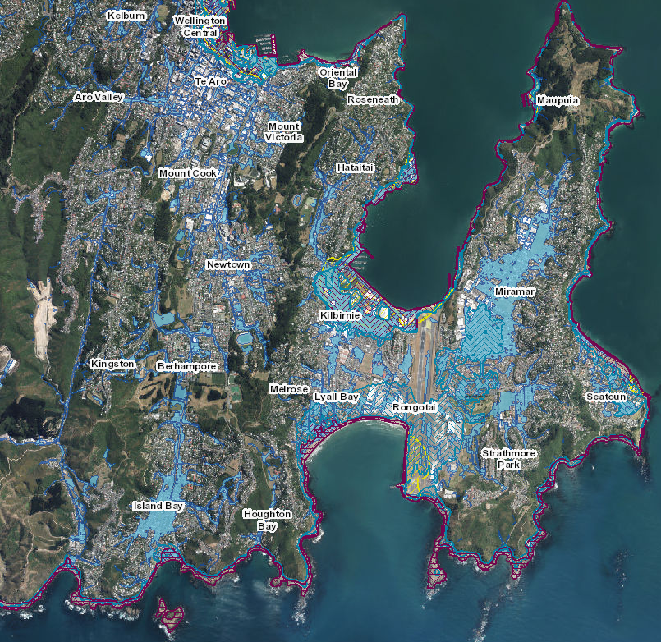
Figure 4.3 Concentrated Liquefaction Risks around Kilbirnie and Evans Bay
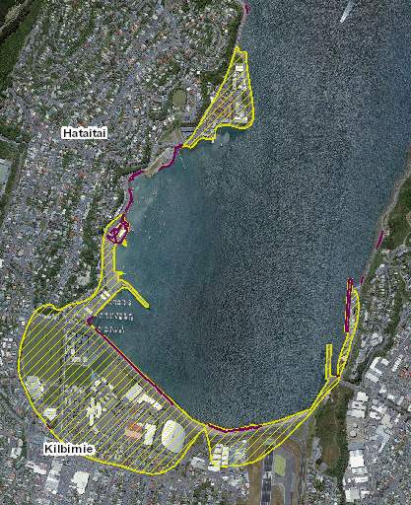
  - Central and Western Wards
The Central Ward has a concentrated area of risk around the City Centre for coastal inundation, tsunami, liquefaction and flooding. These hazards have the potential to impact a number of strategic infrastructure assets and several community facilities for Wellington.
By comparison, the Western Ward has a lower natural hazard risk with flooding being the main concern, particularly throughout Karori.
Figure 4.4 Hazards in the Central and Western Wards
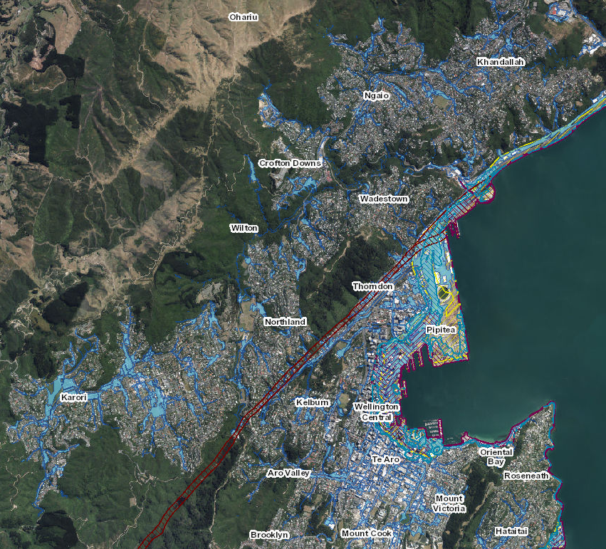

  - Northern Ward
Like the Western Ward, the main hazard facing the Northern Ward is flood risks throughout the area but isolated around streams and tributaries.
Figure 4.5 Natural Hazards in Northern Ward
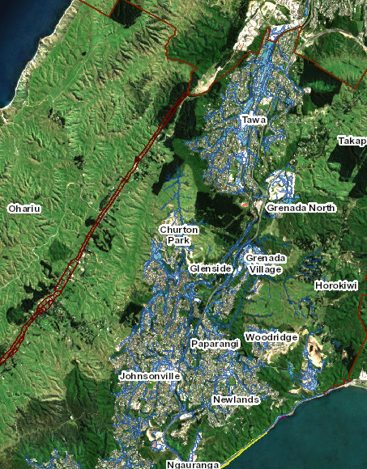

  - Hazards and Community Facilities
Figure 4.6 overlays the primary natural hazards over the locations of Wellington’s community facilities (see section 5.0 for details on this provision). Geographic areas of high vulnerability for community facilities are listed below with specific facility resilience issues identified in Section 5.3:
Coastal and low-lying areas of Eastern/Southern Wards including Kilbirnie, Miramar, Seatoun, Lyall Bay and Island Bay.
City Centre waterfront and lower areas of Thorndon.
Figure 4.6 Wellington’s Natural Hazards and Community Facility Provision
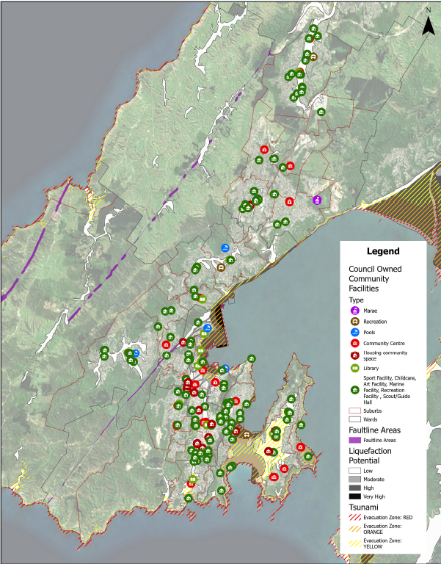

- COMMUNITY FACILITY ECOSYSTEM
Wellington City Council has 277 community facilities included in the scope for this needs analysis, based in 282 buildings as some community centres have multiple buildings. Figure 5.1 provides a map of the community facilities (except public toilets), with more detail in Table 5.1 (next page).
Figure 5.1 Wellington City Council’s Community Facilities
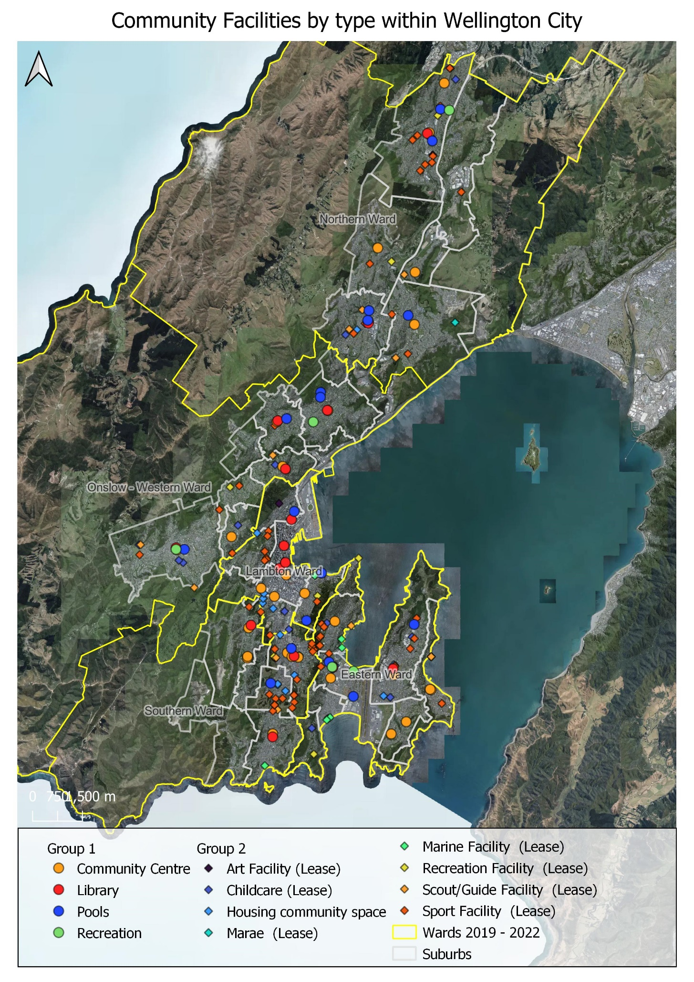
Table 5.1 Summary of Wellington City Council's Community Facilities (with average age where available)
FACILITY TYPE | NUMBER | FOOTPRINT | AVE. SIZE | AGE | NOTES
COMMUNITY CENTRES | 25  (32 buildings) | 11,600m²  (5% of network) | 374m² | 60 | 49 facilities  25%  68,701m²  28%  Average size 1,389m²  Excluding 3 largest facilities 695m²
LIBRARIES | 12 | 21,666m²  (includes expanded Central Library)  (9% of network) | 1,806m²  (628m² excluding Central) | 44
SWIMMING POOLS | 7 | 14,731m²  (6% of network) | 2,104m² | 67
RECREATION CENTRES | 5 | 20,074m²  (8% of network) | 4,015m² | 52
COMMUNITY SPACES IN COUNCIL HOUSING ASSETS | 13 | 762m²  (<1% of network) | 59m² | -
MARAE  (GROUND LEASE) | 1 | Not available | - | - | 5 other marae across Pōneke
LEASES: CHILDCARE | 28 | Approx. 13,249m²  (5% of network) | 602m² | 68 | Lease facilities:  131 facilities  41 premises leases  90 ground leases  Approx. 177,000m²  72% of network
LEASES:  CREATIVE FACILITIES | 6 | Approx. 1,175m²  (<1% of network) | 235m² | 61
LEASES: RECREATION FACILITIES | 10 | Approx. 3,597m²  (1% of network) | 514m² | 73
LEASES: SCOUT/GUIDE FACILITIES | 14 | Approx. 4,461m²  (2% of network) | 319m² | 51
LEASES:  SPORT FACILITIES | 64 | Approx. 131,354m²  (53% of network) | 2,153m² | 55
LEASES:  MARINE FACILITIES | 9 | Approx. 17,660m²  (7% of network) | 2,208m² | 52
PUBLIC TOILETS | 83 | Not available | - | - | 12 public toilets in sport pavilions  (not in scope)
TOTALS | 277 facilities  282 buildings | Approx. 245,735m² | 1,328m²  Excluding buildings  >5,000m²= 524m² | 57

A summary of the metrics on Group A community facilities is included in Appendix 1.

  - Council’s Facility Provision By Type
Excluding public toilets, the Council is involved in the provision of 194 community facilities, which equates to one facility per 1,045 people and about 1.2 square metres (footprint) per resident. It is difficult to provide comparisons with other equivalent cities, as no local authorities have analysed community facility provision across the same scope. At any level, this is substantial provision of facilities.
Across the population, there are varying levels of interest in using different types of community facilities. Table 5.2 provides analysis of the current community facility provision by the total Wellington population (202,737 in 2018) and by the indicative number of users (determined by the percentage of people who reported using different community facilities – refer to Section 6.3).
From Table 5.2, the following findings are noted:
Lease facilities have the highest provision, by number of facilities and footprint. Noting lease facilities cover a broad spectrum of sub-facility types and includes the ground lease for certain activities such as tennis courts and bowling greens. It does not include sports fields which are managed by Wellington City Council.
Recreation centres have the lowest provision by number of facilities, whereas housing community spaces have the lowest provision by square metreage.
Libraries are the most popular facility type, followed by public toilets, as determined by the Wellington Sample Survey.
Libraries, swimming pools and recreation centres are relatively similar in the number of indicative users per facility and by square metre of space.
In contrast, there is lower indicative number of users per facility for community centres, lease facilities and public toilets.
Housing community spaces, by virtue of the very small footprint, have the highest indicative users per square metre of space.
Table 5.2 Analysis of Community Facility Provision Across the Population
FACILITY TYPE | POPULATION PER FACILITY | POPULATION PER SQM | INDICATIVE POPULATION USING# | INDICATIVE USERS VISITING | INDICATIVE USERS PER FACILITY | INDICATIVE USERS PER SQM
Community centres | 8,109 | 18.0 | 26% | 52,712 | 2,108 | 4.7
Libraries | 16,895 | 9.4 | 73% | 147,998 | 12,333 | 6.8
Swimming pools | 28,962 | 13.8 | 42% | 85,150 | 12,164 | 5.8
Recreation centres | 40,547 | 10.1 | 27% | 54,739 | 10,948 | 2.7
Housing spaces | 15,595 | 266.0 | 6% | 12,164 | 936 | 16.0
Lease facilities ^ | 1,548 | 1.1 | Up to 49% | 99,341 | 758 | 0.6
Public toilets | 2,443 | Not available | 69% | 139,888 | 1,685 | Not available
TOTAL* | 1,045 | 0.8 | - | - | - | -
* Totals excludes public toilets
# Indicative user percentage was derived from the Wellington Sample Survey - refer to Section 6.3
^ Includes the lease area which can include specified outdoor space such as bowling greens and tennis courts

  - Council’s Facility Provision by Ward
Council’s community facilities are not evenly distributed across the city as provision has been heavily influenced by the city’s growth and geography. Figure 5.2 outlines the number of community facilities (excluding public toilets) by ward and the associated footprint in square metres. Figure 5.3 provides analysis of each ward population for the number of facilities and associated footprint. Figure 5.4 on the following page, provides the distribution of facility types by ward. Maps on the following pages provides a zoomed-in perspective on the facility distribution by ward.
From Figures 5.2 and 5.3, the following findings are noted:
The Southern and Eastern wards have the highest provision by both number and footprint. The most significant factor contributing to this higher level of provision is the Wellington Town Belt, which accommodates many facilities. As the Town Belt occupies a large geographic area, there are fewer people living in these wards. The combination of fewer people living in the ward and large number of facilities results in less people per facility and for the facility footprint.
In contrast the Central and Western wards have the lowest provision by number and footprint. With a larger population, this equates to more people per facility and footprint.
The Northern Ward has a large number of facilities, but these have a notably smaller footprint per facility. The larger population in the ward and smaller footprint contributes to more people per square metre of footprint.
Figure 5.2 Council’s Community Facilities by Ward (excludes public toilets)
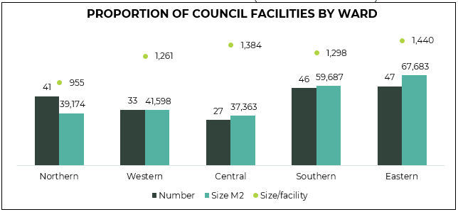
Figure 5.3 Population of each Ward per Facility and per square-metre (excludes public toilets)
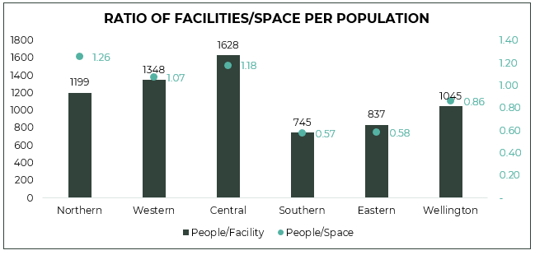

Figure 5.4 Distribution of Community Facility Types by Ward
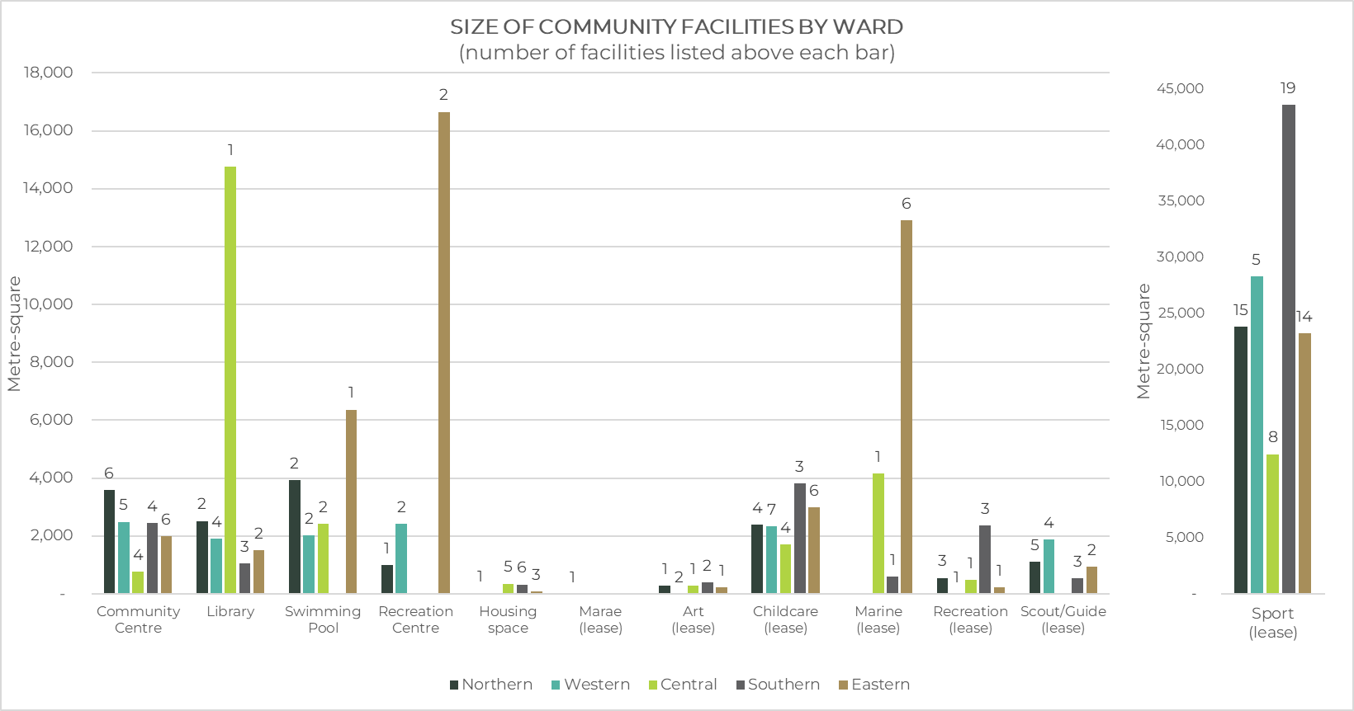

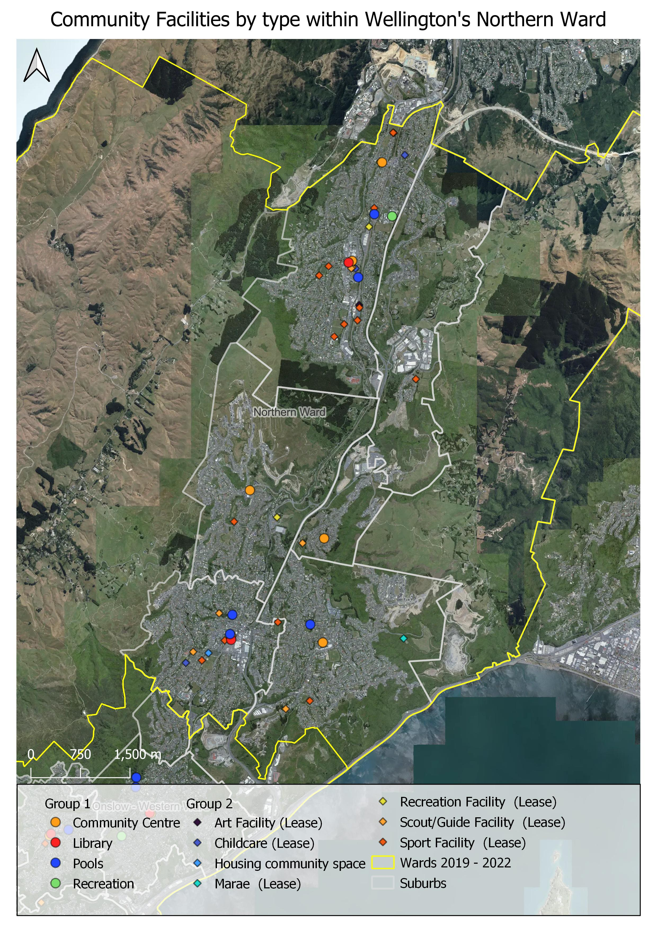

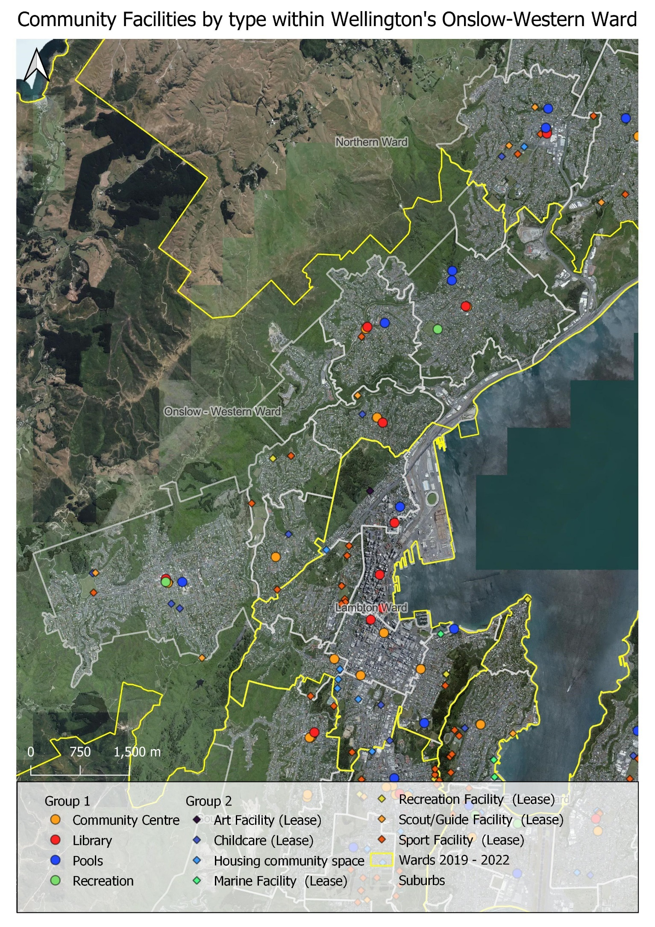

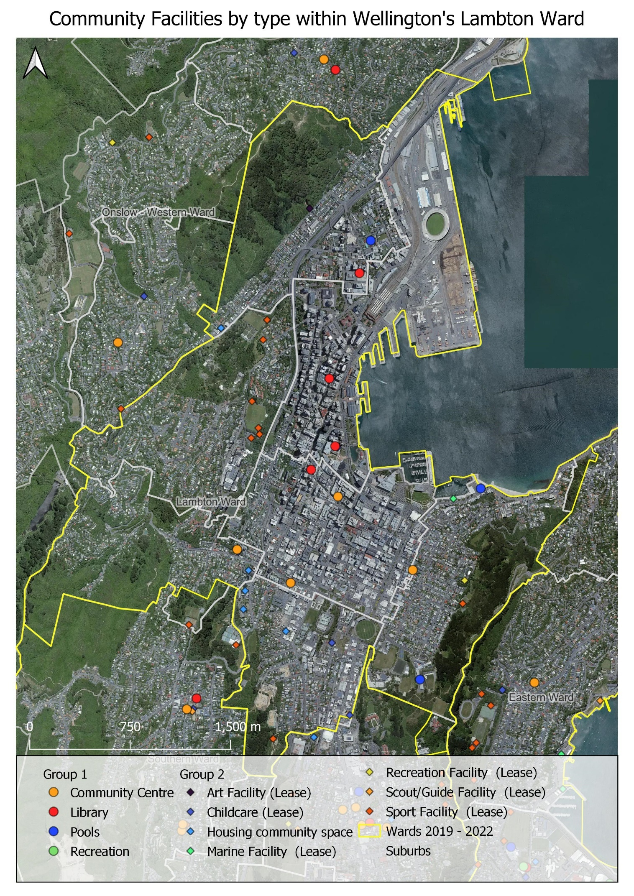

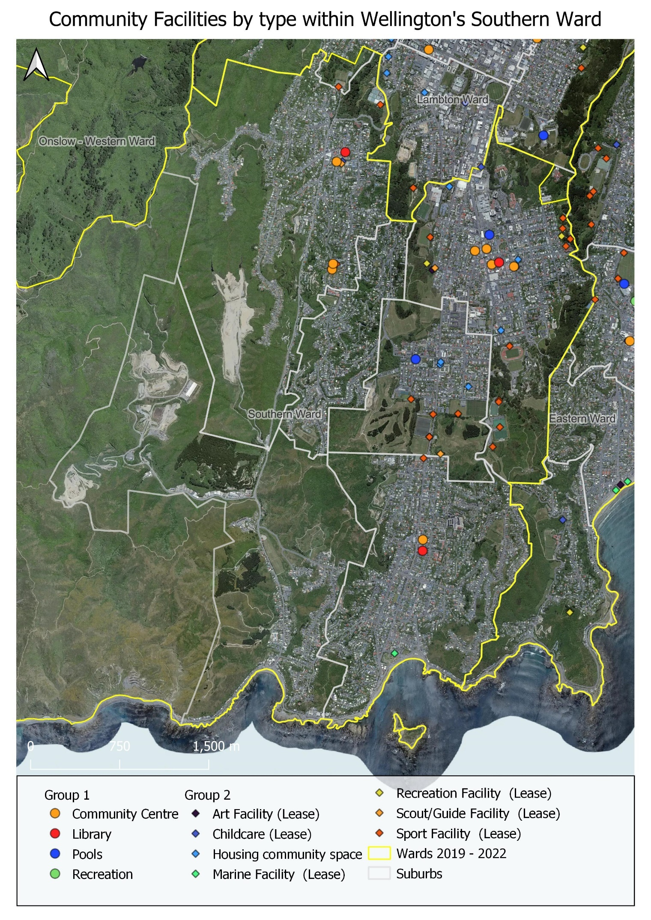

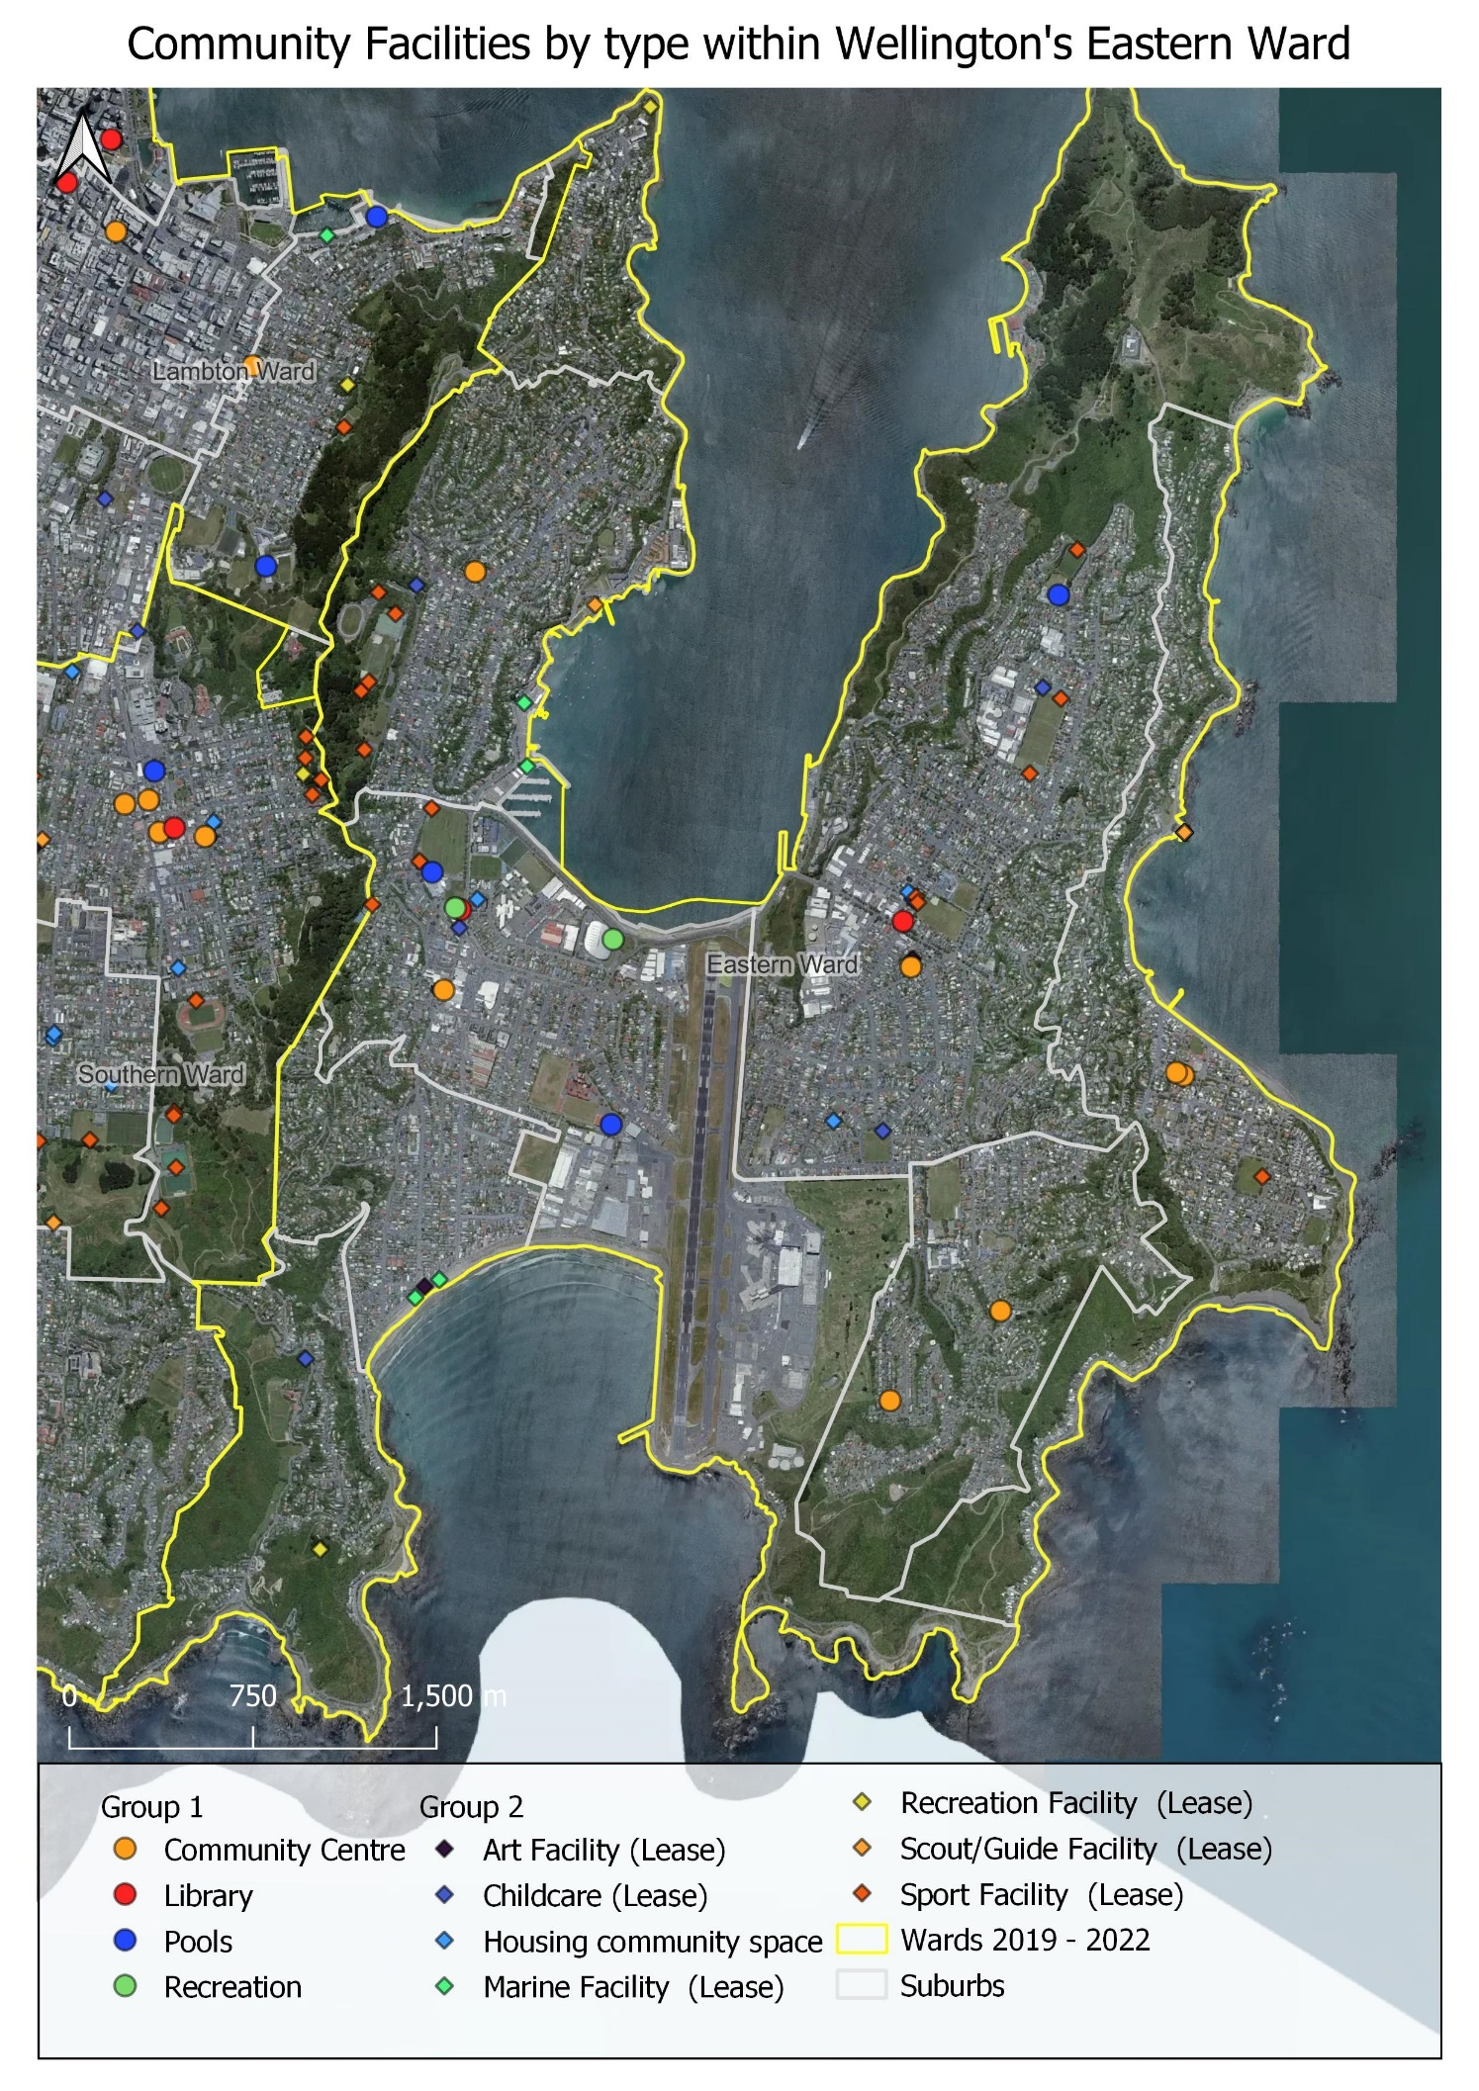

  - Fit-for-Purpose Overview
A set of fit-for-purpose criteria was developed to review the appropriateness of buildings for the intended uses. This review was applied to Group A facilities (49 community centres, libraries, swimming pools and recreation centres) and completed with Council staff input.
The criteria comprise both strategic requirements that apply to all facilities and specific requirements bespoke for each facility type which is listed in full in Appendix 2. Table 5.3 provides a summary of the strategic fit-for-purpose requirements applied to the Group A facilities, with the full assessment of Group A individual facilities in Appendix 1.
Table 5.3 Fit-for-Purpose Assessment of Group A Facilities – Percentage of Facilities rated POOR
FIT-FOR-PURPOSE CRITERIA | COMMUNITY CENTRES | LIBRARIES | SWIMMING POOLS | RECREATION CENTRES | OVERALL  % (#)
Celebrating te ao Māori  - Aesthetic of building  - Celebrates te reo Māori & te ao Māori  - Feeling of tūrangawaewae  - Significance of the location | 69%  rated poor | 82%  rated poor | 86%  rated poor | 80%  rated poor | 75%  (39)  poor
Universal design  - Accessible for people of all abilities  - Meet NZ4121 and Article 9 of CRPD | 41%  rated poor | 36%  rated poor | 57%  rated poor | 60%  rated poor | 44%  (23)  poor
Inclusive for everyone  - Inclusive amenities for range of needs eg baby change, sensory, gender | 34%  rated poor | 64%  rated poor | 29%  rated poor | 20%  rated poor | 38%  (20)  poor
Transport accessibility  - Ease of transport access via range of transport modes: public transport, carparking, micro-mobility etc | 17%  rated poor | 0%  rated poor | 29%  rated poor | 40%  rated poor | 17%  (9)  poor
Safety and security  - Designed for user safety  - Incorporate CPTED principles  - Staff visibility  - Facility safety concerns | 10%  rated poor | 9%  rated poor | 43%  rated poor | 20%  rated poor | 15%  (8)  poor
Efficient & climate-smart  - Efficient to operate and heat / cool  - Climate smart building objectives  - Waste (& kai) reduction & recycling | 41%  rated poor | 45%  rated poor | 43%  rated poor | 40%  rated poor | 42%  (22)  poor
Ease of maintenance  - Ease of maintenance and robust | 21%  rated poor | 27%  rated poor | 29%  rated poor | 0%  rated poor | 21%  (11) poor
Location  - Well-located relevant to the network and catchment serving | 0%  rated poor | 9%  rated poor | 57%  rated poor | 0%  rated poor | 10%  (5) poor
Visibility  - Prominence of facility and ease of finding | 14%  rated poor | 0%  rated poor | 43%  rated poor | 20%  rated poor | 15%  (8) poor
Quality facility  Condition of facility | 24%  rated poor | 36%  rated poor | 29%  rated poor | 20%  rated poor | 27%  (14) poor
Sufficient capacity  - Sufficient size to meet demand | 17%  rated poor | 36%  rated poor | 29%  rated poor | 40%  rated poor | 25%  (13) poor
Functional  - Right design, configuration, materials and specification for intended activities | 7%  rated poor | 36%  rated poor | 29%  rated poor | 0%  rated poor | 15%  (8) poor
Seismic resilience  - Seismic strength and design | 14%  rated poor | 0%  rated poor | 29%  rated poor | 20%  rated poor | 13%  (7) poor
Hazard vulnerability  - Vulnerability of the location / building for natural hazards | 10%  rated poor | 18%  rated poor | 43%  rated poor | 40%  rated poor | 19%  (10) poor

Facilities with SUBSTANTIAL fit-for-purpose issues:
From this fit-for-purpose analysis, several facilities were identified with substantial issues that will need to be considered as part of future provision. These facilities include:
Seven facilities with seismic resilience issues include Network Newtown, Freyberg Pool, Khandallah Pool, and Kilbirnie Recreation Centre and facilities not owned by Council Vogelmorn Community Centre (ex-bowling club), St Christophers (Seatoun) and Hataitai Centre (ex-bowling club).
Facilities vulnerable to natural hazards include Miramar-Maupuia Community Centre, Kilbirnie/Lyall Bay Community Centre, Seatoun Village Hall & St Christophers, Miramar Library, Kilbirnie Library, Freyberg Pool, Khandallah Pool, Wellington Regional Aquatic Centre, Ākau Tangi and Kilbirnie Recreation Centre.
Wadestown Community Centre: the building is located on a hill, with a steep pathway, steps and no carparking meaning the universal design is poor. The spaces are small and mostly configured in an open layout which limits flexibility to accommodate dual/multiple activities. The older building does not include inclusive amenities and is costing more to maintain. Transport availability is low due to the location in the residential area rather than in the heart of Wadestown. The visibility is limited due to the set-back position on a hill.
Island Bay Community Centre: while located in the heart of Island Bay, there is no visibility due to the location and narrow driveway. The building is quite small and lacks flexibility to accommodate a range of activities. The narrow corridor limits the universal design, and the older building does not have inclusive amenities and is costing more to maintain.
Johnsonville Community Centre: the building is well located, highly visible and has a good combination of spaces. However, there are design issues with the roof and windows causing a range of issues.
Tawa Community Centre: located in the re-purposed borough council building, the design and layout of spaces are not appropriate for a community centre. While there is a good number and sized spaces the layout is poor particularly as some rooms have no natural light and access is through another room. The building does not have inclusive amenities.
Brooklyn, Island Bay and Khandallah Libraries are all small libraries of a similar era. All are well-positioned but do not have strong visibility into the building due to the design of the building. The small footprint limits the range of activities that can be accommodated. The older buildings lack the inclusive amenities required in a modern library.
Wadestown Library: size is the most limiting factor for this building contributing to poor flexibility and lack of inclusive amenities.
Khandallah Pool: the facility is located adjacent to a stream prone to flooding and the older pool has leaks which flow into the stream. The buildings have structural issues and the pipework has asbestos containing material. There is no universal access into the pools or buildings. The pool is unheated and the structured design is not ideal for the nature of activities undertaken.
Freyberg Pool: the building is not universally accessible, does not have inclusive amenities and the pools/spaces are too small for the level of demand. The facility is not easy to operate due to the positioning of the plant-room. The building is seismically susceptible and in a vulnerable location for sea-level rise.
Thorndon Pool: the building and pool are not universally accessible and it does not have inclusive amenities. The pool is too small and the structured design is not ideal for the nature of activities. Some of the brickwork is seismically vulnerable.
Kilbirnie Recreation Centre: the building has structural issues due to alternations made to the building. The building does not have good insulation leading to variable temperatures, which is problematic to manage and not always pleasant for users.
Nairnville Recreation Centre: the older building is not universally accessible and does not have inclusive amenities. The building is too small to accommodate demand for the range of activities. The old squash courts are not used and the layout is not cohesive. The older building has limited insulation and heating/ventilation systems which leads to variable temperatures and inefficiency.
  - Utilisation Overview
Usage data is only collected for a few facility types, therefore there is limited information on the overall utilisation of community facilities. Table 5.4 provides an overview of the usage data that was available or derived from other sources (as indicated in the source column). One of the key findings from this Needs Analysis is to establish a network-wide data collection system so there is better understanding of facility utilisation. At face value, the network of community facilities appears to be under-utilised. Data on Group A facilities is included in Appendix 1.
Table 5.4 Summary of utilisation for each Facility Type
FACILITY TYPE | SOURCE | 2018/19 | 2019/20 | 2020/21 | 2021/22
COMMUNITY CENTRES | - No consistent data  - Council records for 7 Council-run facilities only | 398,706  131/sqm  (7 sites only) | NA | 371,050  122/sqm  (7 sites only) | 214,098  71/sqm  (7 sites only)
LIBRARIES | - Council records (door-counts) | 1,156,603  167/sqm | 1,035,195  150/sqm | 1,132,230  164/sqm | 786,702  114/sqm
SWIMMING POOLS | - Council records (sales) | 1,260,912  86/sqm  246/water sqm | 905,985  62/sqm  177/water sqm | 948,631  64/sqm  185/water sqm | 860,088  58/sqm  168/water sqm
RECREATION CENTRES | - Council records (sales) | 1,289,323  64/sqm  75,843/court | 895,008  45/sqm  52,648/court | 1,076,712  54/sqm  63,336/court | 803,715  40/sqm  47,277/court
COMMUNITY SPACES IN HOUSING | - No data available | Primarily used by residents of housing complexes.  A few complexes run programmes and take bookings which involve wider community participation.
MARAE  (GROUND LEASE) | - No data available | Key feature of Māori society. The marae is a wāhi tapu (sacred place) to gather for cultural, social and ceremonial purposes. Also a place where Māori language and customs are preserved and practiced.
LEASES: CHILDCARE | - Leaseholder survey (6/28 facilities) | 67% used for 20-40 hours / week  33% used 40-80 hours / week  Average membership: 58
LEASES:  CREATIVE FACILITIES | - Leaseholder survey (5/6 facilities) | 20% used for less than 20 hours / week  60% used for 20-40 hours / week  20% used for 80+ hours / week  Average membership: 138
LEASES: RECREATION FACILITIES | - Leaseholder survey (4/10 facilities) | 25% used for less than 20 hours / week  75% used for 20-40 hours / week  Average membership: 245
LEASES: SCOUT/GUIDE FACILITIES | - Leaseholder survey (4/14 facilities) | 50% used for less than 20 hours / week  25% used for 20-40 hours / week  25% used for 40-80 hours / week  Average membership: 83
LEASES:  SPORT FACILITIES | - Leaseholder survey (44/64 facilities) | 11% used for less than 20 hours / week  50% used for 20-40 hours / week  27% used for 40-80 hours / week  11% used for 80+ hours / week  Average membership: 1,177
LEASES:  MARINE FACILITIES | - Leaseholder survey (5/9 facilities) | 20% used for less than 20 hours / week  20% used for 20-40 hours / week  20% used for 40-80 hours / week  40% used for 80+ hours / week  Average membership: 206
PUBLIC TOILETS | - Council estimation of usage | 4% of toilets are reported to have low use levels  53% of toilets are reported to have average use levels  43% of toilets are reported to have high use levels

  - Operational Perspectives
Site visits with most Group A facilities provided insight on the operation of community facilities. The survey and engagement with lease facilities provided insight on the operation of these facilities. Common findings for facility types are summarised below.
COMMUNITY CENTRES
Lack of clarify in the common purpose of community centres.
Most feel there are insufficient operating budgets to enable appropriate staffing levels, opening hours and programming.
The mixed delivery model has led to perceptions of inequity of funding by both community-led and council-led community centres.
Perception of decreasing investment in regular maintenance.
Re-purposed and older buildings do not provide fit-for-purpose spaces, but make the best use of what is available. Sound-proofing, size, layout of spaces, accessibility, insufficient storage and temperature control are common issues.
Community run centres struggle to attract volunteers.
Need support for common management eg human resources, marketing etc.
Limited collaboration, even when located together. Lack of time is the main barrier.
Some centres support the most vulnerable people in the community.
Need for revenue generating activities such as op-shops.
LIBRARIES
Use of libraries reflects a blend between the book library (access to resources), the social library (relaxing and interaction) and learning (programmes and events).
Closure of Central Library and opening of Waitohi Library has changed the environment over recent years.
Older, smaller libraries do not have sufficient space to deliver a variety of programmes but are still well-loved and some attract good visitation levels.
Most libraries have insufficient staff facilities, meeting rooms or administration areas.
Perception of decreasing investment in refurbishment and renovations.
High demand on space (eg meeting rooms) and resources (eg computers).
SWIMMING POOLS
Regular shut-down programme has enabled proactive maintenance approach.
Older aquatic facilities are increasingly harder to maintain and have layout/design aspects, which are operationally challenging.
Issues around managing demand at peak times across the community. There is a tension in the allocation of space for Council programmes and community use.
Most facilities quiet during the school-day but busy in mornings, afternoons and evenings.
Limited fitness offerings limits revenue generation.
Some facilities are very popular for both formal and informal community events and gatherings, such as birthday parties.
Older facilities have strong sense of community ownership.
Critical importance of WRAC to the sport network: local, regional and national.
RECREATION CENTRES
Dual role to support sport activity and also provide recreation/entertainment activities, particularly as a wet-weather option.
High demand particularly after school and weekends.
Growing day-time use for recreation like tai chi and badminton.
Relationship to other sport facilities, community centres and commercial entertainment facilities. Opportunity for greater cohesion in provision of activities.
Some facilities are very popular for both formal and informal community events and gatherings such as birthday parties.
Perception of decreasing investment in refurbishment and renovations with heating, lighting, and ventilation identified as important issues.
Limited capacity to respond and accommodate emerging sports and activities as the current facilities have heavy demand by existing / traditional users.
Challenging staffing resources to maximise programming and use.
Opportunity for greater collaboration across the recreation centre network.
Importance of Ākau Tangi to the sport network and Kilbirnie Recreation Centre to skate and wheeled sports.
COMMUNITY SPACES IN HOUSING
Spaces were developed to support residents first and foremost.
Secondary role to meet community need – although programmes for residents / community have a role in building social connections.
Many spaces were not custom built and therefore not fit-for-purpose or ideal location. Some newer spaces, such as Central Park have more fit-for-purpose and larger facilities.
Some complexes have little libraries and maker spaces mainly for tenant use but open for wider community use.
Many spaces are tired and need upgrading.
LEASE FACILITIES
These facilities play an important role in supporting community organisations to thrive.
Many organsations are struggling to generate sufficient funds to maintain older buildings and there is reliance on funding (through external grants and other mechnanisms) to address building issues.
Most organisations are volunteer run and consequently have limited organisational capacity.
Many facilities try to hire out facilities to other user groups but are limited by people capacity to manage or building constraints.
The majority of organisations report membership levels are staying the same or decreasing.
PUBLIC TOILETS
Balancing act to manage sufficient provision with the overall cost of delivery.
High community expectations for cleanliness but it only takes one “incident” for cleanliness to be impacted for the next user.
Focus on high pedestrian areas including in shopping areas, parks, tourist areas and pathways.
Need to improve signage, accessibility, and all-gender provision of toilets.
Recognise public toilets play a role in supporting the most vulnerable and homeless members of the community.

  - Non-Council Provision
There is a wide range of facilities that make up the social fabric of Pōneke. Schools, universities, churches, marae, kaupapa Māori spaces, event facilities, play areas, open-space and, increasingly, cafés, bars and private venues provide places for people to socialise, connect and participate. Scoping to identify the wider community facility eco-system was analysed at the facility type level. Figure 5.5 provides an overview of the number of non-Council community facilities, which are mapped in Figure 5.6 (on the next page).
The following findings are noteworthy:
Church halls are the most predominant type of non-Council community facility across all wards.
There is the highest non-Council community facility provision in the Central and North wards.
Conversely there is lower non-Council community facility provision in the East and South wards.
This is counter-positioned to Council’s community facility provision, ie where there is lower Council provision, there is higher non-Council community facility provision, and vice versa. This indicates there is a relationship between Council and non-Council provision.

Figure 5.5 Types of Non-Council Community Facility Provision by Ward
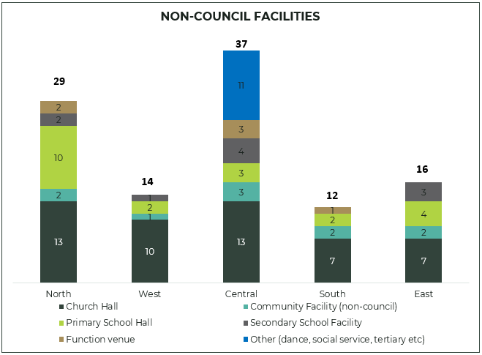

Figure 5.6 Distribution of Non-Council Community Facilities
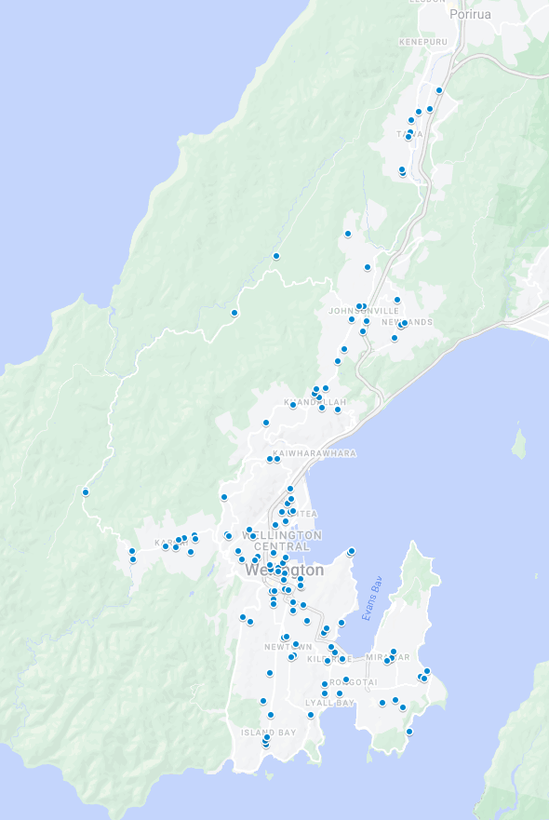

  - Regional Facilities
Community facilities can also serve a regional function beyond local residents. Figure 5.7 provides a map of the notable regional facilities with a summary of the regional functionality listed in Table 5.6.
Table 5.6 Notable Regional Community Facilities serving the Wellington Region
TYPE | FACILITY NAME | REGIONAL FUNCTION | TA
Libraries | Te Matapihi (Central library) | Special & heritage collections and regional attraction | WCC
Pools | Wellington Regional Aquatic Centre | 50m pool for national and regional aquatic events and 10m dive-tower | WCC
 | Naenae Pool & Fitness Centre | 50m pool for national and regional aquatic events | HCC
 | H20 Xtreme | Leisure water and regional attraction | UHCC
 | Te Rauparaha Arena & Aquatic Centre | Leisure water and regional attraction | PCC
Recreation Centres / Sport | Ākau Tangi Sports Centre | 12 courts, national indoor sports events | WCC
 | Walter Nash Centre | 5 courts, national indoor sports events | HCC
 | TSB Arena | 1 court. Major events only. | WCC
 | Renouf Tennis Centre | 4 indoor courts, 12 outdoor courts and 2 show courts and grandstand | WCC

Figure 5.7 Notable Regional Community Facilities
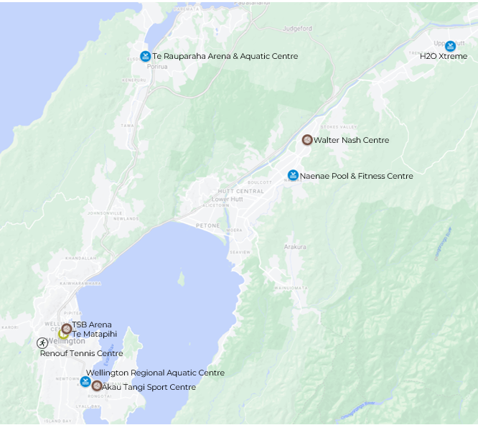

- COMMUNITY VIEWS & USER PROFILE
  - Overview
A sampled survey and four community surveys were undertaken between October and November 2022 to gather the views and input from the community. Each survey is summarised below.
Sample survey
When | Conducted by Dynata between 31 October and 21 November 2022.
Who | The survey collected a sample of 786 Wellington residents and 575 residents from Lower Hutt and Porirua.  The Wellington sample closely matched the profile of Wellington residents and has only been weighted where necessary.  The Lower Hutt and Porirua sample was open and is not weighted.
QUESTIONS | The sample survey asked questions about community use of community facilities (to determine user-profiles) and attitudes towards community facility provision across the population. This data was compared with other city-wide surveys conducted by the Council to provide comparative analysis.
margin of error | For the Wellington City sample of n=786 the maximum margin of error at the 95% confidence level is plus/minus 3.5%.  Given the Lower Hutt/Porirua sample is not a representative sample, calculating a margin of error is not feasible. But as a guide, the margin of error for a representative sample of n=575 at the 95% confidence level would be plus/minus 4.1%.
Lease Holder survey
When | The survey was conducted between 14 October and 7 November 2022.
Who | It was sent to all 131 organisations that hold either a premises or ground lease (under the scope of this mahi). We received a total of 78 responses but 10 were partials, so 68 fully completed the survey.
Questions | The survey collected data from organisations in leased facilities about the use, condition, fit-for-purpose assessment of their buildings, and their future aspirations.
Public engagement – three separate questionnaires
When | Three open questionnaires were hosted on the Council’s Kōrero Mai / Let’s Talk page between 1st to 29th November 2022.
Who | - General community facility questionnaire: 2,258 respondents.  - Specific community facility questionnaire: 1,040 respondents (feedback on a specific facility they have used or are interested in).  - Public toilet questionnaire: 992 respondents.
QUESTIONS | We asked for feedback on use of community facilities including their views on the benefits and suggestions for the future.
promotion | The three community surveys were promoted through:  Council social media challenges.  Posters and hard-copies at libraries, community centres, recreation centres, and swimming pools.  Promotion through Council’s membership lists: library card-holders, pool / recreation centre memberships and other lists.

  - Profile of Survey Respondents
Respondents by Ward
Figure 6.1 shows the ward of where respondents reside, from both the Wellington sample survey and the public community facility survey (open sample). There were slightly more responses from the Wellington sample survey in the Eastern Ward and less in the Western (these results were weighted to provide a balanced result). The public survey received more responses from the Western and less in the Northern.
Figure 6.1 Ward Location of the Survey Respondents
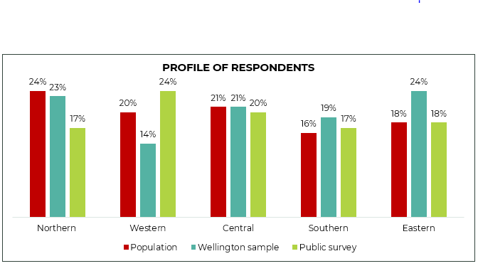
Respondents by Age
Figure 6.2 shows the age profile of respondents from both the Wellington sample survey and public survey. In the public survey, less responses were received from people 16-29 years, this is a common trend in surveys. Neither survey was open to respondents below 16 years, in-line with research ethics.
Figure 6.2 Age Profile of Respondents
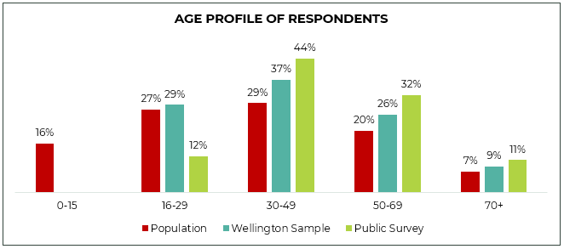

  - Users of Community Facilities
Figure 6.3 outlines the reported use of community facilities by respondents in the Wellington sample survey and the public community facility survey (open sample). The public survey was self-selecting, and consequently there is a higher proportion of users in comparison to the Wellington sample survey.
As the Wellington sample survey is a weighted sample that reflects the overall Wellington population, these survey results have been used to infer how the underlying Wellington population behaves in relation to community facilities. These results were compared against the 2022 Wellington Residents Monitoring Survey, which shows strong consistency in the reported use. Wellingtonian’s use of community facilities is on par or higher when compared with other New Zealand cities.
Figure 6.3 Use of Different Community Facilities as reported by Respondents in each Survey
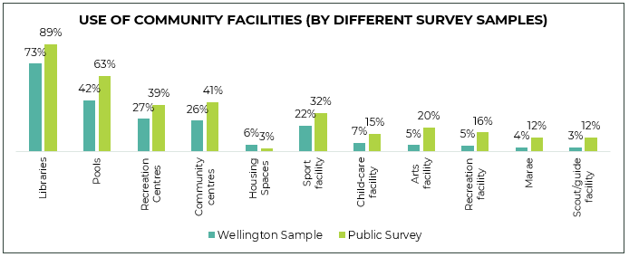
Use of community Facilities by ward
Figure 6.4 provides the indicative users of community facilities by ward compared to Wellington city overall. The following are the notable differences in facility engagement across the wards:
Northern ward – more likely to use community centres, marae and child-care facilities.
Western ward – more likely to use public toilets and libraries.
Central ward – less likely to use swimming pools and recreation centres.
Southern ward – more likely to use public toilets.
Eastern ward – more likely to use recreation centres.
Figure 6.4 Indicative user of Community Facilities by Wards (Sample Survey)
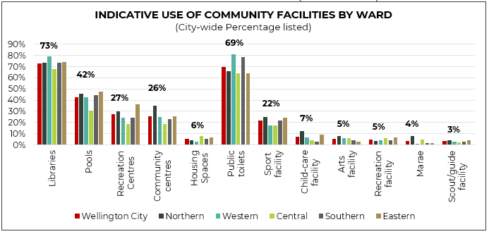

Tables 6.1 and 6.2 (following page) provide an overview of user profiles for each facility type. The data shows that the presence of children in the household is the most significant demographic factor across all community facility types. However, this doesn’t mean children are the primary driver for use of community facilities. Another question asked whether respondents visited for themselves, their children, other people or a combination. The majority of adult users visit community facilities for themselves, ranging from 87% for library users to 51% for recreation centre users. This potentially indicates households with children have higher awareness and higher motivation to use community facilities compared with households without children.
Table 6.1 User Profile of Facility Types and Key Demographic Differences in Users (Sample Survey)
FACILITY TYPE | PERCENTAGE OF WELLINGTON USING | KEY DEMOGRAPHIC DIFFERENCES
COMMUNITY CENTRES | 26%  Similar or slightly higher than other cities | - Mix of ages but tending older  - Mix of ethnicities  - Households with children <15 years  - More retired and less full-time workers
LIBRARIES | 73%  Similar to other cities | - Mix of ages and ethnicities  - Higher proportion of 40-49 year olds  - Households with children <15 years
SWIMMING POOLS | 42%  Higher than other cities | - Higher proportion of 40-49 year olds  - Lower proportion of 60+ years  - Higher proportion of Pasifika peoples  - Households with children <15 & >15 years  - Fewer single person households  - Fewer retired people
RECREATION CENTRES | 27%  Similar or slightly higher than other cities | - Households with children <15 years  - Higher proportion of Pasifika peoples  - Fewer single person households  - Lower proportion of 60+ years
COMMUNITY SPACES IN COUNCIL HOUSING ASSETS | 6%  No comparisons available | - Higher proportion of 18-29 years  - Higher proportion of Pasifika peoples & other ethnicities  - Households with children <15 years  - People with temporary disability  - People with part-time employment
MARAE  (GROUND LEASE) | 4%  No comparisons available | - Higher proportion of Māori and Pasifika peoples
LEASES: CHILDCARE | 7%  No comparisons available | - Higher proportion of 30-39 year olds  - Lower proportion of 60+ years  - Households with children <15 years  - Fewer retired people
LEASES:  CREATIVE FACILITIES | 5%  No comparisons available | - Mix of ages, ethnicities, households and employment status
LEASES: RECREATION FACILITIES | 5%  No comparisons available | - Households with children <15 years  - Households with children > 15 years  - Fewer single person households
LEASES: SCOUT/GUIDE FACILITIES | 3%  No comparisons available | - Households with children > 15 years
LEASES:  SPORT FACILITIES | 22%  (combined result)  No comparisons available | - Higher proportion of males and lower proportion of females  - Households with children > 15 years
LEASES:
MARINE FACILITIES
PUBLIC TOILETS | 69%  Similar or slightly higher to other cities | - Mix of ages, ethnicities, households and employment status

Table 6.2 Sampled Survey Data that supports the User Profile Summary in Table 6.1 (Blue numbers are significantly higher and red text significantly lower)
 | Libraries | Pools | Recreation  Centres | Community  centres | Housing  Spaces | Marae | Child-care | Arts | Recreation | Scout/guide | Sport | Public toilets
Wellington City | 73% | 42% | 27% | 26% | 6% | 4% | 7% | 5% | 5% | 3% | 22% | 69%
AGE
18-29 | 72% | 43% | 28% | 21% | 10% | 5% | 6% | 7% | 7% | 4% | 24% | 71%
30-39 | 74% | 50% | 31% | 28% | 7% | 4% | 14% | 7% | 4% | 3% | 20% | 69%
40-49 | 79% | 54% | 39% | 23% | 3% | 6% | 13% | 6% | 4% | 5% | 26% | 72%
50-59 | 67% | 33% | 23% | 25% | 2% | 0% | 2% | 3% | 4% | 3% | 18% | 64%
60+ | 73% | 30% | 15% | 34% | 2% | 1% | 1% | 2% | 6% | 1% | 18% | 69%
ETHNICITY
NZ European / Pākehā | 72% | 41% | 26% | 24% | 3% | 2% | 6% | 5% | 4% | 3% | 22% | 70%
Māori | 79% | 49% | 29% | 29% | 6% | 7% | 7% | 5% | 4% | 7% | 31% | 68%
Pasifika peoples | 73% | 66% | 46% | 33% | 19% | 15% | 18% | 5% | 11% | 2% | 37% | 59%
Asian | 83% | 39% | 26% | 28% | 5% | 4% | 9% | 6% | 5% | 3% | 22% | 61%
Other | 74% | 45% | 24% | 30% | 13% | 3% | 7% | 6% | 5% | 3% | 20% | 73%
DISABILITY STATUS
Permanent disability | 72% | 39% | 26% | 32% | 7% | 5% | 6% | 5% | 5% | 6% | 25% | 66%
Temporary disability | 85% | 52% | 41% | 34% | 21% | 6% | 13% | 9% | 7% | 3% | 25% | 72%
HOUSEHOLD COMPOSITION
House with Child <15Y | 84% | 71% | 50% | 33% | 10% | 4% | 23% | 6% | 8% | 6% | 31% | 73%
House with Child >15Y | 76% | 57% | 36% | 26% | 8% | 3% | 6% | 6% | 11% | 10% | 28% | 66%
GENDER
Male | 72% | 42% | 26% | 25% | 6% | 3% | 5% | 4% | 5% | 3% | 27% | 69%
Female | 74% | 43% | 29% | 27% | 5% | 4% | 9% | 7% | 5% | 4% | 17% | 70%
Another gender | 74% | 21% | 0% | 11% | 0% | 5% | 0% | 0% | 0% | 0% | 0% | 81%
Transgender | 80% | 33% | 54% | 39% | 11% | 0% | 0% | 0% | 11% | 7% | 22% | 100%
OCCUPATION
Work full-time | 71% | 42% | 28% | 21% | 4% | 4% | 7% | 5% | 5% | 3% | 22% | 69%
Work part-time | 84% | 50% | 32% | 32% | 16% | 2% | 9% | 8% | 3% | 3% | 25% | 80%
Student | 73% | 46% | 31% | 23% | 10% | 6% | 3% | 10% | 6% | 5% | 29% | 73%
Retired | 77% | 28% | 18% | 39% | 2% | 1% | 1% | 3% | 7% | 0% | 17% | 69%
Receive benefit | 71% | 44% | 15% | 25% | 7% | 5% | 2% | 1% | 2% | 0% | 24% | 69%

  - User Behaviours
Purpose of Visiting
As part of the sample survey, users of facilities listed the activities they undertook when visiting the facilities (these questions were only asked for Group A facility types). Table 6.3 provides the list of results for each facility type.
The notable differences in the activities undertaken by users at different community facilities are:
Community centres – primarily used for social interaction, obtaining advice, and participating in range of activities.
Libraries – primarily used to source books/information but also to relax/meet other people and access other resources like computers and wifi.
Swimming pools – primarily used for fitness, play, learning to swim and relaxing.
Recreation centres – primarily used for sport leagues, play, hiring space or fitness programmes.
Table 6.3 User Activities undertaken at Facility Types (Sample Survey)
COMMUNITY CENTRES
Social activity like drop-in lounge or community event 25%
Hire space or attend a private function 25%
Get advice, visit CAB or JP 22%
Arts, craft, music, performing arts activity 19%
Volunteer in community organisation 14%
Fitness programme like yoga 9%
Programmes for pre-schoolers, children or youth 9%
Programmes for seniors 8%
Health initiative like screening programme 6%

LIBRARIES
Browse / use books 72%
Read or relax 38%
Access computers / wifi 19%
Use a quiet, low sensory space 17%
Meet up with other people 14%
Study 15%
Entertain children 12%
Attend a programme or event like story-time 6%
Use special resources / equipment like a 3-D printer 6%

SWIMMING POOLS
Swim, aqua-jog, aqua-walk for my personal fitness 41%
Play around for fun or to cool off 36%
Learn to swim (either yourself or your children) 24%
Soak or relax in spa / sauna / steam-room 21%
Rehabilitate in warm water 10%
Use dry-fitness equipment or classes 7%
Participate in aqua-fitness class 5%
Participate in aquatic sport – training or competitions 4%

RECREATION CENTRES
Sports leagues 33%
Programmes for pre-schoolers, children or youth 28%
Casual drop-in play 24%
Hire space or attend a private function 21%
Fitness programme like yoga 15%
Wheeled sports 10%
Programmes for seniors 4%

Frequency of visiting
There are notable differences in the frequency of visiting between different types of community facilities, illustrated by Figure 6.5:
Swimming pools have the high frequency of visiting, with 38% visiting at least once a week or more.
Libraries are most frequently visited on a monthly basis (which aligns with typical library loan periods of 3-4 weeks).
Recreation centres have regular weekly users and infrequent users visiting every six months or less.
Community centres have predominantly infrequent users visiting every six months or less.
Figure 6.5 Frequency of Users Visiting to Facility Types (Sample Survey)

Mode of Transport
There are notable differences in the mode of transport used between facility types, illustrated by Figure 6.6:
Libraries and community centres have higher proportion of visitors walking/running. Although a good proportion of community centre users also visit by car.
Swimming pools and recreation centres have higher proportion of visitors travelling by car.
Users of libraries and recreation centres have the greatest use of public transport.
Figure 6.6 Mode of Transport Visiting to Facility Types (Sample Survey)

  - User Challenges
Facility users in both surveys were asked if they experienced any challenges in using community facilities Overall, most respondents reported they did not experience any challenges, or they were personally too busy as illustrated in Table 6.4 below. Of the respondents that did report they experienced challenges, there are notable differences between facility types, as follows
Users of swimming pools report the facility is too busy (both surveys).
Users of pools and recreation centres are more likely to site financial reasons as a challenge.
Users of libraries report the opening hours are not convenient for them.
Users in the public survey are seeking a greater range of offerings at all facility types.
Users of swimming pools, recreation centres and community centres in the public survey report the poor appearance of the facilities is impacting their use.
Table 6.4 Challenges experienced by Facility Users (Sample and Public Survey).
 | Libraries |  | Pools |  | Recreation  Centre |  | Community  Centre
Survey | Sample | Public | Sample | Public | Sample | Public | Sample | Public
Personally too busy | 24% | 13% | 23% | 14% | 13% | 10% | 16% | 10%
Facility too busy | 6% | 5% | 24% | 32% | 11% | 15% | 4% | 3%
Financial reasons | 4% | 0% | 14% | 8% | 10% | 4% | 7% | 2%
Opening hours | 12% | 21% | 11% | 16% | 6% | 7% | 10% | 6%
Range of offerings | 8% | 16% | 8% | 15% | 8% | 12% | 9% | 12%
Poor appearance | 6% | 6% | 9% | 15% | 8% | 11% | 8% | 14%
Not inclusive &  accessible for needs | 2% | 3% | 5% | 5% | 4% | 3% | 1% | 3%
Unwelcoming | 4% | 3% | 4% | 4% | 5% | 3% | 4% | 4%
Other | 6% | 9% | 5% | 10% | 1% | 5% | 4% | 4%
No challenges | 45% | 51% | 38% | 34% | 55% | 51% | 53% | 61%

  - Non-Users
Non-users of community facilities were asked in both surveys why they did not use community facilities. Overall, most non-users report they are not interested, personally too busy, or the facility is not relevant to them right now (in their life-stage). The notable differences in why non-users don’t use specific facility types are listed in Table 6.5. The results from both surveys are shown in Table 6.6.
Table 6.5 Key Differences in Reasons for Not Using between Facility Types (Sample and Public Survey)
COMMUNITY CENTRES
Lack of awareness of the facilities (written commentary indicates this relates to where they’re located and what community centres offer).
Don’t offer the range of offerings (written commentary indicates this relates to range of programmes offered or design of the facility suitable for activities such as heating, flooring).
LIBRARIES
Don’t offer the range of activities to meet non-users’ needs.
Opening hours are not convenient.
Locations are not convenient, or no facilities close by.
SWIMMING POOLS
Confidence to use swimming pools.
Quality / appearance of swimming pools.
Pools are too busy.
Financial reasons / barriers.
RECREATION CENTRES
Lack of awareness of the facilities (written commentary indicates this relates mostly to where they’re located and some uncertainty about the distinction between recreation and community centres).
Don’t offer the range of activities desired to meet non-users’ needs.
Locations are not convenient, or no facilities close by.
Financial reasons / barriers.

Table 6.6 Reasons for Not Using Community Facilities (Sample and Public Survey)
 | Libraries |  | Pools |  | Recreation Centres |  | Community Centres
Survey | Sample | Public | Sample | Public | Sample | Public | Sample | Public
No interest | 27% | 22% | 40% | 25% | 44% | 24% | 44% | 19%
Personal too busy | 29% | 22% | 26% | 17% | 24% | 12% | 24% | 11%
Not relevant right now | - | 31% | - | 39% | - | 59% | - | 58%
Don't feel welcome | 5% | 4% | 7% | 5% | 4% | 3% | 5% | 2%
Don't offer range | 13% | 6% | 4% | 4% | 9% | 7% | 7% | 8%
Facility too busy | 4% | 2% | 9% | 11% | 3% | 2% | 2% | 1%
Financial reasons | 2% | 0% | 11% | 7% | 9% | 4% | 4% | 1%
Lack of awareness | 4% | 1% | 3% | 1% | 12% | 13% | 15% | 17%
Lack of confidence | - | - | 16% | 14% | 6% | - | 6% | -
No facilities close by | 9% | 15% | 11% | 11% | 8% | 8% | 3% | 3%
Not inclusive or accessible | 3% | 4% | 2% | 3% | 2% | 2% | 2% | 1%
Opening hours | 8% | 12% | 3% | 2% | 3% | 1% | 3% | 3%
Facility appearance/quality | 7% | 8% | 13% | 8% | 3% | 3% | 3% | 4%
Use other facilities | 9% | 9% | 4% | 6% | 8% | 5% | 4% | 4%
Other reasons | 20% | 26% | 11% | 15% | 8% | 6% | 8% | 5%

  - Community Facility Satisfaction
Users and non-users were asked to rate their satisfaction with community facilities (the sample survey only asked satisfaction for Group A facilities). The results are outlined in Tables 6.7 and 6.8. This show there is high satisfaction with community facilities, with less than 10% of respondents reporting dissatisfaction across community facilities. Respondents of the public survey are more satisfied compared to the sample survey, due to the greater proportion of users in the public survey.
Table 6.7 Satisfaction with Community Facilities (Both Surveys)
 | Libraries |  | Pools |  | Recreation Centre |  | Community Centre
Survey | Sample | Public | Sample | Public | Sample | Public | Sample | Public
Very dissatisfied | 2% | 2% | 2% | 1% | 3% | 1% | 1% | 1%
Dissatisfied | 4% | 4% | 4% | 6% | 4% | 3% | 5% | 2%
Neutral | 19% | 8% | 24% | 13% | 23% | 17% | 23% | 21%
Satisfied | 52% | 36% | 57% | 53% | 49% | 52% | 51% | 49%
Very satisfied | 23% | 50% | 13% | 27% | 20% | 27% | 21% | 27%
Table 6.8 Satisfaction with other Community Facilities (Public Survey)
 | Very dissatisfied | Dissatisfied | Neutral | Satisfied | Very satisfied
Sports facilities | 2% | 3% | 32% | 55% | 8%
Recreation facilities | 1% | 2% | 33% | 55% | 9%
Scouts/guides facilities | 2% | 8% | 40% | 44% | 7%
Arts facilities | 1% | 2% | 32% | 55% | 10%
Cultural facilities | 0% | 2% | 34% | 56% | 7%
Childcare facilities | 1% | 2% | 27% | 49% | 21%
Marae | 0% | 0% | 22% | 60% | 18%
Housing space | 4% | 6% | 35% | 33% | 21%

  - Benefits of Community Facilities
Users and non-users were asked to rate the importance of community facilities for different purposes, which provides an indication of the benefits of community facilities. The results from the sample and public surveys are listed in Table 6.9 which shows each facility type performs a specific role as well as generic roles.
Table 6.9 Benefits of Facility Types (Sample Survey)
COMMUNITY CENTRES | Sample | Public
Free, safe and warm place | 3.7 | 4.1
Support volunteering | 3.7 | 4.2
Space to hire or hold events | 3.5 | 4.0
Connect / socialise with others | 3.5 | 4.0
Foster creative development | 3.5 | 4.0
Get advice or support | 3.5 | 3.8
Have fun and play around | 3.1 | 3.7
Improve fitness, health & wellbeing | 3.1 | 3.4

LIBRARIES | Sample | Public
Access to information & learning | 4.0 |  | 4.3
Free, safe, and warm place | 4.0 |  | 4.2
Place to study, read, or relax | 3.9 |  | 3.9
Place for tamariki and whānau | 3.5 |  | 3.9
Place for rangatahi | 3.3 |  | 3.7
Access to resources | 3.7 |  | 3.5
Get advice and support | 3.1 |  | 3.3
Participate in programmes or events | 2.8 |  | 3.1
Connect/socialise with others | 2.7 |  | 3.1
Place to have fun | 2.8 |  | 3.0

SWIMMING POOLS | Sample | Public
Learn to swim | 4.1 | 4.4
Improve fitness, health, and wellbeing | 3.8 | 4.3
Support in-water rehabilitation | 3.6 | 4.1
Have fun and play around | 3.5 | 4.0
Relax and de-stress | 3.5 | 3.9
Support athlete development | 3.3 | 3.6
Enable aquatic sport events | 3.3 | 3.6
Participate in aquatic sports | 3.2 | 3.6
Connect/socialise with others | 3.0 | 3.3

RECREATION CENTRES | Sample | Public
Improve fitness, health, and wellbeing | 3.4 | 4.0
Have fun and play around | 3.4 | 4.0
Enable sport events | 3.6 | 3.9
Participate in sport leagues/games | 3.3 | 3.8
Connect/socialise with others | 3.5 | 3.7
Support physical rehabilitation | 3.4 | 3.7
Support athlete development | 3.3 | 3.6

COMMUNITY SPACES IN HOUSING | Sample | Public
Bring the community together | - | 4.1
Connect / socialise with others | 3.1 | 4.0
Social space for tenants | 3.2 | 4.0
Have fun and play around | 2.9 | 3.8
Space for functions and events | 2.9 | 3.8
Improve fitness, health & wellbeing | 2.8 | 3.5
Free, safe and warm place | 3.4 | -

LEASE FACILITIES | Sample
Support children and youth development | 3.6
Support community organisations and volunteering | 3.5
Connect / socialise with others | 3.4
Improve fitness, health & wellbeing | 3.4
Foster arts, culture, music, and creative development | 3.4
Space to hire or hold events | 3.3
Have fun and play around | 3.2
Support sport and athlete development | 3.2
  - Ranking of Future Ideas
Users and non-users were asked to rank potential future ideas for community facilities. The weighted results (weighted rankings) from the sample and public surveys are provided in Table 6.10. The results indicate a strong desire to improve current facilities rather than increasing / decreasing provision and to expand the benefits of current facilities through longer opening hours, promoting more and providing for a wider range of needs.
Table 6.10 Ranking of Future Provision Ideas (Sample & Public Survey & Lease Facility Survey)

COMMUNITY CENTRES | Sample | Public
Promote more | 79% |  | -
Improve appearance & quality | 62% |  | 78%
Improve accessibility for wider range of needs | 58% |  | 68%
Extend opening hours | 55% |  | 64%
Provide more larger spaces | 55% |  | 57%
No change | 52% |  | 55%
Increase number of centres | 48% |  | 47%
Consolidate centres | 41% |  | 31%

LIBRARIES | Sample | Public
Extend opening hours | 69% | 73%
Improve appearance & quality of libraries | 64% | 70%
Improve accessibility for wider range of needs | 62% | 67%
No change to library provision | 48% | 48%
Increase number of libraries | 51% | 47%
Consolidate libraries & build bigger libraries | 56% | 45%

SWIMMING POOLS | Sample | Public
Improve the appearance & quality of pools | 63% | 76%
Improve accessibility for wider range of needs | 61% | 68%
More hydrotherapy & relaxation pools | 68% | 64%
More play and fun pools | 61% | 64%
Another 50m pool | 50% | 52%
Increase the number of swimming pools | 52% | 50%
No change in pool provision | 53% | 46%
Consolidate number of swimming pools | 43% | 31%

RECREATION CENTRES | Sample | Public
Improve appearance/quality | 61% | 68%
Provide a wider range of experiences | 71% | 76%
Improve accessibility for wider range of needs | 61% | 67%
Provide more indoor courts | 56% | 56%
No change | 56% | 54%
Increase number of recreation centres | 50% | 47%
Consolidate number of recreation centres | 45% | 34%

COMMUNITY SPACES IN HOUSING ASSETS | Sample | Public
Provide more programmes in spaces | 61% | 87%
Promote community spaces more | 71% | 76%
Improve appearance/quality/welcoming feel | 59% | 62%
No change | 56% | 55%
Increase number of community spaces | 47% | 45%
Improve accessibility for wider range of needs | 55% | 24%

LEASE FACILITIES | Sample | Lessees
Promote facilities more | 72% | 70%
Improve appearance/quality/ feel | 56% | 66%
Improve accessibility for wider range of needs | 55% | 61%
No change | 52% | 58%
Share facilities to improve usage | 71% | 54%
Consolidate number and build multi-purpose facilities | 44% | 41%

  - Willingness to Travel
Respondents to both surveys were asked to indicate how far was acceptable to travel to the Group A community facilities, with the results outlined in Figure 6.10.
The results bear a strong similarity to the current level of provision, where a higher proportion of respondents indicate an expectation to travel a shorter distance to libraries and community centres, which have more facilities in Wellington. In contrast there is a willingness to travel further to swimming pools and recreation centres, which are fewer in number in Wellington.
Figure 6.10 Respondents expectations on the distance to travel to Community Facilities (Sample Survey)

  - Community Facility Hubbing
Both surveys asked respondents to indicate their preference for community facility hubs, such as Waitohi. The results of the surveys are illustrated in Figure 6.11. The results indicate a preference towards a hubbing approach:
55% of the sample survey respondents have a greater preference for multi-purpose hubs (this survey provides a balanced perspective across Wellingtonians due to its sampling approach) as opposed to 19% of the sample survey who have a preference for single purpose.
44% of the public survey respondents favour multi-purpose hubs (this survey more strongly represents the perspectives of current community facility users).
There is little differentiation between the users of different community facility types.
Figure 6.11 Preferences for Community Facility Hubbing (Sample and Public Surveys)
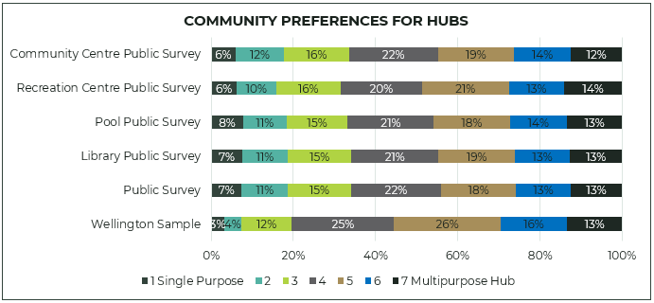

- FINANCIAL PICTURE
  - Value of Community Facilities
The Council has a community facility portfolio based on a current capital value of $420 million. This current value is based on the residual value of Council-owned swimming pools, libraries, community centres, recreation centres and premises leases. This does not include current capital expenditure such as on Te Matapihi Central Library rebuild.
  - Current Operating Costs
The total cost of delivering libraries, community centres, swimming pools and recreation centres (49 facilities) including those funded by the Council is approximately $64 million in 2021/22. This includes operating costs after deducting user revenue. Figure 7.1 provides the net operating cost of the four community facility types. Libraries and swimming pools make up 78% of the operating costs, due to the large operating and staffing costs of these facilities.
Across all facilities, there has been 37% escalation in operating costs over the last seven years, driven by increasing staff costs, greater maintenance and declining revenue due to the Covid-19 pandemic.
There are other costs associated with lease facilities, community spaces in Council’s housing assets and public toilets. These costs are included in the Council’s overall budgets for parks, open-space and housing assets. It is difficult to isolate the cost of delivering these facilities.
Figure 7.1 Net Operating Cost of Community Facilities

Table 7.1 provides an overview of the 2021/22 operating costs compared with facility visits and the indicative level of usage (see Table 5.2 and Section 6.3). This shows despite the high level of visits to and the high number of users of libraries and swimming pools, the cost per visit and per indicative number of users are still the highest across all community facilities.
Table 7.1 Overview of Operating Costs compared with Facility Visits and Indicative Users
 | 2022 NET COST | 2022 Visits | Cost/Visit | indicative user | cost per indicative user
Libraries | $29,176,727 | 1,115,371 | $26.16 | 147,998 | $197
Community centres | $5,999,127 | NA | - | 52,712 | $114
Swimming pools | $20,901,421 | 860,195 | $24.30 | 85,150 | $245
Recreation Centres | $7,797,606 | 803,715 | $9.70 | 54,739 | $142
Breakdown of Operating Expenditure
Figure 7.2 provides a breakdown of community facility operating costs across libraries, swimming pools, community centres and recreation centres. The trends are highlighted as:
Decrease in operating revenue of 22%, largely due to the impact of the Covid-19 pandemic.
Increase in personnel costs of 28%, largely as a result of inflation on salaries and wages and some increases in staff levels.
Increase in operating costs of 1%, due to inflation on aspects like energy and maintenance.
Increase in depreciation of 94%, due to increasing maintenance expenditure on community facilities.
Increase in allocations of 25%, which covers overhead costs such as technology, human resources, marketing and administration.
Overall, the net cost of operations has increased by 45% in six years.
Figure 7.2 Breakdown of Operating Costs across all Community Facilities

Share of Revenue
The majority of revenue is generated by swimming pools, accounting for around two-thirds of community facility revenue, followed by recreation centres accounting for approximately 25%.
As eighteen of the community centres are operated by independent organisations, there will be revenue generated by these facilities that is not included in the revenue category but will be recognised as part of the net-grant provided to these facilities by the Council to subsidise operations.

  - Projected Operating Costs
The Council provided the projected operating costs for community facilities based on the 2021-31 Long-term Plan (LTP) projections, shown in Figure 7.3. The graph shows there is little growth signalled in future operating costs (noting inflation costs are addressed in the overall Long-term Plan). This indicates there is little capacity to improve the current provision, therefore it is likely additional investment will be required over what is currently planned.
Figure 7.3 Actual and Projected Net Operating Costs for Community Facilities (2021-31 LTP)

Financial Reflections
Currently there is a constrained financial environment for most local authorities, Wellington is no different. As part of the development of Te Awe Māpara (the Plan), there will need to be improvement in the financial performance of community facilities while also addressing the key needs identified in this needs analysis. Wellington City Council will need to proactively and carefully plan future provision of community facilities, so any future investment is realistic in the context of Council’s overall financial constraints, but also addresses the projected cost of operations and recognises opportunities for more sustainable/efficient operations. This will require careful consideration on how to get more from existing facilities but also considering optimisation in some circumstances.

- SUPPLY & DEMAND MODELLING
  - Overview
Market Economics completed supply and demand modelling for the Group A facilities (libraries, community centres, swimming pools and recreation centres). The purpose is to understand the catchments and capacity of current provision and consider the changing demand associated with future population growth. The detailed analysis is outlined in the Market Economics’ companion report titled Community Facilities Plan Modelling and Supporting Analysis and also summarised in the companion reports for each of the Group A facilities. This section provides an overview of the analysis and the key findings.
Figure 8.1 summarises the methodology for the supply and demand modelling (refer to Section 1.4 for the detailed methodology including the limitations and constraints).
Some facilities had a very small sample within the GPS data set, which limited the modelling but also indicates low interaction with these facilities. Some facilities located on schools could not be modelled as it was not possible to distinguish the school data from the facility data. For these facilities, the GPS data was supplemented with data from similar facilities (where possible).
Figure 8.1 Overview of Supply and Demand Modelling

GPS DATA SET: people’s interaction with individual facilities
SPATIAL MODELLING & DISTANCE DECAY: spatial relationship between where people live and the facilities they visit
FACILITY CATCHMENT AREAS: patterns used to indicate the primary geographic area a facility serves.
CATCHMENT SIZE & GROWTH: calculate the current (2018 Census) and future 2043 population in each catchment area.
OVERLAPPING CATCHMENTS: facilities compete for users. Relative facility attractiveness applied to allocate users to each facilities.
The modelling is intended to provide a high-level overview of the supply and demand of community facilities and has been used to identify potential geographic gaps and overlaps in provision and where there may be capacity constraints. This is the first level analysis applied at the macro level across the city. The purpose is to identify the areas and facilities where more detailed and refined analysis is required. Importantly at this level, the model can identify potential issues that need to be considered further. It is only at the detailed level we can understand the reasons and therefore consider the appropriate response.

  - Distance Decay
The collective distance travelled by users to each facility type is illustrated in Figure 8.2. This provides a collated view of people’s interaction with their ‘chosen’ facility.
There is a strong correlation between provision and distance travelled, with libraries and community centres drawing a larger proportion of users from a closer distance compared to swimming pools and recreation centres where a larger proportion of users are from a further distance, as outlined in Table 8.1.
Figure 8.2 Distance Decay Curve for Facility Types

Table 8.1 Distance Decay for Facility Types – Percentage of Users living in each distance
 | Within 5km | within 10kms | more than 10kms
Libraries | 54% | 76% | 24%
Community Centres | 54% | 72% | 28%
Swimming Pools | 37% | 66% | 34%
Recreation Centres | 37% | 60% | 40%

The distance decay analysis follows a similar pattern to the level of provision and community willingness to travel, illustrated in Section 6.10. Greater provision (number) of libraries and community centres has resulted in people travelling less distance compared to swimming pools and recreation centres.

  - Facility Catchments
The following maps show people’s interactions with each facility type and the primary catchment areas determined for each individual facility (catchment population sizes are based on 2018 Census results). The full-size maps are included in the Market Economics companion report and Group A facilities companion reports.
The following observations are made about the catchments of each facility type.
COMMUNITY CENTRES:
The visitor interaction map shows less dense interactions, this correlates with the lower proportion of people engaging with community centres (26%).
There are significant catchment overlaps, particularly in the Western and Central areas. This indicates users, and demand, are spread between community centres.
Due to the number of facilities, the catchment sizes are relatively small, particularly in comparison to other cities.
Smallest primary catchment captures 1,781 people.
Largest primary catchment is 23,263.
Average primary catchment size has 10,185 people.
LIBRARIES
The visitor interaction map shows greatest density of interactions, which reflects the higher proportion of people engaging with libraries (73%).
There are some catchment overlaps, particularly in the Western and Central areas where the libraries are smaller and located in close proximity.
Smallest primary catchment captures 5,169 people.
Largest primary catchment is 49,775 which is the Central Library.
Excluding the large central library catchment, the average primary catchment size is 19,173 people.
SWIMMING POOLS
The visitor interaction map shows a greater density of interactions, which reflects the higher proportion of people engaging with pools (42%).
There are minimal catchment overlaps.
Smallest primary catchment captures 36,774 people.
Largest primary catchment is 53,897 people.
Average primary catchment size has 41,687 people.
Note modelling for swimming pools was undertaken across four functions: structured, learning, leisure and hydrotherapy. This report summarises the indoor pool provision only – the other aquatic functions are outlined in the Swimming Pool Companion Report.
RECREATION CENTRES
The visitor interaction map shows less density of interactions, which reflects the lower proportion of people engaging in recreation centres (27%).
There are minimal catchment overlaps and a gap in provision has been identified in the Northern area between Nairnville and Tawa Recreation Centres.
Smallest primary catchment captures 23,436 people.
Largest primary catchment is 109,961 people.
Average primary catchment size has 53,765 people.

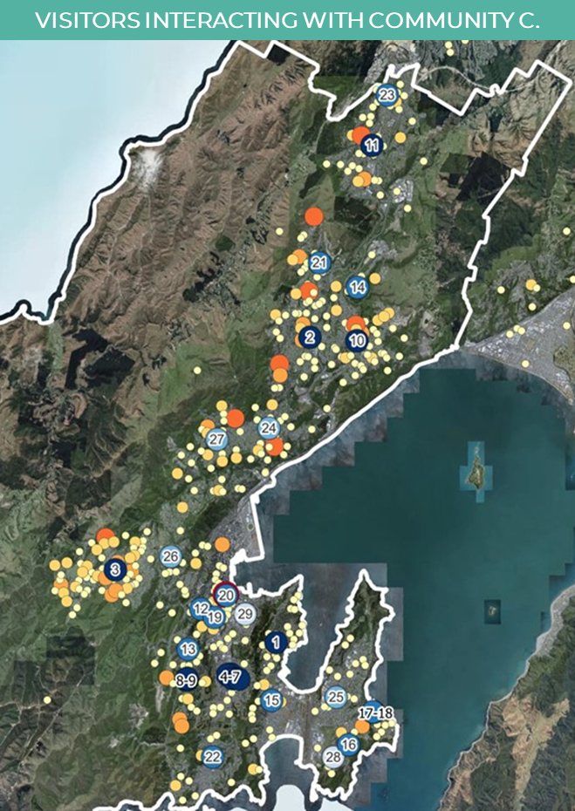 | 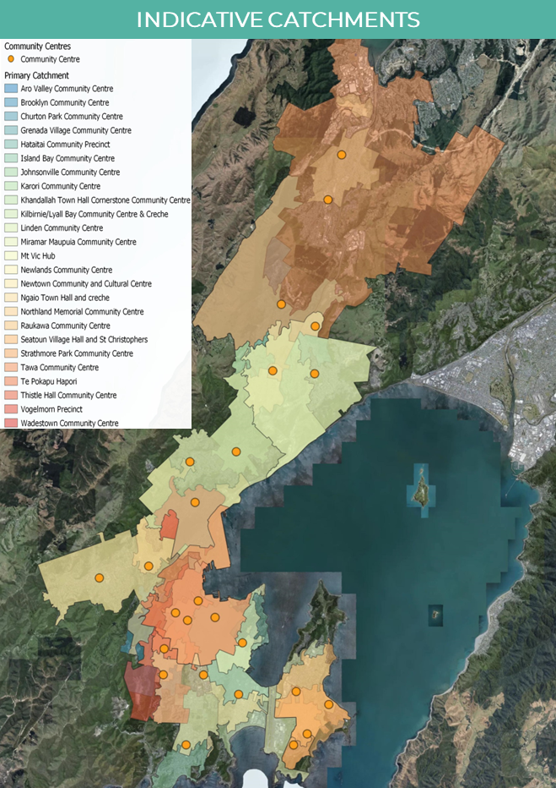
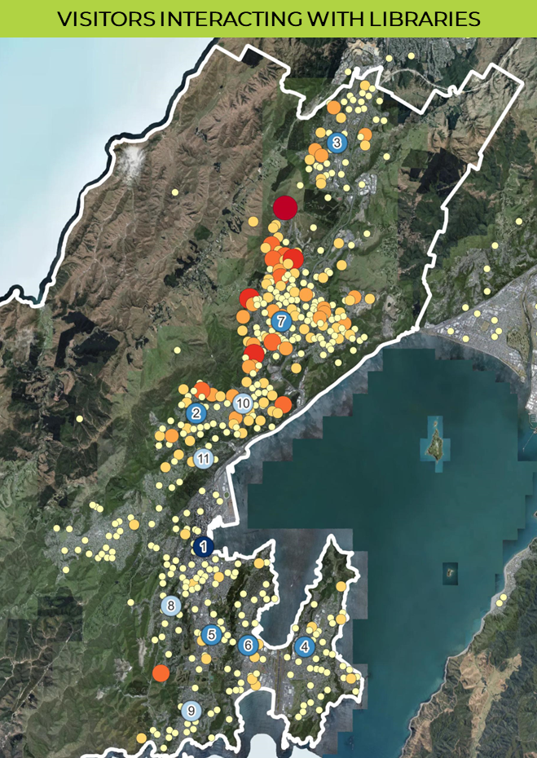 | 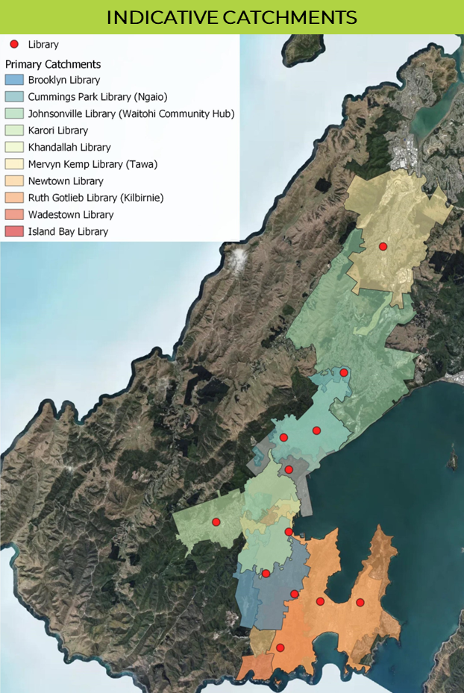
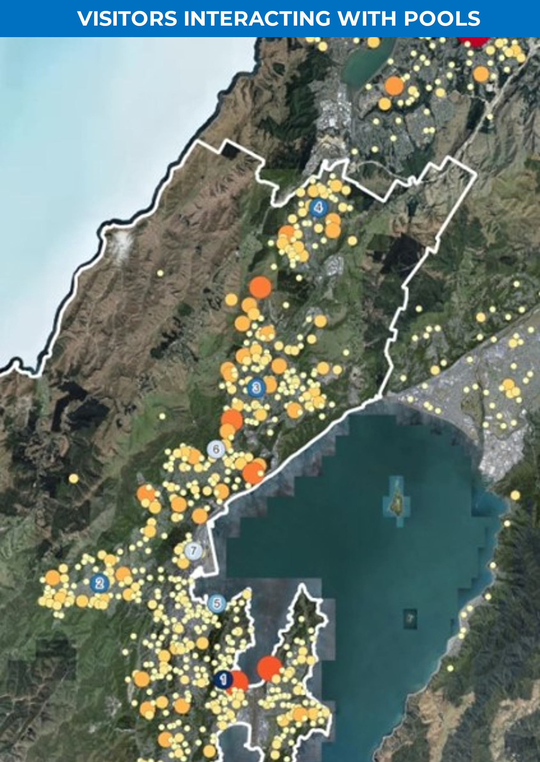 | 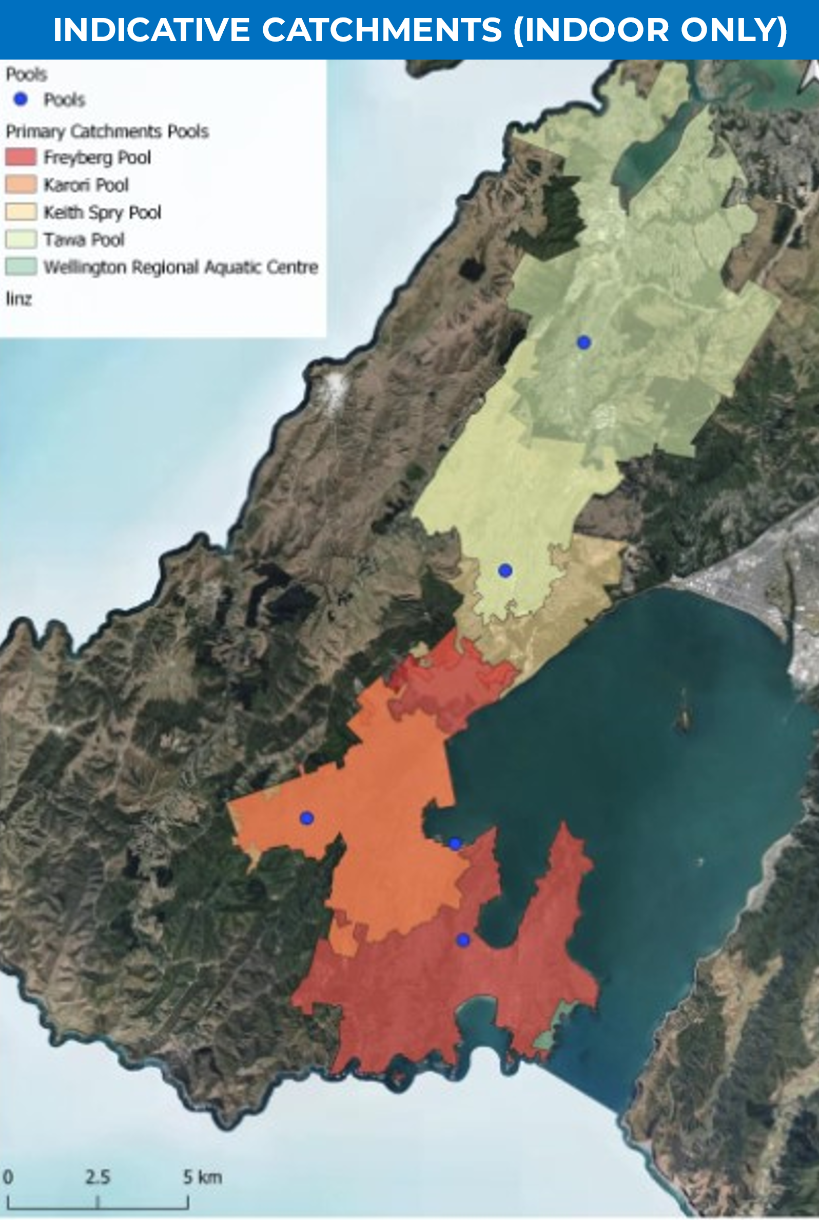
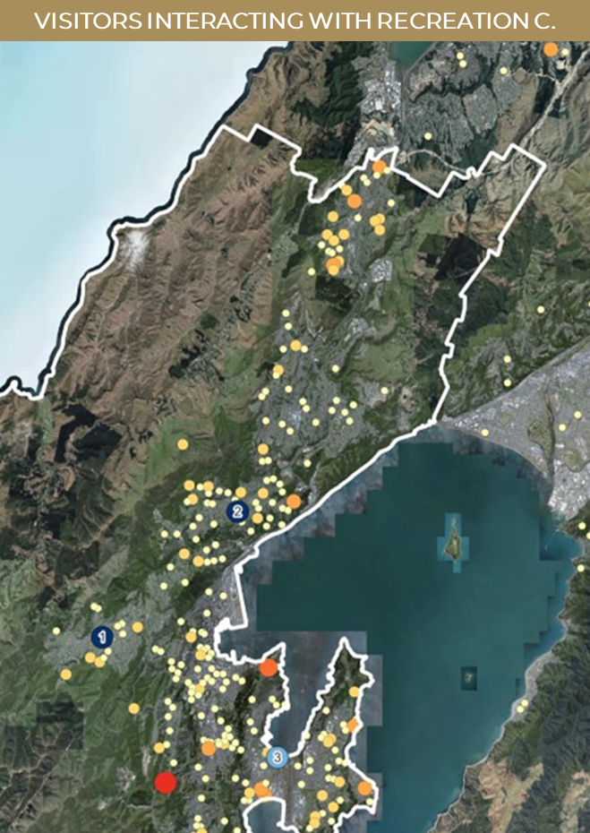 | 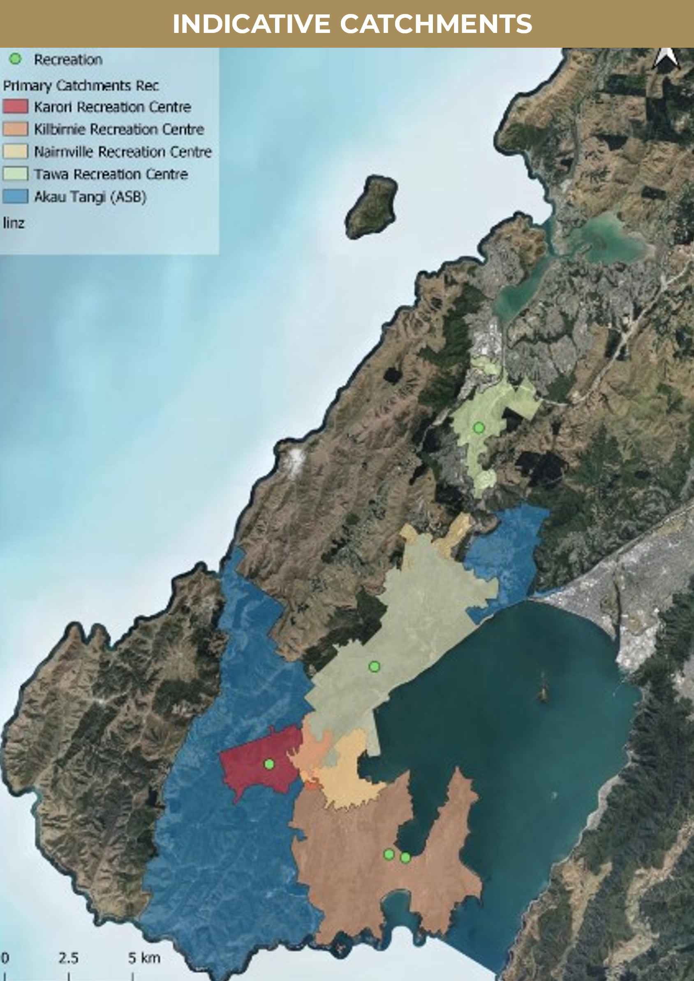

  - Impact of Population Growth
A key objective of the supply and demand modelling was investigating the level of population growth projected in each facility catchment. Population growth within the catchment is a potential source of increased facility demand. Where a facility is already under demand pressure, this can indicate the need for increased capacity.
Figures 8.3 to 8.6 outline the current facility catchment (based on 2018 Census) and projected growth to 2043, with the percentage growth indicated. The modelling indicates all community facilities will experience some level of growth in their primary catchments. Particular facilities likely to experience demand pressure given the current level of use / facility capacity are:
Community centres: Tawa and Linden; Central: Mt Vic Hub, Thistle Hall and Te Pokapū Hapori.
Libraries: Tawa and Newtown Libraries.
Swimming pools: Tawa, Keith Spry and Freyberg Pools.
Recreation centres: Tawa and Nairnville Recreation Centres.
Figure 8.3 Community Centre Primary Catchment Modelling including Growth

Figure 8.4 Libraries Primary Catchment Modelling including Growth

Figure 8.5 indoor Swimming Pool Primary Catchment Modelling including Growth

Figure 8.6 Recreation Centre Primary Catchment Modelling including Growth

  - Catchment Size & Building Size
The analysis compared the size of the building relative to the catchment size to consider whether the quantity of provision is suitable for the catchment population. It is important to state upfront, there are no prescribed levels of provision for different community facility types. However, to assist with this assessment, upper and lower bandings are drawn on the graphs (in dotted red lines). The bandings were calculated as the low and high average across the facility type in Wellington.
Community Centres
Figure 8.7 Community Centre Catchments and Building Footprint per Catchment Size

Figure 8.7 shows there are significant variations in the size of community centres relative to the catchment population. There are a number of reasons for these variations, including:
The building was acquired and repurposed into a community centre rather than being designed and sized specifically for catchment, for example Seatoun is a repurposed church facility and Te Pokapū Hapori is a repurposed commercial building.
The building was developed a long time ago and reflects the needs present at the time of construction, for example Northland Community Centre.
The application of different community centre models, for example Mt Vic Hub uses a range of spaces across the community and the office is used to coordinate the activities.
Across all community facilities but particularly community centres (due to the number of centres) it is important to take a holistic view across facilities within a suburb rather than considering each facility in isolation. The overlapping catchments of community centres indicate multiple facilities are serving each communities. People in these communities may access multiple facilities due to the programmes or spaces available at different community centres.
As an indicative guide only, the level of community centre provision has been banded between 30 to 60 square-metres per 1,000 people (calculated as the low and high average of current provision). Community centres below or above these bandings are potentially too small/large for the catchment they are serving, but this needs deeper analysis to consider all facilities across the catchment, community needs and functionality before it can be determined if the size of facility needs to change.

LIBRARIES
Figure 8.8 Library Catchments and Building Footprint per Catchment Size

In the early 2000s, an indicative national provision level of 41 square-metres per 1,000 people was developed for library provision. The provision level was developed prior to the evolution of libraries from book repositories to interactive community roles and therefore may be too low. However, it provides a useful starting point to assess the quantity of provision.
Figure 8.8 shows most Wellington suburban libraries are relatively small for the catchment population, with only Waitohi Hub in Johnsonville above 41 square-metres for its catchment population. A key conclusion from the analysis is Wellington has many library sites but insufficient library footprint.
As an indicative guide only, the level of library provision has been banded between 35 to 55 square-metres per 1,000 people (calculated as the low and high average of current provision).
Swimming Pools
Figure 8.9 Indoor Swimming Pool Catchments and Indoor water-space per Catchment Size

The catchment analysis for swimming pools has been broken down by aquatic functions: structured, learning, leisure and hydrotherapy. Due to the availability of data only indoor swimming pools could be analysed. Figure 8.9 provides the catchment area for the indoor swimming pools (based on the structured function).
The key conclusion is indoor aquatic provision is pressured in Wellington and will become increasingly pressured in the future, particularly leisure and hydrotherapy provision.
Further analysis of the aquatic functions is outlined in the Swimming Pool Companion Report.
Recreation Centres
Figure 8.10 Recreation Centre Catchments and Building Footprint per Catchment Size

Provision analysis for recreation centres indicates Nairnville and Kilbirnie Recreation Centres have low levels of provision and may need additional capacity to cater for growth.
Like other facility types there is no defined level of provision for recreation centres, however there are national guides for number of indoor courts required (these are considered in the Recreation Centre Companion Report).
Using indicative low and high bandings (calculated as the low and high average across Wellington’s recreation centre provision), Figure 8.10 shows the four community-based recreation centres have small footprints for the catchment being served. Combined with the finding there is a potential gap in recreation centre provision, this indicates there is insufficient capacity in the recreation centre network to meet current needs and growth.
As an indicative guide only, the level of recreation centre provision has been banded between 30 to 40 square-metres per 1,000 people (calculated as the low and high average of current provision).

- KEY FACILITY FINDINGS
This section draws together the key findings for each facility type, drawing on data included throughout this Needs Analysis Report. Detailed information on each facility type is included in the Companion Report for the relevant facility type.
  - Community Centres
STRATEGIC
Valued as a welcoming place to visit, supporting community organisations and as spaces to hire, get advice and participate in a range of activities.
PROVISION
There are 25 community centre sites, across 32 buildings totaling an approximate footprint of 11,288m².
There is a mixed model of delivery, building ownership and outcomes.
One community centre per 8,000 people. Other cities have provision of one centre per 10,000 to 15,000.
Average size is 464m² but the buildings range in size from a 25m² drop-in centre to a 1,217m² multi-room centre with a large hall.
Small facilities lack the flexibility to cater for a range of needs.
More than half the community centres are based in repurposed buildings.
Two thirds of the buildings require fit-for-purpose improvements.
There is significant variation in the focus and delivery models between centres. Some operate primarily as a venue for hire while others deliver a proactive range of programmes.
There are a number of non-Council facilities providing similar functions.
Sites with substantial fit-for-purpose issues: Wadestown, Johnsonville, Island Bay and Tawa.
Sites potentially constrained by size: Kilbirnie/Lyall Bay, Churton Park, Island Bay and four centres in the central city.
USER PROFILE
Around 26% of the population visit, on par with other cities.
Used by a cross-section of population, but higher engagement from households with children and retired people.
Community centres are selected for where they are, type of spaces available and what is on offer.
There is a lower proportion of people travelling to centres by car, compared to other community facilities in Wellington
UTILISATION
There is no consistent data collection across all community centres, so it is difficult to assess and compare utilisation.
From the data available, occupancy and visits range from very low to high.
The larger and more flexible facilities appear to have better utilisation.
Limited collaboration across community centres and with other facilities.
COMMUNITY VIEWS
Generally there is high satisfaction and they are highly valued by users.
Non-users cite a lack of awareness as a key reason for not using. This includes long-term residents who weren’t aware or didn’t understand the role of community centres.
Users would like to see a greater range of offerings at community centres, along with improving the quality and appearance of facilities.
Desire to promote more and consider extending the opening hours.
CATCHMENT MODELLING
Catchment populations average around 10,000 people.
There are some small catchments, like Wadestown at just under 2,000 and a few larger like Tawa at 20,000.
There are significant overlapping catchments, which means facilities are competing with each other within catchment areas.
A number of facilities may not be able to accommodate growing demand: Tawa, Churton Park, City Centre, Island Bay and Kilbirnie/Lyall Bay.
KEY FINDINGS
Wellington has more than enough facilities but many are not fit-for-purpose including location, size, design, functionality and quality.
Limited understanding and awareness of community centre offerings.
Greater collaboration is required to minimise duplication and maximise the benefits of existing facilities.
  - Libraries
STRATEGIC
Valued for literacy and as a place to visit, relax, study, participate, source advice and connect with others.
Libraries are evolving into interactive places for learning, engagement and community connections.
PROVISION
12 libraries sites (including Te Matapihi, excluding temporary libraries).
High number of sites, equating to one library for 17,000 people (by comparison Auckland has 1 per 31,000 and Christchurch 1 per 19,000).
Total footprint of 21,666m² (includes expanded Te Matapihi).
Community libraries average footprint of 628m², which is low compared to the standard library size in New Zealand of 900m².
The small size limits flexibility to cater for a wide range of needs.
Four sites are constrained by size: Brooklyn, Island Bay, Khandallah and Wadestown.
Three sites are constrained by design: Kilbirnie, Tawa and Newtown.
USER PROFILE
Around 73% of the population visit libraries, which is on par with other cities.
A cross-section of population uses libraries.
Households with children under 15 are more likely to use libraries.
Libraries are more often selected for where they are and what’s on offer.
Over half of users walk/run/use a mobility device to visit libraries, which is higher compared to other facility types.
Library users are less likely to travel by car (46%).
UTILISATION
1.1 million visits on average per year, declined from 2 million pre-2020.
Central Library closing and Covid-19 has impacted visitation.
5.5 visits per head of population, good in comparison to other cities.
51 visits per square metre of library space, which is high for the space.
Across all libraries, Wellington has 103m² of space per 1,000 people. Higher than the national benchmark of 41m² per 1,000 people.
At a suburban and regional level, library space is low.
There has been increased issuing of books in the last three years, currently sitting at around 2 million issues per annum.
Some libraries are used predominantly for their spaces, books and experiences on offer, while others are used primarily to pick-up books.
Waitohi Hub is successful and has seen increased use and popularity.
COMMUNITY VIEWS
Generally there is high satisfaction and libraries are highly valued.
Desire for opening hours and range of offerings to be extended.
Appearance of some libraries should be improved.
CATCHMENT MODELLING
Catchments average 22,000 people and range from 5,000 to 50,000.
There are no geographic gaps in Wellington’s library network.
There are some overlapping catchments due to the distribution and small size of library spaces.
The size and functionality of library spaces is the key constraint to meet community needs as the population grows.
Tawa and Newtown libraries have limited capacity to cater for growth.
KEY FINDINGS
Pōneke has a lot of library sites but insufficient library capacity (space).
Small size of some libraries limits the ability to provide a wide range of activities and needs.
The size and functionality do not reflect modern libraries and the changing modes of use.
Community desire for extend opening hours, wider offerings and improve appearance.
  - Swimming Pools
STRATEGIC
Valued for supporting learn to swim, improving fitness and wellbeing, providing water-therapy, relaxation and play opportunities.
Important role for aquatic sports (national strategy under review).
PROVISION
There are 7 council pools = 5,135m² of water-space.
There are 16 non-council pools = 1,874m² of water-space.
Total all-year publicly available water in Pōneke from the 5 indoor Council pools and 9 private learn to swim facilities is 5,206m².
Updated National Aquatic Strategy with a provision benchmark of 27 sqm of water per 1,000 people. Wellington currently has 24 sqm of water per 1,000 people, indicating under-supply of provision.
Wellington pools are mostly structured with 67% of water in structured pools, 14% for learning, 15% for leisure and 3% for relaxation / hydrotherapy.
Structured provision contributes to pools being busy, with rectangular pools being used for all activities.
A clear conclusion is under-supply of leisure and hydrotherapy water in the network.
There is only one pool in the network providing deep-water for aquatic sport, which appears to be under pressure. Further analysis required on whether more deep-water is required.
Three pools have significant issues: Freyberg, Thorndon and Khandallah.
Two pools have less urgent facility issues: Tawa and Karori.
Indoor pools account for ~45% of WCC’s building CO2 emissions.
Pool energy audits highlight strategies to reduce emissions by 75% with potential expenditure ~$16 million.
USER PROFILE
Around 42% of population visit pools, high compared to other cities.
Adults 40-49Y and households with children are more likely to visit pools.
A high proportion of Pasifika peoples visit pools.
Users mostly select pools based on the location.
High frequency of visiting compared to other facilities, 39% weekly+.
Across all pools, higher proportion of users travel by car, compared to other community facilities.
UTILISATION
In the last year there were 860,000 visits to our pools, which has declined from 1.2 million pre-2020.
There is an unusual flat pattern of annual use, which is likely due to the predominant structured style of provision.
Prior to Covid, there were 6.2 visits per population, 86 visits per square-metre of building and 246 per square-metre of water. All indicate high demand for swimming pools.
COMMUNITY VIEWS
Generally, there is high satisfaction and pools are highly valued.
Users and non-users report pools being too busy as a challenge / barrier.
Non-users also cite lack of confidence and financial reasons for not using.
Respondents prioritise improving the appearance and condition of pools.
Respondents also want greater accessibility for a wider range of needs, including more play/leisure and therapy experiences
CATCHMENT MODELLING
Indoor pool catchments are around 41,000 people, on par with other cities.
There is an undersupply of play and therapy provision across the network.
There is a spatial gap in the North for therapy provision.
Potential geographic gaps for learn to swim in City Centre and South-East.
With population growth, existing provision will equate to 21 sqm per 1,000 people. On this basis, Wellington will have insufficient water space.
KEY FINDINGS
Pōneke has insufficient play, therapy and learning water.
Three central pools have significant resilience, fit-for-purpose and capacity issues.
  - Recreation Centres
STRATEGIC
Valued for improving fitness, health and wellbeing, supporting sport leagues and events, and a place for casual play and fun.
Important role for indoor court sports (national strategy under review).
PROVISION
There are 5 facilities with a total of 17 courts = 20,074m²
Including non-Council facilities, there are 50 indoor courts in Wellington, with 46 accessible, equates to one court per 4,600 people.
Further analysis is required to understand the level of community access to courts as it is indicated there is pressure at peak times.
Aside from Ākau Tangi, all other recreation centres are 1-2 court facilities, with an average size of 1,275m². This smaller size limits flexibility to accommodate a range of recreation activities.
Two sites have fit-for-purpose issues: Nairnville and Kilbirnie.
USER PROFILE
Around 27% of population visit recreation centres. Similar to other cities.
Adults 40-49Y and households with children are more likely to visit.
A high proportion of Pasifika peoples visit.
Location is not the predominant reason for selecting centres, with the programmes/sport leagues on offer the primary reason.
Ākau Tangi is the key facility within the network.
Across all centres, a higher proportion of people travel to recreation centres by car compared with other community facilities.
UTILISATION
800,000 visits on average per year, declined from 1.2M pre-2020.
Based on pre-Covid 2018/19 visits, there were 5.9 visits per population, 64 visits per square-metre and 75,000 visits per court. All indicate demand pressure on the network.
Kilbirnie Recreation Centre is important for youth participation, especially skateboarding.
Nairnville experienced most decline in visits in the last few years.
Tawa has the lowest visitor numbers of all centres.
There is limited collaboration between recreation centres and other facilities like community centres and libraries (even when located adjacent). More collaboration is needed to make the best use of facilities.
COMMUNITY VIEWS
There is good satisfaction and recreation centres are highly valued.
Across the population, there is limited awareness and understanding of what recreation centres offer and where they are.
Other issues include costs, range of offerings and available locations.
Respondents identified need for more capacity and better-quality facilities that can provide a wider range of offerings
There is a voice for a bigger / dedicated indoor skate facility.
CATCHMENT MODELLING
There is insufficient facility capacity in the network to cater for growth. This goes beyond indoor courts and includes recreation activities.
Facility catchment populations average around 54,000, high compared to other cities.
Potential gap between Johnsonville, Newlands and Churton Park areas. Growth in the Northern Ward indicates need for increased capacity.
KEY FINDINGS
Pōneke has insufficient recreation centre capacity with a growing gap in the West-North area.
Limited understanding and awareness of recreation centre offerings
Some facilities have limited range of offerings and have fit-for-purpose issues.
  - Community Spaces in Council Housing Assets
STRATEGIC
Valued for supporting tenant wellbeing but also as a place to visit and build community connections.
PROVISION
There are 13 community spaces in Council’s Housing Assets.
The spaces were primarily developed to support tenant wellbeing, enable tenant-led programmes and events.
The spaces have a total combined footprint of about 762m².
Average size is 52m², with a range from 14m² to 235m².
Some spaces are well located within the complex and have good design for wider community use.
Some spaces are better suited for tenant use only.
USER PROFILE
Up to 6% of population visit city housing community spaces.
User profile reflects tenant populations, which includes:
  - younger people
  - people who work part-time
  - people with a temporary disability.
UTILISATION
There is limited data on use of spaces as most are booked through the complex.
Anecdotally, most utilisation is associated with tenant’s use and needs.
Some community groups book spaces for programmes for both tenants and wider community.
A few successful community partnerships have been established in these spaces to support programmes for tenants and the community. For example, ‘BenchSpace’ at Central Park.
COMMUNITY VIEWS
A significant portion of respondents were not aware of the spaces or aware the spaces could be available for community use (91% public survey).
There is general support to see increased community use of the spaces to build tenant-community connections and address barriers in accessing these spaces.
Quality, safety (of complexes) and accessibility are key issues for users.
For the future: more promotion, programming and addressing the quality and accessibility of spaces are important.
KEY FINDINGS
Limited community awareness and understanding of community spaces and their availability for use.
Some spaces have functionality and quality issues, and some are not suited for community use.
Greater collaboration is required to build connections with other community facilities to provide a range of programmes and opportunities for tenants and the community.
  - Lease Facilities
STRATEGIC
Valued to bring people together, enabling participation in range of activities and supporting community groups.
PROVISION
There are 131 leased facilities = approximately 176,902m² total area.
41 premises leases (Council-owned building and land).
90 ground leases (Organisation-owned building, Council land).
Range of types: 64 sports, 28 childcare, 14 scout/guide, 10 recreation, 9 marine based and 6 art/creative.
39 leases are located on Wellington Town Belt, 74 on reserve land and 18 on fee simple land.
There is an uneven distribution of lease facilities with the availability of space a key factor for higher provision in Eastern and Southern wards.
There is an uneven allocation of facilities for different activities.
Two facilities are successful sport hubs – Toitu Pōneke and Waiora Hub.
Mostly single-purpose facilities (ie predominately one group/ activity).
An ageing network with inherent liabilities for future maintenance, the average age is 58 years.
Some facilities described or assessed in poor condition by the lessee.
Respondents rated accessibility and flexibility as greatest limitations.
USER PROFILE
Up to 49% of the population visit leased facilities (across the range).
People from all demographic groups visit leased facilities, with demographic variations expected for particular types of facilities (ie more households with children visit childcare facilities).
Across all types, households with children are more likely to visit.
There is limited awareness of all lease facilities across the population.
UTILISATION
52% of lessees responded to survey, which provides limited visibility.
Facilities are largely run by volunteers, and often there is limited resource and capacity.
Survey respondents report facilities: 44% regularly hired and 62% casually used for one-off activities.
Two-thirds of facilities are used for less than 40 hours per week with 50% used between 20-40 hours and 15% below 20 hours.
Membership of responding lease facilities range from 60 to 10,000, with an average of 1.2 members per square-metre.
Larger/multi-purpose facilities appear to be used by more people and for more hours.
Lessees identified more promotion and better-quality facilities are required to increase use.
Many leased facilities are located close together but leaseholders report limited collaboration between facilities.
COMMUNITY VIEWS
Mixed satisfaction levels: people are least satisfied with scouting facilities.
There are varying levels of awareness of facilities and opportunities available in the facilities.
Respondents advocate for more promotion of facilities, addressing quality of facilities and increasing sharing of spaces in facilities.
There was low support for consolidation of facilities.
KEY FINDINGS
A key conclusion of the analysis is the limited oversight on the use and impact of lease facilities.
Use appears to be lower than desired.
Volunteer capacity, promotion of facilities, increased resourcing and making facilities more fit-for-purpose are the key issues to address to improve use.
  - Marae and Kaupapa Māori Spaces
STRATEGIC
Hubs of Māori communities, they provide a place where people can gather and connect with their whanaunga and te ao Māori.
Contribute to the wellbeing of whānau, hapū and iwi.
PROVISION
Ngā Hau e Whā o Paparārangi is the only marae in the scope of this Plan as a ground lease and allocation of Council funding to support Māori outcomes. The marae is an urban papakāinga located in Newlands. It promotes and provides opportunities for the local community to learn about Māori cultural practices (kawa and tikanga).
Other Pōneke marae are:
  - Pipitea Marae,
  - Rongomaraeroa (at Te Papa),
  - Tapu Te Ranga Marae,
  - Te Rau Karamu Marae (on Pukeahu Campus), and
  - Te Tumu Herenga Waka Marae.
Te Raukura – Te Wharewaka o Pōneke is located by Wahirepo Lagoon, a cultural centre that houses the city’s two waka and the Karaka Café.
The Cook Islands Society Hall is a Council ground lease located on Wellington Town Belt in Newtown. While not a marae, the hall functions as a cultural and recreation centre for Cook Islanders in Pōneke.
SURVEY INSIGHTS
Approximately 4% of the population visit marae facilities (sample survey).
There are higher proportions of Māori (7%) and Pasifika peoples (15%) visiting marae facilities.
There are high levels of satisfaction by survey respondents visiting marae.
Some respondents identified the poor condition of some marae facilities as an area of concern.
Survey respondents indicate desire for greater connections to marae. Suggestions to develop marae facilities to improve the quality and increase provision.
There were also some views on the need for a significant marae facility to serve Pōneke where important community engagement through debate and discussion can be facilitated.
Across all types of community facilities, design and sense of welcomeness was a greater issue for Māori (compared to other ethnic groups), particularly at swimming pools, recreation centres and community centres. There is a desire to acknowledge and recognise cultural outcomes across all types of community facilities.
KEY FINDINGS
A key conclusion from the analysis is the limited insight on the provision, condition, use and impact of marae facilities.
In-depth research is required working with mana whenua and hapori Māori to identify key facility issues and priorities for the future.

  - Art and Creative Facilities
STRATEGIC
Access to space, resource and opportunities to inspire, develop arts, culture and creativity.
PROVISION
A broad spectrum of art and creative activity is undertaken in community facilities, ranging from community participation in art and craft classes to artists’ developing and showcasing their work, through to professional groups rehearsing and performing in facilities.
Dedicated art and creative facilities in Pōneke include:
  - Toi Pōneke Arts Centre provided by the Council. The Council’s “Reimagining Toi Pōneke” considered options to deliver dedicated creative spaces for the arts community.
  - 6 arts/creative facilities in the lease facilities portfolio.
  - Performing arts and creative venues, and commercial spaces (out of scope for this plan).
A few community facilities have specific art spaces including:
  - Thistle Hall: gallery space showcases 50 artist’s shows per year.
  - Newlands, Vogelmorn and Linden community centres: resident performing arts groups and stage, storage and rehearsal spaces.
  - Northland, Ngaio and Khandallah community centres: large hall space with a stage.
  - Waitohi Community Hub: dedicated maker space which provides a range of arts activities.
  - Newtown Community Centre and Karori Community Hall: stages, changing rooms and rehearsal spaces.
SURVEY INSIGHTS
Arts and creative activity is undertaken in a range of community facilities:
  - 19% of community centre users visit for arts, craft, music or performing arts activities.
  - 5% of the population visit dedicated arts and culture centres like the Karori Arts & Craft Centre.
  - 6% of all lease facilities are hired by other groups to undertake arts and creative activities.
The Aho Tini 2030: Arts, Culture and Creativity Strategy identified the need for improved access to affordable, accessible and fit-for-purpose venues, places and spaces.
Feedback from arts and creative communities identified some specific needs, including (but not limited to):
  - preference for longer-term occupancy rather than short-term,
  - the ability to store equipment on-site,
  - preference for central suburban locations, and
  - cater for disciplines including theatre, dance, music and visual.
Limited functionality of some community facilities for art and creative activities is a significant limitation identified by both users and facility providers.
KEY FINDINGS
Desire for greater provision of spaces dedicated for arts and creative activities, along with greater access to community spaces for arts activity.
There needs to be a more comprehensive and focused needs assessment across the arts community to understand the specific facility needs and assess options/opportunities to meet these needs.
There is also a need to facilitate connections between arts and creative users and existing facilities to make assist with making greater use of existing facilities.

  - Public Toilets
STRATEGIC
Valued for public convenience and contributing to public health and wellbeing.
Requirements under Local Government Act 1974 and Heath Act 1956.
New Zealand Standard for Public Toilets NZS 4241:1999.
PROVISION
83 sites (not including 12 inside changing facilities).
14 in City Centre, 21 in town centres, 35 in parks, 13 coastal locations.
25 of the 83 toilets are open 24 hours, 7 days a week.
Average level of provision for population compared to other cities.
11 public toilet facilities assessed in poor condition.
Across all public toilets, the fit-for-purpose assessment identified signage was relatively poor. This includes a lack of signage, poor placement of signage and in some cases poor condition of signs. Council advised it is progressing a city-wide strategy to improve public toilet signage.
USER PROFILE
Around 69% of population visit public toilets, which is similar to other cities (range from 61% to 82% of data available).
Cross-section of population using public toilets.
City Centre toilets most visited, but a good spread across other locations.
About a quarter of users visit more than once a week.
UTILISATION
Equal levels of satisfaction to dissatisfaction.
Females, gender diverse, younger people, and people with disabilities are more likely to be dissatisfied.
Appearance is the most significant area of dissatisfaction due to perceptions of being unclean, smelly, and poorly maintained.
Some users in the public survey are dissatisfied with availability (locations, hours, number of toilets) and would like to see more provision across city.
COMMUNITY VIEWS
Community priorities for the future are increasing provision, improving signage, and improving the cleanliness and safety.
Increasing provision: more locations, open longer and more capacity.
Requests for provision in the CBD, Lambton Quay area, in parks, and at playgrounds, beaches and coastal walkways.
More signage and information to direct people to facilities.
Some people called more Changing Places facilities.
ANALYSIS
Wellington has about 1 toilet facility per 2,500 people. This is similar to other cities, which range from 2,000 to 2,800 people per toilet.
The cost of delivery is a key factor for future provision with an indicative capital cost of $400,000-$500,000 to install a new public toilet and annual operating cost of over $40,000 per annum for each toilet (covers cleaning and maintenance).
Spatial analysis based on 5-minute walking catchments has been used to identify potential areas for provision.
Some gaps in the City Centre area and identified parks.
KEY FINDINGS
Current provision is focused on central and town centres, high use parks and coastal areas.
Equal levels of satisfaction to dissatisfaction.
Greatest areas of dissatisfaction are perceptions of cleanliness, smell and maintenance.
Greatest priorities are to increase provision across city, and improve cleanliness and signage.

- CONCLUSIONS
Drawing across the needs analysis are the following conclusions about Wellington’s community facility network:
SUBSTANTIAL PROVISION, BUT NOT NECESSARILY FIT-FOR-PURPOSE
Council is involved in the provision of 194 community facilities plus 83 public toilets across a total of 282 buildings.
Excluding public toilets there is one facility per 1,045 people or 1.2 square-metres per person.
The average age of buildings (based on available data) is 57 years, and some buildings are reaching the end of their useful life.
The average size of buildings is 1,328m² but excluding a few very large facilities like Ākau Tangi, the average size is 524m².
Many facilities are not fit-for-purpose, eg 44% of Group A facilities are not universally accessible, 42% are not energy efficient, 38% are not inclusive for diverse needs, 27% have significant quality issues, 25% have insufficient capacity and 15% have safety issues.
The small size and older design limits flexibility to meet a range of needs.
There is a relationship between Council and non-Council provision with higher non-Council provision in areas where there are fewer Council facilities.
TOPOGRAPHY INFLUENCED UNEVEN DISTRIBUTION
Wellington’s topography has led to uneven distribution of smaller facilities, with greater number of facilities in Southern/Eastern wards where there is more open space.
Community facilities have been developed in alignment with suburb growth. Many facilities reflect the time in which they were developed, when suburbs were smaller and intra-suburb travel was limited.
Catchment analysis shows user interaction with facilities and the distance travelled. There is evidence of overlapping catchments particularly for libraries and community centres but less so for swimming pools and recreation centres.
The main geographic gaps were identified in the northern/western area for recreation centres and potential gaps in public toilet provision in the City Centre and some parks.
GROWTH IMPLICATIONS
Wellington’s population is forecast to grow by 50,000 to 80,000 people.
Growth is projected across the city but two-thirds in the northern and central areas. Certain facilities in the central area, Tawa and Newtown are likely to experience pressure given the size and the current level of use.
Provision of leisure and hydrotherapy water in swimming pools and Council’s recreation centres is also likely to experience future demand pressure.
Wellington’s population is forecast to age, which is likely to modify the nature of demand such as hydrotherapy in pools, libraries and community centres (which are all well-used by older age-groups).
STRONG COMMUNITY ENGAGEMENT
Wellingtonians highly value community facilities, indicated by more than 5,000 respondents to surveys.
There is good engagement, with 73% visiting libraries to 26% visiting community centres. All on par or higher compared to other cities.
High importance placed on the value of community facilities including spaces to connect, learn or access information/resources/support, develop wellbeing and to have fun.
There is good satisfaction with community facilities ranging from 69% satisfaction with recreation centres to 75% satisfaction with libraries.
DESIRE FOR BETTER FACILITIES
Across all community facilities, improving the quality and appearance of facilities was rated as the most important for the future.
Also important was expanding the benefits of existing facilities through longer opening hours (libraries / community centres), promoting more (community centres, recreation centres and leased facilities) and improving accessibility for a wider range of needs (most facility types).
There were limited calls for new/more facilities except for more public toilets in specific areas and more indoor courts.
Non-users identified lack of awareness, quality of facilities, range of services/spaces, convenient locations and opening hours as greatest issues.
RELATIONSHIP BETWEEN PROVISION AND TRAVEL
There is a relationship between the number of facilities, the way people travel and user expectation regarding willingness to travel.
Libraries and community centres have a higher number of facilities (12 and 25): a lower proportion of users travel by car to these facilities (survey), the distance travelled is less (catchment analysis) and there is an expectation to travel a short distance (survey).
Swimming pools and recreation centres have less facilities (7 and 5): a higher proportion of users travel by car (survey), the distance travelled is greater (catchment analysis) and there is a willingness to travel further (survey).
INCONSISTENT DATA ON UTILISATION
There is inconsistent data on the use and performance of facilities, particularly for community centres and leased facilities.
Across all libraries, swimming pools and recreation centres there is relatively food use of the facilities, when compared against the size and population. However, a few individual facilities have low use and some very high use.
There is a noteworthy number of facilities not well used. There appears to be a combination of reasons including how fit-for-purpose the facilities are and diluted demand arising from catchment overlap.
The Covid-19 pandemic had a significant impact on the use of community facilities, and levels of use are still in the recovery phase.
COLLABORATION ACROSS COMMUNITY FACILITIES
Feedback from facility managers and leaseholders indicates there is limited collaboration between community facilities, even when co-located.
Facility managers and leaseholder surveys indicate significant willingness to collaborate, but a lack of people resource is cited as a barrier.
There was support for hubbing approach with 55% of the sample survey respondents favouring hubbing of community facilities compared to 19% favouring single purpose community facilities.
RESILIENCE ISSUES
Seven facilities were identified with seismic resilience issues.
Ten facilities are vulnerable to natural hazards.
Swimming pool energy audits indicate the five indoor pools account for ~45% of WCC’s building CO2 emissions.
INCREASING COSTS
The cost of delivering libraries, community centres, swimming pools and recreation centres cost approximately $64 million in 2021/22.
There was 37% escalation in operating costs over the last seven years driven by increasing staff costs, greater maintenance and declining revenue over the Covid-19 pandemic period.
Swimming pools and libraries have the highest cost per visit/user. This is partly due to the high staffing requirements for these facilities.

- APPENDIX 1: FACILITY METRICS
Libraries Metrics
Libraries | Brooklyn | Cummings Pk | Island Bay | Johnsonville | Karori | Khandallah | KILBIRNIE | Miramar | Newtown | Tawa | Wadestown
BUILDING SIZE | 169 | 576 | 181 | 1800 | 956 | 153 | 888 | 626 | 611 | 716 | 230
YEAR BUILT – AGE (2023) | 1959 -64 | 1989 - 34 | 1953 - 70 | 2019 – 4 | 2005 - 18 | 1953 - 70 | 1991 – 31 | 1984 – 39 | 1990 – 33 | 1974 – 49 | 1987 - 36
VISITS
2017-18 | 29,018 | 67,862 | 65,965 | 126,983 | 370,023 | 60,660 | 152,005 | 76,799 | 115,383 | 108,513 | 20,981
2018-19 | 26,468 | 66,211 | 67,099 | 135,866 | 360,123 | 55,395 | 113,150 | 89,227 | 119,076 | 97,057 | 26,931
2019-20 | 24,070 | 56,229 | 56,628 | 154,191 | 203,980 | 44,754 | 142,587 | 74,739 | 172,436 | 80,025 | 25,556
2020-21 | 24,606 | 55,021 | 62,083 | 314,724 | 195,556 | 44,965 | 136,548 | 71,256 | 112,734 | 85,750 | 28,987
2021-22 | 24,169 | 37,004 | 31,937 | 263,003 | 115,970 | 26,813 | 97,099 | 50,713 | 70,154 | 53,649 | 16,191
VISITS / SQUARE-METRE
2017-18 | 172 | 118 | 364 | 71 | 387 | 396 | 171 | 123 | 189 | 152 | 91
2018-19 | 157 | 115 | 371 | 75 | 377 | 362 | 127 | 143 | 195 | 136 | 117
2019-20 | 142 | 98 | 313 | 86 | 213 | 293 | 161 | 119 | 282 | 112 | 111
2020-21 | 146 | 96 | 343 | 175 | 205 | 294 | 154 | 114 | 185 | 120 | 126
2021-22 | 143 | 64 | 176 | 146 | 121 | 175 | 109 | 81 | 115 | 75 | 70
OPENING HOURS
2017-18 | 1,800 | 2,125 | 2,050 | 2,375 | 2,475 | 2,100 | 2,350 | 2,225 | 2,350 | 2,375 | 1,950
2018-19 | 1,800 | 2,125 | 2,050 | 2,375 | 2,475 | 2,100 | 2,350 | 2,225 | 2,350 | 2,375 | 1,950
2019-20 | 1,548 | 1,828 | 1,763 | 2,005 | 2,129 | 1,806 | 2,021 | 1,914 | 2,021 | 2,043 | 1,677
2020-21 | 1,800 | 2,000 | 1,950 | 2,750 | 2,475 | 1,975 | 2,250 | 2,125 | 2,250 | 2,125 | 1,800
2021-22 | 1,656 | 1,840 | 1,794 | 2,530 | 2,277 | 1,817 | 2,070 | 1,955 | 2,070 | 1,955 | 1,656
VISITS / OPENING HOURS
2017-18 | 16.1 | 31.9 | 32.2 | 53.5 | 149.5 | 28.9 | 64.7 | 34.5 | 49.1 | 45.7 | 10.8
2018-19 | 14.7 | 31.2 | 32.7 | 57.2 | 145.5 | 26.4 | 48.1 | 40.1 | 50.7 | 40.9 | 13.8
2019-20 | 15.5 | 30.8 | 32.1 | 76.9 | 95.8 | 24.8 | 70.6 | 39.1 | 85.3 | 39.2 | 15.2
2020-21 | 13.7 | 27.5 | 31.8 | 114.4 | 79.0 | 22.8 | 60.7 | 33.5 | 50.1 | 40.4 | 16.1
2021-22 | 14.6 | 20.1 | 17.8 | 104.0 | 50.9 | 14.8 | 46.9 | 25.9 | 33.9 | 27.4 | 9.8
FIT FOR PURPOSE ASSESSMENT
Celebrating te ao Māori | Poor | Poor | Poor | Excellent | Poor | Poor | Poor | Poor | Average | Poor | Poor
Accessibility | Poor | Excellent | Poor | Excellent | Excellent | Poor | Excellent | Average | Average | Excellent | Poor
Transport availability | Average | Excellent | Average | Excellent | Excellent | Average | Excellent | Excellent | Average | Excellent | Average
Inclusivity | Poor | Poor | Poor | Excellent | Average | Poor | Average | Poor | Poor | Average | Poor
Safety and security | Poor | Average | Average | Average | Average | Average | Average | Average | Average | Average | Average
Efficient & Climate smart | Average | Poor | Poor | Excellent | Excellent | Poor | Average | Poor | Poor | Average | Average
Ease of maintenance | Average | Poor | Average | Average | Average | Average | Average | Average | Poor | Poor | Average
Location | Excellent | Average | Excellent | Excellent | Excellent | Average | Excellent | Excellent | Excellent | Excellent | Poor
Visibility | Average | Excellent | Average | Excellent | Excellent | Average | Average | Excellent | Average | Average | Average
External appearance | Poor | Average | Poor | Excellent | Excellent | Poor | Average | Average | Average | Poor | Poor
Entrance – mahau | Poor | Excellent | Average | Excellent | Excellent | Average | Poor | Excellent | Average | Excellent | Poor
Internal appearance | Poor | Average | Average | Excellent | Excellent | Poor | Average | Average | Poor | Average | Average
Layout | Average | Excellent | Average | Excellent | Excellent | Average | Average | Excellent | Average | Average | Average
Condition | Poor | Average | Poor | Excellent | Excellent | Poor | Average | Average | Poor | Average | Average
Size | Poor | Excellent | Poor | Excellent | Excellent | Poor | Average | Average | Average | Excellent | Poor
Sound & light | Average | Excellent | Poor | Excellent | Excellent | Poor | Average | Average | Average | Excellent | Average
Functional | Poor | Excellent | Poor | Excellent | Excellent | Poor | Average | Average | Average | Average | Poor
Flexibility | Average | Excellent | Poor | Excellent | Excellent | Poor | Poor | Poor | Poor | Average | Poor
Back of house | Poor | Average | Poor | Poor | Average | Poor | Poor | Poor | Poor | Average | Poor
Storage | Poor | Poor | Poor | Average | Poor | Poor | Poor | Poor | Poor | Average | Poor
Seismic | average | average | average | Excellent | Excellent | average | average | average | average | average | average
Natural hazards | average | average | average | average | average | average | poor | poor | average | average | average
CATCHMENT ANALYSIS & POPULATION GROWTH
2018 Catchment Population | 9,959 | 19,565 | 6,120 | 32,809 | 27,318 | 5,169 | 24,714 | 18,541 | 37,803 | 21,189 | 7,714
2043 Catchment Population | 12,458 | 23,391 | 7,287 | 42,292 | 31,113 | 6,361 | 27,679 | 21,742 | 45,673 | 28,233 | 9,220
difference | 2,500 | 3,826 | 1,167 | 9,483 | 3,795 | 1,192 | 2,964 | 3,201 | 7,870 | 7,044 | 1,506
Growth | 25% | 20% | 19% | 29% | 14% | 23% | 12% | 17% | 21% | 33% | 20%
Compound Growth | 0.9% | 0.7% | 0.7% | 1.0% | 0.5% | 0.8% | 0.5% | 0.6% | 0.8% | 1.2% | 0.7%
Catchment overlap | Limited with Newtown | Significant - Khandallah, Wadestown, Johnsonville | Limited with Kilbirnie | With Khandallah & Ngaio | Minimal | Significant with Ngaio and Johnsonville | With Newtown, Island Bay & Miramar | Limited with Kilbirnie | Limited with Brooklyn & Kilbirnie | None | Significant with Ngaio
Size / 1,000 people in 2018 catchment | 17 | 29 | 30 | 55 | 35 | 30 | 36 | 34 | 16 | 34 | 30
Size / 1,000 people in 2043 catchment | 14 | 25 | 25 | 43 | 31 | 24 | 32 | 29 | 13 | 25 | 25
2020/21 Visits/ 2018 catchment | 2.4 | 1.9 | 5.2 | 8.0 | 4.2 | 5.2 | 3.9 | 2.7 | 1.9 | 2.5 | 2.1
USED BY POPULATION (COMMUNITY SURVEY)
Visited by library users | 9% | 5% | 9% | 29% | 11% | 6% | 12% | 12% | 17% | 8% | 4%
Main library by all library users | 5% | 1% | 3% | 18% | 6% | 2% | 6% | 8% | 8% | 5% | 1%
Visited by Ward users | 23% | 23% | 26% | 77% | 42% | 21% | 35% | 38% | 38% | 27% | 6%
Main library by Ward users | 13% | 7% | 17% | 59% | 34% | 8% | 20% | 28% | 24% | 20% | 3%
Popularity by all library users | 6 | 10 | 6 | 1 | 5 | 9 | 3 | 3 | 2 | 8 | 11
Popularity by Ward users only | 3 | 2 | 2 | 1 | 1 | 3 | 2 | 1 | 1 | 2 | 4
SUMMARY
Visits | Average | Average | High | High | High | High | Average | Average | Average | Average | Low
Fit for purpose | Poor | Average | Poor | Excellent | Excellent | Poor | Average | Average | Average | Average | Average
Catchment | Small | Medium | Small | Large | Large | Small | Medium | Medium | Large | Large | Small
Growth | Medium | Medium | Low | High | Low | Medium | Low | Low | Medium | High | Medium
Capacity | Low | Low | Low | Sufficient | Low | Low | Sufficient | Sufficient | VERY LOW | Low | Low
Community Popularity | Average | Average | Average | High | High | High | High | High | High | High | Low

swimming pool Metrics
 | Freyberg | Karori | Keith Spry | Khandallah | Tawa | Thorndon | WRAC
BUILDING SIZE | 1975 | 1609 | 1800 |  | 2134 |  | 6368
WATER SPACE | 451 | 547 | 701 | 399 | 434 | 443 | 2148
YEAR BUILT – AGE (2023) | 1963 – 60 | 1936 – 87  2001 - 22 | 1982 – 41  2019 – 4 | 1925 – 98 | 1973 – 50 | 1924 – 99 | 1989 - 34
VISITS
2017/18 | 203903 | 128036 | 201835 | 19467 | 86040 | 42526 | 554362
2018/19 | 216145 | 164487 | 163266 | 14145 | 87550 | 39237 | 576082
2019/20 | 171194 | 94324 | 107629 | 9404 | 64894 | 29481 | 429059
2020/21 | 156458 | 100501 | 161075 | 10732 | 71109 | 36838 | 411918
2021/22 | 164460 | 104733 | 132903 | 12949 | 63725 | 27157 | 354161
VISITS/BUILDING SPACE
2017/18 | 103 | 80 | 112 |  | 40 |  | 87
2018/19 | 109 | 102 | 91 |  | 41 |  | 90
2019/20 | 87 | 59 | 60 |  | 30 |  | 67
2020/21 | 79 | 62 | 89 |  | 33 |  | 65
2021/22 | 83 | 65 | 74 |  | 30 |  | 56
VISITS/WATER-SPACE
2017/18 | 452 | 234 | 288 | 49 | 198 | 96 | 258
2018/19 | 479 | 301 | 233 | 35 | 202 | 89 | 268
2019/20 | 380 | 172 | 154 | 24 | 150 | 67 | 200
2020/21 | 347 | 184 | 230 | 27 | 164 | 83 | 192
2021/22 | 365 | 191 | 190 | 32 | 147 | 61 | 165
FIT-FOR-PURPOSE ASSESSMENT
Celebrating te ao Māori | Poor | Poor | Average | Poor | Poor | Poor | Poor
Accessibility | Poor | Average | Excellent | Poor | Poor | Poor | Excellent
Transport availability | Excellent | Average | Excellent | Poor | Average | Poor | Excellent
Inclusivity | Poor | Average | Excellent | Poor | Average | Excellent | Excellent
Safety and security | Average | Poor | Poor | Average | Poor | Average | Average
Efficient & Climate smart | Poor | Average | Poor | Average | Average | Poor | Average
Ease of maintenance | Average | Poor | Average | Average | Excellent | Poor | Excellent
Location | Average | Poor | Excellent | Poor | Poor | Poor | Average
Visibility | Excellent | Poor | Excellent | Average | Poor | Poor | Excellent
External Appearance (frontage) | Excellent | Poor | Average | Poor | Excellent | Average | Average
Entrance - mahau | Poor | Poor | Average | Poor | Average | Poor | Excellent
Condition | Average | Average | Excellent | Poor | Average | Poor | Excellent
Facility Capacity | Poor | Poor | Average | Average | Average | Average | Excellent
Layout | Poor | Average | Average | Average | Average | Average | Average
Pool accessibility | Poor | Average | Excellent | Poor | Poor | Poor | Excellent
Changing rooms | Poor | Average | Excellent | Poor | Average | Average | Excellent
Pool function | Average | Average | Excellent | Poor | Poor | Average | Excellent
Pool depth | Excellent | Average | Excellent | Average | Poor | Poor | Excellent
Pool size | Poor | Average | Average | Excellent | Average | Average | Excellent
Pool quality | Average | Average | Excellent | Average | Average | Average | Excellent
Storage | Poor | Poor | Excellent | Poor | Excellent | Average | Excellent
Plant room | Poor | Poor | Average | Average | Excellent | Average | Excellent
Seismic | poor | average | good | poor | average | average | good
natural hazards | poor | good | good | poor | average | average | poor
CATCHMENT ANALYSIS & POPULATION GROWTH (STRUCTURED WATER)
2018 Catchment Population | 38557 | 36774 | 43545 |  | 35662 |  | 53897
2043 Catchment Population | 46649 | 41421 | 54685 |  | 48756 |  | 65934
Difference | 8092 | 4647 | 11141 |  | 13094 |  | 12036
Growth | 21% | 13% | 26% |  | 37% |  | 22%
Compound Growth | 0.76% | 0.48% | 0.92% |  | 1.26% |  | 0.81%
Water-space / 1,000 people in 2018 catchment | 11.7 | 14.9 | 16.1 |  | 12.2 |  | 39.9
Water-space / 1,000 people in 2043 catchment | 9.7 | 13.2 | 12.8 |  | 8.9 |  | 32.6
2020/21 Visits/ 2018 catchment | 4.3 | 2.8 | 3.1 |  | 1.8 |  | 6.6
USED BY POPULATION (COMMUNITY SURVEY)
Visited by all Pool users | 27% | 17% | 24% | 9% | 13% | 12% | 49%
Main pool by all Pool users | 14% | 9% | 15% | 1% | 6% | 3% | 36%
Visited by Ward users | 54% | 53% | 61% | 22% | 36% | 17% | 76%
Main Pool by Ward users | 39% | 41% | 44% | 2% | 15% | 8% | 55%
Popularity by all Pool users | 2nd | 4th | 3rd | 7th | 5th | 6th | 1st
Popularity by Ward users only | 1st | 1st | 1st | 7th | 2nd | 3rd | 1st
SUMMARY
Visits | High | High | High | Low | Low | Average | High
Fit for purpose | Poor | Average | Excellent | Poor | Average | Average | Excellent
Catchment | Large | Medium | Large | NA | Medium | NA | Large
Growth | Average | Low | High | NA | High | NA | Average
Capacity | Low | Low | Low |  | Low |  | Sufficient
Community Popularity | High | Average | High | Low | Average | Average | High

RECREATION CENTRE METRICS
 | Akau Tangi | Karori | Kilbirnie | Nairnville | Tawa
BUILDING SIZE | 14972 | 1177 | 1686 | 1239
COURTS | 12 | 1 | 1 | 1 | 2
YEAR BUILT – AGE (2023) | 2011 – 12 | 1963 – 60 | 1940 – 83 | 1969 – 54 | 2004 - 19
VISITS
2017/18 | 866549 | 97857 | 78069 | 141898 | 22315
2018/19 | 917168 | 100414 | 85901 | 158949 | 26891
2019/20 | 632585 | 62095 | 49932 | 121627 | 28769
2020/21 | 731597 | 95235 | 68126 | 141692 | 40062
2021/22 | 549221 | 82979 | 59781 | 85808 | 25926
VISITS/BUILDING SPACE
2017/18 | 58 | 83 | 46 | 115 | 22
2018/19 | 61 | 85 | 51 | 128 | 27
2019/20 | 42 | 53 | 30 | 98 | 29
2020/21 | 49 | 81 | 40 | 114 | 40
2021/22 | 37 | 71 | 35 | 69 | 26
VISITS/COURTS
2017/18 | 72212 | 97857 | 78069 | 141898 | 11158
2018/19 | 76431 | 100414 | 85901 | 158949 | 13446
2019/20 | 52715 | 62095 | 49932 | 121627 | 14385
2020/21 | 60966 | 95235 | 68126 | 141692 | 20031
2021/22 | 45768 | 82979 | 59781 | 85808 | 12963
FIT-FOR-PURPOSE ASSESSMENT
Celebrating te ao Māori | Average | Poor | Poor | Poor | Poor
Accessibility | Excellent | Poor | Average | Poor | Poor
Transport availability | Excellent | Excellent | Excellent | Poor | Poor
Inclusivity | Excellent | Average | Average | Poor | Average
Safety and security | Excellent | Excellent | Excellent | Average | Poor
Efficient & Climate smart | Average | Average | Poor | Poor | Average
Ease of maintenance | Average | Average | Average | Average | Average
Location | Excellent | Excellent | Excellent | Average | Average
Visibility | Excellent | Excellent | Excellent | Average | Poor
Entrance | Excellent | Excellent | Excellent | Average | Average
External Appearance (frontage) | Excellent | Average | Average | Average | Average
Condition | Excellent | Average | Poor | Average | Excellent
Facility capacity | Excellent | Poor | Average | Poor | Average
Layout | Excellent | Average | Excellent | Average | Average
Changing rooms | Excellent | Average | Average | Average | Average
Space function | Excellent | Average | Excellent | Average | Excellent
Size | Excellent | Poor | Excellent | Poor | Average
Storage | Excellent | Poor | Average | Poor | Average
Seismic | good | average | poor | average | good
natural hazards | poor | good | poor | good | good
CATCHMENT ANALYSIS & POPULATION GROWTH
2018 Catchment Population | 109961 | 29637 | 58288 | 47505 | 23436
2043 Catchment Population | 134358 | 35468 | 69396 | 57601 | 29824
Difference | 24397 | 5831 | 11108 | 10096 | 6388
Growth | 22% | 20% | 19% | 21% | 27%
Compound Growth | 0.80% | 0.72% | 0.70% | 0.77% | 0.97%
Building size / 1,000 people in 2018 catchment | 136 | 40 | 29 | 26 | 43
Building size / 1,000 people in 2043 catchment | 111 | 33 | 24 | 22 | 34
People in 2043 catchment per court | 9163 | 29637 | 58288 | 47505 | 11718
People in 2018 catchment per court | 11197 | 35468 | 69396 | 57601 | 14912
2020/21 Visits/ 2018 catchment | 5.0 | 2.8 | 1.0 | 1.8 | 1.1
USED BY POPULATION (COMMUNITY SURVEY)
Visited by all RC users | 62% | 11% | 32% | 14% | 11%
Main facility by all RC users | 47% | 7% | 21% | 9% | 6%
Visited by Ward users | 64% | 38% | 50% | 51% | 30%
Main RC by Ward users | 50% | 21% | 36% | 34% | 22%
Popularity by all RC users | 1st | 4th | 2nd | 3rd | 5th
Popularity by Ward users only | 1st | 3rd | 2nd | 1st | 2nd
SUMMARY
Visits | High | High | Average | High | Low
Fit for purpose | Excellent | Average | Average | Poor | Average
Catchment | Large | Medium | Large | Large | Small
Growth | Average | Average | Average | Average | High
Capacity | Sufficient | Sufficient | Low | Low | Sufficient
Community Popularity | High | Average | High | High | Low

Community centre metrics – Facilities 1-13
 | Churton Park | Island Bay | Linden | Newlands | Ngaio Town Hall | Tawa | Wades  town | Aro Valley | Brooklyn | Grenada Village | Hataitai House | Hataitai Centre | Johnson  ville | Karori
BUILDING SIZE | 158 | 242 | 333 | 895 | 430 | 850 | 128 | 212 | 250 | 139 | 696 |  | 1217 | 604
BUILDING OWNERSHIP | Lease | Council | Council | Council | Council | Council | Council | Council | Community | Council | Community | Community | Council | Council
OPERATION | Council | Council | Council | Council | Council | Council | Council | Com. | Community | Community | Community | Community | Community | Community
YEAR BUILT – AGE (2023) | 2013 – 10 | 1920 – 113 | 1998 – 35 | 2008 – 15 | 1920 – 103 | 1985 – 38 | 1911 – 112 | 1986 - 37 | 1947 – 76 | 1975 – 48 |  | 1910 - 113 | 1990 – 33 | 1990 - 33
VISITS
2017/18 | 56993 | 44596 | 32727 | 51687 | 21486 | 73475 | 7960
2018/19 | 56235 | 83504 | 40717 | 97071 | 32136 | 82496 | 6547
2019/20
2020/21 | 45621 | 24200 | 77109 | 83322 | 18520 | 120891 | 1387 |  | 41520
2021/22 | 8883 | 15746 | 46407 | 53587 | 20796 | 68120 | 559 |  | 43440 |  |  |  | 150000
VISITS/BUILDING SPACE
2017/18 | 361 | 184 | 98 | 58 | 50 | 86 | 62 | 0 | 0 | 0 | 0 |  | 0 | 0
2018/19 | 356 | 345 | 122 | 108 | 75 | 97 | 51 | 0 | 0 | 0 | 0 |  | 0 | 0
2019/20 | 0 | 0 | 0 | 0 | 0 | 0 | 0 | 0 | 0 | 0 | 0 |  | 0 | 0
2020/21 | 289 | 100 | 232 | 93 | 43 | 142 | 11 | 0 | 166 | 0 | 0 |  | 0 | 0
2021/22 | 56 | 65 | 139 | 60 | 48 | 80 | 4 | 0 | 174 | 0 | 0 |  | 123 | 0
FIT-FOR-PURPOSE
Celebrating te ao Māori | Poor | Poor | Poor | Average | Poor | Poor | Poor | Average | Average | Poor | Poor | Poor | Poor | Poor
Universal design | Average | Poor | Average | Average | Poor | Average | Poor | TBD | Average | Poor | Poor | Poor | Average | Excellent
Transport availability | Excellent | Poor | Good | Excellent | Excellent | Excellent | Poor | Average | Average | Poor | Poor | Poor | Excellent | Excellent
Inclusivity | Average | Poor | Average | Average | Poor | Poor | Poor | Average | Average | Poor | Average | Poor | Average | Average
Safety and security | Average | Average | Good | Excellent | Poor | Poor | Poor | Average | Average | Average - | Average - | Average - | Average | Average +
Efficient & Climate smart | Good | Poor | Good | Good | Poor | Average | Poor | Average | Average | Poor | Poor | Poor | Poor | Average
Ease of maintenance | Good | Average - | Average | Average + | Poor | Average | Poor | Good | Good | Average | Average | Poor | Average - | Average
Location | Excellent | Excellent | Average | Excellent | Excellent | Excellent | Average | Average | Average | Average+ | Average- | Average+ | Excellent | Excellent
Visibility | Excellent | Poor | Average | Average | Excellent | Average | Poor | Average | Poor | Average | Poor | Average | Excellent | Average
External appearance | Average+ | Average | Excellent | Excellent | Excellent | Poor | Excellent | Excellent | Excellent | Average | Average | Poor | Average | Excellent
Entrance – mahau | Average | Average | Excellent | Excellent | Average | Average | Poor | Excellent | Excellent | Average | Poor | Poor | Average | Excellent
Internal appearance | Excellent | Average | Average | Excellent | Average- | Average | Average | Excellent | Average+ | Poor | Average | Poor | Excellent | Excellent
Layout | Average | Average | Average | Average | Excellent | Poor | Poor | Average | Average+ | Excellent | Average + | Average- | Poor | Excellent
Condition | Excellent | Average | Average | Excellent | Poor | Poor | Poor | Good | Good | Poor | Average+ | Poor | Average- | Excellent
Size | Poor | Poor | Excellent | Excellent | Excellent | Poor | Poor | Average+ | Good | Average- | Average | Average | Good | Good
Functional | Average | Average | Excellent | Excellent | Excellent | Average | Poor | Good | Good | Poor | Average | Average | Average | Average
Flexibility | Poor | Poor | Good | Excellent | Good | Average | Poor | Average | Average | Poor | Poor | Average | Excellent | Excellent
Storage | Poor | Poor | Good | Average | Good | Average | Poor | Average | Average | Poor | Poor | Average | Average | Average
Seismic | Good | AVERAGE | GOOD | GOOD | AVERAGE | AVERAGE | AVERAGE | GOOD | GOOD | AVERAGE | AVERAGE | POOR | AVERAGE | AVERAGE
Natural hazards | average | average | average | average | average | average | average | average | average | average | average | average | average | average
CATCHMENT ANALYSIS & POPULATION GROWTH
2018 Catchment Population | 5095 | 9814 | 7009 | 12509 | 14180 | 23263 | 1781 | 10840 | 6504 | 3235 | 10856 |  | 15856 | 10970
2043 Catchment Population | 6601 | 10996 | 10027 | 15479 | 16365 | 34981 | 1860 | 14100 | 8533 | 4115 | 12901 |  | 19843 | 12064
Difference | 1506 | 1183 | 3018 | 2970 | 2185 | 11719 | 79 | 3261 | 2029 | 880 | 2045 |  | 3988 | 1094
Growth | 30% | 12% | 43% | 24% | 15% | 50% | 4% | 30% | 31% | 27% | 19% |  | 25% | 10%
Compound Growth | 1.04% | 0.46% | 1.44% | 0.86% | 0.57% | 1.65% | 0.17% | 1.06% | 1.09% | 0.97% | 0.69% |  | 0.90% | 0.38%
Building size / 1,000 people in 2018 catchment | 31 | 25 | 48 | 72 | 30 | 37 | 72 | 20 | 38 | 43 | 64 |  | 77 | 55
Building size / 1,000 people in 2043 catchment | 24 | 22 | 33 | 58 | 26 | 24 | 69 | 15 | 29 | 34 | 54 |  | 61 | 50
2020/21 Visits/ 2018 catchment | 1.74 | 1.60 | 6.62 | 4.28 | 1.47 | 2.93 | 0.31 |  | 6.68 |  |  |  | 9.46
USED BY POPULATION (COMMUNITY SURVEY)
Visited by all CC users | 3% | 4% | 5% | 9% | 1% | 9% | 1% | 9% | 13% | 2% | 10% |  | 26% | 8%
Main facility by all CC users | 1% | 3% | 1% | 5% | 0% | 5% | 0% | 4% | 8% | 0% | 8% |  | 21% | 6%
Visited by Ward users | 10% | 20% | 12% | 22% | 6% | 2525% | 3% | 28% | 35% | 2% | 30% |  | 57% | 42%
Main CC by Ward users | 3% | 16% | 1% | 15% | 3% | 16% | 3% | 16% | 30% |  | 26% |  | 45% | 33%
Popularity by all CC users | 18th | 14th | 13th | 8th | 23rd | 6th | 24th | 7th | 3rd | 20th | 5th |  | 1st | 9th
Popularity by Ward users only | 6th | 3rd | 11th | 3rd | 7th | 2nd | 6th | 1st | 1st |  | 2nd |  | 1st | 1st
SUMMARY
Visits | High | Average | High | Average | Low | Average | Low |  | High |  |  |  | High
Fit for purpose | Average | Poor | Average | Excellent | Average | Poor | Poor | Excellent | Average | Poor | Average |  | Average | Excellent
Catchment | Medium | Medium | Medium | Large | Large | Large | Small | Average | Small | Small | Average |  | Large | Average
Growth | High | Average | High | High | Average | High | Low | High | High | High | Average |  | High | Low
Capacity | Low | Low | Sufficient | Sufficient | Low | Low | Sufficient | Low | Sufficient | Sufficient | Sufficient |  | Sufficient | Sufficient
Community Popularity | Average | Average | Average | High | Low | High | Low | High | High | Low | High |  | High | High

Community centre metrics – Facilities 14 -25
 | Khandallah Town Hall | Kilbirnie/ Lyall Bay | Miramar Maupuia | Newtown CC | Network Newtown | Newtown Hall | Northland | Raukawa | Strathmore Park | Seatoun | Thistle Hall | Vogelmorn Centre | Vogelmorn Hall | Te Pokapū Hapori | Mt Vic Hub
BUILDING SIZE | 457 | 267 | 312 | 1255 | 102 | 515 | 870 | 62 | 269 | 700 | 300 | 699 |  | 230 | 25
BUILDING OWNERSHIP | Council | Council | Council | Council | Council | Council | Council | Lease | Council | Private | Council | Community | Council | Lease | Lease
OPERATION | Community | Com. | Com. | Community |  |  | Community | Community |  | Com. | Com. | Community |  | Contract | Com.
YEAR BUILT – AGE (2023) | 1910 – 113 | 1992 – 31 | 1911 - 112 | 1920 – 103 | 1965 – 58 | 2007 – 16 | 1957 – 66 |  | 1954 – 69  2022 – 1 | 1919 & 1932 | 1907 - 116 | 1947 - 76 | 1932 – 91
VISITS
2017/18
2018/19 | 24465 |  |  |  |  |  | 29000
2019/20 | 21000 |  |  |  |  |  | 19000 |  |  |  | 19047
2020/21 | 13000 |  |  | 29193 |  |  | 22945 |  |  |  | 28382
2021/22 |  |  |  | 18404 |  |  | 17600 |  |  |  | 16681
VISITS/BUILDING SPACE
2017/18 | 0 | 0 | 0 | 0 |  |  | 0 | 0 | 0 | 0 | 0 | 0 |  | 0 | 0
2018/19 | 54 | 0 | 0 | 0 |  |  | 33 | 0 | 0 | 0 | 0 | 0 |  | 0 | 0
2019/20 | 46 | 0 | 0 | 0 |  |  | 22 | 0 | 0 | 0 | 63 | 0 |  | 0 | 0
2020/21 | 28 | 0 | 0 | 23 |  |  | 26 | 0 | 0 | 0 | 95 | 0 |  | 0 | 0
2021/22 | 0 | 0 | 0 | 15 |  |  | 20 | 0 | 0 | 0 | 56 | 0 |  | 0 | 0
FIT-FOR-PURPOSE
Celebrating te ao Māori | Poor | Average | Average | Good | Poor | Poor | Poor | Average | Excellent | Poor | Poor | Poor | Poor | Average | Poor
Universal design | Average | Average | Poor | TBD | Poor | Average | Poor | Poor | TBD | Average | Poor | Poor | Average | Excellent | Average
Transport availability | Good | Average | Average | Average | Average | Average | Average | Good | Excellent | Average | Average - | Average - | Average - | Excellent | Average
Inclusivity | Average | Average | Average | Average + | Average | Average - | Poor | Average + | Excellent | Average - | Poor | Poor | Average | Excellent | Poor
Safety and security | Average + | Average | Average - | Average + | Average - | Average - | Average | Average + | Average + | Average - | Average | Average | Average | Average + | Average
Efficient & Climate smart | Average + | Average | Poor | Good | Poor | Average | Poor | Good | Good | Poor | Average | Poor | Average | Good | Good
Ease of maintenance | Average + | Average + | Average - | Good | Poor | Good | Poor | Good | Good | Average - | Average | Poor | Average | Excellent | Good
Location | Excellent | Excellent | Average | Average + | Excellent | Average+ | Average | Average+ | Average+ | Average+ | Excellent | Average | Average | Excellent | Average+
Visibility | Excellent | Excellent | Excellent | Excellent | Excellent | Excellent | Average+ | Excellent | Excellent | Average | Excellent | Average | Excellent | Excellent | Excellent
External appearance | Excellent | Average | Average + | Excellent | Average+ | Excellent | Poor | Excellent | Excellent | Average + | Excellent | Average | Average + | Excellent | Excellent
Entrance – mahau | Excellent | Excellent | Average | Excellent | Average | Average+ | Poor | Excellent | Excellent | Average | Average | Poor | Average | Excellent | Excellent
Internal appearance | Excellent | Average+ | Average+ | Excellent | Average | Average+ | Average | Excellent | Excellent | Average | Excellent | Poor | Average+ | Excellent | Excellent
Layout | Excellent | Average+ | Average | Excellent | Average | Excellent | Average | Excellent | Excellent | Average- | Average | Average | Excellent | Excellent | Excellent
Condition | Excellent | Average+ | Average | Excellent | Poor | Average | Average- | Excellent | Excellent | Average- | Average | Poor | Average+ | Excellent | Average
Size | Good | Poor | Average- | Good | Average | Average | Average | Average- | Good | Excellent | Excellent | Good | Good | Good | Average
Functional | Good | Average | Average | Good | Average | Good | Average | Average | Good | Average | Excellent | Average | Good | Average | Average
Flexibility | Excellent | Average | Average | Excellent | Poor | Good | Average | Poor | Excellent | Average | Good | Average | Good | Average | Poor
Storage | Average | Poor | Average | Good | Average | Good | Average | Poor | Good | Good | Average | Average | Average | Average | Poor
Seismic | GOOD | AVERAGE | AVERAGE | GOOD | POOR | AVERAGE | AVERAGE | GOOD | GOOD | POOR | AVERAGE | POOR | AVERAGE | GOOD | GOOD
Natural hazards | average | poor | poor | average | average | average | average | average | average | poor | average | average | average | average | average
CATCHMENT ANALYSIS & GROWTH
2018 Catchment Population | 14105 | 12817 | 8934 | 16800 |  |  | 15646 | 2445 | 4151 | 5039 | 13778 | 8748 |  | 11848 | 8409
2043 Catchment Population | 17087 | 14726 | 9926 | 19028 |  |  | 17418 | 2623 | 4477 | 5464 | 18582 | 11017 |  | 16420 | 10800
Difference | 2982 | 1908 | 993 | 2228 |  |  | 1772 | 179 | 326 | 425 | 4804 | 2270 |  | 4572 | 2391
Growth | 21% | 15% | 11% | 13% |  |  | 11% | 7% | 8% | 8% | 35% | 26% |  | 39% | 28%
Compound Growth | 0.77% | 0.56% | 0.42% | 0.50% |  |  | 0.43% | 0.28% | 0.30% | 0.32% | 1.20% | 0.93% |  | 1.31% | 1.01%
Building size / 1,000 people in 2018 catchment | 32 | 21 | 35 | 75 |  |  | 56 | 25 | 65 | 139 | 22 | 80 |  | 19 | 3
Building size / 1,000 people in 2043 catchment | 27 | 18 | 31 | 66 |  |  | 50 | 24 | 60 | 128 | 16 | 63 |  | 14 | 2
2020/21 Visits/ 2018 catchment |  |  |  | 1.10 |  |  | 1.12 |  |  |  | 1.21
USED BY POPULATION (SURVEY)
Visited by all CC users | 4% | 15% | 7% | 11% |  |  | 2% | 2% | 3% | 0% | 5% | 6% |  | 3% | 1%
Main facility by all CC users | 2% | 9% | 3% | 7% |  |  | 1% | 1% | 1% | 0% | 1% | 2% |  | 2% | 1%
Visited by Ward users | 10% | 44% | 18% | 30% |  |  | 4% | 7% | 11% | 2% | 14% | 23% |  | 5% | 6%
Main CC by Ward users | 4% | 28% | 6% | 21% |  |  | 2% | 4% | 5% |  | 4% | 4% |  | 5% | 6%
Popularity by all CC users | 15th | 2nd | 10th | 4th |  |  | 21st | 19th | 16th | 25th | 12th | 11th |  | 17th | 22nd
Popularity by Ward users only | 3rd | 1st | 4th | 2nd |  |  | 11th | 8th | 5th |  | 8th | 7th |  | 7th | 6th
SUMMARY
Visits | Average |  |  |  |  |  | Low |  |  |  | Average
Fit for purpose | Excellent | Average | Average | Excellent |  |  | Average | Excellent | Excellent | Average | Average | Poor |  | Excellent | Excellent
Catchment | Large | Average | Small | Large |  |  | Large | Small | Small | Small | Large | Small |  | Average | Average
Growth | High | Average | Low | Low |  |  | Low | Low | Low | Low | High | High |  | High | High
Capacity | Low | Low | Low | Sufficient |  |  | Sufficient | Low | Sufficient | Sufficient | Low | Sufficient |  | Low | Low
Community Popularity | Average | High | Average | High |  |  | Low | Low | Low | Low | Average | Average |  | Average | Average

- APPENDIX 2: FIT-FOR-PURPOSE CRITERIA
Universal criteria
CRITERIA | DESCRIPTION
Celebrating te ao Māori | Does the facility celebrate te reo Māori and te ao Māori? Eg how visible is te reo? Is the aesthetic of the facility relatable to Māori? Does it encourage a feeling of tūrangawaewae? In what ways does the facility meet spiritual safety elements? Does the facility recognise the significance of the location to mana whenua?
Accessibility | Are all people able to use and access the whole facility with ease and dignity? Does it meet NZ4121 and Article 9 of the UN Convention on the Rights of Persons with Disabilities (CRPD)?
Transport availability | Is the facility easy to access in terms of transport ie is there sufficient carparking, mobility carparks, public transport availability, and parking for mobility scooters, bikes and micro-mobility devices (skate, scooter etc)?
Inclusivity | Does the facility provide inclusive amenities suited to a range of community needs such as all gender toilets, cultural needs, baby changing facilities, and spaces for different sensory needs?
Safety and security | Is the facility and its surrounds designed appropriately to facilitate user safety? Does the facility incorporate CPTED principles? Is there good visibility for staff across the facility? Are there any safety concerns for the facility? Acknowledging there are different safety standards for facilities
Efficient & Climate smart | Is the facility efficient to run, heat and maintain? Does the facility support climate smart objectives and technical guidelines [draft] Climate Smart Building and Infrastructure Technical Guidelines? Is there a large energy bill? Does the facility recycle and support waste and kai waste reduction? Does the facility support sustainable transport modes?
Ease of maintenance | Is the facility easy to maintain and operate, eg design contributes to robustness for high use and ease of cleaning and maintenance like changing a light-bulb.
Criteria specific to COMMUNITY CENTRES
CRITERIA | DESCRIPTION
Location | Is the centre well located relevant to the network and the community/ catchment it is serving, such as in a town-centre or co-located with other facilities?
Visibility | Does the facility have good visibility and is easy to find such as located on a road-frontage or in a highly prominent position?
External appearance | Does the facility distinguish itself as a community centre, so users can easily recognise it as a community facility they’re able to freely enter?
Entrance – mahau | Is the entrance to the community centre visible, easy to use and convey a welcoming invitation to enter? Does the entrance area provide opportunities for the staff to welcome people?
Internal appearance | Is the internal appearance of the community centre appealing and welcoming (or is it tired and out-dated)
Layout | Is the layout easy to navigate and provide a cohesive experience across the facility? Easy for staff to manage and observe what is going on in the centre?
Condition | Is the facility in a state of good repair? Is the underlying design easy to maintain?
Size | Is the size of the community centre (and spaces) the right size to meet demand and sized appropriate for the community / catchment the facility is serving?
Functional | Do the spaces have the right configuration, design and materials/specification for the intended activities?
Flexibility | Do the spaces have the flexibility to accommodate the range of intended activities? Acknowledging some spaces need to be bespoke for the required purpose.
Storage | Does the facility have sufficient and appropriate storage to accommodate the range of intended activities?
Criteria specific to lIBRARIES
CRITERIA | DESCRIPTION
Location | Is the library well located relevant to the network and the community/catchment it is serving, such as in a town-centre or co-located with other facilities?
Visibility | Does the library have good visibility and is it easy to find, such as located on a road-frontage or in a highly prominent position?
External appearance | Does the library distinguish itself as a library, so it is obvious it is a library and conveys a welcoming feel to draw people in?
Entrance – mahau | Is the entrance to the library visible, easy to use and convey a welcoming invitation to enter? Does the entrance area provide protection from the weather and helps to control the movement of the collection?
Internal appearance | Is the internal appearance of the library warm and inviting (or does it feel tired and out-dated)?
Layout | Is the layout easy to navigate and provide a cohesive experience across the library. Are there any layout challenges?
Condition | Is the facility in a state of good repair? Is the underlying design easy to maintain?
Size | Is the building sized appropriately for the range of collections, programmes and activities required?
Sound & light | Does the building provide appropriate noise attenuation and lighting appropriate for library activity?
Functional | Do the spaces have the right layout, design and materials/specification for the intended activities?
Flexibility | Does the library have the flexibility to accommodate a range of programmes, activities and events? Does it have flexible meeting room spaces?
Back of house | Is there sufficient space for back of house activities to accommodate resources, administration and staff needs, as well as staff collaboration space?
Storage | Does the library have sufficient storage as required?  Eg programme and resource storage – may be regular or seasonal. Room to store equipment for future use eg shelving?
Criteria specific to SWIMMING POOLS
CRITERIA | Description
Location | Is the pool well located relevant to the catchment it is serving (or intended role) and co-located with other facilities?
Visibility | Does the pool have good visibility? Eg located on road-frontage or a highly visible location?
External appearance (frontage) | Does the external appearance of the pool convey a welcoming feel and draw people in? Is it obvious it is a pool?
Entrance - mahau | Is the entrance to the pool visible and welcoming? Does it flow, are the entry doors easy to navigate, and does it provide protection from the weather? Are the retail/ancillary services appropriately placed and enough space for them?
Condition | Is the facility in a state of good repair (or is it tired and out-dated)?
Facility Capacity | Does the facility have sufficient capacity to meet overall demand and sized appropriate for the catchment it is serving?
Layout | Is the layout well designed for pool supervision or are there blackspots which require additional lifeguarding
Pool accessibility | Are all pools accessible through ramps or hoists or aquatic wheelchairs. Note there are specific needs for hydrotherapy pools, including for Changing Places (for people with complex disabilities).
Changing rooms | Are there sufficient changing rooms to meet demand? Are there inclusive facilities for all-gender, family groups or individual change spaces? Are there baby changing facilities?
Pool function | Are each of the pools functional for the intended aquatic activities?
Pool depth | Are the pool depths appropriate for the intended activities or range of activities?
Pool size | Are the pools appropriately sized for intended activities and range of activities?
Pool quality | Are the pools the required quality for intended activities / level of demand?
Storage | Does the facility have sufficient storage to accommodate the range of intended activities?
Plant room | Does the plant room have a functional layout? Does it connect with the pool space? Is it easy to access for plant replacement?
Criteria specific to rECREATION CENTRES
CRITERIA | Description
Location | Is the recreation centre well located relevant to the catchment it is serving and co-located with other appropriate facilities/amenities?
Visibility | Does the recreation centre have good visibility, located on road-frontage, high-profile road or a highly visible location?
Entrance | Is the entrance to the recreation centre visible, welcoming, easy to operate and does it offer protection from the weather? Is it large enough to manage demand?
External appearance (frontage) | Does the external appearance of the recreation centre convey a welcoming feel and draw people in? Is it obvious it is a recreation centre?
Condition | What is the overall condition and quality of the facility? Is the facility in a state of good repair?
Facility capacity | Does the recreation centre have sufficient capacity to meet overall demand and sized appropriate for the catchment it is serving?
Layout | Is the layout well designed for staff supervision or are there blackspots that require additional staffing?
Changing rooms | Are there sufficient changing rooms to meet demand? Are there sufficient accessible changing rooms? Are there inclusive facilities for gender-neutral or individual change spaces? Are there baby changing facilities?
Space function | Are each of the spaces functional for the intended recreation centre activities? Including height, flooring, obstructions etc
Size | Are the spaces appropriately sized for intended activities and range of activities?
Storage | Does the building have sufficient storage to accommodate the range of intended activities?
Criteria specific to cOMMUNITY SPACES IN HOUSING COMPLEXES
CRITERIA | Description
Visibility | Is the community space placed in a visible location for external users to access – such as the front of the complex or is there a clear route to gain access?
Condition | What is the overall condition and quality of the facility?  Is the facility in a state of good repair?
Appearance | Does the appearance of the community space convey a welcoming feel and draw people in? Is it obvious it is for community use?
Size | Is the community space appropriate size for a range of external community activity?
Functional | Is the community space functional for external community activity?
Storage | Does the community space offer storage to accommodate the range of external community activities?

Criteria specific to Leased Facilities
CRITERIA | Description
Placement | Is the facility well-placed in relation to other facilities and amenities, and is it placed within a suburb?
Visible | Is the facility placed in a visible location, located on road frontage or in a highly visible place? Is it easy to find?
Appearance | Is the external appearance of the facility welcoming, appealing and inviting?
Condition | What is the overall condition and quality of the facility? Is the facility in a state of good repair and been well-maintained?
Size | Is the facility an appropriate size for the intended activities or a range of activities?
Functional | Do the spaces have the right design and specification for the intended activities?
Flexible | Do the spaces have the flexibility to accommodate a range of activities? Acknowledging some spaces need to be bespoke for required purposes.
Storage | Does the facility have sufficient and appropriate storage to accommodate the range of activities?
Criteria specific to Public Toilets
CRITERIA | Description
Availability | Is the public toilet well located relevant to the network and intended group of users (eg well located in a town-centre or the park, the toilet is serving)
Visibility | Is the public toilet located in a visible location? Easy to locate through wayfinding?
Safety | Is the public toilet designed and positioned to provide maximum safety for users? Does the facility incorporate CPTED principles?
Quality | Is the public toilet in a good state of repair, well maintained and easy to maintain? Is it durable?
Accessibility | Is the public toilet accessible to code or better?
Signage | Does the facility have sufficient signage and include braille and te reo?

Prepared for the Council by Sense Partners.
SA1 is a geographic area defined by Statistics New Zealand to provide population data.
The Council only provides land or buildings to community-based ECE providers. Community-based providers are those with a trust or community organisation as a management board i.e. they are not for profit organisations. WCC Leases Policy requires organisations to be either a trust or an incorporated society. Services that are included within that definition offer casual, sessional, full day, and long day services, or a combination of these, and include childcare centres, crèches and preschools, kindergartens, play centres, Pacific Island language nests and te Kohanga Reo.
These catchments sizes appear low compared with other cities, for example Tauranga average is 15,000.
Noting this national benchmark from early 2000s does not account for the evolving community role that libraries play.
For example, Tauranga average indoor court catchment population of 30,000.
For Example, Wellington has 2,443 toilets per head of population, Lower Hutt has 2,825 per population, Porirua has 1,950 per population, Christchurch has 2,883 per population.

