Exoskeletal Encroachments on Streets
Guidelines for assessing the acceptable impact of exoskeletal building strengthening structures on the street.
NOTE - Both an Encroachment Licence and a Resource Consent are required for any building on the street
Carriageway impact – There is to be no loss of kerbside parking or other effect on carriageway use
Building Heritage needs – These will be assessed on a case by case basis, using Heritage principles, in the Resource Consent process
Streetscape and CPTED needs – (Crime Prevention Through Environmental Design) These will be assessed on a case by case basis, using both Urban Design and CPTED principles, in the Resource Consent process
Footpath, Utility and Carriageway space needs – Will be assessed using the following diagram and table

Diagram - Showing allowable encroachment of exoskeletal structures
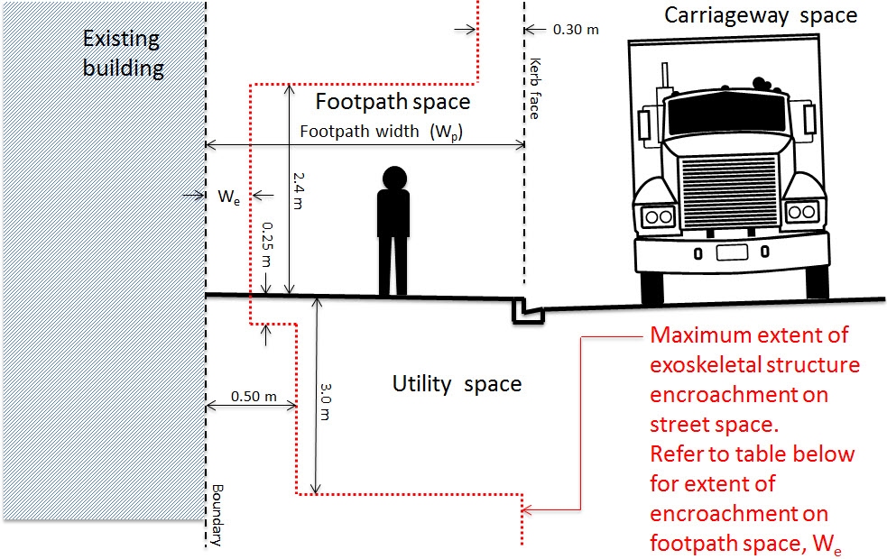

Table - To determine extent of encroachment on footpath space, W_{e}
Step 1 – Select the Category of Street
Step 2 - Identify narrowness of existing footpath width, W_{p}
Step 3 – Select the corresponding Allowable encroachment on footpath space, W_{e}
 | Existing Footpath Width (W_{p})
Category of Street⁽¹⁾ and the corresponding minimum width in WCC Code of Practice for Land Development ⁽²⁾ (W_{d}) | Very narrow  (m) | Narrow  (m) | Wide  (m)
Golden Mile 5.0m | < 4.0 | 4.0 - 5.0 | > 5.0
Central City Shopping 4.0m | < 3.0 | 3.0 - 4.0 | > 4.0
Central Business District 3.0m | < 2.0 | 2.0 - 3.0 | > 3.0
Suburban Shopping 4.0m | < 3.0 | 3.0 - 4.0 | > 4.0
Other Arterial/Principal Roads 2.5m | < 1.7 | 1.7 - 2.5 | > 2.5
Other Collector/SubCollector Roads 2.0m | < 1.4 | 1.4 - 2.0 | > 2.0
All other roads 1.5m | < 1.4 | 1.4 - 1.5 | > 1.5
Allowable encroachment on footpath space, W_{e} = | 100mm | 200mm | W_{p} - W_{d}

- Road Categories are recorded in the Roading Shapefile on the WCC Intranet Mapping system
- WCC Code of Practice for land Development http://wellington.govt.nz/~/media/services/environment-and-waste/urban-development/files/04partC.pdf

