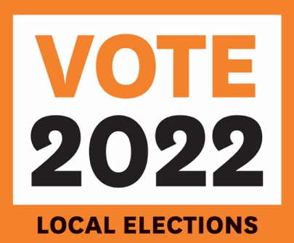
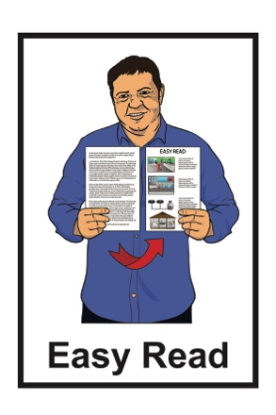

How to get enrolled

and vote in the 2022

Local Authority Elections
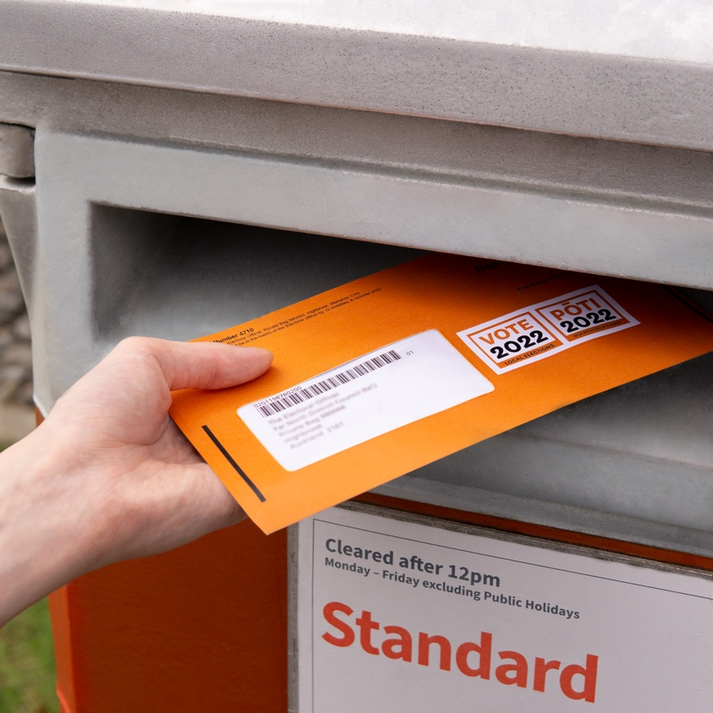

Before you start

This is a long document.

While it is written in Easy Read it can be hard for some people to read a document this long.

Some things you can do to make it easier are:
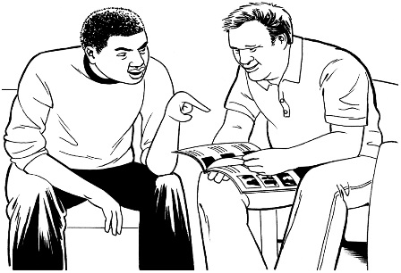
- read it a few pages at a time

- have someone help you to understand it.

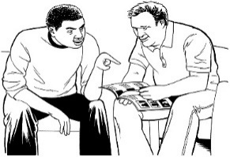
What you will find in here

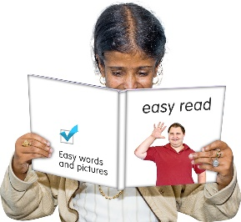
Page number:

What is this document about? 4

What is a local authority? 7

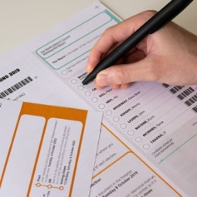
Why you should vote in your
local authority election 11
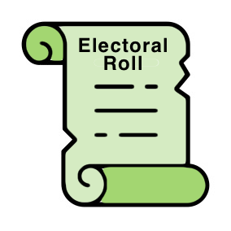

What is the electoral roll? 13

How to get enrolled to vote 16

Page number:
What will happen if you are
already enrolled to vote 23

What are the 2 different kinds of voters? 25

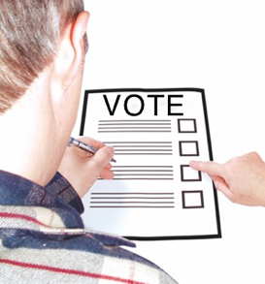

How to vote in the local
authority election 33

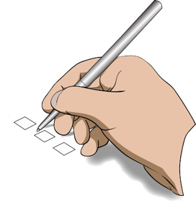

What to do if you find it difficult
to vote 38

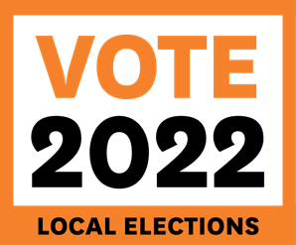
Key dates for the 2022 local
authority elections 40

What is this document about?
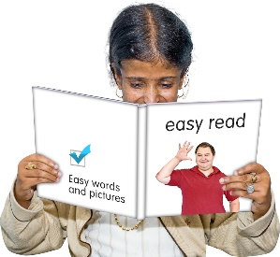

This Easy Read document is about the 2022 local authority elections.

An election is the time when you vote.

When you vote for someone you get to have your say about who you think should win an election.

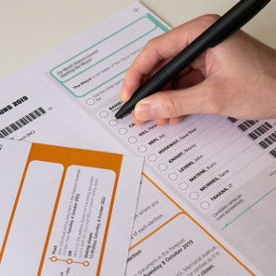
Local authority elections are when you vote for the people you want to have on your local council.

A local authority election is different to a general election which is when you vote for who runs the country.

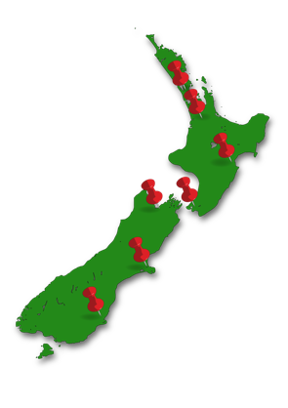
In this document:

- when we say area we mean a community / communities covering an area of land.

- when we say community we mean a particular area where a group of people live.

This Easy Read document gives you information you need to know about:

- how to make sure your name is added to a list so you can vote called enrolling

- how to vote.

Enrolling means you fill in a form to add your name to the electoral roll.

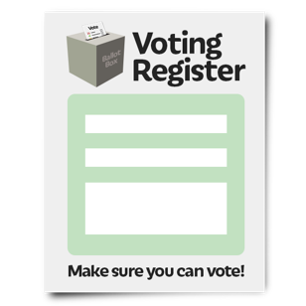
The electoral roll is a list of all the people who have enrolled to vote.

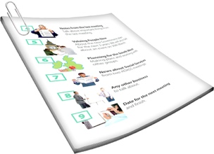
You can find out more about enrolling to vote on page 16 of this document.

What is a local authority?

Local authorities are also known as local councils.

Local councils look after different areas of New Zealand such as:
- towns / communities

- cities

- other areas of land called:

- regions

- districts.
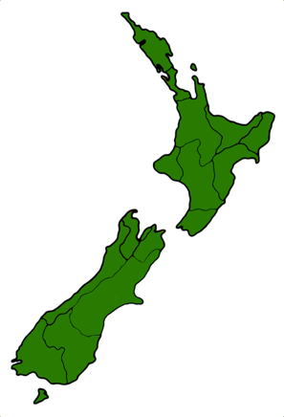

All of these different areas are kept apart from each another by a regional boundary.
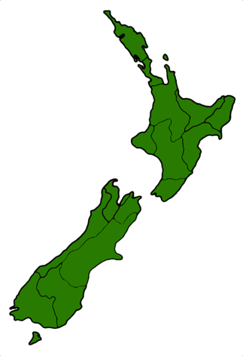
A regional boundary:

- is a line / border on a map

- shows the amount of land that makes up a certain area.

Local councils do lots of important things for your community like:

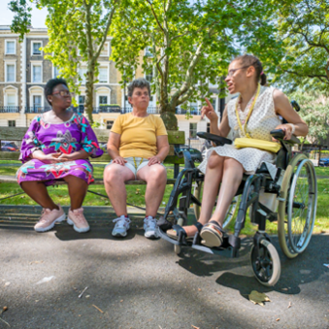
- collect your rubbish / recycling

- look after green spaces / local parks

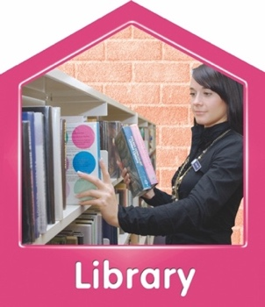
- look after community services like libraries and museums

- encourage local arts / culture by supporting events like festivals and parades.

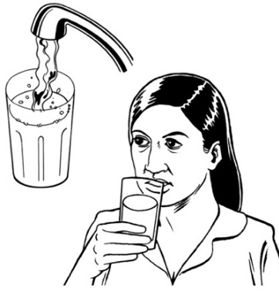
Local councils also do other important jobs to make sure that:

- you always have fresh water coming from your taps

- the pipes that get rid of your
dirty water / waste work properly

- new buildings are well built / safe for people to use them
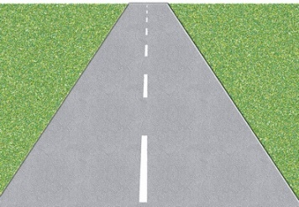
- roads are safe / well looked after

- footpaths are safe to use and have working streetlights

- there are good places to park your car.

New Zealand is made up of 78 local councils that have different voting areas.

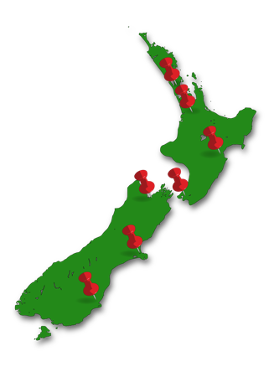
The voting area a local council looks after is called a council area.

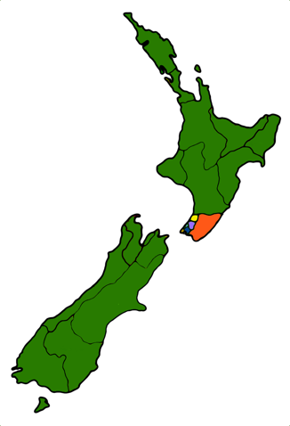
Sometimes the area of land that makes up a council area is divided into smaller voting areas called:

- wards

- community boards.

Divided means it is split into parts.

Large cities in New Zealand like Wellington and Auckland are divided into wards.

The people who live in each ward vote for the people they want to speak for them about things that affect their local community.

Why you should vote in your local authority election

The people who work for your local council make important decisions that can affect:
- how you live

- the lives of other people.

Different people have different ideas about the best way to do things.

Voting in a local authority election is the best way for you to have your say about what happens in your local community.

The people you vote for in an election are called candidates.

When someone says they want to be a candidate in an election it is called standing for election.

It is up to you to choose which candidate you want to vote for.

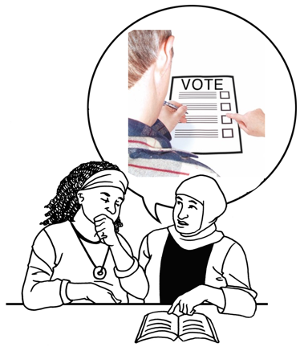
Nobody is allowed to tell you who to vote for.

Every vote is important.

Your vote could make sure the candidate you choose wins the election.

What is the electoral roll?

You must be on the electoral roll to be able to vote.

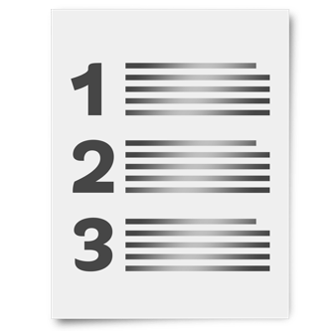
The electoral roll is a list of all the people who have enrolled to vote.

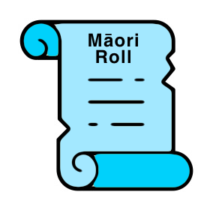
The electoral roll can be split into two lists:

- the Māori roll that is open to voters who are Māori

- the general roll that is open to all voters.
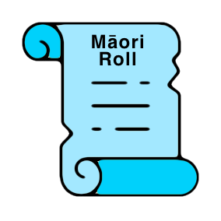

No one can be on both rolls at the same time.
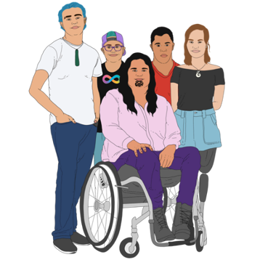
You can choose if you want to be on the Māori roll or the general roll if you are:

- Māori
and

- enrolling to vote for the first time.
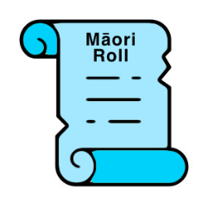

If you are on the Māori electoral roll you will be able to vote for:

- who will be the leader of the local council called the mayor
- candidates who want to work for your local Māori ward if your council has them
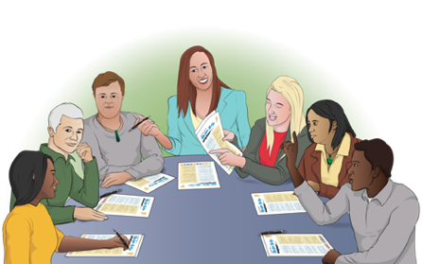
- other people who want to be a part of your community board / local board if there is one in your area.
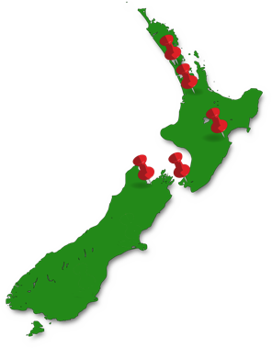
A Māori ward is a voting area in
which people on the Māori electoral roll can vote.

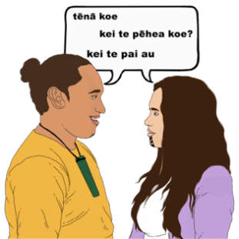
Māori wards were set up to give Māori a more equal say about what happens in their local community.

If you are on the Māori electoral roll your voting documents may look different to documents you have seen in other local elections.
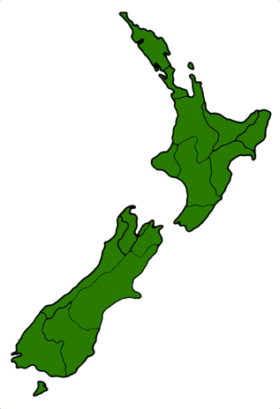
If you are on the Māori electoral roll you will not be able to vote for candidates in general wards.

How to get enrolled to vote

18
To get enrolled to vote in New Zealand you must:

- be at least 18 years old

and

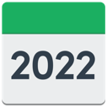
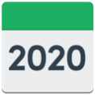
- have lived in New Zealand for more than 1 year at some time in your life

and

- be:

- a New Zealand citizen
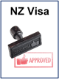
or

- a New Zealand permanent resident.
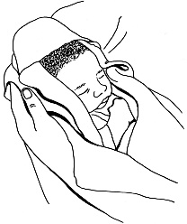
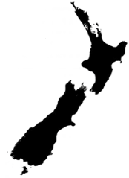
A New Zealand citizen is someone who was born in New Zealand.

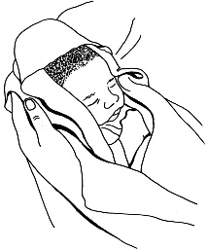
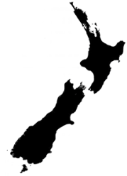
A New Zealand permanent resident is someone who:

- was not born in New Zealand
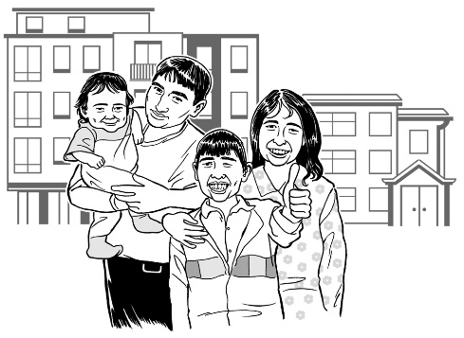
- has been told by the government they can live in New Zealand all the time.

It is easy to:

- enrol to vote

- check your information
- update your information like where you live.

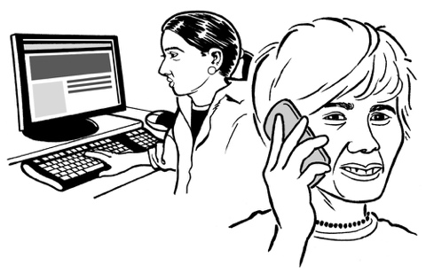
You can check if you are enrolled to vote at any time by:

- calling 0800 36 76 56

- visiting the website www.vote.nz

You can also enrol / update your details online at www.vote.nz.

To enrol online you will need to
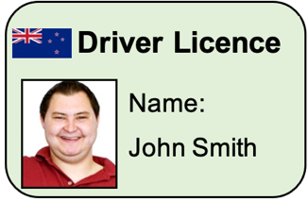
use 1 form of identification from this list:

- your New Zealand driver licence

or

- your New Zealand passport

or

- your Real Me verified identity.
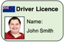
A form of identification is an official document that you can use to prove who you are.

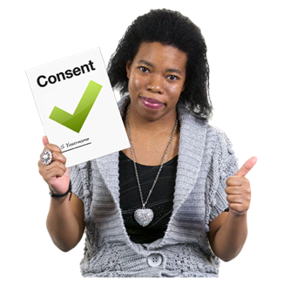
Verified means something that:

- has been checked

- is true.

You can call 0800 36 76 56 to ask for an enrolment form to be sent to you by post if you:

- cannot get online
- do not want to update your voter details online.
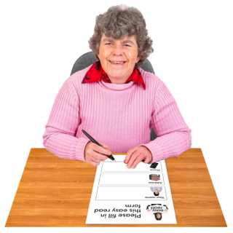

You will need to put some information about you on the enrolment form.
It is important to put the right information on the enrolment form.

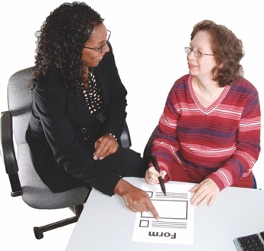
If you need assistance to put your information on the enrolment form you should ask someone to support you.

After you have enrolled to vote your name will go on the electoral roll.

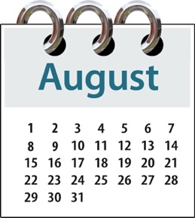
You should make sure your name is on the electoral roll by 12 August 2022.

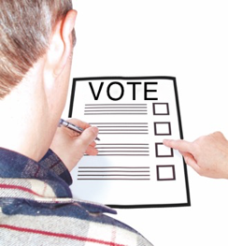
This is to make sure you can vote easily.

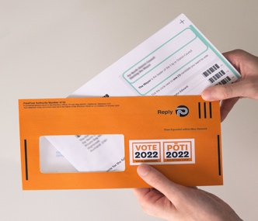
Everyone who is enrolled by
12 August 2022 will get their voting documents:
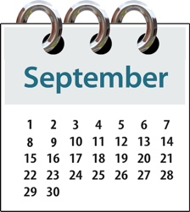
- by post

- from 16 September 2022.

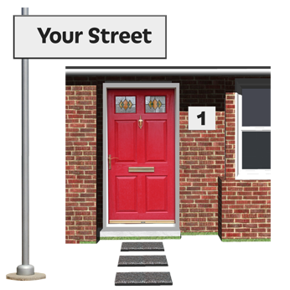
The voting documents will be sent to:

- your home address which is where you live

or
- your postal address which is where your personal or business mail gets delivered to.

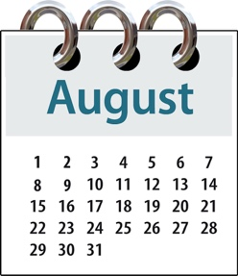
If you enrol after 12 August 2022 you can still vote

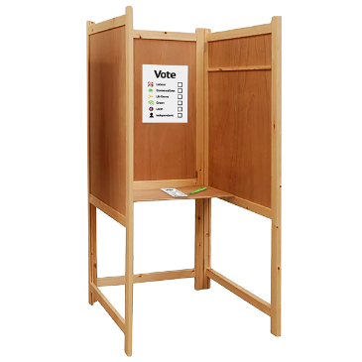
but

your vote will be called a
special vote.

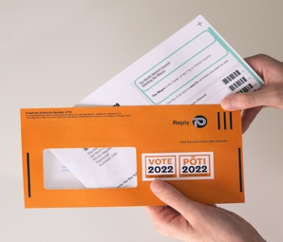
A special vote is a vote made by someone who:

- did not get their voting documents in the post

- made a mistake when they filled out their voting documents

- enrolled to vote after 12 August 2022.

What will happen if you are already enrolled to vote

If your name is already on the electoral roll you will get an enrolment update pack:
- by post
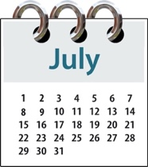
- in early July 2022.

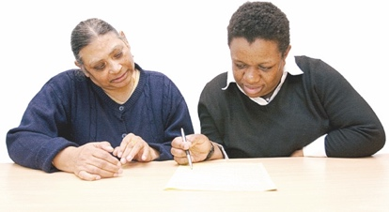
You should check that all the information about you on the enrolment update pack is correct.

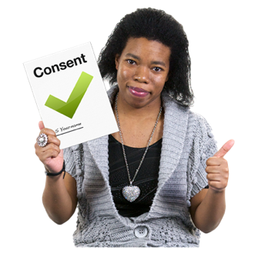
If all the information about you is correct you do not need to do anything.

If any of the information about you is wrong you should make sure you update it as soon as possible.

If you do not get an enrolment update pack in the post it might mean that:

- you are not enrolled to vote

- you need to update your details.

If you do not get an enrolment update pack you should check if you are enrolled to vote by:

- calling 0800 36 76 56

- visiting the website www.vote.nz

What are the 2 different kinds of voters?
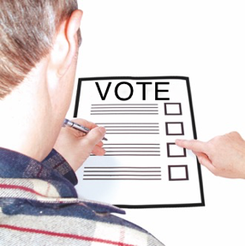

People who can vote are also called electors.

There are 2 kinds of voters / electors:

- residential electors

- non-resident ratepayer electors.

A resident is someone who lives in a certain place / area.

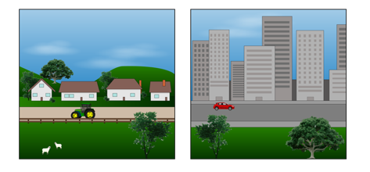
Residential means things to do with that place / area.

Residential electors
If your name is already on the electoral roll you will be able to vote in your voting area.

You will get your voting documents sent to you by post.

Non-Resident Ratepayer electors

Non-resident ratepayer electors are people who:

- live in one council district
- pay rates on a property in a different council district.

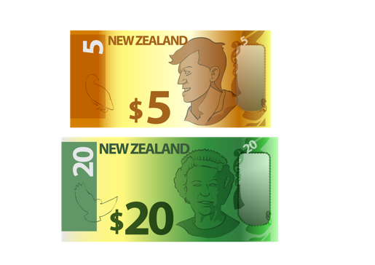
Rates is money you pay to the council that they use to look after the local area.

A property means the type of building that you live in.

A property could be:
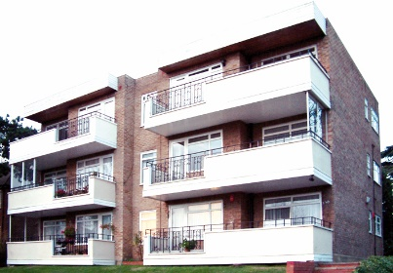
- a house

- an apartment
- a townhouse

- another type of building.

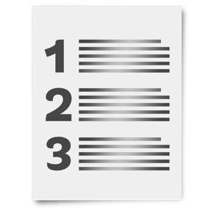
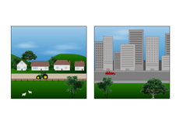
You may be allowed to vote in 2 voting areas if:

- you are on the district valuation roll

and

- pay rates in that area

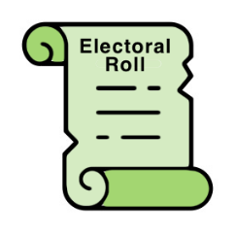
and

- the address where you are enrolled to vote is in a different area.

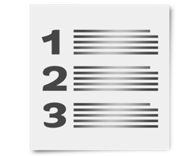
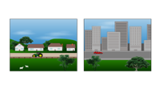
The district valuation roll is a list of all the properties in a council district.

It sets out how much money people pay as rates.

Some people may not be able to enrol as a non-resident ratepayer.

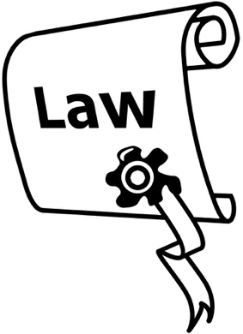
This is because of rules set out in a law called the Local Electoral Act 2001.

You can read the full Local Electoral Act on the New Zealand Legislation website at:

https://bit.ly/3y1ShaG

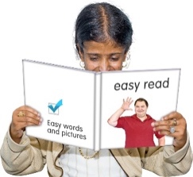
The information on this website is not in Easy Read.

A business / organisation that pays rates to the council can choose someone who works for it to vote on its behalf.

This means that 1 person can vote in an election in place of a group of people / a business.

This person will vote for the candidate chosen by the people who work in the business / organisation.

It does not matter how many properties you own in a voting area you can only:

- enrol 1 time in a council district
- be chosen by a business / organisation to enrol 1 time in a council district.

New Non-resident Ratepayer Electors

You can get an enrolment form from the local council where you pay your rates to:
- enrol as a non-resident ratepayer elector

- choose someone else to be a non-resident ratepayer elector.

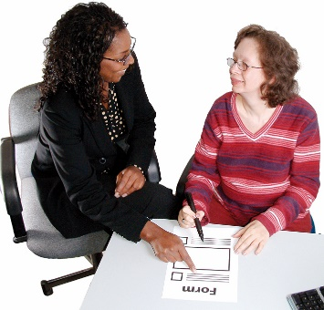
The Electoral Officer will be able to help you with your application.

The Electoral Officer works for their local council to make sure local elections are run properly.

You can get more information about the non-resident ratepayer electoral roll by calling:

0800 54 8683

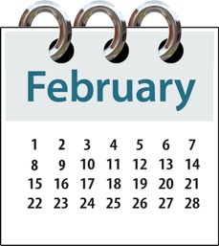
You can call this number between:

- 7 February 2022
to

- 30 August 2022.
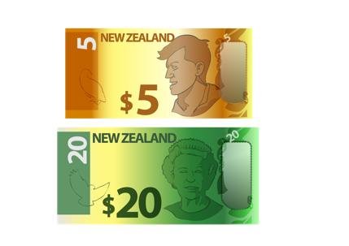
It will not cost you any money to call this number.

The non-resident ratepayer electoral roll closes on 12 August 2022.

How to vote in the local authority elections

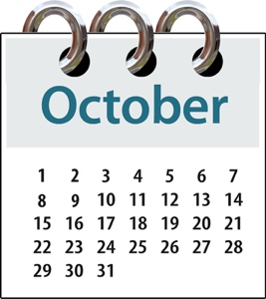
The local authority elections in New Zealand are on 8 October 2022.

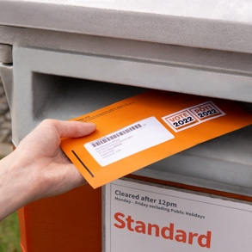
Voting will be done by post.

At the local authority elections you will be able to vote for:

- the person who will be the leader of the local council called the mayor

- people who work for the local council called councillors

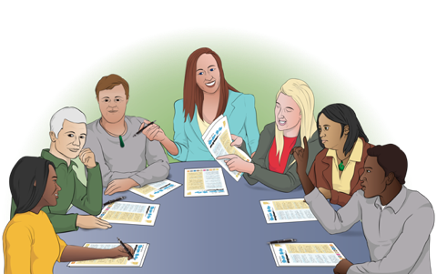
- other people who want to be a part of your community board / local board if there is one in your area.
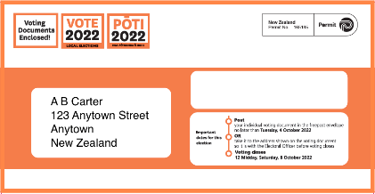
You will get your voting documents in the post from:

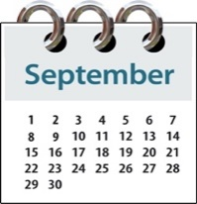
- 16 September 2022

to

- 21 September 2022.

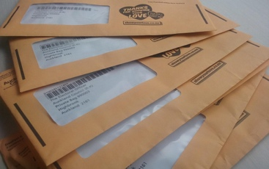
You will also get a free return envelope so you can post your vote back.

The voting documents will have information about:

- how to fill in the voting forms

- who are the candidates that you can vote for

- when you can vote.

You will need to put a mark on the voting documents to show which candidate you have chosen.

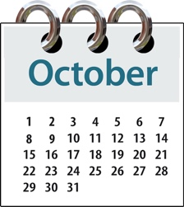
The time when you can vote in the local authority elections:

- starts on 16 September 2022

- ends at 12 midday on 8 October 2022.

You must make sure you have posted your vote back to your local council by 4 October 2022.

This is to make sure your council gets it before the voting time is over.

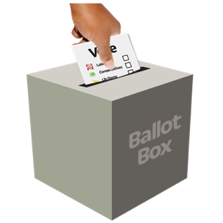
If you vote after 4 October 2022 you will have to put your vote in a local council secure ballot box.
A ballot box is a sealed box that voters put their completed voting documents in.

You will be able to find more information about where to find your local ballot box on your local council website.

Ballot boxes will be at places like:
- council service centres

- local libraries.
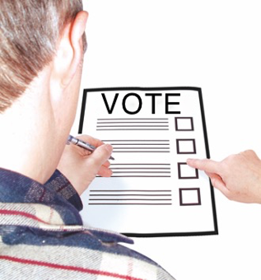

This information will be put online closer to election time.

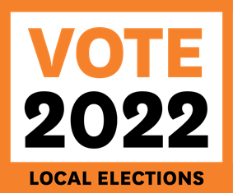
You can find out more about voting in the local elections at the Vote Local website at:
www.votelocal.co.nz

The information on this website is not in Easy Read.

What to do if you find it difficult to vote

Some people may find it difficult to put a mark on the voting documents to say who they want to vote for.

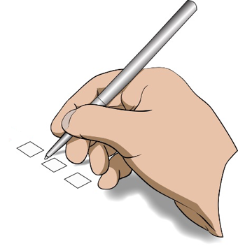
Things that might make voting difficult could be:

- you have a physical disability that makes it difficult for you to hold a pen
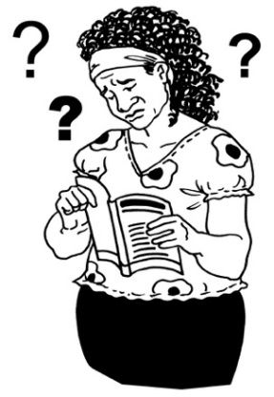
- you cannot read or write

- you cannot understand the
words / language used on the voting document.

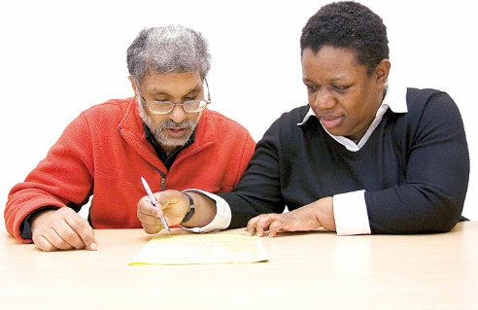
If you think you will find it difficult to make your vote it is okay to ask someone you trust to mark the voting document for you.
It is important that you do not let anyone else tell you who to vote for.

Key dates for the 2022 local authority elections

16 to 21 September 2022
- voting documents will be sent to you by post.

4 October 2022

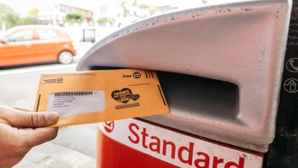
- last day for sending your completed vote by post

- after this date votes must be put in local council ballot boxes.
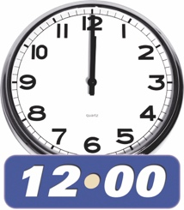

8 October 2022
- election day

- voting ends at 12 midday.
This information has been provided by Taituarā – Local Government Professionals Aotearoa.
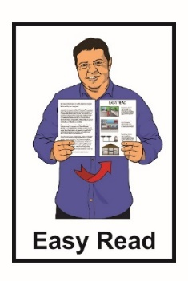
It has been translated into Easy Read by the Make It Easy service of People First New Zealand Inc. Ngā Tāngata Tuatahi.

The ideas in this document are not the ideas of People First New Zealand Inc. Ngā Tāngata Tuatahi.
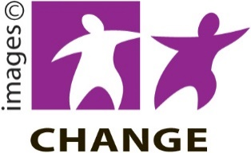
Make It Easy uses images from:
- Changepeople.org

- Photosymbols.com
- Sam Corliss
- Huriana Kopeke-Te Aho

Some images have also been provided by Taituarā.

All images used in this Easy Read document are subject to copyright rules and cannot be used without permission.

