# What to expect at Gardens Magic

Kia ora! This document is to help you prepare for coming to our events. It will cover what Gardens Magic looks like, what you should bring and what you can expect.

More specifically, this document will cover the evening concerts that Gardens Magic runs in the Botanic Garden in Wellington, which are free to attend and don’t require tickets.

Hopefully, this document will help you feel comfortable and prepared to come along.

We’re excited about you attending and hope you have a nice time.

## What am I allowed to bring?

When you come to Gardens Magic, you can bring headphones, fidget toys, earplugs, your bag, and any other comfort items.



## What should I bring?

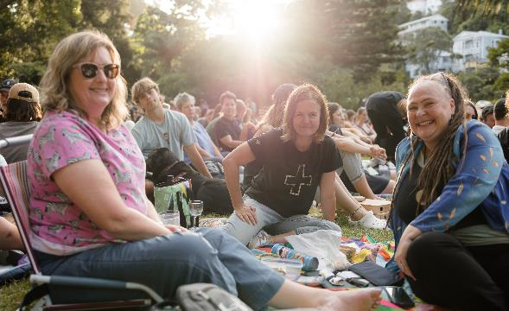This concert is outside in the evening. It’s a good idea to bring something to sit on, like a blanket, a water-bottle and some snacks.

The evenings are often warm and light but since Wellington weather can change suddenly, you might also like to bring some warm layers to wear.



Where can I get food and how do I pay?

There is one food truck at Gardens Magic that sells coffee, hot chocolate, tea and snacks. There are restaurants and a dairy nearby that you can bring takeaways from, but you can also bring your own food and drink or have dinner before you come.

The food truck is parked by the main entrance on Glenmore Street. You will be able to pay with a debit or credit card, or cash.

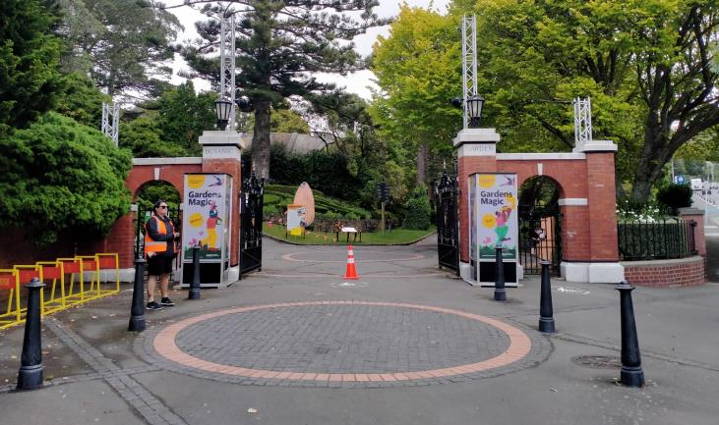

## How do I get there?

There is less parking than there used to be on Glenmore Street. Paid parking is available at the Lady Norwood Rose Garden, at the top of the Cable Car, Ballantrae Place, Clifton Terrace, Bolton Street and Mowbray Street.

You may consider coming by public transport. The buses that stop by the Main Entrance include numbers 2, 13, 33, and 34. The bus stop is number 5313 and is called “Glenmore Street at Botanic Gardens”.

There is also a drop off point at the main entry on Glenmore Street.

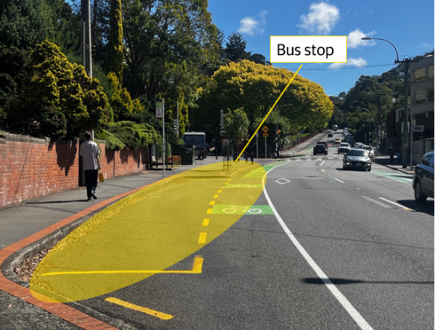

## Where are the concerts?

The concerts will be on the Soundshell Stage. This is located near the main entrance with the brick pillars on Glenmore Street.

The Soundshell is a large concrete structure with an open field in front of it. This field is called the Soundshell Lawn, and it’s an even, grassy surface. You can sit on benches around the edges of the Soundshell Lawn, or on the grass.

Lots of people may be seated on the grass in front of the stage or on the hill beside the stage.  The hill is steep, which is something you may want to consider before picking your spot. You can sit wherever you can find a spot.

Some people will be in chairs, others might be on picnic blankets, and some might be sitting directly on the grass. If you choose to bring a chair to sit on, we ask that you sit towards the back or sides of the lawn. This is so that you don’t block other people’s view.

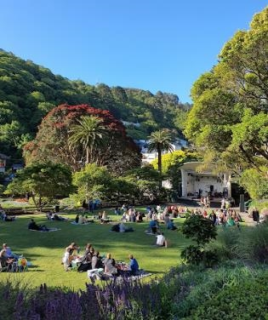

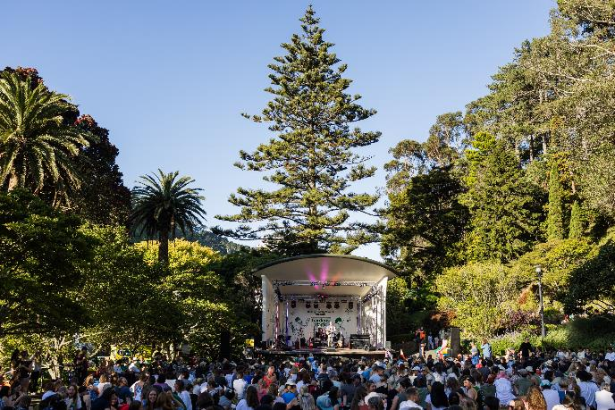

## What time can I arrive/leave?

The concerts begin at 7pm but we recommend arriving at least 30 minutes early to get a good spot. You can arrive and leave whenever you like. Lots of people come and go during the evening and some even come early to have a picnic before the music starts. If you arrive after 7pm, you may have to search around to find a spot to sit. Lots of people do this. Event staff in the orange hi vis vests can help you find a good spot.

The concerts end at 9.15pm, but you don’t have to stay until the end. This is a free event where people can stay for as long or as little as they like.

## What kind of music will there be?

Every night, there will be a different kind of music. Some nights, the crowd might get up and dance. Other nights, the crowd might sit and listen. The crowd might clap and cheer during the concert.

You can find the programme of acts and genres on [our website](https://wellington.govt.nz/news-and-events/events-and-festivals/gardens-magic) or on signs at the Garden to help you choose when to visit.

## Are there quiet spaces I can go to?

Gardens Magic may be crowded, but the large Botanic Gardens have lots of beautiful quiet spaces you can visit to get away from the crowds.

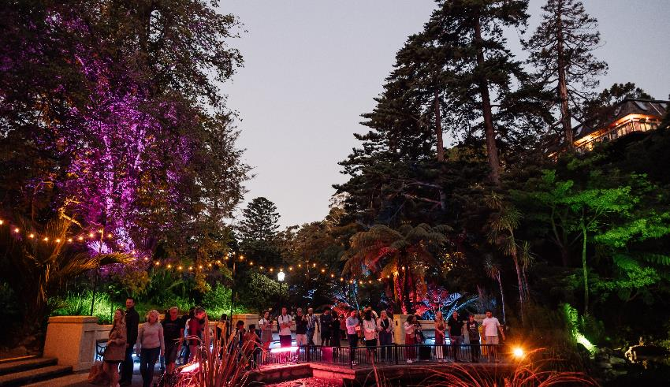

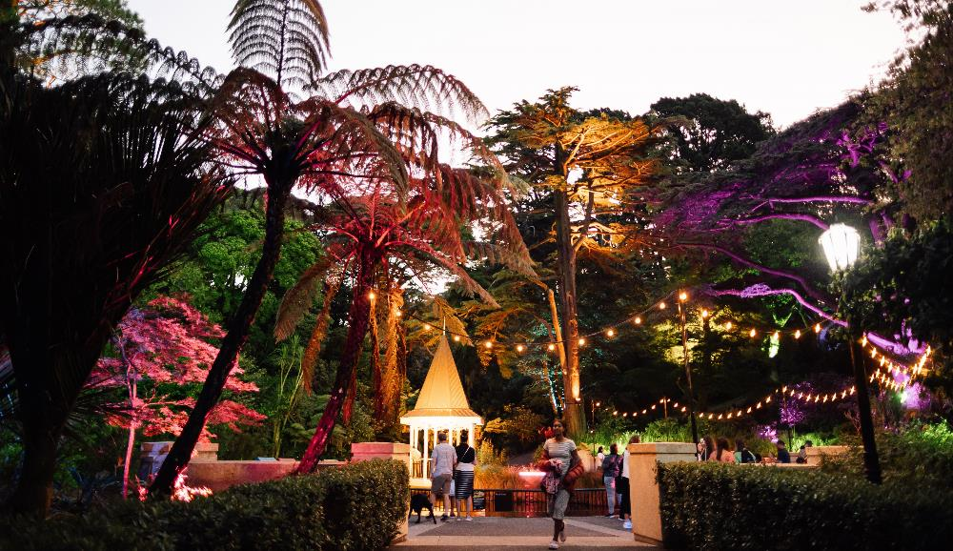

## Who can assist me if I need help?

Every event has event staff who are there to help you. They will be wearing orange hi-vis vests with “Creative Capital City Events” written on the back.  You can approach them and ask for help any time.



There will also be signs at each event to let you know where things like exits and entries, toilets and other activities are. Keep an eye out for them and ask a crew member in hi-vis if you get lost!



A sign directing you to the exit. It has a green background, an icon of a person walking, an arrow pointing to the exit and the following text, which is Māori and English: “Putanga – Exit”




## Where are the toilets and how do I access them?

At Gardens Magic we have permanent public toilets and extra Portaloos.

You will find the toilets near the fountain on Glenmore Street. The accessible toilet is in the small brick building next to the permanent public toilets and the Portaloos will be nearby.

You can use the toilets at any time. When it is busy, a line of people waiting to use the toilets will form and you may have to queue.

The Portaloos lock from the inside and may have hand sanitiser instead of a sink and running water.

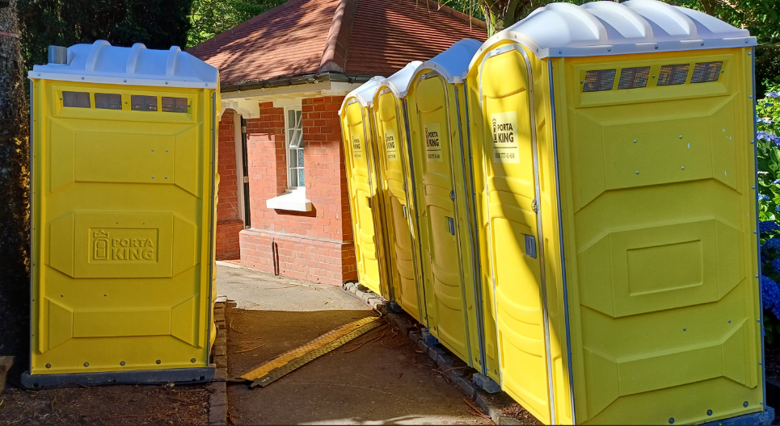

We hope this document is helpful and we’re looking forward to having you at Gardens Magic!

If you have more questions, you can call our call centre on 04 499 4444 or email the events team at [events@wcc.govt.nz](mailto:events@wcc.govt.nz) for more information.

We hope you have a great day!